**NOTICE TO PRODUCE**Regarding Offer of COVID-19 Injection Product

The onus is not on me to do my own research with regards to medical treatment, procedures or any interventions but the one issuing the mandate should provide required information of the risks involved with regards to medical treatment to ensure “informed consent” is provided. Informed consent is required according to the *Health* *Care* *Consent* *Act, 1996,* s. 11 (1) and (2). Refer to Exhibit A.

Without consent, this medical intervention is considered assault under the *Criminal Code of Canada,* RSC 1985, c. C-46, s. 265(1)(b) and (3). Refer to Exhibit B.

Harm is being threatened against me through loss of livelihood in the form of constructive dismissal or unpaid leave. I require the following information and evidence from verified sources, as is my right, in order to provide my informed consent to these mandates and to avoid harm to myself:

1. Please confirm that you, the Respondent, are not under any coercion or threat, nor being monetarily or otherwise compensated for executing these mandates.
2. Please clarify that these mandates are not evidence of Extortion per the Canadian Criminal   
   Code s. 346.  
   **Extortion**

346 (1) Every one commits extortion who, without reasonable justification or excuse and with intent to obtain anything, by threats, accusations, menaces or violence induces or attempts to induce any person, whether or not he is the person threatened, accused or menaced or to whom violence is shown, to do anything or cause anything to be done.

1. Please provide your source of authority for the COVID-19 measures, given that Health Canada, among others, has responded to an FOIA request that they have no evidence of having isolated the virus. Refer to Exhibit C, Health Canada response from Christine Smith. Below is the link to 105 FOIAs from 20 different countries citing the same response.  
   Source: <https://www.fluoridefreepeel.ca/fois-reveal-that-health-science-institutions-around-the-world-have-no-record-of-sars-cov-2-isolation-purification/>
2. Please provide your source of authority to contravene the following Acts in requiring me to disclose my private medical information. Refer to Exhibit D.
   1. Personal Information Protection and Electronic Documents Act, 2000 (PIPEDA)
   2. The Personal Health Information Protection Act, 2004 (PHIPA), and
   3. The Ontario Occupational Health and Safety Act, R.S.O. 1990, c. O.1, s. 63 (2)
3. Please provide the evidence that any mandatory COVID-19 injection you propose to use has been fully and completely approved by Health Canada. According to the Health Canada website, it appears that the injections are only authorized in Canada under an “Interim Order” which states: “The Interim Order provides the Minister with the ability to take into consideration the uncertainties and the urgent public health needs in the context of the COVID-19 pandemic while determining if a drug demonstrates that its benefits outweigh its risks.” This does not provide evidence of a full and complete approval process. None of the currently available vaccines are approved by the FDA in the United States.  
   Source: <https://www.canada.ca/en/health-canada/services/drugs-health-products/covid19-industry/drugs-vaccines-treatments/interim-order-import-sale-advertising-drugs/note.html#a4.1>  
   Refer to Exhibit E for the list of injections demonstrating Interim Order use only.   
   Refer to Exhibit F for the description of the Interim Order.
4. Please provide the evidence that there are no other suitable remedies for the disease known as COVID-19. It appears that medications such as Ivermectin or Hydroxychloroquine, vitamins, and others, have been shown to effectively address COVID-19.
5. Please provide evidence and safety studies that the injection has been fully, independently, and rigorously tested against control groups and the subsequent outcomes of those tests, including long term results as well as carcinogenicity and impact on fertility.
6. Please provide proof that I will not be involuntarily participating in a clinical trial for this injection, as the FDA Clinical Trial site shows that all injections are still in clinical trial as follows:  
   Moderna: ends Nov 22, 2022 <https://clinicaltrials.gov/ct2/show/NCT04283461>   
   Janssen/J&J: ends Jan 2, 2023 <https://clinicaltrials.gov/ct2/show/NCT04505722>  
   AZ: ends Feb 14, 2023 <https://clinicaltrials.gov/ct2/show/NCT04516746>  
   Pfizer: ends May 2, 2023 <https://clinicaltrials.gov/ct2/show/NCT04368728>
7. Please provide the evidence stating that taking this injection will prevent me from getting COVID-19, and therefore justify the mandate. This does not appear to be true.

According to the CDC: “ Vaccine breakthrough infections are expected. COVID-19 vaccines are effective at preventing most infections. However, like other vaccines, they are not 100% effective.” Source: <https://www.cdc.gov/coronavirus/2019-ncov/vaccines/effectiveness/why-measure-effectiveness/breakthrough-cases.html>

1. Please provide the evidence stating that taking this injection will prevent me from transmitting it to others and therefore justify the mandate. This does not appear to be true.

- According to the CDC: “Fully vaccinated people with Delta variant breakthrough infections can spread the virus to others.” Aug 19, 2021   
Source: <https://www.cdc.gov/coronavirus/2019-ncov/variants/delta-variant.html>

- According to Dr. Andrew Badley, M.D., the COVID Research Task Force Chair at the Mayo Clinic, “What we know the vaccine does is it prevents symptomatic disease. What we don't know if it does or not is to prevent infection. And if you are infected, but you don't get sick because of the vaccine, you can still replicate the virus and transmit the virus.” Source: <https://www.mayoclinic.org/can-i-infect-someone-after-receiving-the-covid-19-vaccine/vid-20507040>

1. Please provide the rationale for mandating the injection when the Absolute Risk Reduction shows that this injection will not grant me more effective immunity than remaining unvaccinated.

Based on an NIH study, the Absolute Risk Reduction of the Pfizer and Moderna injections offer only around 1% absolute risk reduction, rendering the injections basically on par with one’s natural immune system. Further, the study concludes that, when relative risk is reported and NOT absolute risk, that “Such examples of outcome reporting bias ***mislead and distort the public’s interpretation of COVID-19 mRNA vaccine efficacy and violate the ethical and legal obligations of informed consent***.”   
Source: <https://pubmed.ncbi.nlm.nih.gov/33652582/>  
Refer to Exhibit G.

1. Please provide the evidence that taking this injection will not result in me experiencing Antibody Dependent Enhancement (ADE), as reports state evidence is coming to light that ADE is occurring in the vaccinated population. If you cannot prove I will not get it, please at least advise of my likelihood of experiencing ADE.

According to a study published by the NIH:  
“Data from the study of SARS-CoV and other respiratory viruses suggest that anti-SARS-CoV-2 antibodies could exacerbate COVID-19 through antibody-dependent enhancement (ADE). Previous respiratory syncytial virus and dengue virus vaccine studies revealed human clinical safety risks related to ADE, resulting in failed vaccine trials.”  
Source: <https://pubmed.ncbi.nlm.nih.gov/32908214/>

1. Please provide the evidence that I will not experience any heart-related issues, including cardiac arrest, myocarditis or pericarditis, and regardless of my health history as it appears that it is difficult to have exemptions honoured by an employer.

Per the CDC: What You Need to Know

Cases of myocarditis reported to the Vaccine Adverse Event Reporting System (VAERS) external icon have occurred:

- After mRNA COVID-19 vaccination (Pfizer-BioNTech or Moderna), especially in male adolescents and young adults,

- More often after the second dose

- Usually within several days after vaccination  
Source: <https://www.cdc.gov/coronavirus/2019-ncov/vaccines/safety/myocarditis.html>

1. Please advise of the full list of ingredients of the injection I am to receive, including:
   1. Proof that no aborted fetal tissue was used in the development or production of the

COVID injection.

* 1. Proof that there are no hazardous materials such as Graphene Oxide (GO) or SM-102 in   
     the injection.

**Note:** Section 245 of the Canadian Criminal Code cites that “Administering Noxious Thing” constitutes an indictable offence. This would apply to each of you, the Respondents. Refer to Exhibit H.

1. Please fully advise of all of the adverse reactions associated with this injection since its introduction and the probability that I may experience each side effect. According to an FDA presentation in October 2020, there are many serious ones which are not communicated publicly. Source: <https://youtu.be/1XTiL9rUpkg> Refer to Exhibit I.
2. Please confirm that the mandated injection you are advocating is not “experimental mRNA gene altering therapy”, including proof that it will not alter my DNA thereby rendering me “property” of the manufacturer via patent, nor alter my access to Human Rights. (Source: Association of Molecular Pathogens et al. v Myriad Genetics Inc, Oct 2012, US Supreme Court.  
   <https://www.supremecourt.gov/opinions/12pdf/12-398_1b7d.pdf>)
3. Please share the rationale for this injection when the mortality rate in Canada is 1.7% within positive cases, and 0.075% overall for the population. Refer to Exhibit J.  
   Sources: <https://data.worldbank.org/indicator/SP.POP.TOTL?locations=CA>; <https://health-infobase.canada.ca/covid-19/epidemiological-summary-covid-19-cases.html?stat=num&measure=deaths&map=pt#a2>
4. Please advise me of the likely risk of fatality that can result from the injection.
5. Please advise me of the likely risk of life-altering disability from the injection.
6. Please confirm that the respective injection companies have not been prosecuted for any impropriety and/or crimes in respect of their products at any time.
7. Please confirm that I will not be under any duress from you in compliance with the Nuremberg Code, among other protections, to take this injection. Please refer to Exhibit K for the Nuremberg Code.
8. Please confirm and provide the details of the insurance coverage you are providing for any injury or death that may occur as a result of the mandated injection, since the government and the manufacturers have been absolved of any and all liability.
9. Please provide me with the corporate policy outlining the sick leave and disability benefits being offered to employees should they need time off work due to injury from the injection.

Once I have received and reviewed the above information in full and I am satisfied that there is no threat whatsoever to my health or my current quality of life, I will be happy to accept your offer to receive the injection, but with certain conditions – namely that:

1. You confirm that I will suffer no harm from the injection in any way, shape or form. To this end, I will take blood screens, a D-dimer blood clot test, and any other appropriate tests, at my expense, prior to receiving the injection to create a benchmark against which any changes may be objectively measured, and
2. Following acceptance of but prior to this injection, the offer must be signed by a fully qualified doctor or authorized representative from your organization who will assume full legal and financial liability for any injuries occurring to myself, up to and including death, and
3. In the event that I elect to decline the offer of injection, you confirm that it will not compromise my position/enrollment and that I will not suffer any [disciplinary action, demotion, pay cut, denial of entry/enrollment, discrimination, termination, suspension, harassment], or any other negative impact as a result.

**Response**A response to each point is required in writing via Affidavit, delivered by Registered Mail, within 14 days of receipt of this Notice. Failure to respond will render the injection mandate null and void with respect to me, and there will be no further recourse or negative impact on me regarding this issue.

**NOTICE TO RESPONDENTS**

IT IS NOT MY INTENTION TO HARASS, INTIMIDATE, OFFEND, CONSPIRE, BLACKMAIL, COERCE, OR CAUSE ANXIETY, ALARM OR DISTRESS. THIS DOCUMENT AND ATTACHMENTS ARE PRESENTED WITH HONOURABLE AND PEACEFUL INTENTIONS, AND ARE EXPRESSLY FOR YOUR BENEFIT TO PROVIDE YOU WITH DUE PROCESS AND A GOOD FAITH OPPORTUNITY TO STATE A VERIFIED CLAIM.

Exhibit A  
Source: <https://www.canlii.org/en/on/laws/stat/so-1996-c-2-sch-a/latest/so-1996-c-2-sch-a.html>

**Health Care Consent Act, 1996**

S.O. 1996, CHAPTER 2  
SCHEDULE A

**No treatment without consent**

**10**(1) A health practitioner who proposes a treatment for a person shall not administer the treatment, and shall take reasonable steps to ensure that it is not administered, unless,

(a)  he or she is of the opinion that the person is capable with respect to the treatment, and the person has given consent; or

(b)  he or she is of the opinion that the person is incapable with respect to the treatment, and the person’s substitute decision-maker has given consent on the person’s behalf in accordance with this Act.  1996, c. 2, Sched. A, [s. 10 (1)](https://www.canlii.org/en/on/laws/stat/so-1996-c-2-sch-a/latest/so-1996-c-2-sch-a.html#sec10subsec1_smooth).

**Elements of consent**

**11**(1) The following are the elements required for consent to treatment:

1.  The consent must relate to the treatment.

2.  The consent must be informed.

3.  The consent must be given voluntarily.

4.  The consent must not be obtained through misrepresentation or fraud.  1996, c. 2, Sched. A, [s. 11 (1)](https://www.canlii.org/en/on/laws/stat/so-1996-c-2-sch-a/latest/so-1996-c-2-sch-a.html#sec11subsec1_smooth).

**Informed consent**

(2) A consent to treatment is informed if, before giving it,

(a) the person received the information about the matters set out in subsection (3) that a reasonable person in the same circumstances would require in order to make a decision about the treatment; and

(b) the person received responses to his or her requests for additional information about those matters.  1996, c. 2, Sched. A, [s. 11 (2)](https://www.canlii.org/en/on/laws/stat/so-1996-c-2-sch-a/latest/so-1996-c-2-sch-a.html#sec11subsec2_smooth).

**Same**

(3) The matters referred to in subsection (2) are:

1.  The nature of the treatment.

2.  The expected benefits of the treatment.

3.  The material risks of the treatment.

4.  The material side effects of the treatment.

5.  Alternative courses of action.

6.  The likely consequences of not having the treatment.  1996, c. 2, Sched. A, [s. 11 (3)](https://www.canlii.org/en/on/laws/stat/so-1996-c-2-sch-a/latest/so-1996-c-2-sch-a.html#sec11subsec3_smooth).

Exhibit B  
Source: <https://www.laws-lois.justice.gc.ca/eng/acts/c-46/section-265.html>

Criminal Code Section 265 - Assault

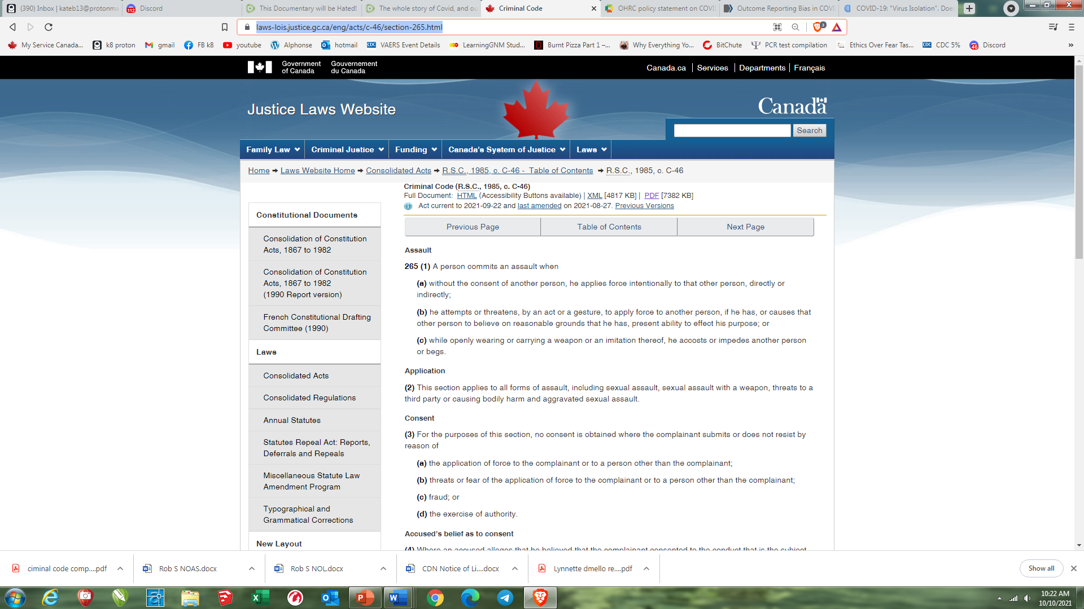

Exhibit C  
Source: <https://www.fluoridefreepeel.ca/health-canada-has-no-record-of-covid-19-virus-isolation/>

Exhibit C (cont’d)  
Source: <https://www.fluoridefreepeel.ca/health-canada-has-no-record-of-covid-19-virus-isolation/>

Health Canada Response to FOIA regarding isolation of the SARS-COV-2 virus

**Exhibit D:**  
  
**PIPEDA**Fair information principles   
Source: https://priv.gc.ca/en/privacy-topics/privacy-laws-in-canada/the-personal-information-protection-and-electronic-documents-act-pipeda/p_principle/

Revised: May 2019

PIPEDA’s 10 fair information principles form the ground rules for the collection, use and disclosure of personal information, as well as for providing access to personal information. They give individuals control over how their personal information is handled in the private sector.

In addition to these principles, PIPEDA states that any collection, use or disclosure of personal information must only be for purposes that a reasonable person would consider appropriate in the circumstances.

The OPC has determined that the following purposes would generally be considered inappropriate by a reasonable person (i.e., no-go zones):

* collecting, using or disclosing personal information in ways that are otherwise unlawful;
* profiling or categorizing individuals in a way that leads to unfair, unethical or discriminatory treatment contrary to human rights law;
* collecting, using or disclosing personal information for purposes that are known or likely to cause significant harm to the individual;
* publishing personal information with the intent of charging people for its removal;
* requiring passwords to social media accounts for the purpose of employee screening; and
* conducting surveillance on an individual using their own device’s audio or video functions.

This section sets out organizations’ responsibilities for each of the 10 fair information principles. It outlines how to fulfill these responsibilities and offers some tips.

**PERSONAL HEALTH INFORMATION PROTECTION ACT, 2004 (PHIPA)**Source: https://www.health.gov.on.ca/english/providers/project/priv_legislation/info_custodians.pdf

Interaction of PHIPA with other law

As a general rule, where there is a conflict between PHIPA and any other legislation, PHIPA prevails: s.  
7(2). If it is possible to comply with both provisions however, there is no conflict. For example, if a  
regulation under another Act requires that a health information custodian ensure that records be kept  
accurate and up to date at all times (e.g., s. 93 of Reg. 832 made under Nursing Homes Act) and PHIPA requires steps to be taken that are reasonable in the circumstances to maintain accuracy, it is possible to comply with both provisions by complying with the higher standard: s. 7(3). Regulations may provide further guidance as to the interpretation of the conflicts provision in s.7(2).

**Exhibit D: cont’d**

**PERSONAL HEALTH INFORMATION PROTECTION ACT, 2004 (PHIPA)**Source: https://www.health.gov.on.ca/english/providers/project/priv_legislation/info_custodians.pdf

**Consent Concerning Personal Health Information**+ Elements of Consent

Where an individual’s consent is required under the Act (or any other Act to which the custodian is subject) for collecting, using or disclosing personal health information, such a consent must:

• be from the individual or an authorized substitute decision-maker of the individual  
• be knowledgeable  
• relate to the information  
• not be obtained through deception or coercion

**Ontario Occupational Health and Safety Act:**Source: https://www.ontario.ca/laws/statute/90o01#BK94

* 1. Section 63, Information Confidential:   
     Employer access to health records

(2) No employer shall seek to gain access, except by an order of the court or other tribunal or in order to comply with another statute, to a health record concerning a worker without the worker’s written consent. <https://www.ontario.ca/laws/statute/90o01>

Exhibit E: List Authorized under “Interim Order”

Source: <https://www.canada.ca/en/health-canada/services/drugs-health-products/covid19-industry/drugs-vaccines-treatments/authorization/list-drugs.html>

Exhibit F: Explanation of Authorized under Interim Order

Source: <https://www.canada.ca/en/health-canada/services/drugs-health-products/covid19-industry/drugs-vaccines-treatments/interim-order-import-sale-advertising-drugs/note.html#a4.1>

The [Interim Order Respecting the Importation, Sale and Advertising of Drugs for Use in Relation to COVID-19](https://www.canada.ca/en/health-canada/services/drugs-health-products/covid19-industry/drugs-vaccines-treatments/interim-order-import-sale-advertising-drugs.html) (the Interim Order) was signed by the Minister of Health on September 16, 2020.

The Interim Order was made under [subsection 30.1(1) of the Food and Drugs Act](https://laws-lois.justice.gc.ca/eng/acts/F-27/page-8.html?txthl=30.1#s-30.1) (the Act), which allows the Minister to make temporary interim orders if the Minister believes that immediate action is required to deal with a significant risk, direct or indirect, to health, safety or the environment.

Without an Order in Council approving it, the Interim Order would, in accordance with paragraph 30.1(2)(a) of the Act, cease to have effect 14 days after it was made. An Order in Council would enable the operation of the Interim Order, allowing it to remain in effect for up to one year after it is made.

Implications:

The Interim Order introduces expedited authorization pathways for drugs with a COVID-19 indication that are not yet authorized in Canada or other jurisdictions;

The Interim Order provides the Minister with the ability to take into consideration the uncertainties and the urgent public health needs in the context of the COVID-19 pandemic while determining if a drug demonstrates that its benefits outweigh its risks. Instead of providing detailed reports of the tests establishing the safety of a new drug and substantial evidence of clinical effectiveness as required by the Food and Drug Regulations, the Interim Order requires an applicant to submit the known information with respect to the safety and effectiveness of a COVID-19 drug.

Exhibit G: Absolute Risk Reduction  
  
Source: <https://pubmed.ncbi.nlm.nih.gov/33652582/>

Based on an NIH study, the Absolute Risk Reduction of the Pfizer and Moderna injections offer only around 1% absolute risk reduction (see below), rendering the injections basically on par with one’s natural immune system.

Further, the study concludes that, when relative risk is reported and NOT absolute risk, that “Such examples of outcome reporting bias ***mislead and distort the public’s interpretation of COVID-19 mRNA vaccine efficacy and violate the ethical and legal obligations of informed consent***.”

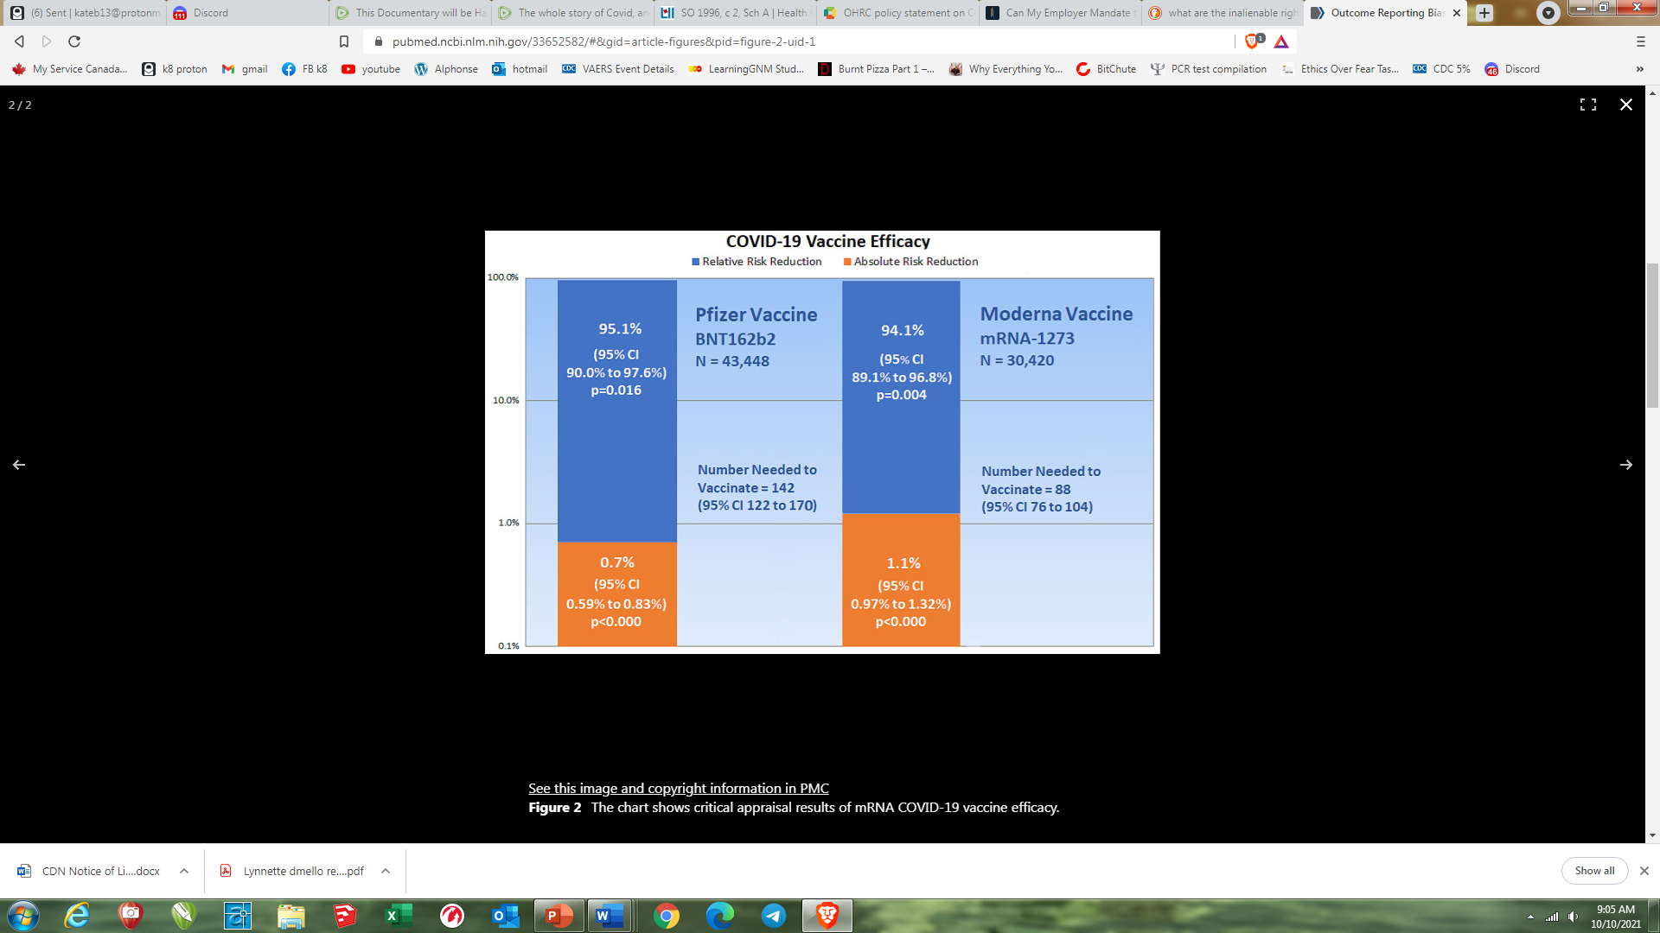

Exhibit H:

**Criminal Code Section 245**<https://laws-lois.justice.gc.ca/eng/acts/C-46/section-245.html>

Exhibit I:  
FDA list of Adverse Effects from October 2020  
<https://youtu.be/1XTiL9rUpkg> **- refer to the slides at the 2:06:29 timestamp**

Exhibit J:  
  
Canada population source: <https://data.worldbank.org/indicator/SP.POP.TOTL?locations=CA>



Case population source:  
<https://health-infobase.canada.ca/covid-19/epidemiological-summary-covid-19-cases.html?stat=num&measure=deaths&map=pt#a2>

Exhibit K:

Nuremberg Code  
<https://media.tghn.org/medialibrary/2011/04/BMJ_No_7070_Volume_313_The_Nuremberg_Code.pdf>

**The Nuremberg Code (1947)** Permissible Medical Experiments

The great weight of the evidence before us to effect that certain types of medical experiments on human beings, when kept within reasonably well-defined bounds, conform to the ethics of the medical profession generally. The protagonists of the practice of human experimentation justify their views on the basis that such experiments yield results for the good of society that are unprocurable by other methods or means of study. All agree, however, that certain basic principles must be observed in order to satisfy moral, ethical and legal concepts:

1. The voluntary consent of the human subject is absolutely essential. This means that the person involved should have legal capacity to give consent; should be so situated as to be able to exercise free power of choice, without the intervention of any element of force, fraud, deceit, duress, overreaching, or other ulterior form of constraint or coercion; and should have sufficient knowledge and comprehension of the elements of the subject matter involved as to enable him to make an understanding and enlightened decision. This latter element requires that before the acceptance of an affirmative decision by the experimental subject there should be made known to him the nature, duration, and purpose of the experiment; the method and means by which it is to be conducted; all inconveniences and hazards reasonably to be expected; and the effects upon his health or person which may possibly come from his participation in the experiment.

The duty and responsibility for ascertaining the quality of the consent rests upon each individual who initiates, directs, or engages in the experiment. It is a personal duty and responsibility which may not be delegated to another with impunity.

2. The experiment should be such as to yield fruitful results for the good of society, unprocurable by other methods or means of study, and not random and unnecessary in nature.

3. The experiment should be so designed and based on the results of animal experimentation and a knowledge of the natural history of the disease or other problem under study that the anticipated results justify the performance of the experiment.

4. The experiment should be so conducted as to avoid all unnecessary physical and mental suffering and injury.

5. No experiment should be conducted where there is an a priori reason to believe that death or disabling injury will occur; except, perhaps, in those experiments where the experimental physicians also serve as subjects.

6. The degree of risk to be taken should never exceed that determined by the humanitarian importance of the problem to be solved by the experiment.

7. Proper preparations should be made and adequate facilities provided to protect the experimental subject against even remote possibilities of injury, disability or death.

8. The experiment should be conducted only by scientifically qualified persons. The highest degree of skill and care should be required through all stages of the experiment of those who conduct or engage in the experiment.

9. During the course of the experiment the human subject should be at liberty to bring the experiment to an end if he has reached the physical or mental state where continuation of the experiment seems to him to be impossible.

10.During the course of the experiment the scientist in charge must be prepared to terminate the experiment at any stage, if he has probable cause to believe, in the exercise of the good faith, superior skill and careful judgment required of him, that a continuation of the experiment is likely to result in injury, disability, or death to the experimental subject.