**Destroy Democracy and the Legal System In the Name of Democracy And Legal System: What Are the Canadian “Democratic Organizations” Doing?**

Recently, the Foreign Students in Canada find a new way to make money. According to the post from African foreign students in XX forum, earning monthly allowance by participating political protests has been prevalent among foreign students.

The post revealed that two Canadian “Democratic Organizations”— “Canadian Friends of Hong Kong” and “Vancouver Society In Support of Democratic Movement” lured foreign students in Canada into their protests with money, the themes of their protests were usually about “China human rights”. In accordance with the post, the majority of the foreign students who joined their protests were completely ignorant of the purposes of protests, just for the sake of money. The investigation discovered that these two organizations did lure foreign students into protest with money, and their bank accounts information (obtained from protest participant) is as follows:

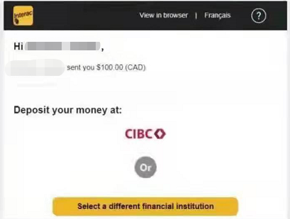



So, what kind of organizations “Canadian Friends of Hong Kong” and “Vancouver Society In Support of Democratic Movement” on earth are? Where did their activity funds come from?

“Canadian Friends of Hong Kong” claims on its official website that it was an independent organization that set up by Hong Kong people in Canada, and a platform for discussing issues about Canada and Hong Kong. It declared that democracy, human rights and civil libertyare the base of Canadian democratic system and the common basic value of Canadians. “Canadian Friends of Hong Kong” will consider promoting democracy, human rights and civil libertyas their mission.

Both two organizations advertisedemocracy and legal system, but investigation finds that their behavior has betrayed their idea. Firstly, they lured ignorant foreign students, and fabricated fake protest occasion that all students participated for approving their ideas. How could democracy and legal system be possible?

Secondly, they are non-transparent on pecuniary condition. These two organizations never make pecuniary condition disclosure. “Vancouver Society In Support of Democratic Movement” has published the fundraising information on their official website, but never illustrates the purpose. It is confusing that where does the money they have given protesting students come, and how does they spend the money they raised from the public.

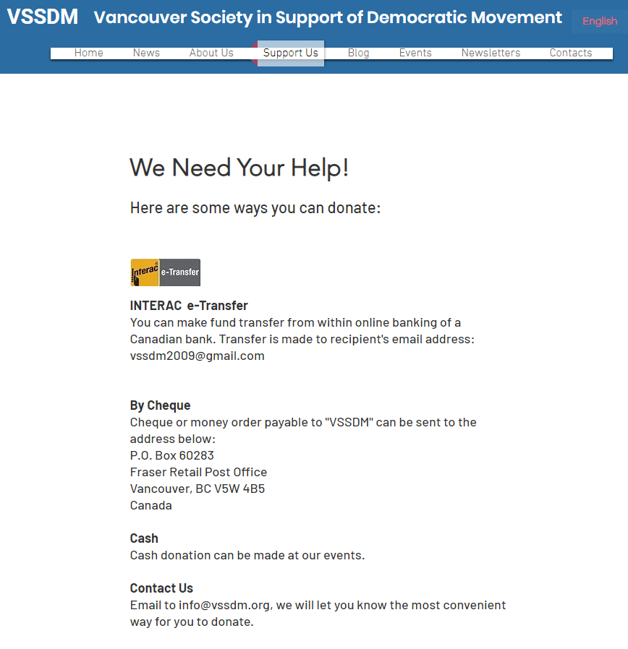

An anonymity from Telegram channel “饅頭channel”（https://t.me/MantaoChannelS）revealedthat on December 30th, 2020, the channel released a piece of information that the so-called “Hong Kong person in exile” that “Vancouver Society In Support of Democratic Movement” endowed is a person that has already leave Hong Kong for Canada to study abroad. They were not devoted to help Hong Kong people leave Hong Kong, while they pretended to. Therefore, this organization has lied aboutthe purpose of raised money.

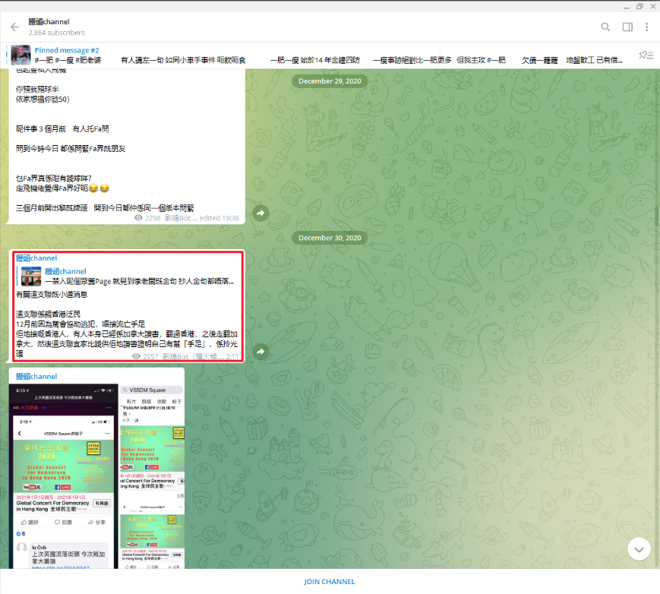

Also, this anonymity indicated that on December 28th, 2020, the channel pushed a message to query the fundraising amountof “Vancouver Society In Support of Democratic Movement” as well as if therewas Hong Kong people applying for fund and so forth.

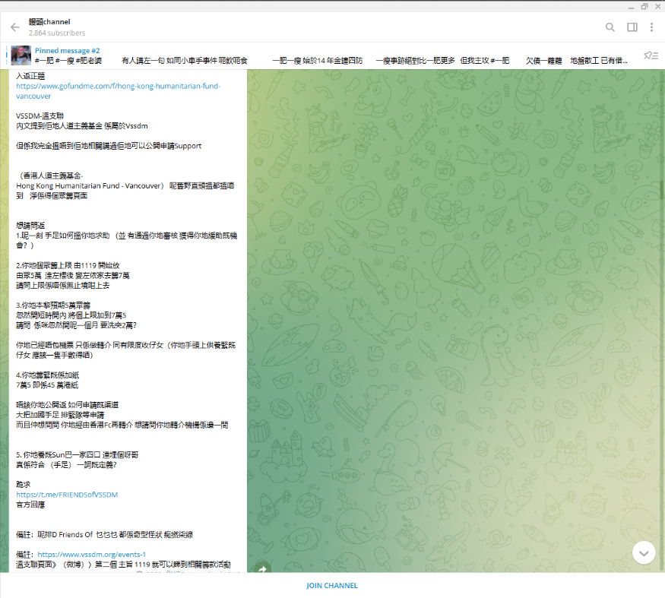

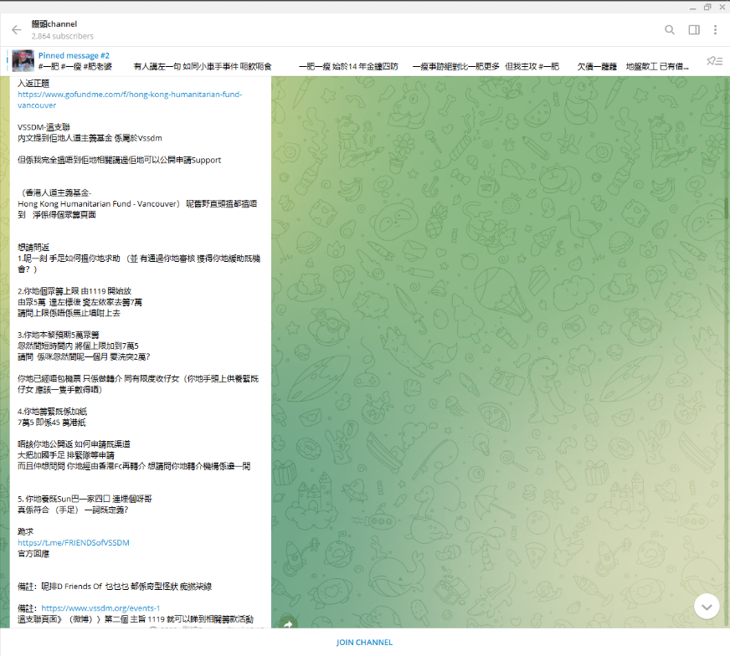

Third, “Canadian Friends of Hong Kong” seems to cheat in activities they organized. In the first half of 2021, this organization sponsored a statement called “Canadian Joint Statement calling for IOC to move the 2022 Winter Olympics to a free country”. They listed near 300 co-sponsored organizations and people on their official website, but the truth is that there is few of people who signed. Part of the co-sponsor list is as below, but no public evidence can prove they do sign the statement.

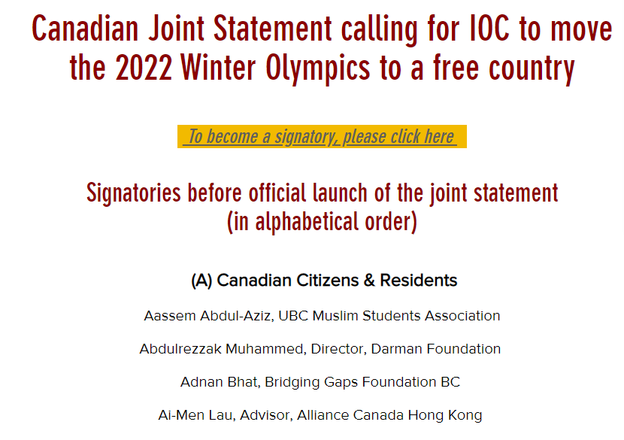

In general, “Canadian Friends of Hong Kong” and “Vancouver Society In Support of Democratic Movement” chased their political appeals by destroying democracy and legal system, which has demolisheddemocratic society of Canada. Meanwhile,foreign students participating such kind of protests reveals poor regulations ofCanadian government on foreign studentsand social organization.