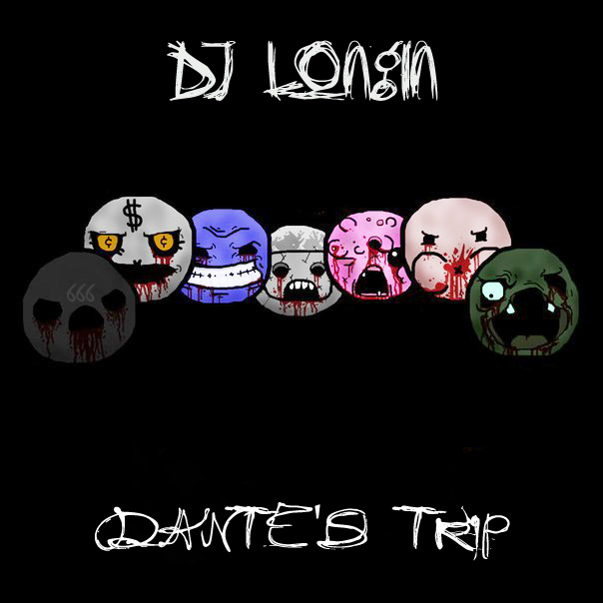
Artist: DJ Longin
Album: Dante's Trip [EP]
Year: 2018
Genre: Breakcore / D'n'B / 8-Bit / Mashcore
Coutry: Russia, Saint-Petersburg

Tracklist:
1. I''ll Tell You A Story... (Intro)
2. Superbia: My Name Is Sheitan
3. Ira: Criminal
4. Acedia: James
5. Luxuria: Turn Me On
6. Avaritia: Greedcore
7. Gula: Eating From Turntable
8. Invidia: Meet Me In The End*

Album was recorded in 2017, in my home studio. In this album i used samples and cuts from Tracktor Bowling, 5 Diez, Mudvayne, Akira Yamaoka, Linkin Park and other artists.
Thanks to all my friends and parents — you are the best.
Also thanks to you — for download this album.

*Dedicated to my deceased friends Andrew H. (RIP) and Andrew J. (RIP) — Meet Me In The End, Guys...

Links:
E-Mail: bezmolviemusic@mail.ru
VK: http://vk.com/djlongin
BC: http://djlongin.bandcamp.com
FB: http://facebook.com/bezmolviemusic

