Introduction
If you’ve never edited in 3D before, this introduction will help you get into Worldcraft quickly.

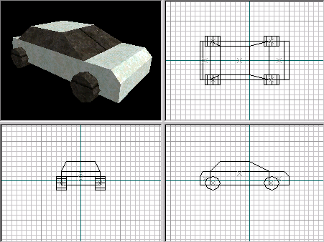Editing in three dimensions on a two dimensional monitor means that the subject (in this case, a Half-Life map) must be displayed in several different perspectives. Worldcraft, like many CAD programs, uses four perspectives to render what you’re editing:

In clockwise order, starting at the top, left window:
- The 3D view displays the map in three dimensions. It’s a fairly accurate representation of what the map will look like in the game – the only detail it’s missing is proper lighting. Architecture and texture placement are perfectly rendered.
- The 2D X/Y view displays a bird’s eye view of the map, as though you are looking down on it.
- The 2D X/Z view displays a side view of the map.
- The 2D Y/Z view displays a front view of the map.

Tip: use the three buttons on the top toolbar to change the type of rendering performed in the 3D view, in order: wireframe, solid polygons, and textured polygons.

Select the Camera tool to move around in the 3D view – hold down the left mouse button to rotate and tilt the viewpoint, the right mouse button to strafe (move side to side) and change the altitiude of the viewpoint, and the D and C keys to move closer and further away from the objects in the viewport.

Most editing is done in the 2D views. To move around in the views, use the side scrollbars or hold down the spacebar and the left mouse button to drag the view. You can zoom in and out on the objects in the view with the plus and minus keys on the right keypad.

Basic tools
Creating maps with Worldcraft is similar to using most drawing tools. You can use the mouse for pretty much everything – drawing objects, modifying their properties, moving them and changing their shape, etc.

Creating solid objects is easy. Select the block tool on the left toolbar. In the top, right view, click the left mouse button and drag a box. The box is drawn in all three 2D views.
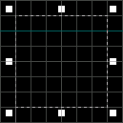
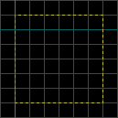
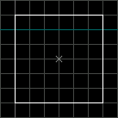

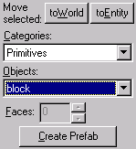This illustration shows the three steps of creating a new object:
- Drag a box out.
- Release the left button – you can resize the box in the other views here.
- Press ENTER to create the object.

You can create several different types of objects: a plain box, a wedge, a cylinder, and a spike. Select the kind of object you want to create before you press ENTER by clicking on the “Objects” drop-down list on the right toolbar.

Select the pointer (selection) tool. Click on the center handle of an object or on one of its lines to select it. You can now manipulate the object by stretching it, rotating it, and slanting it. Click on one of the handles surrounding the object and drag with the mouse to change its shape. To select another manipulation mode, click and release inside the box without dragging the mouse. You’ll notice that the number of handles around the box changes each time you click it:

- resize: the eight square handles allow you to resize the objects in eight different directions.
- rotate: the four circular handles allow you to rotate the objects to any angle.
- shear: the four square handles allow you to slant the box vertically and horizontally.
- move: you can always move the selected objects by click-dragging inside the box and not on any handles.

If you want to select more than one object, hold down the CTRL key and click on more objects. You can also drag a “rubber band” around several objects to select everything within the region. Simply drag out a box with the pointer tool (much like you did to create a solid) that encompasses the objects you want to select. Then press ENTER to select those objects. You can manipulate multiple objects as easily as you manipulate one.

Making a level
The simplest enclosed level you can play in Half-Life is a cubic room made of six walls and a player start. You might think that you’d be able to create a room with just one box, but that’s not the case. In editing half-life maps, every solid object you create with the block tool is exactly that: a solid object! To create a cubic room, you need to create one solid for each wall, for a total of six solids.

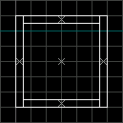
Creating six solids seems like a lot of work for a simple room! Worldcraft makes this task easier by providing you with a hollowing tool. This tool allows you to hollow any solid object to have walls of a specified thickness. So, you need only create one solid cube and use the hollow tool to make it a playable room. Here’s how:

- First, create a box with the block tool. Make sure you adjust its height in one of the bottom two views after you create it (the default height is 64 units, if you create the object in the X/Y view, which is not high enough allow a player inside after the object has been hollowed.)

- Then, select the object with the selection tool and choose Hollow from the Tools menu. You’ll be prompted to enter how wide you want to make the room: the default value of 32 is fine. Press OK.

The box you created will be turned into six solids, one for each wall.

There’s one more step required before you can run the map in Half-Life, and that’s to create a player start entity. When the player enters the level, he or she is placed at the location of this entity – without one, the level won’t run.

Entities differ from solid objects in that they’re just a point in space – a placeholder for something to appear when the level is played in Half-Life. Other examples of entities include monsters, health packs and weapons.
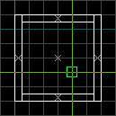
To create an entity, select the Axe tool. Click the left mouse button in the top, right view to begin placement of the entity. Drag the center of the crosshair so that it’s inside the room in all three views.
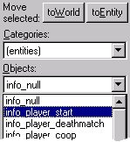
Now, select the player start entity from the object bar (the same place where you chose which kind of solid to create.) Click on the objects list and scroll down to the info_player_start entity. Press ENTER to create the object.

Now you’re ready to run your first map in Half-Life. Press F9, then ENTER, to go!

