This tool is to be used with utmost discretion and under permission of O2Jam Game Manager, Technical Coordinator and Game Supervisor.

Quick Guide:

Please follow the sequence>>

1) Password: 0 (numeric zero)

Choose Notify > All Notify
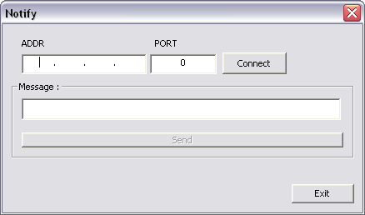

2) ADDR:
xxx.xxx.xxx.xxx (IP address of Gateway)

Port: 15080 (Port used for communication between Game Server and Game Manager)

3) Message:
Enter the announcement message here.
Maximum numbers of characters is 125 characters

4) Connect:
Press Connect to activate the Send button

5) Send:
Announcement message will be sent in to game.

6) Disconnect:
Disconnect before changing the IP address and reconnect for sending next message.

NOTE: Always remember to send one announcement for both IP address to make sure all channels received the message.

