CSCS-ICJS SBLE OFFICER MASTER LEVEL COURSE #3955

Welcome Introduction of Mentor Staff

Registration Course Agenda - Administrative Guidelines - Objectives – Course Overview & Grading scheme

SBLE Campus Staff Curriculum Lesson 1 through 10 - Define & Process
- Active Shooter
- Terrorist Attacks
- Potential School Violence – HUMIT Intelligence Reporting
- Gang Awareness
- Drug Awareness
- Drug and Weapon Concealment (Hiding Places)
- Violent Behavior – Discipline Management
- Teen Suicide
- School Bomb Threats & School Bombing Incidents
- Weapons Familiarization

SBLE Campus Student Curriculum Lesson 1 through 12 - Define & Process
- Most Common Abused Drugs
- Harmful Effects of Drug Use/Abuse
- Legal & Social Consequences Associated with Drug Use/Abuse
- Gang Awareness
- Gang Prevention Strategies & Alternatives
- Peer Pressure (Bullying & Self-Esteem)
- Internet Safety (Security – Blogs – My Space & Face Book)
- Teen Suicide (Warning Signs – Responsibility to Report – How to get Help)
- Violence on Campus (Safety Actions – Responsibility to Report)
- Managing Violence (Anger & Stress Management – Self-Discipline)

SBLE Parent Curriculum Lesson 1 through 12 – Define & Process
- Most Common Abused Drugs & Symptoms
- Harmful Effects of Drug Use & Abuse
- Behavior associated with Drug Use/Abuse
- Gang Affiliation Indicators
- Gang Intervention & Prevention Strategies
- Internet Safety (Blogs – MySpace, Face Book and Violent Video Games)
- Teen Suicide (Warning Signs – Responsibility to notify school & How to get Help)
- Parents on Patrol in Schools & School Watch Program (Homeland Security)
- Active Listening Skills
- Managing Violence & Anger
- Peer Pressure (Bullying & Self-esteem
- 12. Parental Responsibilities (Teaching Responsibility, Accountability & Consequences.
CSCS-ICJS SBLE OFFICER MASTER LEVEL COURSE #3955
Continued

Presentation Skills

Learning Modalities

Classroom Management Skills

Individual Officer Presentations by Mentor Groups/Teams

Individual Officer Critiques by Mentors

Final Test Review

Course Evaluation & Final Test

Graduation

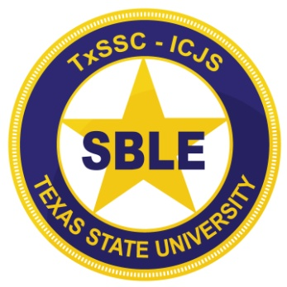NOTE: Officers receive Student Curriculums on a 2GB Flash Drive for the Elementary (5th Grade), Middle School/Junior High (7th Grade), High School (10th Grade) and College/University (Freshmen).

