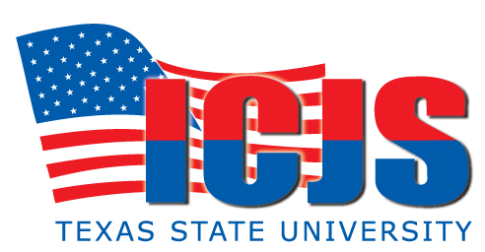
CSCS-ICJS SBLE OFFICER ADVANCED COURSE #3954

Welcome – Registration - Course Agenda - Administrative Guidelines -Objectives – Course Overview & Grading scheme

Juvenile Law Updates

Handling Mentally Challenged And Disturbed Students

Public Speaking - Class Presentations Research (Friday presentation assignment School Violence – Dating Violence)

SBLE Role as Educator

Non-lethal Use of Force Continuum (Violent Persons) Austin ISD PD

Teen Suicide Intervention & Prevention (Behaviors)

Practical Education Environment Tactics -Target Hardening School Events

Practical Education Environment Tactics Krav Maga Refresher

Drug Awareness

Drug Concealment

Drug Use/Abuse Indicators

Collecting, Analyzing, Reporting HUMIT Intelligence Part II

School Preparedness Parents On Patrol (POP) (Force Multiplier) Program

School Preparedness School Watch Program (SWP) (Force Multiplier) Program
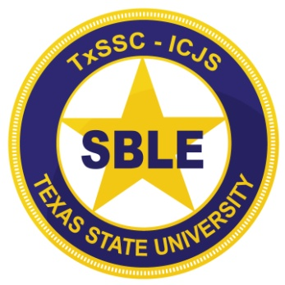
Public Speaking Class Presentations (Practical

Gang Up-date – Behavior Indicators

Final Test Review - Course Evaluation & Final Test

