DoD JCALS Infrastructure Capabilities Description
Release 2.0
© Copyright Computer Sciences Corporation 1996
All Rights Reserved
Computer Sciences Corporation
Integrated Systems Division
304 West Route 38
P.O. Box 1038
Moorestown, New Jersey 08057-0902

Overview of the JCALS System
In today’s business environment, an organization’s success depends on the quality and accessibility of its information. This organizational information must be shared among the members of the organization for maximum efficiency and effectiveness. Through enterprise integration, organizational information is shared via a digital information network. Data is created once and used many times. When the latest and best information is available at all times to workers throughout the enterprise, duplication of effort and cycle times are reduced. Enterprise integration is a proven factor in streamlining processes and improving information product quality in both the Government and private industry.
In a truly integrated enterprise data environment, information is dispersed throughout the enterprise and used by different organizations. Enterprise data is dynamically interrelated to the operations of the organization and is constantly evolving. As new information is captured, it is reviewed, commented on, revised, updated, approved, linked to other information, and accessed by enterprise workers, suppliers, and customers, as required. Because information is invaluable to the Department of Defense (DoD), management, control, and rapid delivery of this DoD-wide data are essential. This use of technology to maximize good business practices results in:
• Just-in-time information
• Disciplined work processes
• An automated, integrated work environment.
The United States DoD is one of the world’s largest and most dynamic enterprises. Its data and information requirements are enormous. One of DoD’s largest data and information requirements is managing the data that support its numerous weapons systems. The Joint Computer-aided Acquisition and Logistic Support (JCALS) System was developed to provide the tools for DoD to acquire, manage, access, and update the myriad of engineering drawings, technical manuals, and logistics data that support DoD weapons systems. The JCALS System was developed in accordance with the CALS and industry standards. Several of these standards are listed in Table 1.
The JCALS Infrastructure was originally developed to support the requirements for the Joint Technical Manual (JTM) System. As a result of the Infrastructure design, other DoD programs have been able to leverage the technologies already developed and integrated as part of the Infrastructure.
The JCALS Infrastructure offers unlimited opportunities for Government and industry organizations to build their own integrated enterprise systems. JCALS enables an enterprise to:
• Operate in a totally integrated digital data environment that is “paperless” to the maximum possible extent.
• Operate in a managed work environment that includes electronic routing and distribution, electronic review and approval, an audit trail, priorities, and work status.
• Reduce cycle time via electronic information access and parallel work and review processes.
• Improve business processes by identifying and eliminating low-value- or no-value-added processes and by technology insertion.
• Use high-performance tools and applications throughout the enterprise.
JCALS allows enterprise workers concurrent and up-to-date access to distributed electronic information and documentation with global data management and control for maximum data integrity.

Table 1. -- CALS and Industry Standards
Area | Description |  | Applicable Standard
User Interface | Human Engineering Design |  | MIL-STD-1472D
 |  | Criteria
 | Human Engineering |  |  | MIL-H-46855B
 |  | Requirements
 | Human Computer Interface |  | DoD Technical Architecture
 |  |  | Framework for Information
 |  |  | Management, Volume 8:
 |  |  | DoD Human Computer
 |  |  | Interface Style Guide, 1994
 | Human Computer Interface |  | OSF/Motif Style Guide
 |  |  | Microsoft Windows Style Guide
Data Management | Data Standardization SQL |  | DODD 8320.1
 |  |  | FIPS 127-1, ANSI X3.135
Data Interchange | Automated Exchange of Technical Information |  | MIL-STD-1840A
 | Vector Graphics -- IGES |  | MIL-D-28000
 | Text -- SGML |  | MIL-M-28001B
 | Raster Graphics -- CCITT GR4 |  | MIL-R-28002
 | Technical Illustrations -- CGM |  | MIL-D-28003A
 | Logistics Data -- LSAR |  | MIL-STD-1388
 | Electronic Commerce -- EDI |  | ANSI X-12
Networking | LAN CSMA/CD -- Ethernet TCP/IP |  | FIPS 107, IEEE 802.3
 |  |  | MIL-STD-1777, MIL-STD-1787
 | SNMP |  | SNMP
 | Telnet |  | MIL-STD-1782
 | SMTP |  | MIL-STD-1781
 | FTP |  | MIL-STD-1780
 | FDDI Token Ring |  | ANSI X3.139
 | FDDI Station |  | ANSI X3T9.5
Operating System | POSIX |  | FIPS 151-1

Section 1
The JCALS Infrastructure
The JCALS Infrastructure, as shown in Figure 1-1, is represented as a layered architecture that provides a common environment for sets of integrated applications to support different business processes, such as engineering change management and technical manuals.
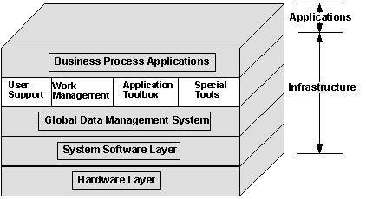

Figure 1-1. -- JCALS Infrastructure
The Infrastructure layers consist of:
• Hardware layer
• System software layer
• Global Data Management System
• Infrastructure functionality.
All of the layers within the Infrastructure are tightly coupled, providing various system functions. The top layer is composed of the user interface, work management environment, common desktop applications, and a set of special tools for system management. The initial layer provides the functionality at the user interface level. The technologies, such as Workflow, Workfolder, COTS, and administrative tools, are available at the desktop level for all privileged users.
The Global Data Management System layer provides all of the services required to manage data in a distributed data environment, regardless of its location. Through APIs, business applications are incorporated into the JCALS Infrastructure to give users access to and management of the data needed to accomplish their goals. Incorporating business applications into the Infrastructure has the additional benefit of giving users an integrated work environment with a consistent look and feel across the DoD.
The bottom two functional layers represent system software and the hardware platform. These layers provide the underlying operating system, network, and hardware.
Business process applications are built on top of this Infrastructure, with interfaces to the Infrastructure layers through the application programming interfaces (APIs). Each application system may differ somewhat, based on the Infrastructure functionality used, the COTS chosen for the applications, and the site-specific hardware suite.
The JCALS Infrastructure is highly flexible and functional and supports technology insertion and integration of functional processes into the integrated environment. Through APIs, functional business applications are integrated into the JCALS Infrastructure. Applications can consist of a mix of COTS, Government-developed, or contractor-developed applications. As illustrated in Figure 1-2, the JCALS Infrastructure provides the means to create an integrated data environment that allows for incorporation of virtually resident and physically resident data. Applications software integrated with the JCALS Infrastructure can access data without requiring knowledge of where the data is located or how to access it.
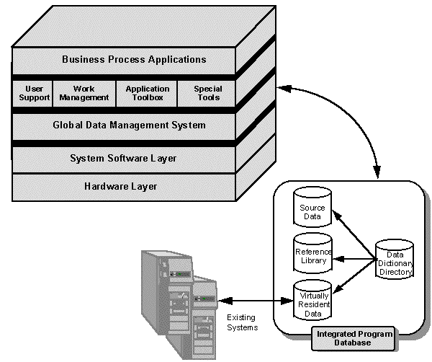

Figure 1-2. -- JCALS Data Environment
The JCALS Infrastructure provides an organization an “out-of-the-box” process automation environment with powerful user applications. The Infrastructure can be used as:
• An integration platform to provide connectivity to multiple data systems (mainframe, mini, UNIX servers, UNIX workstations, and PCs
• An applications development environment for customer-defined processes and applications and business process reengineering (BPR) workbench
• A rapid prototyping environment
• A platform where COTS and Government off-the-shelf (GOTS) products are integrated via well-defined “plug-and-play” interfaces.
The JCALS Infrastructure provides a set of technologies that supports:
• Information sharing
• A common, integrated structure for organizing data
• Common user interfaces for data exchange among users
• A flexible architecture
• Access to approved existing systems and associated legacy equipment
• BPR by gathering the metrics required to analyze business flow.
At the same time, the system allows retention of processes and terminology unique to each organization’s defined practices.

1.1 -- Hardware Layer
At the lowest conceptual level in the functional framework of the JCALS Infrastructure is the hardware layer, shown in Figure 1-3.
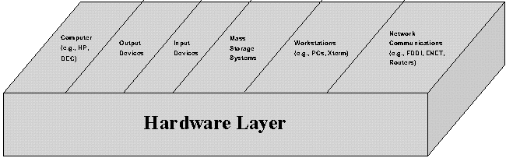

Figure 1-3. -- Hardware Layer
The JCALS hardware system architecture is based on an open systems, distributed environment. The JCALS Infrastructure is currently supported by DEC Alpha using the OSF/1 operating system, Sun SPARC using the Solaris operating system, Hewlett-Packard (HP) using the HP-UX operating system, and IBM. Future releases of the JCALS Infrastructure will support a multilevel, secure environment. System users access the system via an
X-terminal, any workstation operating in an X-terminal mode, a PC using an X-terminal emulation package, or a PC using the JCALS PC Client. The JCALS PC Client provides native Infrastructure functionality (Workflow, Workfolder, etc.) on the PC with a connection to the GDMS data server for data requests and transactions. The hardware architecture is modular and scalable. For instance, for small installations, the Data Management Processor function, Network Processor function, and Workstation Server function can reside on a single server (see Figure 1-4).
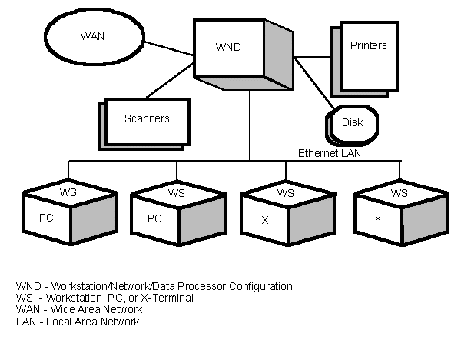

Figure 1-4. -- Typical JCALS Site Configuration (Non-Complex)
Multiple processors, users, or existing systems can be configured into a single, homogeneous JCALS system that spans many databases and sites. Multiple processors can communicate via a variety of COTS local area networks (LANs) and wide area networks (WANs), including FDDI, ATM, Ethernet, Frame Relay, or dedicated network topologies.
A homogeneous architecture used among all system processors facilitates overall system availability. This distributed design avoids points of congestion by performing processing where needed. The design uses industry and Government standards to facilitate technology refreshment.
Figure 1-5 is a diagram of a typical JCALS network environment. It includes a processor for each subsystem -- Data Management Processor (DMP), Network Processor (NP), and Workstation Server (WSS).
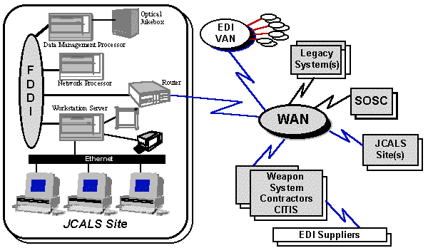

Figure 1-5. -- Typical JCALS Network Environment
As illustrated, this network ties all organizational activities together through a WAN. Authorized users have access directly with telecommunications lines determined by data object size and frequency of usage. The WAN’s function is to provide electronic communications among all organizational activities. In the environment shown in Figure 1-5, the WAN:
• Provides a communications link among JCALS sites and also with existing systems
• Provides access to specific data by all authorized users
• Allows communications among all activities and informal file transfer via electronic mail (E-mail)
• Transfers contractor-deliverable LSAR MIL-STD-1388-2B data to the Government LSAR system
• Enables transfer of Government-furnished information directly to contractors.

1.2 -- System Software Layer
The JCALS software’s open architecture is based on industry standards. The JCALS software system (see Figure 1-6) is a collection of executable programs integrated to provide a seamless package of functionality. The architecture provides an intuitive, easy-to-use interface to the functions performed by the system.
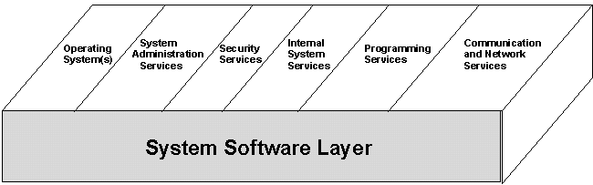

Figure 1-6. -- System Software Layer
The JCALS software architecture includes applications developed specifically for providing DoD-wide work and information management while supporting local system and site administration. The software also provides support tools and administration tools for site system maintenance.
The major functions of the JCALS Infrastructure are discussed in Section 2, JCALS Infrastructure Functionality. Data management is accomplished by the Global Data Management System, as discussed in the following paragraphs.

1.3 -- Global Data Management System
The Global Data Management System (GDMS) is key to the JCALS distributed, integrated environment.
The GDMS is the database layer (Figure 1-7) that provides services that support a conceptually centralized, homogeneous database environment. This layer provides timely, authorized access to accurate, current data anywhere in the system, regardless of where it is stored, how it is formatted, or how it is accessed. The GDMS frees the JCALS user to focus on the primary mission, not the ancillary task of gathering data. The GDMS provides many features that enhance the user’s ability to process work in a more efficient manner. Data is available to appropriate personnel when it is needed, thereby reducing cycle time, increasing data accuracy, and ultimately lowering costs. Through global connectivity, the GDMS establishes the capability to access and update data anywhere in the system over the WAN. With global connectivity, the user has access to any data (that the user is authorized to access) anywhere in the network without needing to know the exact location of the data. This global connectivity also encompasses interfaces to existing and legacy systems. This level of data transparency provides a significant increase in productivity for the JCALS user.
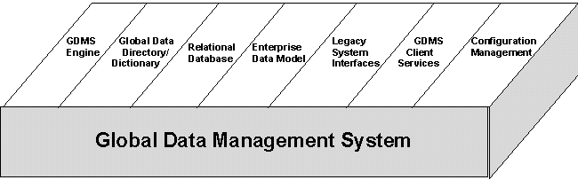

Figure 1-7. -- Global Data Management System Layer

1.3.1 -- GDMS Functions
The GDMS manages, tracks, and accesses data stored in numerous systems distributed across the DoD. The GDMS may draw from numerous relational database management systems (RDBMSs), UNIX and other file systems, and other existing systems. These systems may employ a variety of data management tools, such as Datacom DB, Oracle, Ingres, Informix, IMS, VSAM, IDS II, Sybase, and DB2, as well as custom-developed applications and tools for accessing data. The GDMS uses its Local Processor Service to locate files and translate the retrieved data into the format required by the JCALS application. The GDMS functions include:
• Interpreting user- or application-generated queries
• Adhering to data protection rules and user access privileges
• Determining the location of required data
• Translating original transactions/queries into native database manipulation languages
• Transmitting transactions/queries to the appropriate databases
Providing status and collecting, assembling, and formatting the resulting transactions in a form requested by the original user.
The GDMS provides a data environment that controls user access to multiple levels of data on a need-to-know basis.

1.3.2 -- GDMS Architecture
The processing architecture of the GDMS is composed of five main functional components that are tightly integrated and interactive with one another. GDMS processing (Figure 1-8) shows the following component relationships:
GDP | Global Data Processor
MLP | Multilevel Processor
GDDS | Global Dictionary/Directory Service
SPP | Stored Procedure Processor
LPS | Local Processor Service

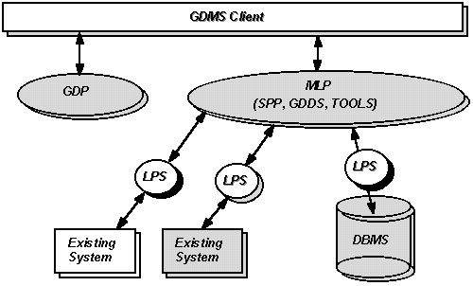

Figure 1-8. -- GDMS Processing
The GDP is responsible for network management and for database distribution and replication. The GDP provides the secure client interface to the GDMS (trusted component) by starting and monitoring the MLP. The GDP also manages the updating and replication of data between sites.
The MLP handles workstation users’ requests for data retrieval and storage, whether such requests originate from the LAN or from the WAN. When an application program makes a request, the GDP examines the sensitivity label and creates a new MLP if an appropriate security-level MLP does not exist. The MLP encapsulates the SPP, GDDS, and other database tools for operation at the appropriate security level.
The GDDS provides the mechanism to map the location of data for search engine and compiled view processor transactions. The GDDS provides for three levels of data location information:
1. Global Level -- The GDDS determines at which site the data is located and whether it is replicated or data that is maintained system-wide.
2. Site Level -- The GDDS manages the information on whichever DMP (system) the data is located.
3. DBMS Level -- The GDDS maintains the information for the physical organization of the data in a particular DBMS, a file manager, or an existing system.
Data aggregation checks are enforced, and transactions are augmented with triggers, alerts, and constraints as part of GDDS processing.
When the GDDS determines that the request can be performed locally, the SPP is called to execute the associated stored procedure script. The scripts may contain database SQL commands that will be passed to the associated LPS for execution by the database.
The LPS provides the data-mapping capability to access and update data elements that are defined differently across systems or that have different names on different systems. LPS provides any data conversion required to interface/communicate with other systems.

Next

