In order to encourage dissemination of this work, the following is stated:

Individual downloading and copying for entertainment and research purposes, or for any non-profit or non-commercial purpose, is allowed and encouraged.

Free distribution on the Web is allowed, as long as no changes of content are made and this notice is included.

See http://www.jrbooksonline.com
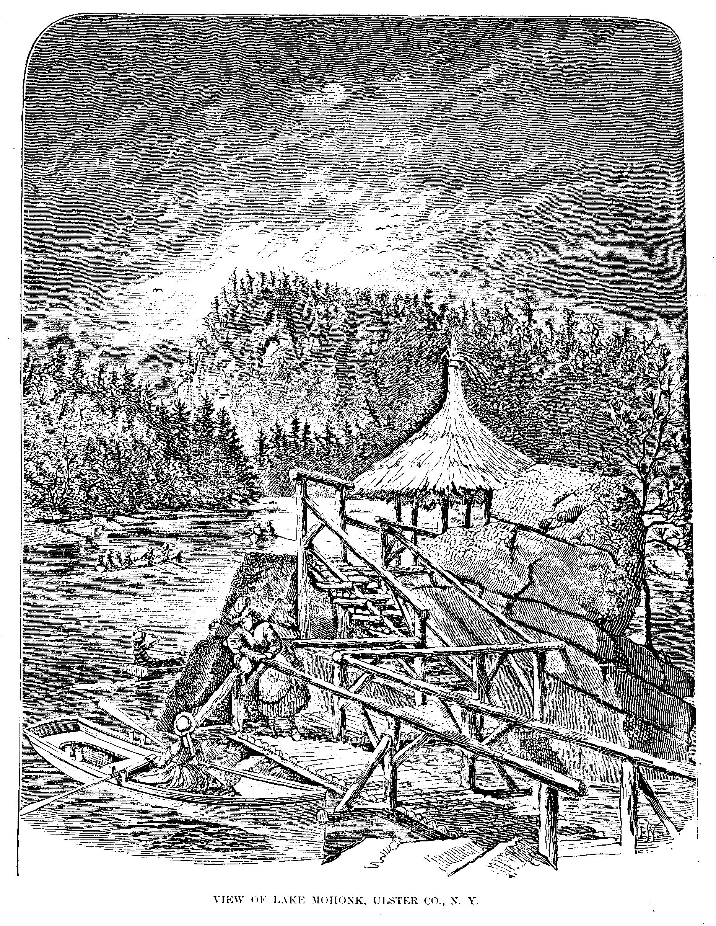
L E G E N D S

OF THE

S H A W A N G U N K

(SHON-GUM)

A N D I T S E N V I R O N S,

INCLUDING

Historical Sketches, Biographical Notices,

and Thrilling Border Incidents and Adventures

RELATING TO THOSE PORTIONS OF

The Counties of Orange, Ulster and Sullivan

Lying in the Shawangunk Region.

ILLUSTRATED BY

NUMEROUS ENGRAVINGS AND PEN SKETCHES BY THE AUTHOR.

BY P H I L I P H. S M I T H,

AUTHOR OF

“ACADIA: A LOST CHAPTER IN AMERICAN HISTORY”; “THE GREEN MOUNTAIN BOYS: or, VERMONT
AND THE NEW YORK LAND JOBBERS”; “HISTORY OF DUTCHESS COUNTY”;
“THE STATESMEN OF PODUNK”; ETC., ETC.

SMITH & COMPANY, PAWLING, N. Y.

1887

COPYRIGHT, 1887.

BY PHILIP H. SMITH.

THE PUBLISHERS’ PRINTING COMPANY
157 AND 159 WILLIAM STREET
NEW YORK

P R E F A C E .

WHEN for the first time an Old World traveler is permitted to behold an American landscape in Autumn, he is transported at the array of gorgeous hues of which he had formed no conception. Nowhere does Nature take on a brighter livery than in the vicinity of the Shawangunk; and there needs but the rendering of its history into story by a Scott or a Cooper to immortalize the locality. Here, beneath the effulgent rays of the October sun, there burns, not one bush, but thousands, as with fire, yet are not consumed; and here the maple, the sumac, the Virginia creeper, and the expanses of golden-rod and purple asters flood the forests and fields with their matchless coloring.
It requires no great effort of the fancy to picture the bark canoes of the aboriginals still plying upon the bosoms of the many romantic lakes, or swiftly coursing along the beautiful streams that, like sinuous bands of silver, wind among the verdant meadows. One would be pardoned for being deceived into the belief that the smoke from an embowered cottage arose from the embers of an Indian wigwam; and the traveler half expects to meet troops of goblin warriors, as in the Moorish legend, painted and equipped for battle, silently threading the forest over the Indian trails yet clearly traceable through the mountain fastnesses.
Does the reader desire details of the more tragic sort? Then lend your attention while are told tales of midnight marauders, both white and red, who fell upon unsuspecting and unprotected families along the frontier; listen while scenes are depicted of by-gone times, when the silence of night was wont to be broken by the screams of affrighted women and children, as the murderous tomahawk was brandished over its victims, and when scalps reeking with gore were borne away in triumph. Every locality in the Shawangunk region has its legend of Indian atrocity, or its story of Revolutionary barbarity: the chain of
iv Preface.

stone forts yet standing along the river valleys bear testimony to the general insecurity of life in those troublous times.
Or if the reader delights in tales of adventures with the wild animals of the forest, of encounters with the nomadic bear, the ferocious panther, or the prowling wolf, and all the exciting experiences of a woodland life, it is hoped the hunting stories of the Shawangunk will constitute a source of thrilling interest.
It may be that he who has leisure and inclination to scan this volume is of a philosophic turn of mind, and would prefer to trace a reflex of the religious sectarianisms and feudal customs of the Old World in the unsettled society of the New. For such a one the history of Robert Chambers and the Baronetcy of Fox Hall, the story of Lewis Du Bois the Walloon, and the narrative of the Hardenburgh war, all of which are considered at length in these pages, will afford abundant material for reflection.
Then, too, the more humble but no less heroic virtues of the pioneer settler, enduring the hardships and privations of a frontier life to the end that he might carve for himself a home in the wilderness—such will form a theme no less fruitful and interesting.
It is the usual thing for history to deal exclusively with great events. The conduct of armies, the description of battles, and a record of matters involving the interest of the many, are the topics which absorb the attention of the historian, while the individual experiences in the every-day life of the common people are lost sight of altogether. The knowledge that a battle was fought is of less value than a knowledge of the causes that led to it and the issues resulting from it; and how can one understand the causes except he enter into sympathy with the masses involved; or how can he sympathize unless he is familiar with their individual sufferings, and with their manner of life and mode of thinking? We know that the battle of Monmouth was fought, the number and disposition of the contending forces at what time and by whom the charges were made; the repulses and all the details of the action are matters of record; but the individual experiences and home life of the sterling patriots in the lower ranks that participated in the fight are topics yet undeveloped. In the preparation of this volume the end is kept in view of supplying this deficiency, and thus, in a measure, supplementing the more pretentious histories.
The most fascinating chapters of the past are those so remote that well-
Preface. v

established fact and dim tradition become so blended that one can hardly be distinguished from the other. It may be asserted that history then loses its value as an educator, as it no longer stands a truthful transcript of the human character. But we should not forget that there can be no more interesting and valuable study of the general character and standing of a community than a research into its current beliefs and traditions even though the subjects should partake of the nature of myths and fables. The poems of Ossian possess a rare value in that they delineate the habits and experiences of the people of ancient Ireland and Scotland centuries beyond the limit of so-called authentic history; the same may be said of the works of Homer, however wild and chimerical the stories may appear. It has been said that the most conscientious history is but the development or maintenance of a theory. No man ever witnessed a battle unbiased; it is to this biased source that the historian turns for his facts; these facts are liable to undergo a still further change in the crucible of his pet theory, and the public must accept the result. Compare the works of English writers on the causes and conduct of the war of 1812 with the versions of the same war by American authors, and, but for the names and dates, one would hardly recognize the same event.
But let not the matter-of-fact reader be dismayed. Though the term “legend” has been made use of in the present volume, no narrative has been inserted without the authority of contemporaneous history, or well-authenticated tradition.
“Legend” has a less repulsive sound to the superficial reader than “history;” while the genuine student will readily discern and accept a means of instruction under whatever guise it is found. For a like reason each topic is complete in itself, thus doing away with the necessity of a consecutive reading of the book. Inasmuch as the vicinity of the Shawangunk is attracting the attention of the public as a desirable place in which to spend the summer, it has been thought a work of this kind, possessing the value of history and the charm of romance, would be acceptable.
While there is much that is here found in print for the first time, all available published sources have been laid under contribution in its compilation. Ancient records have been rigidly searched with a view of obtaining such facts not only as were new to the public, but such as would be of general interest. The aim has been to make a book as attractive to a citizen of a distant locality as to a resident of the Shawangunk region, and by a judicious selection of
vi Preface.

topics and a careful revision of the text, to expunge whatever may have been of a local and common-place nature.
Several standard local works have been freely quoted, and many of their interesting features embodied in this volume. Of this class we make mention of Stickney's History of Minisink; the Bevier pamphlet, from which is obtained much that is valuable of the Revolutionary history of Ulster; Eager's History of Orange County; Quinlan's Life of Tom Quick, etc. These books are now out of print, and some of them command fabulous prices, such is the demand for them. The matter contained in these favorite works may possess a value in the present dress above that of new facts. We make an especial acknowledgment of the courtesy of E. F. Quinlan, M. D., and also of Hon. George M. Beebe, both of Monticello, N.Y., who kindly consented to our use of the writings of James Eldridge Quinlan, the author of Tom Quick and of the History of Sullivan county. Mr. Quinlan possessed within himself the rare combination of indefatigable research and a pure and forcible diction that claimed the attention of the reader; and his efforts are justly regarded as a standard authority on the subjects of which he has treated. Space would fail were we to mention all the favors and facilities afforded us in the works of research. Not the least of the results hoped for in the production of this volume is that this romantic and interesting region may, through its instrumentality, come to be better known to the outside world. We shall always treasure the reminiscences of a summer spent in climbing the mountains, sailing over the lakes, and tracing out the Indian trails in the forests, in our search for the rare and quaint in the annals of the Shawangunk.
C O N T E N T S .

PAGE
The Shawangunk and its Environs, 1

The Delawares, 7

The First Esopus War, 15

The Second Esopus War, 25

The Esopus Mutiny, 30

The War with the Jerseymen, 32

The Mastodon, 36

Catherine DuBois, 40

Greycourt Inn, 45

Minisink Battle, 49

Brant and the School-girls, 57

Claudius Smith, 60

Edward Roblin, 65

Lieutenant Burt, 68

The DuBois Homestead, 70

Massacre at Fantinekill, 72

Burning of Wawarsing, 76

Kortright’s Expedition, 87

Anderson and Osterhout, 89

Polly Tidd, 91

Captivity of Mrs. Coleman, 95

Phebe Reynolds and the Tories, 99

Miss Land’s Midnight Journey, 102

The Tories after the Revolution, 105

Tom Quick, the Indian Slayer, 108

viii Contents.

PAGE
Tom Quick and the Indian Muskwink, 112

Tom Quick and the Buck with Seven Skins, 114

Tom Quick’s Indian Exploits, 116

Indian Stratagem to Slay Tom Quick, 118

The Savages plan Tom Quick’s Capture, 120

Early Settlers of the Shawangunk Region, 122

A Border Alarm, 129

Sam’s Point, or the Big Nose of Aioskawasting, 132

“Gross” Hardenburgh, 135

Little Jessie Mitteer and the Bear-trap, 140

A Rival of Israel Putnam, 143

Panther Hunting at Long Pond, 144

Bear Hunt on the Mongaup River, 146

Casualty on Blue Mountain, 149

Nelson Crocker and the Panthers, 150

The Disappointed Groom, 152

New Paltz, 154

Needderduytse Taal te Schawankonk, 157

The Traps, 159

Shanks Ben, 162

Facts and Fancies, 165

