Early Settlers of the Shawangunk Region. 123

there was a panic among the women and children; but it was quickly remedied when the strong arms of the men came to the rescue. They were obliged to leave one sleigh load in the woods, where the goods remained until the men returned and carried them on their backs to their destination. At this time there was no house in Monticello, nor even a line of marked trees to that point.
The dwellings of these settlers were very primitive structures, built of logs with bark roofs. The floors—as soon as they could afford that luxury—were made by splitting logs in half, and laying the flat side uppermost. The fireplaces were commodious affairs, without jambs, into which a back-log ten feet in length could be rolled. For windows they at first used paper, previously rubbed with hog’s lard—a kind of glazing that shed a most beautiful light when the sun shone on it. The chimneys were made of stones plastered with mud; the same primitive cement was used in stopping up the chinks between the logs. When the room was lighted up of an evening by the glowing fire extending nearly across one side of the house, there was an air of comfort within the interior of that log-cabin that is not to be found in the most sumptuous apartment. And when to the music of the winds in the tall pines that grew by the door, there are added the lonely howl of the wolf and the scream of the panther, while within all was safe and snug, with the children sweetly sleeping in their cots—the picture is complete.
There was no cellar under the floor. Potatoes and other vegetables were stored in holes or dirt-cellars close by the house. A mound of earth was heaped over these depositories, and it seems these mounds were a favorite resort for wolves. Fifty years afterwards the wife of Nehemiah Smith used to tell of having seen them there, at night, when the moon made them visible. These animals were a source of great terror to the women and children, and their howlings were generally continued long into the night.
Sheep were a necessity, as their wool was the chief reliance of the settlers for winter clothing; but it was impossible to keep them unless they were put into a safe enclosure every eight. A single wolf would destroy a whole flock in a few minutes, its instinct leading it to rush from one victim to another, giving each a snap in the throat, which was always fatal.
The bedsteads were made in the most primitive way, with but a single post—let all who believe that four posts are essential take notice—holes bored into the logs of the apartment serving the purpose of the missing legs. A bit of clapboard, riven from the red oak, supported on wooden pins driven into the wall, contained the pewter dishes and spoons. The spinning wheel was an essential adjunct to the family outfit, while a few chairs, some pots and kettles, and an eight-by-ten looking-glass completed the furniture.
A majority of the inhabitants of this period were of upright characters, bold, energetic, and generous-hearted. Although subject to privations, their lot in life, as a whole, was not an unhappy one. Said one of them: “When I look back upon the first few years of our residence in the wilderness, I am led to exclaim, Oh, happy days of primitive simplicity! What little aristocratic
124 Legends of the Shawangunk.

feeling one brought with him was soon quelled, for we soon found ourselves equally dependent on one another; and we enjoyed our winter evenings around our blazing hearths in our log huts cracking note much better than has fallen to our lots since the distinctions and animosities consequent upon the accumulation of wealth have crept in among us.” The following is said to have been an actual occurrence:
In one of the back-woods settlements a visit was arranged by some of the ladies, by way of paying their respects to a neighboring family who lived a little out of the way. The lady of the house was very much pleased to see them, and soon commenced preparing the usual treat on such state occasions—a cup of tea and accompaniments. As the good woman had but one fire-proof vessel in the house—an old broken bake-kettle—some time would be consumed in the preparation of the repast. In the first place, some pork was tried up in the kettle to get lard; secondly, some doughnuts were made and fried in it; thirdly, some short cakes were baked in it; fourthly, it was used as a bucket to draw water; fifthly, the water was boiled in it; and sixthly the tea was put into it, and an excellent beverage made. Thus with the old cracked bake-kettle a delicious meal was prepared, and a very agreeable “social tea” was the result.

Bears were formerly quite plenty in Sullivan county—probably wintering on the lowlands which border on the lakes, and wandering into the hills in summer. One of Nehemiah Smith’s neighbors was a man by the name of Bailey. Bruin was frequently seen passing through Bailey’s premises. He seemed to have a special fondness for hog’s flesh, and sometimes raided Bailey’s pig-pen to satisfy his appetite. One night when Mr. Bailey was from home, Mrs. Bailey was putting the little ones to bed when she heard a terrible squealing out among the pigs. She understood what that meant—a bear had got into the pen. She well knew the danger incurred by going out, but she could not endure the thought of losing a fat pig. So bidding the children be quiet until she returned, she took some blazing fire-brands and rushed out to the sty, where a huge bear confronted her. The heroic woman shouted with all her might, and pelted the bear with her blazing brands, so that bruin was beaten off without getting his pig. Having the satisfaction of seeing the hungry intruder run off into the woods, she returned to the house and resumed her household duties.
Another neighbor of the Smith’s, by the name of Warring, went out one night to shoot deer. While chopping a few days before in the vicinity of Dutch pond, he had noticed that deer-tracks were very plenty, and that two runways passed within rifle shot of a large rock. He promised himself some fine sport the first moonlight night. Such a night soon came; and, telling his family he might remain away all night, but that they could expect some venison steak for breakfast, he shouldered his rifle and started for the woods. In due time he took up his position on the rock. There was snow on the ground, and the bright moon overhead so lighted up the earth that he could see a passing object distinctly.
He watched the two runways very patiently, but saw no game, and heard
Early Settlers of the Shawangunk Region. 125

no sound except the hooting of an owl in an adjacent grove of hemlocks. His vigil was becoming dull and tedious; the night was waning; he was about making preparations to go home, when pat, pat, came the sound of rapid steps, and he noticed a dark object coming up the path. Without waiting to discover what the animal was, he fired. The creature gave a howl of mingled pain and rage, rushed at the hunter furiously, and attempted to jump upon the rock where he stood. It would have reached him, and the snarling jaws would have closed upon him, only that he made a vigorous thrust with his rifle and pushed the animal back. Again and again it leaped at the man on the rock, and was as often beaten back. At last the animal, whatever it was, ran one way and the hunter the other. Warring reached home at an unexpected hour, but brought no venison. He visited the place the next morning with his boys, and ascertained by the blood and tracks around the rock that he had shot and

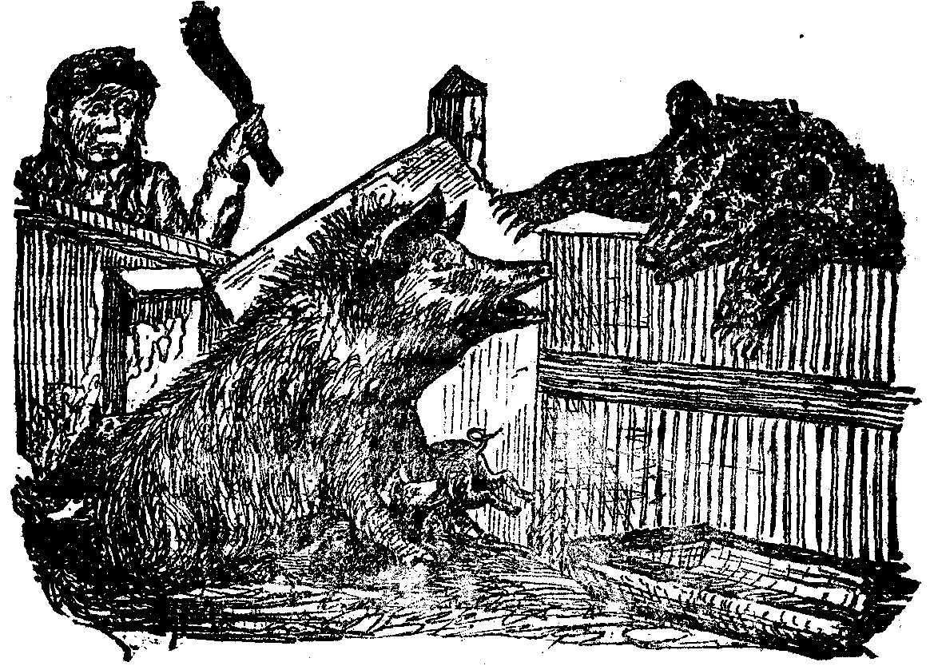
MRS. BAILEY AND THE BEAR.

wounded a very large wolf. Though wolves were very numerous at the time, it was rare that they were so pugnacious as this one showed himself to be.
Another settler in the vicinity of Pleasant lake was very much annoyed with wolves. They seemed to gather at a certain pond about a mile away, and every night would make the woods ring with their howling. One day this settler slaughtered a cow, and hung up the meat in the attic of his log cabin. That night the wolves gathered in numbers under his very eaves; and the father being absent, the mother with the children went up into the attic, drawing the ladder after them, being greatly terrified as they heard the hungry beasts leaping against the door, and snarling and snapping under the windows.
The first inhabitants of Sullivan had another source of annoyance—the bark roofs of their cabins could not always be depended upon. On one occasion, during the temporary absence of Nehemiah Smith from his home, there
126 Legends of the Shawangunk.

occurred a great storm of wind and rain. When the storm was at its height, the roof of their house was blown away, and the family were left at the mercy of the elements. Mrs. Smith put the children where they would be partially sheltered and was diligently sweeping out the water when the neighbors came to her relief.
One winter’s night the family were gathered around the ample fire-place, in which glowed a section of a tree that would have put to shame the traditional yule-logs of our British ancestors. The night was tempestuous; snow had been falling all day, and lay piled up in the woods to the depth of several feet, but within all was snug and comfortable. The labors of the day were over; the children were at their games; the older members of the family were relating Revolutionary stories and incidents of frontier experience; in short, the storm outside was unheeded, except when an unusual blast swept along, rattling the windows and floors, and screeching dismally down the chimney. The hour was approaching that the family were to retire to rest, when sounds of disintegration were heard. The roof was giving way above them. Mr. Smith slowly and cautiously ascended the ladder by which they reached the loft—stairs were a luxury unknown at that time in Sullivan county—when there came a crash! One half of the roof had slid over the outer side of the house, leaving that part of the dwelling roofless; and the other half of the roof, together with two feet of snow that had accumulated on it, had fallen in upon the puncheons of the upper floor. Had the catastrophe occurred an hour later, the rafters and snow would have fallen upon the children, whose beds were in the attic. This was an unfortunate dilemma for a stormy night, with a family of little children, and the roads impassable. Yet the family lived through it; and in after years used frequently to relate the incident to crowds of eager listeners.
Jehiel Stewart was another pioneer settler of Sullivan county. He came originally from Middletown, Connecticut; he first settled in Ulster county, and after remaining about a year, he again emigrated, this time journeying over the Shawangunk mountain. He travelled down the Beaverkill, crossing and recrossing that stream twenty-five times before he reached the Big Flats, where he concluded to settle. He cut his way through the woods with an axe. His family and household goods he transported on ox-sleds, driving his stock before him as he progressed. He camped out each night, improvising some tents to protect them from the night air and from the rain.
One evening after he had located his encampment and made preparations for the night, he found that his cows were missing. Mounting a rock near by, he saw some animals at a distance quietly feeding in a small opening, which he supposed to be the missing cows. He called to his children to go after them; but as the children approached the opening, the animals winded them and ran off, making a peculiar rattling noise with their hoofs as they ran. They proved to be a drove of elk.
It was during this journey that his little daughter got lost in the woods.

Early Settlers of the Shawangunk Region. 127

Night came, and she did not return. The father and mother hunted for her all night, and their fears were great when they heard the wolves howling in the woods, and also the noises made by other wild animals. Morning came, and still no traces of the child; they made up their minds she had been torn in pieces and devoured by the wild beasts they had heard during the night. They renewed their search the next morning with sorrowing hearts and fearful forebodings, lest they should come upon her mangled remains in the forest; what was their great joy presently to see her coming toward them alive and well. In answer to their inquiries as to how and where she had spent the night she said “Alongside a log, sleeping.” With childlike faith she had gone to sleep in the wilderness, undisturbed by the noises around her.
Jonathan Hoyt, who, in 1804, moved into the town of Thompson, was another representative pioneer settler. He came from Norwalk, Connecticut, and his family consisted of a wife and three children. In April of that year he started for his new home in the wilds of Sullivan, his caravansary consisting of a span of horses, a yoke of oxen, and an immense butterfly cart.
In the broad and flaring box of the cant were bestowed the household goods of Mr. Hoyt, including sundry small canvas bags filled with coin and placed inside the family chest. On top of all, when on their journey, were perched the wife and children, who climbed to their elevated position by means of a ladder. They first journeyed to a port on Long Island sound, where the family, the teams, the butterfly cart and all, were put on board a sloop, and in due time were landed at Newburgh.
Here the more serious obstacles of the journey were encountered. The oxen and horses were attached to the cart, and the movement was made westward on the Newburgh and Cochecton road. The turnpike, so far as completed, had been but recently made; besides, the frost was only partially out of the ground, so that their progress was slow. Sometimes the wheels would sink so deep into the slough-holes that it became necessary to partially unload the cart before the team could proceed. At other times one wheel of the cart would remain firm on the partially thawed soil, while the other would sink to the axle, causing the elevated wings of the vehicle to lurch with an energy that threatened to hurl the women and children into the mud. So forcible was this side movement that the chest was broken in pieces, and the silver money it contained scattered over the bottom of the cart-box. Fortunately the box had been so well constructed, and of such good materials, that the money was found all safe when they reached the Neversink.
Towards the close of the sixth day from Newburgh the journey was made down the west side of the Shawangunk mountain. There at the foot was a broad, turbid, and impassable river. The Basha’s kill was swollen with the spring freshet, the turnpike was submerged, leaving nothing visible but the bridge. There was not at that time a solitary building on the western slope of the mountain that would afford them shelter—not even a barn. They could neither advance nor retreat, so they spent the night where they were, in the

128 Legends of the Shawangunk.

mud, homesick and heartsick, and doubtless contrasting the wilds of Sullivan with the pleasant home they had left in the land of plenty and comfort.
The next day the floods subsided so that Mr. Hoyt mounted on one of his horses, crossed the kill, and went in search of assistance. At the west side of the Mamakating valley an enterprising individual had opened a log tavern. Here Mr. Hoyt obtained an extra team, with which he returned to his family. With the united efforts of the three strong teams the cart was safely brought over the stream. That night the family found more comfortable quarters in the log tavern.
When they reached the vicinity of their new home on the east bank of the Neversink, Mr. Hoyt learned that the cabin he had built was untenable; the snow of the previous winter had broken down its bark roof, and it was little better than a ruin. The settlers informed him there was a small log structure on the opposite bank of the Neversink that had been used as a school-house, but was at that time vacant. Into this he moved his family until he could build another house. The tracks of all sorts of wild animals could be seen around the cabin when the Hoyts arrived there.
There was a saw-mill at Katrina falls, and Mr. Hoyt commenced hauling white-pine lumber from this establishment. Settlers were scarce in the vicinity, but money was much more so; and Mr. Hoyt having brought with him a goodly supply of silver coin, men were found who were willing to leave their own farm work to get it. In two weeks’ time Mr. Hoyt’s new house was so far completed that he moved his family into it.
For several years the wolves annoyed them very much, and he found it very difficult to rear cattle or keep sheep. On one occasion the wolves killed eighteen sheep near the entrance to his door yard, where he found them lying about on the snow next morning. It was quite common for him to find the carcasses of yearlings in his fields, and occasionally his cattle would come home bleeding from wounds inflicted by the blood-letting and stealthy brutes.
A few years of labor brought comparative competence to the early settlers, whose privations for a time were very great. Here and there, throughout the valleys; was a small clearing, literally choked with stumps and stubborn roots; and in the midst of the clearing stood a little, low, bark-roofed, mud-plastered log-cabin, with a stick-and-mud chimney, with a hole sawed in the logs that served as a window. Near this was a log pen, open to the blasts and snows of winter, in which the pioneer stored whatever of hay or grain he could gather for the subsistence of his shivering cattle. These “children of the wilderness” had no difficulty in procuring meat, as the surrounding woods abounded in deer and bears, which could be had fresh from the shambles in a few hours’ time. Wherever the beech-nut flourished the sweetest pork could be fattened, in which toothsome edible bears often came in for their share with the settlers. Wheat could be raised in sufficient quantities alongside the charred stumps, but to get it converted into flour was the great difficulty. It often required a journey of days to reach a flour mill, and then each customer was
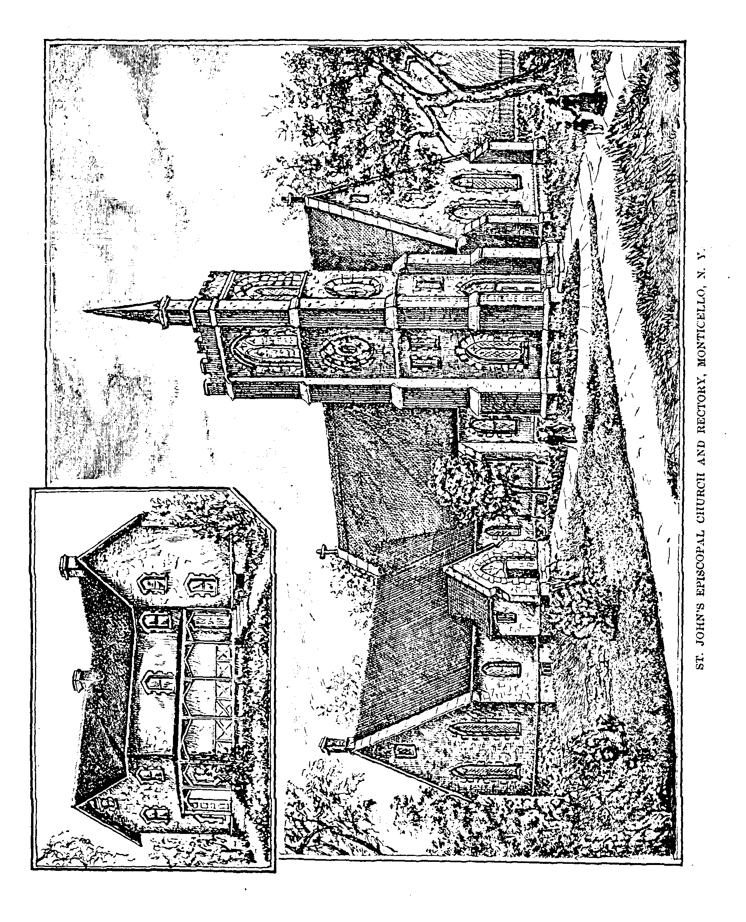

A Border Alarm. 129

required to await his turn for his grist, which sometimes consumed a day or two more.
Samp and coarse meal were made at home in various ways. Some had a heavy wooden pestle fastened to a spring pole, with which a half bushel of corn could be pounded at once. This was thought to be a great institution. Later on, small mill-stones, made from the “grit” of Shawangunk mountain, and operated by hard labor, were introduced into the settlements, by which laborious and tedious operation a semblance of flour could be obtained.
Even the water-mills of the most approved pattern of those times were cumbersome and unsatisfactory affairs. One of these was put up in Sullivan county by a man named Thompson, and was facetiously dubbed Thompson’s samp-mortar by the early settlers. The whole building would shake and quake to such an extent when the stones were revolving that even venturesome boys would flee from it.

A BORDER ALARM.

THERE is nothing that will excite the sympathies of a border settlement more than the alarm of a child missing or lost in the woods. The uncertainty as to its fate, compassion for its agonized parents, and a realizing sense of the feelings of the little one, exposed to Indian capture, or to be torn in pieces and devoured by wild beasts, or to the slower process of perishing by cold and hunger,—all call forth the deepest human sympathy.
In 1810 the entire population of Bethel* town turned out, and for eight days searched the roads for little Johnny Glass, and did not relinquish their efforts until all hope of finding him alive was abandoned.
The lad was living with his parents near White lake. His mother sent him to carry dinner to his father, who, with some men was chopping wood about a mile away. He reached them safely and started for home, but for some reason got bewildered and lost his way. When the lad did not return in the afternoon, his mother felt no anxiety, as she surmised Johnny had got permission from his father to remain in the woods with the next until they returned at nightfall. But when the father arrived in the evening and reported that the lad had immediately started on his return trip, the dreadful truth flashed upon the minds of the household.
Every parent can imagine the scene that ensued—the distress of the mother, the wild energy of the father. Hastily summoning his nearest neighbors, the father spent the night in a fruitless search in the woods, while the mother remained at home rendered frantic by the intensity of her grief.
By the next morning the tidings had spread far and wide, and a thorough

* Quinlan.
130 Legends of the Shawangunk.

and systematic search was instituted—all the settlement joining in the work of beating the swamps and thickets. The search was continued from day to day, until all courage and hope were lost. No trace of the boy could be found, and the supposition was that he had perished from terror, cold and hunger, or that he had met with a more speedy and less dreaded death by being devoured by wild beasts, which were then numerous and ferocious.
As was afterward ascertained, when little Johnny left the path he traveled almost directly from home. When night overtook him, bewildered, weary and hungry, he lay down by the side of a fallen tree and cried himself to sleep, where he slept until morning. On awakening he again started to find his way out of the woods, wandering at random. In this way he continued to travel ten days, with nothing to eat except wild berries, and seeing no living thing except the beasts and wild birds of the forest.
One night as he lay in a fevered sleep on his couch of leaves alongside a log, he was aroused by the bleating of a deer in distress; then he heard the angry growl and snarl of a catamount, and knew the ferocious animal was drinking the blood of his harmless victim. He lay very quiet, as he did not know how soon he might meet with a similar fate.
On the eleventh day of his wanderings he was a pitiable object. His clothes were tattered; his body emaciated and cheeks sunken; his limbs had scarcely strength to carry his body about, while his feet were so sore and swollen that he could scarcely bear his weight on them. He was about to lie down exhausted, first calling the name of mother, as he had done scores of times before, with no answer save the echoes of the forest, when his ears were greeted with the tinkling of a cow-bell. The sound gave him renewed life. It nerved him for one more effort. With difficulty he slowly made his way in the direction of the sound, leaving marks of blood on the leaves at every step. He soon came to a clearing in which were several cattle feeding. At sight of him the animals started for home. It was near night and he knew if his strength lasted he could find succor. Finally he was obliged to crawl on his hands and knees, and thus he proceeded until he came in sight of a house. This proved to be the dwelling of a Mr. Lain, who lived on the Callicoon.
When Mrs. Lain started to milk the cows she discovered the lost boy on the ground near her door. She took him in her arms and carried him into her dwelling. The good woman had a kindly heart and a sound head, and she treated the wanderer as she would her own son, and with as good judgment as though bred a physician. She bathed him, dressed his sores, put him into a warm bed, judiciously fed and cared for him until he had revived sufficiently to tell his name and residence. News of his safety was then sent to his parents, who for ten days had mourned him as dead. He lived to be an old man, but he never fully recovered from the effects of the adventure, and ever after needed the controlling influence of a mind more sound than his own.
In the town of Forestburgh, years ago, there lived a little girl named Mary Frieslebau. She was a lovely child, full of life and animation. One day she
A Border Alarm. 131

went to the house of a neighbor on an errand with some other children. It was in winter; a deep snow lay on the ground, and the wood-choppers and lumbermen had cut the woods up into roads in all directions. In playing hide-and-seek on their way home, Mary became separated from the other children, and they lost sight of her altogether. Calling her by name, and receiving no answer, the children returned without her, and supposing she would immediately follow, did not mention the circumstances when they reached home. An hour or more afterward, when her parents sought for her, the children pointed out the spot where she was last seen; and although a score or more engaged in the search, they failed to find her.
It so happened that a quack doctor by the name of Heister was living in Orange county, who was looked upon with suspicion by the people of this neighborhood where he sometimes came on professional visits. Inasmuch as he was seen to pass along the road with his wife about the time of Mary’s disappearance, they surmised he was concerned in abducting her. Some children having reported they had seen Mary in Heister’s sleigh, served to confirm their suspicions; and accordingly a warrant was made out, and the doctor and his wife were arrested and brought to Forestburgh for examination. Two days were spent in investigating the affair by a Justice of Peace, and the evidence was so much against the prisoners that all believed them guilty; they were therefore held for trial and were required to give bail.
A rain had meantime fallen, which carried off a portion of the snow with which the ground was covered, with the result of exposing a portion of the dress of little Mary, where she lay in the snow with her face downward. She had fallen down exhausted after being separated from her companions, and was concealed from view by the snow which at the time was rapidly falling. She had probably perished before her parents had set out to look for her.
This chapter would not be complete did it not include the adventures of Mrs. Silas Reeves, the wife of an early settler of Fallsburgh. Her husband manufactured mill-stones and was absent from home most of the time. Mrs. Reeves was one of your true women, who met the hardships and privations of frontier life with a courage undaunted. At one time she traveled several miles to the house of a neighbor and brought back living coals to replenish her fire.
One evening, her cows having failed to come home, she bade her children remain in the house while she went after them, and told them not to be afraid of the dark, as she would be gone but a little while. Taking up the chubby babe and kissing it, she gave it and its little sister into the charge of their elder brother, a bright lad of six; then shutting and securing the door behind her, started on her errand. As it began to grow dark the smaller ones showed symptoms of fear; but the little fellow was equal to his charge. As the hours went by, and the mother did not return, he gave them their frugal supper and put them both to bed; not, however, without a protest from the babe, who wanted to sit up till his mamma came home. Then propping himself up in his chair, the whole household was soon wrapt in slumber.
132 Legends of the Shawangunk.

Early next morning, a neighbor in passing found the children alone, and heard their story. The two younger were clamoring lustily for their mamma, while the boy was offering such consolation as he was able. The children were at once sent to the house of a relative to be cared for, while the neighborhood was aroused and search made for Mrs. Reeves. For three days the inhabitants

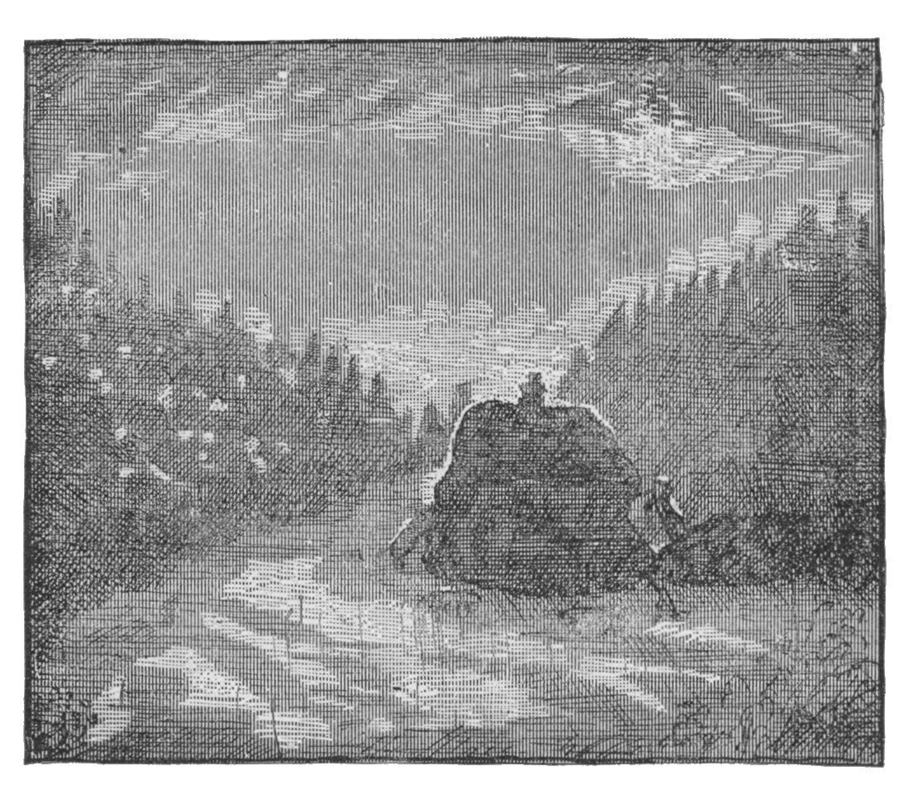
MRS. REEVES AND THE WOLVES.

far and near were ranging the woods looking for her, and when they at last found her, she was exhausted and almost speechless, having lain down to die. One night she climbed to the top of a high rock to get out of the reach of the wolves that were on her track. Here she was serenaded all night, during which they made many unsuccessful attempts to reach her; nor did they leave her until the dawn of day, when they vanished into the forest.

SAM’S POINT, OR THE BIG NOSE OF AIOSKAWASTING.

THE traveler in the region of the Shawangunk has not failed to notice that remarkable feature of the mountain known as Sam’s Point. Even when seen at such a distance that the mountain looks like a blue cloud suspended above the earth, this promontory stands out in full relief against the sky. The name has its origin in one of those quaint legends with which the vicinity abounds. The story as handed down by tradition, and still related by the residents of the neighborhood, is as follows:

Samuel Gonsalus was a famous hunter and scout. He was born in the

Sam’s Point, or the Big Nose of Aioskawasting. 133

present town of Mamakating; was reared in the midst of the stirring scenes of frontier life and border warfare, in which he afterward took such a conspicuous part; and was at last laid to rest in an unassuming grave in the vicinity where occurred the events which have caused his name to be handed down, with some lustre, in the local annals.
He lived on the west side of the mountain, a locality greatly exposed to Indian outrage, and his whole life was spent in the midst of constant danger. His knowledge of the woods, and his intimate acquaintance with the haunts and habits of his savage neighbors, rendered his services during the French and Indian War of inestimable value. He possessed many sterling qualities, not the least among which was an abiding devotion to the cause of his country. No risk of his life was too imminent, no sacrifice of his personal interest too great, to deter him from the discharge of duty.
When the treacherous Indian neighbors planned a sudden descent on an unsuspecting settlement, “Sam Consawley,” as he was familiarly called, would hear rumors of the intended massacre in the air by some means known only to himself, and his first act would be to carry the people warning of their danger. At other times he would join in the expeditions against bands of hostiles; it was on such occasions that he rendered the most signal service. Though not retaining any official recognition of authority, it was known that his voice and counsel largely controlled the movements of the armed bodies with which he was associated, those in command yielding to his known skill and sagacity.
His fame as a hunter and Indian fighter was not confined to the circle of his friends and associates. The savages both feared and hated him. Many a painted warrior had he sent to the happy hunting-grounds; many a time had they lain in wait for him, stimulated both by revenge and by the proffer of a handsome bounty on his scalp; but he was always too wary for even the wily Indian.
In September of 1758 a scalping party of Indians made a descent into the country east of the Shawangunk. The warriors were from the Delaware, and had crossed by the old Indian trail* leading through the mountain pass known as “The Traps;” their depredations in the valley having alarmed the people, they were returning by this trail, closely pursued by a large body from the settlements. At the summit of the mountain the party surprised Sam, who was hunting by himself.
As soon as the savages saw him they gave the war-whoop, and started in pursuit. Now was an opportunity, thought they, to satisfy their thirst for revenge. Sam was a man of great physical strength, and a fleet runner. Very few of the savages could outstrip him in an even race. But the Indians were between him and the open country, and the only way left was toward the precipice. He knew all the paths better than did his pursuers, and he had

* During the spring of 1887, the writer followed this old war trail for a considerable distance, it being still plainly visible.
134 Legends of the Shawangunk.

already devised a plan of escape, while his enemies were calculating either on effecting his capture, or on his throwing himself from the precipice to avoid a more horrid death at their hands.
He ran directly to the point, and pausing to give a shout of defiance at his pursuers, leaped from a cliff over forty feet in height. As he expected, his fall was broken by a clump of hemlocks, into the thick foliage of which he had directed his jump. He escaped with only a few slight bruises. The Indians came to the cliff, but could see nothing of their enemy; and supposing him to have been mutilated and killed among the rocks, and being themselves too closely pursued to admit of delay in searching for a way down to the foot of the ledge, they resumed their flight, satisfied that they were rid of him. But Sam was not dead, as some of them afterward found to their sorrow. To commemorate this exploit, and also to bestow a recognition of his numerous services, this precipice was named Sam’s Point.
Sam had a nephew by the name of Daniel Gonsalus, who was captured by the Indians when he was about five or six years old. The savages were lurking in the vicinity of Mamakating farms; and being too feeble in numbers or too cowardly to make an open attack, they sought to effect their purpose by making secret reprisals. One day the boy, having ventured too far from home, was captured and carried away. He was soon missed, and search made for him, but all to no avail; and after some days his parents gave him up as lost. Whether he had been carried off by some strolling band of Indians, or had become bewildered in the woods, and so perished, was to his agonized parents merely a matter of conjecture.
The Indians, on leaving the valley, stopped and rested at a lake in the mountains, where they remained several days. The boy became the adopted son of a warrior and his squaw; he formed an acquaintance with several of the young Indians, and engaged with them in their sports. Among other things they brought together some small stones and made a miniature wall. After this the band wandered from place to place, and Daniel lost all knowledge of the direction in which his parents lived.
For a time he was watched closely; but eventually was regarded as fully adopted into the tribe, and was suffered to go where he pleased. After some time had elapsed, the band again encamped by a lake, when Daniel discovered the little wall of stones he helped build when he was first captured. His love for his white friends had not diminished, nor had his desire to return to them abated. He would have made his escape from his captors long before, only that he did not know which way to go. Here was a discovery that made plain the way to home and friends.
Waiting a favorable opportunity he set out on his journey, reaching the residence of his father safely after an absence of three years, where he was received by the family as one raised from the grave.
Elizabeth Gonsalus, another relative of Samuel, was captured by savages when she was seven years of age. She was carrying a pail from her father’s
“Gross” Hardenburgh. 135

house to a field near by. Her way led through bars; the rails were all down but the upper one; and as she stopped to pass under this, she was caught by a painted Indian. He so terrified her by threats that she could not give an alarm, and conveyed her to his party encamped near by. In company with other captives she was taken several days’ march in a southwest course over the mountains and along the banks of the rivers until they reached a town in interior Pennsylvania. Here she remained a prisoner twenty years.
Her disappearance from home had been so sudden and mysterious, that her friends were in deep distress as to her probable fate. Had she wandered into the woods and perished? Such instances were comparatively frequent. Had she been killed and devoured by wild beasts? Such a fate was by no means uncommon in a country abounding with wild animals. Or, worse than all, had she been carried off to become the unwilling slave of a brutal savage? These questions had been asked for twenty long years. Her father inclined to the theory that she had been captured by the savages, and continued, year after year, to make inquiries of those who had been among the Indians, in the almost despairing hope that he would yet find tidings of his lost daughter.
At last he heard of a white woman who was with a clan near Harrisburgh, the circumstances of whose capture led him to suspect she might be the one long sought. He lost no time in searching for the clan, with whom he had the good fortune to find the white woman. Twenty years of a life of servitude, with brutal treatment, had so changed her appearance that he could trace no resemblance in her to the little girl he had lost so long before. He listened to her story, some particulars of which led the father to claim her and carry her back to his home. She had entirely forgotten the names of her family. When taken to the house in which she was born, she went directly to the bars where she was taken prisoner by the Indian. The shock and fright of her capture twenty years before had fixed the locality so firmly in her memory, that she pointed out the place where the Indian seized her, and gave some of the details attending her capture. There was no longer any doubt—the lost one was restored to the fold.

“GROSS” HARDENBURGH.

A NARRATIVE OF EARLY LAND TROUBLES.

THE man whose crimes and subsequent history form the subject of this chapter was a resident of the Neversink valley. The deeds of violence attributed to this man are yet traditionary in that locality, and still serve as themes to while away many a winter evening as they are told by the fathers to the younger members of the family, seated by they firesides of the log-cabins and cottages of the neighborhood.
136 Legends of the Shawangunk.

Fear the beginning of the present century the people of this valley were agitated over the question of title to lands. The settlers had very generally paid for the farms they occupied, the title to which they had acquired under the Beekman patent, and had made considerable improvements in the way of clearing up wild lands, and putting up comfortable log-cabins and barns, which greatly enhanced the value of the property. They had settled down with the purpose of obtaining a competence that would assure them a serene and comfortable old age; and now they were threatened with the loss of the fruits of years of trial and sacrifice by a defective title. These pioneers would not look with favor on any one who sought to dispossess them of their farms, even were he a man of sterling qualities, and in possession of a valid title; but it does not appear that Gerard, or “Gross” Hardenburgh, who figured as a rival claimant to the land, enjoyed either of these qualifications. Gross Hardenburgh—we take the liberty of using the name by which he is usually spoken of—was the son of Johannis Hardenburgh, and was born in Rosendale, Ulster county. He was of a haughty and willful temper, and greatly addicted to drink. In early life he married Nancy Ryerson, an estimable lady, by whom he had several children.
During the War of the Revolution he espoused the cause of the Colonies with a devoted patriotism, and frequently imperiled his life in the struggle. His time, his means, and his influence were thrown without reserve into the scale. Quinlan, whom we quote largely, says he organized two companies of infantry, both of which were engaged in defending the frontier against the incursions of the savages, one of them being commanded by him in person.
At the attack on Wawarsing, in 1781, it will be recollected that Captain Hardenburgh hastened forward to the relief of the settlement; and having thrown his detachment into a small stone house, he with a force of only nine men bravely withstood the advance of nearly four hundred Indians and Tories. So stubborn was the defense of the little garrison that thirteen of the enemy were left dead on the field. This Captain was none other than Gross Hardenburgh, by whose courage and leadership Wawarsing was saved from utter annihilation.
As he advanced in years his habits of dissipation grew upon him to such an extent, that his existence was little better than one continuous debauch, which tended to confirm and inflame his evil propensities, while it obscured what was commendable in his disposition. He became morose, impetuous, tyrannical and uncongenial in the extreme. It is said of him that in his old age, when traveling about the country, he would order the innkeeper with whom he lodged to cover his table with candles and the choicest liquors, and taking his seat solitary and alone, drink himself into beastly insensibility.
Owing to his vicious and morose ways, his father disowned him, and devised his share of the paternal estate to the heirs of his wife, Nancy Ryerson. This act of the elder Hardenburgh seemed to extinguish the last spark of manhood that lingered in the heart of his eccentric son.
“Gross” Hardenburgh. 137

The death of Nancy Ryerson antedated that of her husband, and several of her children died unmarried; consequently the purpose of the father was defeated, the dissipated son inheriting the property of his deceased children. Gross Hardenburgh is said to have made the impious and heartless boast, that while his father disinherited him, the Almighty it made all right by removing some of his own children. Such were the antecedents of the man who was about to enter upon the work of evicting the settlers of Sullivan. Little hope of mercy could any expect who were in his power.
His controversy with his father, his wife, his children, and the settlers of the Neversink valley, had the effect of arousing a spirit of antagonism against him which time has scarcely softened, nor the teachings of charity perceptibly modified; few, even at this late day, choosing to say a word in his defense. He hated his family, and defied the world. When he at last met his fate there was not one left to mourn his loss; while many could not conceal their joy that his presence would no longer afflict them.
Before proceeding to extreme measures, Hardenburgh made a general offer of one hundred acres of wild upland to each settler of the disputed territory for his improvements; but the occupants of the valley met his overtures with defiance. They had purchased the bottom lands of the Neversink in good faith, and were not disposed to yield up their improvements for wild mountain lands. They believed that Hardenburgh’s claim was fraudulent; or should it prove otherwise, that the state would provide a remedy for the difficulty.
Meanwhile, finding that his offers were refused. Hardenburgh instituted suits of ejectment against several of the settlers. Without waiting, however, for the courts to decide the question, he took the law into his own hands, and commenced the work of seizing upon property and forcibly dispossessing the inhabitants. In the fall of 1806 he took six hundred bushels of grain in bulk, and all the growing crops, from James Brush and his three sons. The grain was placed in a grist-mill owned by himself, which stood on the site of the Hardenburgh saw-mill.* Gross also owned a house and barn in the vicinity, and his son also owned some buildings there. Among the latter was a barn in which was stored three hundred bushels of grain, which had been forcibly taken from the settlers.
It was not long before the mill, houses, and barns, were all destroyed by fire. Under such circumstances it was strongly suspected that the dissatisfaction of the settlers had an intimate connection with the burning of the property, and that a terrible vengeance awaited upon the patentee. Some of the Hardenburgh family were then residing near by, but became so alarmed that they soon left the neighborhood.
During that same year it is asserted that Hardenburgh forcibly set the family of James Brush out of doors, and kicked Mrs. Brush as she went, though

* Quinlan’s “History of Sullivan.”
138 Legends of the Shawangunk.

only three days before she had given birth to a child which she then held in her arms. During the absence from home of a neighbor, Jacob Maraquet, his family were ejected, Mrs. Maraquet being dragged from her home by the hair of her head. She died a few days afterward from the effects of her treatment.
During the two years following, outrage followed outrage. Hardenburgh was excited to frenzy, and the blood of the settlers was fully aroused. The usurper of their lands was looked upon as a common enemy, whose death would prove a public blessing.
In November, 1808, Gross Hardenburgh passed through the Neversink valley. He was at that time seventy-five years of age. Notwithstanding he had led a life of dissolute habits, he was sill active and energetic, and controlled his spirited and somewhat perverse horse with skill and boldness. He was, withal, possessed of a magnificent physique, on which neither time nor dissipation had made perceptible inroads; and he boasted of a weight of two hundred and fifty pounds. He feared neither man nor beast and appeared to entertain no respect for his Creator.

Calling on his way along the valley at the house of one of the Grants, he made the emphatic declaration that “he would raise more hell in the next seven years than had ever been on earth before.”

When passing along what is locally known as the “Dugway,” he noticed that the chimney of a house owned by him, and occupied by a man named John Coney, was not completed. Calling Coney from the house he upbraided him in a towering passion, and concluded with the remark that “unless the chimney was topped out when he came back he would throw him out of doors.” Coney immediately employed the services of a neighbor, and the chimney was finished next day.
Hardenburgh went that night at the house of his son, and soon after sunrise on the following morning he started to go up the river. About an hour afterward he was found in the road, helpless and speechless. His horse was caught about a mile above. Hardenburgh was taken to a neighboring house, where he lingered until about three o’clock the next morning, when he died. He did not know that he had been shot, and those about him did not think best to acquaint him with the fact. Before he died he was heard to remark that his friends had often told him his horse would throw and probably kill him, “and now,” said he, “he has done it.”
While preparing his body for burial, a bullet-hole was found in his coat, and a wound in his shoulder. His friends were unwilling to admit he had been murdered, and were on the point of burying him without an inquest. An old soldier standing by, who had seen many wounds received in battle, declared that nothing but lead could have made the hole in the dead man’s shoulder. A coroner was sent for, and the nearest physicians (one of them Hardenburgh’s son Benjamin) were requested to be present.
A crowd of people surrounded Van Benscoten’s house where the inquest took place, and was attended with scenes and incidents almost too shocking for
“Gross” Hardenburgh. 139

credence. Some of them brought jugs of whiskey to make merry over the death of their enemy, and drunkenness became the order of the day. One, who had just come from butchering hogs, as he beheld the dead man prepared for dissection, exclaimed: “That is fatter pork than I have killed to-day.” The speaker bore unfriendly relations to one of the physicians; and, while the dissection was going on, he continued: “That is more than I ever expected to see—my two greatest enemies—one cutting the other up!” When the body was opened, and the heart exposed, he cried: “My God! that’s what I’ve longed to see for many a day!”
Another composed and sang an obscene and irreverent song, in which he described the death of Hardenburgh, the feeding of birds on his body, and other indelicate details. This greatly pleased the assembled multitude, and was repeated so often, that some can yet recite parts of the composition.
Quinlan, from whom we glean most of the preceding, says that a woman of the neighborhood, whose descendants are among the most respectable citizens of Fallsburgh, declared that “Gross had gone to ——, to fee more lawyers.” One of the witnesses, on being asked if he knew who shot Hardenburgh, answered that he did not; but expressed regret that he did not himself do the deed, as “Doctor Benjamin had offered two hundred acres of land to have his father put out of the way.”
These remarks evoked shouts of merriment from the crowd. Vain were all efforts to preserve order; decorum and decency were set aside; the rejoicing of the settlers, inflamed by the all-potent rum, took the form of the revels of Pandemonium.
From evidence elicited at the inquest and from subsequent developments, it is supposed the assassins were three in number, and that they were posted behind a tree about eight rods from the road, where they had cut away some laurels that had obstructed their view. The ball had entered the victim’s shoulder, and passed through, breaking the back-bone; and the shock to his nervous system was such as to instantly deprive him of sensation. This accounts for the circumstance of his not hearing the report of the gun.
Several were suspected of being implicated in the murder, some of them being arrested either as principals or accessories; it is probable that a number of individuals in the “infected” district could tell more than they were willing to disclose. When the fatal shot vas heard in the valley, one of the men who was at work on the chimney at the “Dug-way,” slapped his hands and remarked, “That’s a dead shot! An old fat buck has got it now!”
A tradition is current in the neighborhood that a suspected person moved west, who, on his death-bed, confessed that he assisted at the murder, but stubbornly refused to disclose the name of any of his accomplices. If the death of Gross Hardenburgh was the result of a conspiracy involving a number of persons, the secret has been well kept; and guilty souls, blackened with the horrible crime, have gone down to the grave with the burden of their unconfessed transgression. After the assassination, such of the settlers as had not
140 Legends of the Shawangunk.

removed from the valley, found no difficulty in making satisfactory terms with the heirs of Hardenburgh. Thus was ended what the old settlers termed the “Hardenburgh war,” a term by which it is usually spoken of to this day by the residents of the valley.

LITTLE JESSIE MITTEER AND THE BEAR-TRAP.

“BE sure and start for home early; you know I don’t like to have Jessie out after dark, when there are so many wild animals about. You remember it was only a night or so ago that we heard the wolves howl dreadfully over by the creek; and I heard to-day they killed some sheep of Job Jansen’s.”
Such was the parting injunction of Mrs. Samuel Mitteer, as her husband and little daughter Jessie set out one afternoon on an errand to the house of a neighbor some three miles distant. The husband bade her not to disturb herself on that account, assuring her that he would be home before nightfall; and the little girl, first kissing her mamma good-bye, took her father’s hand and departed in high spirits.
They reached their destination, but were obliged to wait a short time for the neighbor to return. The business being arranged, the men engaged in a friendly chat, and the moments flew by unheeded. The sun had already disappeared behind the wall of forest to the west when Samuel bethought himself of his promise to his wife. Still, he did not dream of any more serious result than a little anxiety on the part of the good woman; and taking his daughter by the hand, set out on their homeward journey as fast as her little feet could carry her.
Her merry voice rang through the woods, now growing dim and solemn with the gathering darkness: and they had already passed the Hemlock wamp, and were more than half way home, when their ears were greeted with a sound that made the father involuntarily clutch the arm of his little companion with an energy that could not fail to alarm her. Again the sound came through the darkening forest aisles and echoed from hill to hill, and at last died away to a whisper.
“What is it, Papa?” exclaimed the child, whose quick glance noted the strange demeanor of her father; “is it anything that will hurt us? I do wish I was with Mamma!” Without deigning a reply, Samuel caught the child in his arms, and ran in the direction of home with all his might.
Reader, did you ever hear the howl of a wolf in the woods of a still night—when some old forester opens his jaws and sends forth a volume of sound so deep, so prolonged, so changeful, that, as it rolls through the forest and comes back in quavering echoes from the mountains, you are ready to declare that his single voice is an agglomerate of a dozen all blended into one? Then as you wait for the sound to die away, perhaps, across the valley, another will open
Little Jessie Mitteer and the Bear-Trap. 141

His mouth and answer with a howl as deep, and wild, and variable as the first; then a third and a fourth will join in the chorus until the woods will be full of howling and noise? If you have heard this weird music of the forest, far from home, without means of protection, and with helpless beings in your charge, then you may realize the feelings of Samuel Mitteer as he fled along the path with the speed of a deer.
Mr. Mitteer hoped he might reach home before the first wolf had time to call the others to its assistance, as he understood their habits sufficiently to know these animals seldom attack singly. He was within a mile of his house, and less than half that distance from the clearing. So great was the effort he was making in his flight, encumbered by the weight of the child, that he began to show signs of exhaustion; he feared lest his strength should fail entirely before he reached a place of safety.
To add to his terror he knew by the well-known sounds that the pack had collected, and that the hungry brutes were upon his track. The disclosure added new energy to his frame. He was a powerfully built man, and rock and tree flew by as he sped on in his flight. Yet his were the efforts of sheer despair, as he heard the din of snarling beasts, and knew they were rapidly gaining in the race.
He thought of home; he wondered if his friends heard the howling of the pack, and knew that he was making a race for life. He imagined what would be their feelings when they should find his fleshless bones is the woods next day; and even calmly conjectured as to what would be the sensation of being torn limb from limb by the fierce brutes.
Nearer, ever nearer, came the howling and snarling of the pack. He realized that his moments were numbered if he depended on the speed of his flight alone. By abandoning his child he knew he could climb a tree beyond the reach of his pursuers; but he could not do so with her on his shoulders. Rather than leave her to her fate he would die with her—the little one whose arms were then encircling his neck, and whose breath came thick and fast against his cheek. Ah, that death shriek, when at last her form would be crushed in the jaws of the bloodthirsty brutes—would it strike him dead?
“I see them coming, Papa,” said little Jessie, who from her position could look back over her father’s shoulder, “and, oh, Papa, there are so many of them; you won’t let them hurt me, will you?” A scarcely audible groan was the only response.
While every means of escape was being canvassed in the mind of the agonized parent with a rapidity that is possible only in times of great danger, he bethought himself of a bear-trap he had seen in the vicinity but a short time before. Could he reach the trap? It was worth the trial. All that human energy could do he would accomplish. Striking obliquely from the path he bounded away. The door to the trap was raised when he last saw it; if still in that position he believed he could place the child inside and spring the trap; but if the door was down, he knew he would not have time to raise
142 Legends of the Shawangunk.

the ponderous weight, and all would yet be lost. It was a forlorn hope at the best.
What is that object looming up directly in his path? It is the bear-trap. But the door! the door! The shadows of the forest render the vision indistinct. He cannot tell whether the door is shut or raised. It appears to be shut. A few more steps will decide. Already he hears the panting of the brutes at his heels, and expects each moment to feel their sharp claws ill his flesh. There is a mist before his eyes. He feels that his strength is failing. One moment, and—“Thank God,” he cries; “the door is raised.” With a wild energy begotten of despair he tears the terrified child from his breast, thrusts her through the opening, touches the spindle and down comes the ponderous door with a thud. Then seizing an overhanging limb he swung himself up out of reach just as the jaws of the foremost wolf came together as he snapped after his prey.

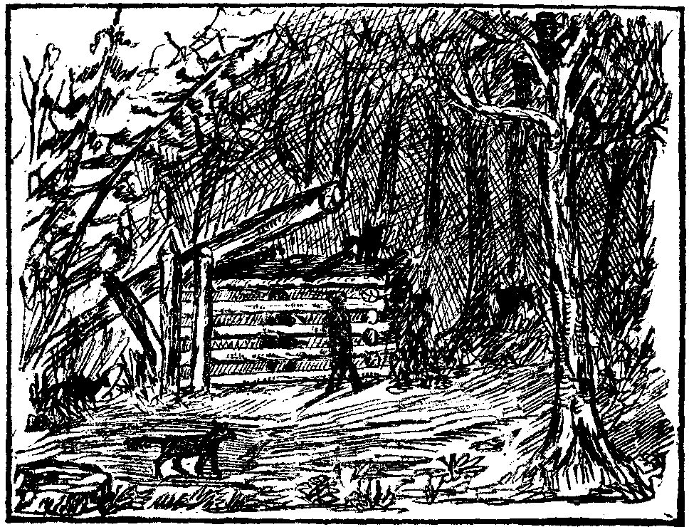
JESSIE MITTEER AND THE BEAR-TRAP.

Now that the necessity for immediate exertion no longer existed, the reaction was so great that Mr. Mitteer feared he would fall from the tree from sheer exhaustion; to prevent such an occurrence, he tied himself securely with his cravat and handkerchief. All night long the wolves perambulated about that bear-trap and tree, and made the night hideous with their howling. It was a night ever to be remembered by both father and child. They were sufficiently near to one another to converse, so they could cheer each other during the long and tedious hours.
The trap in which little Jessie lay was built so strongly that the largest bear could not get out after it had once sprung the door. The father had told her to keep as near the centre of the pen as she could, and she would be safe: Though out of reach of harm, her position was far from enviable, with the ferocious brutes all around and over her prison, thrusting their noses and their
A Rival of Israel Putnam. 143

sharp claws into the crevices between the logs in their frantic efforts to reach her. Morning came at last, but Mr. Mitteer dare not leave his perch for fear their late assailants might yet be lurking in the vicinity.

The people in the village of Liberty where he resided had heard the unusual howling of the wolves during the night, and much anxiety had been felt, as it was feared they were on his track; the wife and mother had been inconsolable. She had spent the whole night in alternately going to the door of her log cabin to listen to the wolves in the forest through which her husband and child were to return, and then throwing herself upon the bed and giving way to violent paroxysms of grief. Before sunrise a party was sent in search of the wanderers. Proceeding along the Hurley road the relieving party hallooed the names of the missing ones, and presently were rewarded with an answer. Then, following up the direction of the sound, they came upon Mr. Mitteer still in the tree, and little Jessie safe and sound in her bear-trap. The wolves had gone, but had left behind abundant evidences of their visit. The father and child were speedily restored to their friends, who had given up all hope of ever seeing them alive. Though Samuel Mitteer lived many years after this occurrence, he ever after exhibited an almost childish terror at the howling of a wolf.

A RIVAL OF ISRAEL PUTNAM.

EVERY schoolboy has heard the story of Israel Putnam and the wolf. Comparatively few have heard of the similar experience of a lad in a panther den at Callicoon. Without detracting from the glory of Putnam, we think the story of little William Lane, of Callicoon, worthy of honorable mention.
In the spring of 1843 the track of a very large panther was discovered, and a party of hunters turned out and followed it to its den in a ledge of rocks. Closing up the entrance to the cave carefully, they went home, proposing to return next day with reinforcements.
The following day they were on the ground and found everything as they had left it. They first dislodged the rocks for about twenty feet, or half way to the extremity of the den, so as to admit the passage of a man to that point; beyond this they found the hole too small and the surrounding material immovable. A small lamp was tied to the end of a pole and thrust inward far enough to enable the “fiery eye-balls” of the monster to be seen. A candle was next placed so that the light would shine on the barrel of a rifle, and thus enable the daring man who attempted to shoot the panther to take sure aim. The first shot was fired by William Adams, who wounded the game, causing it to scream so terribly that every one fled front the spot, fearing the enraged creature would emerge and rend them in pieces. Except a few contusions,
144 Legends of the Shawangunk.

caused by a hasty scramble over fallen tree-trunks and scraggy rocks, no damage was incurred. One by one the hunters returned and obtained a furtive view of the scene of terror. All seemed quiet, and after a hasty consultation, the entrance was again securely walled up and the place abandoned for the night.
On the third day all the men and boys that the surrounding country afforded mere assembled to witness the sport. They were armed with an endless variety of weapons,—rifles, shot-guns, bayonets, hatchets, axes, crowbars, and butcher knives. It was agreed to resume the plan of operations adopted the day previous. The boulders were once more rolled away from the entrance, and the lights properly placed. A brother of William Adams, the hero of the previous day, went into the passage as far as he was able and fired. The same scene followed as on the second day, the screams of the panther causing a panic in the whole crowd, and the forty men and boys ran as if life depended on the celerity of their flight.
The company rallied sooner than on the former occasion, however, and John Hankins fired the third shot, prostrating the panther in his lair. But how to get him out was the difficulty. None but a lad could enter; and now was a rare opportunity to test the bravery of the boys. One lad volunteered but at the last moment his courage failed him. Next a spirited little fellow named William Lane threw off his coat, hat and vest, and arming himself with a hunting axe and dirk, went into the den, accompanied by Mr. Hankins as far as the latter could get. While his friends remained outside in breathless suspense, young Lane cautiously crept through the narrow passage, pausing occasionally to listen. The panther still exhibited signs of life, as the boy could see by the faint light of his lamp. As soon as young Lane was within reach he buried the blade of his axe in its brain, and then applied the dirk to its throat—a very hazardous experiment. The young hero then ended his adventure by hauling out the body of the panther, which proved to be the largest of its kind.

PANTHER HUNTING AT LONG POND.

NO sports are more thoroughly enjoyed by robust men than those of hunting and trapping. The freedom from restraint; the mountain air and vigorous exercise; living in constant communion with Nature, with just enough of danger to add relish to a calling full of excitement and adventure—these are among the causes that lend to such an existence a charm that no other life can give.
Cyrus Dodge had a thrilling adventure at Long Pond, one of the many beautiful sheets of water found in the county of Sullivan. This pond was conspicuous in times gone by for its large trout, and for the numbers of deer

Panther Hunting at Long Pond. 145

found in its vicinity. One day in mid-summer, Dodge went to this lake to look for deer. He sat under some huge trees that grew near the shore, waiting for the deer to come to the water. While thus engaged, his attention was directed to a suspicious noise overhead. Looking up he saw a large catamount on at limb just above him. The animal was watching him intently, as though mentally discussing the relative merits of a man or deer for dinner. Believing there could be no merit in procrastination, Dodge brought his rifle to his shoulder and fired. The next instant he heard a dull thud on the ground at his feet, and saw that the turf and dead leaves were being crimsoned by the blood of a panther in its dying throes.
The report of his rifle started other lithe forms into activity among the tree-tops, and, as Dodge declared afterwards, he believed the woods were full of panthers, and realized that he was in great peril.
Knowing the aversion of the cat-tribe to water, he waded out into the lake waist deep. As he loaded his gun he counted no less than five panthers among the trees that lined the shore. They were probably a mother and her young; and the latter, though nearly grown, had continued to follow the old one. The hunter kept up a fusilade from his position in the water until three more panthers were brought down. The other two ran off and were seen no more. He then waded ashore, skinned the four panthers and made the best of his way homeward, sensibly concluding that it was a dangerous locality for deer hunting.
One day in mid-winter a hunter by the name of Sheeley discovered the track of a large animal not far from a cabin occupied by a widow. He followed the track until it led to a den in the rocks. He examined the entrance carefully, but did not care to explore the interior alone. The next day, in company with a companion, he revisited the place. The passage into the lair of the animal was very narrow, so that a person could enter only by creeping on his hands and feet. Procuring a sapling, they tied a birch bark to one extremity, and thrust the lighted end into the hole. By the light they discovered a very large panther quietly reposing in the cave. A rifle-ball speedily deprived the animal of life, and the hunters started home with their game. On their way they came upon the half-devoured carcass of a large buck, which the panther had killed, and had been feeding upon.
William Woodward, while roaming through the woods in the town of Rockland, discovered a panther’s den. Though entirely alone he crept into it. The lady of the house was not at home, but was absent foraging, leaving her children to take care of themselves. Woodward took up the little panther kittens, thrust them inside his torn shirt, and carried them home. Had the old mother panther discovered him in the act of purloining her little ones, this story would have had a different ending.
Peter Stewart and a young friend were once hunting in this town, but with no success. Game seemed to be scarce. They examined the mountain runways, and the crossings in the soft spongy soil of the valleys, without find-
146 Legends of the Shawangunk.

ing the print of a hoof. While passing near a ledge they discovered a hole in the rocks, near which were a number of bones of deer and other animals. This they concluded was the lair of some wild beast, which was in the habit of bringing food home to its young. Examining carefully the priming of their guns, they secreted themselves within easy gun-shot of the hole, and awaited the development of events.
In a few moments they saw a bear come out of the hole with a young panther in his mouth. As Stewart’s friend was abort to shoot, the other signaled him to withhold his fire. The bear quickly crunched the life out of the kitten, went back into the hole, and presently issued forth with another one struggling in his teeth. Bruin had come upon a panther family in the absence of the old ones, and had thought this was his opportunity. As he crushed this second kitten between his jaws, it gave a loud squeal. The cry was heard by its mother who happened to be returning home. Soon there was heard the sound of swift feet, and the crashing through brush and dry branches of some rapidly moving body. Then a large panther merged into view, with eyes blazing and hair bristling—boding dire vengeance on the despoiler of its home.
The bear saw the panther coming, and his animal instinct took in the situation. He saw he was about to reap the fruits of his indiscretion. He made an awkward effort to shamble away, but was too closely pursued by the infuriated beast; to escape he took refuge in a tree. But the tree afforded no asylum from the sharp claws and teeth of the panther. The bear rolled himself into a ball and dropped to the ground, and again essayed to shuffle off. His antagonist was once more upon him; and forced to extremities Bruin turned to fight and a fierce and bloody conflict ensued. The hunters were meanwhile looking on with breathless interest while the actors in this drama of the forest were contributing to their entertainment. However, the end was soon reached. The bear proved no match for his adversary, and the feline monster, fastening its teeth in the shoulder of his victim, with its hind feet ripped out his intestines. The hunters now both fired upon the panther and killed it. Then skinning both animals, they hung the bear meat out of the reach of wolves, and went for assistance to take the carcass home.

BEAR HUNT ON THE MONGAUP RIVER.

THE pioneers of the region of the Shawangunk, who were, by turns, lumbermen, farmers, hunters and soldiers, as inclination led or occasion required, were a robust race of men, fearless and active, who thoroughly enjoyed forest life. Encounters with the fierce denizens of the forest were frequent, always exciting, and occasionally hazardous in the extreme. This territory abounded in wild game, and was a famous hunting-ground for both
Bear Hunt on the Mongaup River. 147

white and red men, even after the country adjacent had settled down to civilization. After the War of the Revolution it is said that “John Land, the Tory,” trapped enough beaver in the town of Cochecton to pay for four hundred acres of land. David Overton used to tell of standing in his father’s door in the town of Rockland, and shooting deer enough to supply the family. Once he counted thirty of these animals at one time in a pond near the house. Five or six of the larger ones seemed to be standing in a circle and pawing the water with their forefeet.
In the winter of 1819, three young men by the name of Burnham, Horton and Brown, residing in Forestburgh, engaged in a hear hunt. Burnham, while turning from his work in the woods, discovered fresh bear tracks in the snow, and engaged the others to go with him and capture the animal. Armed with rifle and axe, before daylight the next morning they were on the trail, which they followed for several hours until the track came to a flat on the Mongaup river. Here the snow was very much trampled, and they judged the bear’s winter-quarters must be in the vicinity. The three commenced to search, when Burnham found a hole near the centre of the flat under some large rocks, with bear tracks leading to and from it. He called out to his companions that he had found the den, and presently all three were peering into it, but could see nothing.
They then cut a pole and thrust it into the opening, when they found the end of the pole came in contact with some soft substance. Burnham then split the end and twisted it vigorously against the substance, and was rewarded with some short, black hairs, which were held in the split. They had found the bear, and the animal was within reach of the pole. One of the men suggested they would better go home, but Burnham utterly refused to leave until he had killed the bear.
His next move was to make the stick very sharp, with which he punched the bear with all his might. Immediately there was an angry growl within, with a scrambling of feet and scratching of claws; the bear seized the sharpened end and pushed the pole outwardly, carrying Burnham with it. Burnham dropped the pole, stepped back, caught up his rifle, and aimed it just as the bear reached the entrance. As he showed his head at the hole, Burnham fired, and the bear fell back into his retreat.
At first they could not determine whether or not the bear was dead; a few vigorous punches with the pole satisfied them on that point. They then tried to get out their game with crooked sticks, but their efforts wore fruitless. Then Burnham went head-first into the den, and taking hold of the bear’s shaggy coat, his companions, by pulling on his legs, drew out both him and the bear.
While waiting to get breath, they heard a noise under the rocks, and presently the head of another bear was thrust forth, which speedily met the fate of its companion.
It was now dusk and they were occupied with the question as to how to get the bear home. The feet of the small bear were tied together and slung
148 Legends of the Shawangunk.

across the shoulder of one of the party. The large bear was suspended from a pole and carried by the other two. In this way they reached the road, a mile distant, just at dark, where they met a team with an empty sled, on which they were permitted to deposit their game. On reaching home, tired and hungry as they were, they would not eat until a steak was cut from one of the bears and prepared for their supper.
Zephaniah and Nathan Drake, also of the town of Forestburgh, once had an adventure with a bear. They were out hunting and the dogs had driven Bruin up a tree. The hunters came up and saw the bear seated on a limb thirty feet or more from the ground, calmly eyeing the dogs. Zephaniah quickly brought his rifle to bear upon the animal, when Nathan meekly advised him to be careful and make a sure shot. “Why,” said Zeph., a little vexed at the suggestion; “I can shoot the critter’s eye right out of his head.” The ball, however, missed its mark, but it shattered the upper jaw so that the bear’s

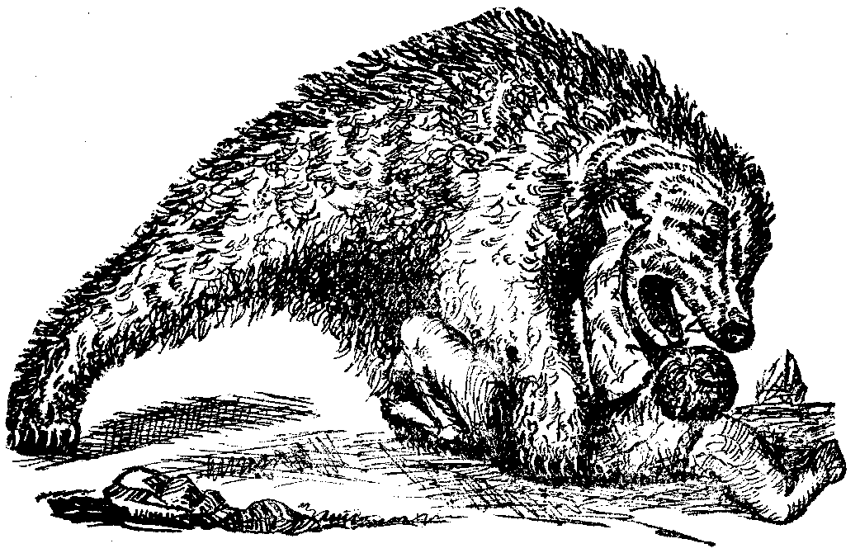
ZEPHANIAH DRAKE AND THE BEAR.

nose and about half of its upper teeth turned up over its forehead. The bear fell to the ground, and the dogs fell upon the bear. The bear caught one of the dogs between his paws and attempted to crush it; when the other dog bit the black brute so viciously, that he dropped the first dog and turned his attention to the other. Thus the battle went on back and forth, the animals being so mixed up that the brothers dare not shoot, for fear of killing their dogs.
Zephaniah finally sailed in with his hunting knife, when the bear left the dogs and attacked his human assailant. The man retreated as the animal advanced upon him. His heel caught in a laurel bush, down he went upon his back, with the bear on top, and the dogs on top of all. For a brief period there was a lively tussle among the bushes. Every actor in that drama was in earnest, as much so as though thousands were witnessing the progress of the fight. From impulse Zephaniah threw up his hand to keep off his assailant as much as possible, and thrust his finger into Bruin’s mouth. The bear’s jaws, torn and mangled, as they were, closed on one of the fingers and crushed it.
Casualty on Blue Mountain. 149

Finally, as Zephaniah was about giving up for lost, the bear, by some means not now known, was killed; but the hero of this bear fight ever afterward exhibited a crooked finger.

CASUALTY ON BLUE MOUNTAIN.

ONE method adopted by the early settlers in clearing up timber lands was by “jamming.” This consisted in partially cutting through the trunks of a number of trees, and by felling some of the outside ones against the others, all would be brought down, and a considerable saving of labor effected. In a few months the interlaced limbs would be sufficiently dry, when fire would be applied, and usually nothing but the charred stumps and prostrate trunks would remain.
Other farmers would first cut the brushwood and small trees, while the larger ones were girdled and left standing. The latter, particularly the hemlocks and other evergreens, the foliage of which would remain green too long after girdling, were sometimes trimmed from the top downward. This method was adopted to save the labor of gathering the trunks into heaps for burning, a very laborious undertaking where the timber is large. When the limbs and brushwood had became thoroughly dried, and no rain had fallen for several days, the refuse was set on fire. If the result was “a good black burn,” the ground was ready for planting. When the standing trunks began to decay, fire was again applied, and in a few years all was thus consumed. Sometimes, however, the burning was not good, when the fallow would be abandoned, and allowed to be overrun with briers and other rubbish. These “fallow fires, gleaming in the spring time,” are still a feature of Sullivan county.
Years ago, in the town of Liberty, there occurred an incident that is still fresh in the minds of the people residing in the locality. One of these abandoned fallows was on Blue mountain, near the residence of Nathan Stanton. This fallow had come to be a famous spot for blackberries, and the children were in the habit of visiting the place to fill their baskets and pails with the fruit. It was near the middle of August, and the day mild and pleasant, that the four children of Nathan Stanton went thither to gather berries. While there one of the trees toppled and fell, and, in its fall, struck against another, until a number of the immense trunks were brought to the ground. When the children heard the first sound of warning, they ran for a place of safety, only to be caught under the wide-spreading branches of the trunks that were falling all around them. Two of the three boys were killed outright, and the sister was injured badly. The children had gone forth happy and joyous, and before the hour set for their return, two had met a violent death, and a third was dangerously if not fatally injured, by a casualty so remarkable and unprecedented as to appear like a dispensation of Providence. The dead bodies were
150 Legends of the Shawangunk.

extricated, and taken to the house of mourning, where soon the neighbors gathered to witness the sad occasion of bereavement, and to bestow such aid and consolation as it was in their power to give. It was an affecting burial scene at the little rural grave-yard on Blue mountain, when the settlers assembled about the open graves of the Stanton children and participated in the last sad rites of their sepulture.
What added to the impressiveness of the occasion, was the superstitious awe with which the early settlers regarded the mysterious phenomenon which led to the children’s death. Those trees had withstood the blasts of the previous winter and spring, and on a bright day in midsummer, when scarce a breath of air was stirring, they were laid prostrate. What unseen hand caused them to fall? What unknown agency in nature made those forest giants to quiver and reel and then come rushing headlong to the ground, when to mortals there seemed to be no cause? Is it the result of some chemical change in the atmosphere, or are we to await a solution of the problem until the supernatural is unveiled to our understanding?
Though no one has yet explained away the mystery, it is a well-attested fact that trees do thus fall. When the sun is shining brightly, and all nature seems to repose in the beams of the morning; when not a zephyr fans the cheek and no unwonted sound disturbs the ear, lo! a monarch of the forest suddenly begins to tremble, and totter, and then falls crashing to the earth. Now, far away, a dull heavy roar will arise; and again nearer at hand, comes the rushing sound of the bushy top of some lofty pine, as one patriarch after another yields to its fate. It seems as if the direct agency of God produced these effects; and the hunter, untutored though he may be, as he beholds these evidences of the power and incomprehensibleness of the Infinite, breathes a silent prayer of adoration.

NELSON CROCKER AND THE PANTHERS.

NELSON CROCKER was a noted hunter, of whose adventures in the woods many interesting stories are told. It is said that when he accompanied a hunting expedition his companions felt certain of bagging their game. The following narrative, which is given by Quinlan, is highly illustrative of early life in the wilds of Sullivan.
Northwest of Big pond in the town of Bethel, there is a tract of low, wet land known as Painter’s swamp. In former times this ground was as good for deer hunting as any in the country; and where deer were found, panthers generally abounded. This was, consequently, a favorite hunting-ground for Crocker; but on one occasion he found more panthers than he wished to see.
While rambling one day with his dog on the outskirts of the swamp, he counted the tracks of no less than seven of these ferocious animals. As they

