Minisink Battle. 51

strongest men, in these effeminate days, could endure such a tramp, encumbered with guns and knapsacks?
On the morning of the 22nd they were joined by a small reinforcement of the Warwick regiment under Col. Hathorn, who, as the senior of Tusten, took the command. At Halfway brook they came upon the Indian encampment of the previous night, and another council was held. Colonel Hathorn, Tusten and others were opposed to advancing further, as the number of Indian fires, and the extent of ground the enemy had occupied, were conclusive evidence of the superiority of Brant’s force. A scene similar to that which had broken up the former council was here enacted, with the same results. The voice of prudence had less influence than the voice of bravado. It is said that the officer to whose tauntings this last rash act is attributed made quite a display of his bravery while on the march, but, with his company, was only within hearing while the engagement lasted, and could not be induced to go to the relief of his countrymen.
It was evident that Brant was not far in advance, and it was important to know whether he intended to cross the Delaware at the usual fording-place. Captains Tyler and Cuddeback, both of whom had some knowledge of the woods, were sent forward with a small scouting party to reconnoitre Brant’s movements. What they saw led them to think Brant had already crossed, as there were savages and plunder on the opposite shore, and an Indian was then passing over, mounted on a horse that had been stolen from Major Decker. The two scouts fired at this fellow, and, it is said, wounded him fatally. But they mere immediately shot at by some savages in their rear, and Capt. Tyler fell dead. Cuddeback succeeded in reaching the main body of the militiamen, and reported what he had seen and heard. Tyler’s death caused a profound sensation among his fellow soldiers, but it only served to add fierceness to their determination.
After leaving the mouth of the Halfway brook* (now Barryville) it is believed that Brant followed the river bank to the Lackawaxen ford, to which he had sent his plunder in advance. Hathorn resolved to intercept him at the crossing, and to do so attempted to reach the ford first by a rapid march over the high ground east of the river. As they approached the ground on which the battle was fought, Brant was seen deliberately marching toward the ford. Owing to intervening woods and hills, the belligerents lost sight of each other, when Brant wheeled to the right and passed up a ravine known as Dry brook, over which Hathorn’s route lay. By this stratagem, Brant was enabled to throw himself into Hathorn’s rear, cutting off a portion of Hathorn’s command, deliberately selecting his ground for a battle, and forming an ambuscade.
The battle-ground, says Quinlan, is situated on the crest of a hill, half a mile northeasterly from the Dry brook at its nearest point, three miles distant

* We follow the description given by Quinlan, in his admirable History of Sullivan, as the best yet given of the battle.
52 Legends of the Shawangunk.

from Barryville and one from Lackawaxen. The hill has an altitude of twenty-five or thirty feet above its base, and two hundred above the Delaware, and descends east, west and south, while there is a nearly level plateau extending toward the north. This level ground is rimmed (particularly on the south side) with an irregular and broken ground of rocks. On that part of the ground nearest the river the Americans were hemmed in, and caught like rats in a trap.
The battle commenced at nine in the morning. Before a gun was fired, Brant appeared in full view of the Americans, told them his force was superior to theirs, and demanded their surrender, promising them protection. While engaged in parley, he was shot at by one of the militiamen, the ball passing through Brant’s belt. The warrior thereupon withdrew and joined his men.
The battle opened and the forces were soon engaged in deadly conflict. Above the din of the strife, the voice of Brant was heard, in tones never to be forgotten by those who survived, giving orders for the return of those who were on the opposite side of the river.
A part of the Americans kept the savages in check on the north side of the battle-ground, while others threw up hastily a breastwork of stones about one hundred and fifty feet from the ledge which terminated the southern extremity of the plateau. Confined to about an acre of ground, screened by trees, rocks, flat stones turned on their edges, or whatever opportunity offered or exigency demanded, were ninety brave men, who, without water, and surrounded by a host of howling savages, fought from ten o’clock to near sundown on a sultry, July day.
The disposition of the militia, and the effectual manner in which every assailable point was defended, reflects credit on the mind that controlled them. By direction of Hathorn there was no useless firing. Ammunition was short, and it was necessary to husband it carefully. A gun discharged in any quarter revealed the position of its possessor, and left him exposed until he could reload. With the exceptions indicated, every man fought in the Indian mode, each for himself, firing as opportunity offered, and engaging in individual conflicts according to the barbarian custom.
The annals of modern times contain no record of a more stubborn and heroic defense. In vain Brant sought for hours to break through the line. He was repelled at every point.
What the fifty men were doing all that eventful day, who were separated from their companions during the morning, no one can now tell. We will put a charitable interpretation on their conduct, and suppose they were driven away by superior numbers. Their movements are veiled in oblivion, and there let them remain.
As the day drew to a close, Brant became disheartened. The position of the brave patriots seemed to be impregnable, and it is said he was about to order a retreat when the death of a militiaman opened the way into the American lines. This faithful soldier had been stationed behind a rock on the north-
Minisink Battle. 53

west side, where he had remained all day, and kept the savages in check. Brant saw the advantage his death afforded, and, with the Indians near him, rushed into the midst of the Goshen militia. The latter seeing the savages swarming into the centre of the hard-fought field, became demoralized, and sought safety by flight. Many of them were killed or wounded in the attempt. Some incidents of the battle are worth repeating.

Brant killed Wisner with his own hand. Some years afterward he was heard to say that after the battle was over, he found Wisner on the field so badly wounded that he could not live nor be removed; that if he was left alone on the battle-field wild beasts would devour him; that he was in full possession of all his faculties; that for a man to be eaten by wild beasts while alive was terrible; that to save Wisner from such a fate, he engaged him in conversation, and shot him dead.
Captain Benjamin Vail was wounded in battle, and after the fight was over, was found seated upon a rock, bleeding. He was killed while in this situation, and by a Tory.
Doctor Tusten was behind a rock attending to the necessities of the wounded when the retreat commenced. There were seventeen disabled men under his care, who appealed for protection and mercy. But the savages fell upon them, and all, including the Doctor, fell victims to the tomahawk and scalping-knife.
Several attempted to escape by swimming the Delaware, and were shot. Of those engaged in the battle, thirty escaped, and forty-five, it is known, were killed. The remainder were taken prisoners, or perished while fugitives in the wilderness.
Major Wood, of the militia, though not a Mason, accidentally gave the Masonic sign of distress. This was observed by Brant, who interposed to save Wood’s life, giving him his own blanket to protect him from the night air while sleeping. Discovering subsequently that Wood was not one of the Brotherhood, he denounced the deception as dishonorable, but spared his life. The blanket was accidentally damaged while in the prisoner’s possession, which made Brant very angry.
One of the militiamen attempted to escape with the others, but was so far exhausted that he was forced to turn aside and rest. In a little while he saw several Indians, one after the other, pass by in pursuit of the militia, but managed to keep himself out of their sight. Presently a large and powerful Indian discovered him, when, raising his gun, he fired his last shot and fled. The savage did not pursue; he was probably disabled by the shot if not killed.
Samuel Helm was stationed behind a tree, when he discovered the head of an Indian thrust from behind a neighboring trunk, as if looking for a patriot to shoot at. Helm fired and the savage fell; but Helm was immediately hit in the thigh by a ball from another Indian whom he had not seen. Helm dropped to the earth, but the savage did not immediately rush up to take his scalp, being anxious first to discover the result of his shot. This gave Helm a chance to reload which he did behind a natural breast-work which screened him from
54 Legends of the Shawangunk.

view. After dodging about a little the Indian made a dash for his scalp, but received a bullet instead; which put an end to his life. Helm said that the consternation of the Indian, on being confronted with the muzzle of his gun, was truly ridiculous.
In April of the following year, Brant started from Niagara with another force to invade the frontier. At Tioga Point he detailed eleven of his warriors to go to Minisink for prisoners and scalps. With the remainder of his force, he started to invest the fort at Scoharie. Here he captured some prisoners who made him believe that the place was garrisoned by several hundred men—a bit of strategy that foiled even the wily Indian chieftain. Brant turned back, and shaped his course down the Delaware. One day his command was startled by the death-yell, which rang through the woods like the scream of a demon. They paused, waiting for an explanation of this unexpected signal, when, presently, two of the eleven Indians who had been sent to the Minisink emerged from the woods, bearing the moccasins of their nine companions. They informed their chief that they had been to Minisink, where they had captured, one after the other, five lusty men, and had brought them as far as Tioga Point and encamped for the night. Here, while the eleven Indians were asleep, the prisoners had freed themselves from the cords which bound them, when each took a hatchet, and with surprising celerity brained nine of their captors. The other two savages, aroused by the noise of the blows, sprang to their feet and fled; but as they ran, one of them received the blade of a hatchet between his shoulders. Thus was the death of the slain heroes of Minisink avenged.
For forty-three years the bones of those heroes slain on the banks of the Delaware were allowed to molder on the battle-ground. But one attempt had been made to gather them, and that was by the widows of the slaughtered men, of whom there were thirty-three in the Presbyterian congregation of Goshen. These heroic ladies set out for the battle-field on horseback; but, finding the journey too hazardous, they hired a man to perform the pious duty, who proved unfaithful and never returned.
In 1822, the citizens of Goshen were led to perform a long-neglected duty by an address of Dr. D. R. Arnell at the annual meeting of the Orange County Medical Society, in which he gave a brief biography of Dr. Tusten. A committee was appointed to collect the remains and ascertain the names of the fallen.
The committee at once set upon the duty before them. The first day they traveled forty miles through the wilderness. At Halfway-brook, six miles from the battleground, the party left their horses. The vicinity was an unbroken wilderness, with no trace of improvement of any kind, and the danger of attempting to ride was so great that they chose to clamber over the rough ground on foot.
The committee were astonished at the route taken by the little army; the descents were frightful and the country rugged beyond conception. The majority of the bones were found on the spot where the battle was fought and
Minisink Battle. 55

near a small marsh or pond a few rods east. This fact shows that the militia, made reckless by thirst, went for water and were killed. Some were found at a distance of several miles. They were the remains probably of wounded men, who had wandered away and finally died of their wounds and hunger. Wild beasts may have removed others. The skeleton of one man was found in the crevice of a rock where he had probably crept and died. The whole number of bones collected by the Committee was about three hundred; other bones were subsequently found by hunters and brought in.
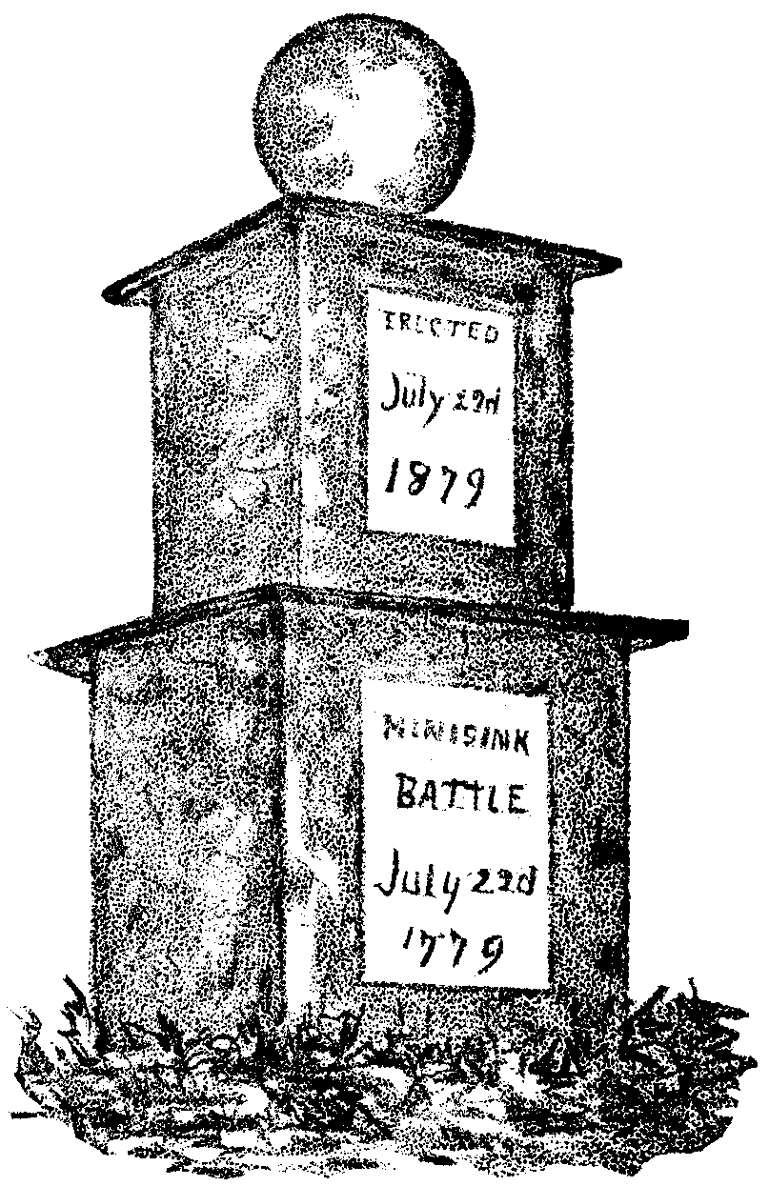
It may be suggested that all of the bones collected may not have been the remains of the white soldiers; that it would be impossible to distinguish, so long afterwards, the skeleton of a white man from that of an Indian. It should be borne in mind that it was the rule of Indian warfare, when successful, to gather up and carry off all their slain. On this occasion the survivors saw the Indians engaged in this very duty.
The gathered remains were taken to Goshen, where they were buried with imposing ceremonies in the presence of fifteen thousand persons, including the military of the county, and a corps of Cadets from West Point under the command of Major Worth.
This monument gradually fell into decay and no measures were taken to preserve it. In 1860, Merrit H. Cook, M. D., a resident of Orange county, bequeathed four thousand dollars for a new one, which was dedicated on the 83d anniversary of the battle, on which occasion John C. Dimmick, a native of Bloomingburgh, officiated as orator of the day. Mrs. Abigail Mitchell, a daughter of Captain Bezaleel Tyler (slain at the battle of Minisink), was present, and witnessed the ceremonies. She was five years old at the time of the battle, and had resided the greater part of her life at Cochecton. On the 22d of July, 1879, the one hundredth anniversary of the Minisink battle; a large and enthusiastic gathering was held on the battle-ground. Although the approach to the place was rough and exceedingly difficult, it being necessary to cut a road through the woods for the occasion, upwards of two thousand persons were present at the ceremony. A monument was set upon the ground sacred to the blood of the slain heroes, and dedicated in commemoration of their services.
MONUMENT ON MINISINK BATTLE-GROUND.
56 Legends of the Shawangunk.

It was on one pleasant morning in June that we left the hotel at Lackawaxen before the people were astir, and crossing the Delaware and Hudson aqueduct, began the winding ascent of the mountain. After a brisk walk of about two miles we came to the residence of Mr. Horace E. Twichell, to whom we had a letter of introduction. That gentleman kindly volunteered to go with us to the battle-ground, which lies partly on his premises, and locate the points of interest.
The battle-field comprises several acres of table-land, bordered by an abrupt descent on all sides except a narrow neck at its northern extremity. It is thickly strewn with pieces of slate rock, which the brave heroes turned to good account in standing upon their edges, and lying behind their friendly shelter during the engagement. Some of these stones still remain in the position in which they were then left.
On the neck of land there is a huge boulder. Behind this natural rampart, a hunter had taken his position on the day of the fight, and while his comrades loaded the guns for him, he so effectually swept the only available approach to the battle-ground as to keep the whole force of Indians at bay during the entire contest. At length the hunter was killed, and the Indians, taking advantage of the circumstance, rushed in and the battle became a rout.
A few yards from this rock, screened on all sides by the contour of the ground and the protecting ledge, the spot was pointed out where for years lay the skeletons of the brave Dr. Tusten and his seventeen slain companions, who were all tomahawked and scalped after the battle was over. Further on stands an old pine tree, on which are the initials “J. B.,” believed to have been cut in the bark by the Indian fighter, Joseph Brant.
An incident of the battle was related to me while rambling over the field. A soldier was assisting a wounded comrade to escape. The Indians were heard in close pursuit, and the wounded man soon saw that all efforts on his part were fruitless. So taking his pocket-book and papers he handed them to his companion, with the request that he give them to his wife at Goshen, and bade him leave him to his fate. The man made good his escape, and delivered the package and money as directed.
Mother McCowan, still living at Handsome Eddy, used to see the skeletons around the spring to the east of the battle-ground, and remembers seeing some of the soldiers that were engaged in the battle.
Mr. Isaac Mills, about forty years ago, found a skeleton about three-fourths of a mile from the battle-field. Judge Thomas H. Ridgeway, of Lackawaxen, informed us that he remembers going to pick huckleberries on the mountain seventy years ago, when the skeletons of the slain Minisink heroes lay thickly scattered about among the bushes, and distinctly recalls his childish fears of the bones.
Near the foot of the monument, entirely covered up with loose slate, was found the skeleton of a man. This was probably the work of the Indians, who, for some reason, gave this man a sepulture.
Brant and the School-Girls. 57

The round stone on the top of the monument is a white flint boulder, found in the Delaware river near the spot where the Indian was shot by the scouts previous to the battle.

BRANT AND THE SCHOOL-GIRLS.

THE name of Brant was sufficient to strike the hearts of the early pioneers with terror. Fears of an attack from the Mohawk chief and his red warriors kept the settlements in a continual ferment. Stories of pillage and murder, carried on under Brant’s direction, were passed from lip to lip—some doubtless without foundation, others greatly exaggerated—still the chieftain had committed deeds of blood sufficient to merit the reputation he bore.
As might be expected, there were many false alarms, on which occasions the women and children would take refuge in the nearest block-house, while the men would arm themselves and prepare for defense. The young people were particularly alert, and at the least unusual noise in the woods would sound the alarm. A young man in Sullivan county ran breathless into the nearest village declaring that his father’s house was surrounded by more than twenty savages. The men turned out with their guns; but on reaching the scene of the supposed danger, they discovered the enemy to be only a number of hoot-owls.
The dread of Indians overcame all other fear. It is related of Mrs. Overton, of Mamakating valley, that, during the temporary absence of her husband, the young mother would abandon her log-cabin at night, and taking her children with her, sleep in the woods or in a rye-field. Tradition says that her youngest child was but a few weeks old and very cross and troublesome; but it was observed that at such times it was very quiet.
But if the people were sometimes needlessly alarmed, at other times it would have been greatly to their advantage to have been more on their guard. The day before the massacre at Minisink, the notorious Brant, with a body of Tories and Indians, attacked the settlement in the present town of Deerpark. Such of the inhabitants as were warned of their danger in time, fled to the blockhouse for shelter. Others were surprised in their homes and in the field, and were either captured or slain.
Some savages entered James Swartwout’s blacksmith shop. In the shop were Mr. Swartwout and a negro who assisted at the forge. Swartwout directed the negro to stay in the shop as the Indians would not be likely to molest him, while Swartwout crawled up the forge chimney and concealed himself there. Scarcely had he done so when the savages rushed into the shop, and appeared much disappointed at finding no one but the negro present. They, however, contented themselves with rummaging about the shop, tumbling everything over, and making havoc of whatever came in their way. Presently
58 Legends of the Shawangunk.

one of them, spying the bellows handle, caught hold of it. Finding it would move, he began to operate the handle, which of course made the sparks fly. He now began blowing at a furious rate, and the other savages gathered round to see the operation. Swartwout, being directly over the fire, was nearly suffocated by the heat and smoke. The negro, apprehensive that Swartwout could not much longer retain his position, called upon the savage to desist, crying out with a voice of authority—“Stop, or you will spoil that thing.” The Indian respected the caution, and ceased to blow.
Not far away, near the fort of the Shawangunk, was the log school-house. The savages raided the settlement while the school was in session. While the fathers and mothers were fleeing for their own safety, they thought of their children, a mile or more away, and hoped the school-house might escape the attention of the savages. But in this they were doomed to disappointment. The

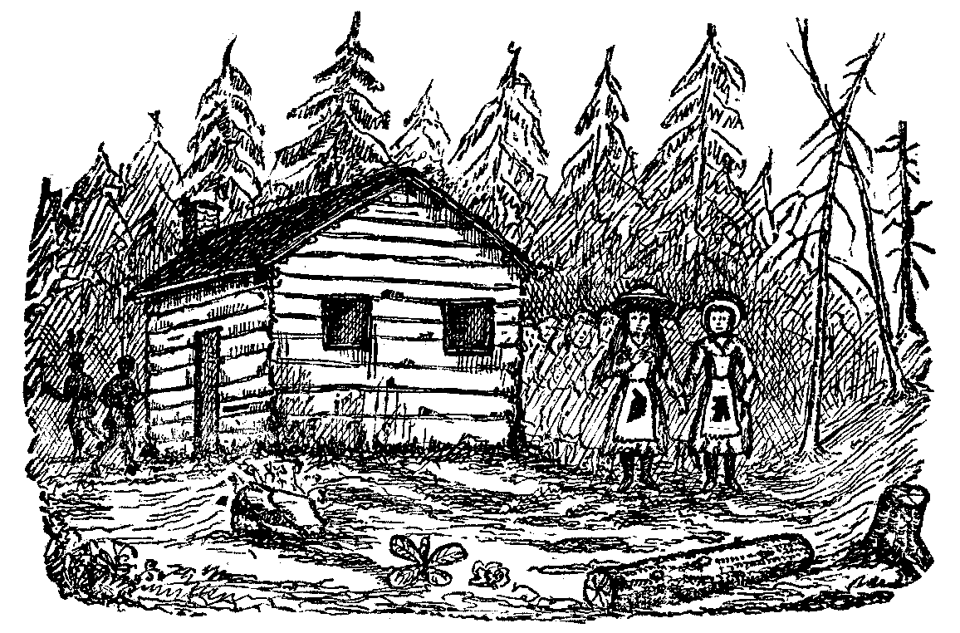
BRANT AND THE SCHOOL-GIRLS.

Indians entered, killed and scalped the teacher, Jeremiah Van Ankeu, in the presence of the scholars. Some of the larger boys shared the same fate, being cut down with the tomahawk; others succeeded in escaping to the woods. The girls stood by the slain body of their teacher, not knowing where to turn or what to do.
Presently an Indian came along, and dashed some black paint on their aprons, bidding them hold up the mark when they saw the Indians coming, and that would save them; and with the yell of a savage he sprang into the woods. This Indian was none other than Brant; and as the savages ran about from place to place, murdering and scalping such as came in their way, on seeing the black mark they left the children undisturbed. The girls induced the boys to come out of the woods, and the children arranged themselves in rows, the girls with the marked aprons standing in front. As the Indians passed and repassed they would hold up the palladium of safety, and were suffered to remain unharmed.
Brant and the School-Girls. 59

Major John Decker resided in the Mamakating valley, and tradition says the Indians raided it for the purpose of obtaining his scalp, for which the British had offered a handsome reward. He was Major of the Goshen Regiment of Foot of Orange county.
The Major’s house was constructed of wood, with logs laid up by way of fortification, and was closed by a heavy gate. It was the month of July. The risen were at work in the harvest field, and no one was in the house except the aged mother and a child. The Major’s wife and a colored woman were at a spring washing.

A Tory entered and told the mother they were going to burn down the house, and proceeded to build a fire in the middle of the floor. Two pails of water stood in the kitchen; the old lady poured this on the fire and extinguished it. The Indians told her not to do that again or they would kill her. Mrs. Decker attempted to run across the fields to another fort, but Brant sent a savage to bring her back; coolly informing her that his object in having her brought back was that she might see her husband’s house burn down; at the same time assuring her that she would not be harmed.
“Can I save anything?” cried the terrified woman.
“Yes, anything you can,” was the response of the Mohawk chief.
Mrs. Decker rushed into the Burning dwelling, caught up two beds and bedding, one after the other, and, with the assistance of some young Indians that Brant sent to help her, brought them to a place of safety. That night the family of Major Decker slept on the banks of the Neversink, with no other covering than the canopy of heaven.
The Major was absent that day at a funeral; it was on his return that he had seen from afar the smoke of his burning dwelling. He put spurs to his horse, and presently met a party of Indians in the road. The Major rode directly through the party without being fired at. Then, probably through fear of encountering a larger force, he wheeled about and rode back again, when he was fired upon and wounded. His horse becoming unmanageable, he rode into a tree-top, closely pursued by the savages. Here he left his horse and took refuge in a cave, at a place near where the Erie railroad now passes. The Indians followed to the opening in the rock, but did not find the object of their search. That night he made his way on foot through the mountains to Finchville, where he found his son, who was one of the lads that had escaped slaughter at the school-house.
This son, on running away from the Indians at the time of the attack, found a child a year and a half old, which had been lost by its mother in the confusion. He took up the little child, found his father’s cow by following the sound of the bell, gave the little one some milk, and restored it unharmed to its mother.
60 Legends of the Shawangunk.

CLAUDIUS SMITH; OR THE ORANGE COUNTY TORIES.

THERE is much in the career of Claudius Smith to interest the student of human nature. Whether we regard his deeds of violence as but the legitimate working of his evil propensities, in defiance of God and man, or whether we deem him in a measure fortified in his attitude toward the Whigs by his sense of loyalty to the king, we cannot deny that he displayed qualities of leadership worthy of a better cause. Had he shown a like energy and prowess at the head of a few thousand troops, his praises would have been sounded on every lip. We leave for others to draw the fine between the bandit chief, whom all abhor, and the lordly conqueror, whom all affect to honor.
Claudius Smith is described as having been a man of large stature and of commanding presence; possessed of powerful nerve and keen penetration; cautious and wily; in short, he was admirably formed by nature for a bandit chieftain.
Claudius early manifested a thieving propensity, in which it is said he was encouraged by his father. The boy, on one occasion, having stolen some iron wedges, on which were stamped the owner’s initials, his father assisted him to grind the letters out. His mother, who appears to have been of a different mould, was shocked at the depravity manifested by her son; and she once said to him as though with the voice of prophecy—“Claudius, some day you will die like a trooper’s horse—with your shoes on,” meaning that he would come to his death by violent means. These words of his mother seemed to rankle in the heart of Claudius; and at a subsequent period of his life he publicly recalled them under circumstances that indicated an infernal depravity, deep and ingrained, in his nature.
The topography of the country in which he resided, and the times in which he flourished, were eminently favorable for the development of those qualities which made his mane such a terror to the Shawangunk region. The town of Monroe, Orange county, is entitled to the distinction of having been the residence of Claudius Smith. This and the adjoining towns abound in wild mountains with almost impregnable fastnesses, favorable alike for marauding incursions and the secreting of booty. From these inaccessible mountain haunts the robbers would swoop down upon the unsuspecting and defenceless residents of the valley, murder and plunder to their hearts’ content, and escape to their retreats before assistance could be obtained. Besides, the British forces located at Stony Point and Fort Lee furnished a cover for the marauders to whose protection they could fly when hard pressed, and likewise a favorable market for stolen property; and we may add, the British frequently were known to instigate these expeditions by the offer of reward.
Under such conditions, Claudius Smith, who, had circumstances been
Claudius Smith; or the Orange County Tories 61

otherwise, might have developed into a respected citizen, speedily acquired a local reputation as unenviable as that of Robin Hood. His name is first met with in public records as being in jail at Kingston, “charged with stealing oxen belonging to the continent.” From Kingston he was transferred to the jail at Goshen, where he soon found means to escape. He had sons old enough to join him in his plundering expeditions, and one of them, after the death of Claudius, assumed command of the gang.
The active and influential Whigs of the vicinity were the especial objects against which the Tory bandits directed their attacks. Claudius had made public threats against Col. Jesse Woodhull, Samuel Strong, Cole Curtis and others. From some act of personal kindness shown him by Col. Woodhull he revoked his threat against that gentleman, but carried it out against Major Strong. The Colonel was in such continual dread of his enemy that he did not sleep in his own house for months before the threat was revoked.
The Colonel had a valuable blooded mare which the freebooting Tory had set envious eyes upon, and had given out that he would steal it. For better security Woodhull had the animal placed in the cellar of his dwelling. One evening Claudius, having secreted himself in a straw barrack near the house for the purpose, seized a favorable opportunity to dart into the cellar while the family were at tea, and took the animal out. He had not left the yard with his stolen property before he was discovered by the inmates of the house. A gentleman at the table sprang up with his gun, and was about to fire upon the retreating robber when the Colonel stopped him, observing, “Don’t shoot; he’ll kill me if you miss him.”
On another occasion Claudius made a forcible entry into the Colonel’s house during the absence of the latter from home. Mrs. Woodhull possessed a valuable set of silver, and it was that which excited the cupidity of the Tory chief and his gang. While the robbers were engaged in breaking down the door, the heroic lady had hurriedly secreted the silver in the cradle, and placing her child into it was apparently endeavoring to calm the little one to sleep. Claudius searched thoroughly for the missing plate; not finding it, he was content to leave, taking with him some articles of minor value only. Mrs. Woodhull had some difficulty in quieting the child, who was old enough to talk a little, and who inquired of her mother if she thought they would steal her calico frock.
It was that same night that the gang attacked the house of Major Strong. They came to the Major’s house about midnight when that gentleman was in bed. They broke open and entered the outer door of the house; they next removed a panel from the door leading to another room out of which opened a bedroom, where the Major lodged. The latter had come out of his sleeping apartment with a pistol and a gun; he was fired at by the miscreants, who held the muzzles of their guns through the broken panel, but was unhurt by the discharge. He was preparing to return their fire when his assailants called upon him to deliver up his arms, when he should have quarter. Setting down his gun against the wall, he approached the door to open it; but as he advanced
62 Legends of the Shawangunk.

they perfidiously fired upon him a second time, killing him instantly, two balls entering his body.
Other incidents are given of Claudius Smith’s career which would disprove the accepted opinion that he was lost to the common dictates of humanity. It is claimed in his behalf that the poor man found in him a friend; that he was ever ready to share his meal and purse with any who stood in need; and furthermore, that what he stole from the affluent he frequently bestowed upon the indigent.
Col. McClaughry was taken prisoner at the fall of Fort Montgomery in 1777, and confined in British dungeons and prison ships for a long time. During much of his confinement he was absolutely suffering for the necessaries of life. To ameliorate his condition his wife proposed to send him some home comforts, and applied to Abimal Young for a small loan for that purpose, who she knew had plenty of specie by him. The old miserly fellow surlily and peremptorily refused the loan, and the poor woman went home discomfited.
The incident came to the ears of Claudius. “The old miser,” exclaimed the Tory chief; “I’ll teach him to be a little more liberal. If he won’t lend Mrs. McClaughry of his own will, I’ll take the money from him and send it to the Colonel myself.”
Tradition says that shortly after this, one dark night, Claudius with a few trusty followers actually invested the house of Young to force that gentleman to produce the desired money. The old man refused to yield to their demands. Claudius knew there was money secreted somewhere about the house, but a diligent search failed to reveal it. They threatened to no purpose. They next took Young out into the yard and told him they would swing him up to the well-pole if he did not divulge the place of its concealment; he persisted in his refusal to tell, whereupon the bandit put a rope around his neck and suspended him from the well-pole.
Letting him down after he had hung a sufficient time, as they judged, he soon revived, and they again demanded his money. The old man was still stubborn; he refused to reveal the place where it was kept, and again he was dangling in the air. This was done three times. The robbers were getting impatient; and the third time they let the old man hang so long that he was nearly dead when let down. When he finally revived they renewed their demand, but he had not changed his determination in the least. It was evident to them that he would sooner part with his life than his money. They returned to the house, made another search, and were rewarded by finding some money, together with a number of mortgages, deeds and other papers, which they carried off. To the credit of Claudius be it said, a part of the booty went to minister to the comfort of Mrs. McClaughry’s imprisoned husband.
When Claudius Smith was about to suffer the penalty of death for his crimes, while he stood at the scaffold at Goshen with the noose about his neck, Abimal Young made his way to the platform and inquired of Smith where those papers were that he and his followers stole from him the night they hung
Claudius Smith; or the Orange County Tories. 63

him up to the well-pole, averring that they could be of no use to him now. To which request the hardened man retorted, “Mr. Young, this is no place to talk about papers; meet me in the next world and I will tell you all about them.”
An old resident of Orange county, still referred to as Judge Bodle, on one occasion met Claudius in the road in a lonely locality. Each knew the other, as they were neighbors; the Judge saw that escape was impossible, so he approached the noted bandit with a bold front. The meeting was seemingly a friendly one, Claudius evidently enjoying the discomfiture of the Judge. He inquired of the latter the news from the river, and continued: “Mr. Bodle, you seem weary with walking; go to my dwelling-house yonder and ask my wife to get you a breakfast, and tell her I sent you.” It is not related whether the Judge accepted the invitation or not; probably he made the speediest time possible to a place of safety as soon as he was out of sight of his would-be entertainer.
The atrocities of the Tory gang at last became so daring and formidable that, after the assassination of Major Strong, Gov. Clinton, October 31, 1778, offered a large reward for the apprehension of Smith and his two sons, Richard and James. On being apprised of the Governor’s proclamation, he fled to Long Island for safety. What is worthy of remark, both Gov. Clinton and Claudius Smith—the executive and the outlaw—were residents of southern Orange county, and may have been personally known to each other.
The determination of Claudius to go to Long Island for greater security was most unfortunate for himself. One Major John Brush made up a party, and during a dark night visited the house in which the Tory chief was stopping, seized him while he was in bed and carried him across the sound into Connecticut. He was next conveyed under a strong escort to Fishkill Landing, where he was met by Col. Isaac Nicoll, sheriff of Orange county; and from thence, under guard of Col. Woodhull’s troop of light-horse, was taken to Goshen. Here he was heavily ironed and placed in jail to await his trial. He was tried on the 13th of January, 1779, on three indictments for burglary and robbery, and found guilty on each of them, and nine days thereafter was publicly executed in Goshen.
During the period of his incarceration at that place, both before his trial and while he was awaiting execution, Claudius Smith lived in hopes his men would undertake his rescue. Even when he was being led to the scaffold he was observed to cast furtive glances over his shoulder towards Slate hill, where about a mile away was a cave which was said to be a rendezvous of the robber gang. But he was so strongly guarded that no attempt at rescue was made, and would doubtless have failed if undertaken. One of the guard was stationed at all times at the “grief-hole” opening into his cell, with a loaded musket, with orders to shoot him dead if any attempt was made on the jail by his friends outside.
The fated hour arrived, and Claudius was led out of his gloomy prison and permitted to take his last look upon earth. He walked up the steps of the
64 Legends of the Shawangunk.

scaffold with a firm tread. He had dressed himself with scrupulous neatness, in black broadcloth with silver buttons, and white stockings. This was in the days of public executions; and he looked from the scaffold into the faces of thousands who had gathered there to see him die. He smiled grimly as he spoke to several men in the crowd below whom he knew.
Before the final adjustment of the noose Claudius stooped to remove his shoes. When asked why he did so he repeated the words of his mother that he would die with his shoes on, and added that he “wanted to make her out a liar.” He was interred near the scaffold. Years afterwards a gentleman by the name of Wood, as he stood conversing with an acquaintance on the village green at Goshen, happening to press upon the greensward with his cane at a certain spot, found it would easily pierce the soil as though there was some sort of hollow underneath. A slight examination of the place showed it to be a shallow grave, and that the bones of a human skeleton lay entombed there. Further inquiry proved the remains to be those of the noted bandit chief, Claudius Smith.
Scores of people were attracted to the place, and some of the more curious carried away portions of the skeleton as souvenirs. Orrin Ensign, the village blacksmith, made some of the bones into knife-handles; doubtless some of them are still doing duty in that capacity. It is even believed by many of the people of Goshen that the skull of Claudius Smith is embedded in the masonry over the front door of the present court-house in that place.
Some of Smith’s associates were even greater criminals than himself. His son James was hung at Goshen soon after his own execution; his eldest son, William, was subsequently shot in the mountains, and the body never was buried but became the food of wolves and crows, where the bones lay bleaching for years afterward.
The following facts, gathered from a newspaper printed in 1779, will serve to gave a little more of the history of this family:
“We hear from Goshen that a horrible murder was committed near the Sterling Iron Works on the night of Saturday, the 26th of March, by a party of villains, five or six in number, the principal of whom was Richard Smith, the oldest surviving son of the late Claudius Smith, of infamous memory. These bloody miscreants it seems that night intended to murder two men who had shown some activity in apprehending those robbers who infested the neighborhood.
“They first went to the house of John Clark, near the iron works, whom they dragged from his house and then shot him. Some remains of life being observed in him, one of them said ‘He is not dead enough yet,’ and shot him through the arm again, and then left him. He lived some hours after, and gave some account of their names and behavior. They then went to the house of a neighbor, who, hearing some noise they made on approaching, got up and stood on his defense, with his gun loaded and bayonet fixed, in a corner of his little log cabin. They burst open the door, but seeing him stand with his gun,
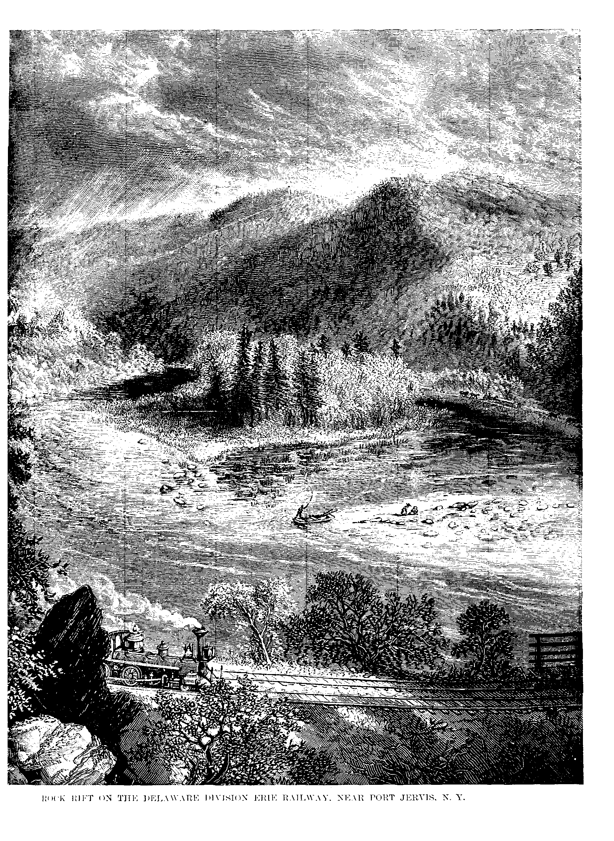

Edward Roblin. 65

they were afraid to enter, and thought proper to march off. The following was pinned to Clark’s coat:—
“‘A WARNING TO THE REBELS.—You are hereby warned at your peril to desist from hanging any more friends to government as you did Claudius Smith. You are likewise warned to use James Smith, James Fluelling, and William Cole well, and ease them of their irons, for we are determined to hang six for one, for the blood of the innocent cries aloud for vengeance. Your noted friend Captain Williams and his crew of robbers and murderers we have got in our power, and the blood of Claudius Smith shall be repaid. There are particular companies of us that belong to Col. Butler’s army, Indians as well as white men, and particularly numbers from New York, that are resolved to be avenged on you for your cruelty and murder. We are to remind you that you are the beginners and aggressors, for by your cruel oppressions and bloody actions you drive us to it. This is the first, and we are determined to pursue in on your heads and leaders to the last till the whole of you are murdered.’”
But this son of Claudius did not possess the qualities of leadership displayed by his father, and the clan was finally broken up by the people of Monroe, assisted by some troops from Washington’s army. Richard Smith took refuge in Canada; others fled to parts unknown, and thus ended the highwayman’s profession in Orange county. Many localities of the vicinity will long be remembered from their association with the deeds of blood and crime that made the clan famous. Their retreats in the mountains can be readily found to this day by the curious.
That the Tories buried much valuable booty in these mountains may be inferred from the circumstance that about the year 1805 some of Smith’s descendants came from Canada, and searched for the property according to directions that had been handed down to them. They found a lot of muskets, but nothing else. About the year 1824, descendants of Edward Roblin, another of the gang, came from Canada with written directions, and explored the country with no better results. Search was made in a certain spring where it was said valuable silver plate had been secreted, but nothing of value was found. Perhaps the other members of the band found the depository, and, unknown to Smith and Roblin, appropriated the property.

EDWARD ROBLIN.

MORE than a century ago there lived near the base the Shawangunk mountain, in Orange county, a well-to-do-farmer by the name of Price. One day a boy came to him seeking employment. Mr. Price eyed the lad circumspectly over the rim of his gold spectacles, asked him a few questions, and was so well pleased with his ready answers and intelligent ways that he consented to take him on trial. The boy proved to be an industrious and trust-
66 Legends of the Shawangunk.

worthy hand, and remained with Mr. Price until he had grown up into a tall, fine-looking young man. That lad was Edward Roblin.
Now it so happened that Mr. Price had a comely daughter named Zadie, a year or two younger than Edward. Inasmuch as the young people were thrown much into each other’s company, with few other associates of their own age, it was but natural that the childlike friendship of youth should ripen and develop into a more tender and enduring affection as they grew to maturity.
Mr. Price was not a very observing man, or he was too much absorbed in money-making; or else the young people maintained a very discreet behavior during their courtship; certain it is, that the first intimation the old man had of the state of affairs, was when young Edward one day approached him and formally asked the hand of his daughter in marriage.
This revelation fell upon the father like a thunderbolt. He flew into a towering passion; sent his daughter up stairs, and forbade their speaking to one another again. In vain the young man pleaded his cause; he had served him long and faithfully, almost as many years as Jacob had served of old. The father was immovable. “You can’t have my daughter, and that’s the end of it;” and he sent the young man from his presence.
In one important matter the father failed to exhibit the wise foresight for which he was noted—he did not discharge the young man; in fact he could not well manage the farm without him. It must not be thought strange, therefore, that the young people found means to communicate with each other, and to carry on a sort of clandestine courtship.
One morning Edward was not found at his chores. And he was always so punctual. Mr. Price went to his room and knocked. No response. He opened the door. The room was empty, nor did the bed bear evidence of having been slept in the night before.
“A pretty how-d’ye-do, I do declare,” and the old man flew quickly to the door of his daughter’s apartment. He did not stop to knock. The door yielded to his touch. Her room, too, was without an occupant, the bed carefully made, and the pillows in place. The truth now broke in upon the mind of the old man.
“It’s fully twenty miles to the Dominie’s, and, by my troth, I’ll be there, too!” ejaculated he.
He hastened to a local magistrate, where he swore out a warrant on a false accusation against young Roblin for debt. He next secured the attendance of a constable, and thus equipped the two went flying over the country behind Mr. Price’s fleetest horse. Arrived at the house of the Dominie they did not stop for ceremony; there was no time for that; but they burst unannounced into the room just as the young couple were standing up before the minister.
“Ha, my pretty birds, but I’ve caught you finely!” And while the father took charge of the young lady, the constable took charge of the young man; leaving the Dominie to muse at his leisure on the mutability of human affairs, and mourn over his loss of a marriage fee. Zadie, dis-
Edward Roblin. 67

consolate and inconsolable, was taken back to her home; while Edward, without friends and in the clutches of the law, was thrown into prison along with felons of the basest sort. In vain he protested he was under no pecuniary obligation to Mr. Price; that the money paid to him by that gentleman, on which the charge for his arrest was based, was for services well and faithfully rendered. The word of Mr. Price was sufficient to deprive Edward of his liberty, whether by just cause or otherwise was then nothing to the question; while his influence was such that he could get the trial postponed for an indefinite period. Meanwhile Edward’s incarceration was an insurmountable barrier to his love-making for the present; at the same time the old man chuckled at the success of his scheme to get Edward effectually out of the way, while he proceeded to mature his plan of marrying Zadie more to his wishes.
To while away the dull hours of his imprisonment Edward learned to play the fiddle. He soon became so skillful in the use of the instrument that he found in it a new language in which to express his disappointment, and merge his never-dying affection for his sweetheart into sounds of melancholy melody that were wafted far beyond the limits of his prison bars. His story of romantic incident had got abroad; and love-lorn damsels would come with slippered feet to listen to his tale of disappointment, as he drew it out in languishing harmonies. Not unfrequently whole bevies of Goshen maidens would gather under his window of a pleasant summer evening, and, casting anxious glances upward at the barred window, heave a sigh of pity in his behalf.
Months rolled by. Edward was still in prison. No trial had been accorded him, with no immediate prospect of any. All this while he had received no word, no token from Zadie. The vigilance of a father was never relaxed, and no love epistles could pass between them.
Driven to desperation by the entreaties and commands of her tyrant father, Zadie at last married a man she abhorred, much older than herself, but who had the reputation of being wealthy. As soon as this was consummated, the father with a malicious pleasure took means to have it speedily communicated to the ears of young Roblin. The strains of the fiddle were now more melancholy and grief-laden than ever; and one of the fair listeners under Edward’s window was moved to tears, so great a sorrow did the doleful vibrations convey.
The jail keeper had a pretty daughter. It was a part of her duty to take food to the prisoners. It may have been the result of accident, or sheer advertence on her part, but the fullest plate and the choicest slice was apt to be handed in at the “grief-hole” of Edward’s cell. The jailer himself often condescended to speak a kindly word to him. An interest now began to be awakened in the minds of outsiders for his release; even Mr. Price himself could now have no reason for desiring a continuance of his imprisonment. But young Edward did not wait for the slow process of law to relieve him from his confinement.
One morning as the jailer was making his accustomed rounds he was surprised to find the cell of Edward tenantless. An inspection of his dwelling re-
68 Legends of the Shawangunk.

vealed the fact that his daughter’s room was likewise unoccupied. Just then word came to him from the stable boy that the stall of his favorite chestnut gelding was empty. Putting this and that together, the poor jailer was lost in imagining all sorts of evils; in short he was so bewildered he knew not which way to turn; his grief at the loss of his chestnut gelding was the most bitter of all; and to satisfy himself he made a visit in person to the stable, and found it was but too true—his favorite was gone, the stall was empty, with the exception of a limb from a chestnut tree in the yard, which limb was tied to the manger in lieu of the horse. To this limb was attached a note addressed to himself in the following words:

MY DEAR FATHER-IN-LAW—As you will be when you read this,—pardon the liberty I take in exchanging horses with you. I acknowledge this is a horse of another color, still there is not much difference; as yours was a chestnut horse the exchange is but fair, for this is a horse chestnut. It is the best legacy I can leave you at present, coupled with the best wishes of
EDWARD ROBLIN.

All the village dames suddenly discovered that the jailer’s daughter was a shiftless minx. Nothing more was heard of her or of her husband until Edward turned up with the Tory gang of Claudius Smith. Edward was second in enterprise and daring to none but his chief.
The husband of Zadie Price turned out to be a poor, miserable fellow, whose reputed wealth was only pretension. Zadie soon returned to her father’s home, rapidly went into a decline, and in a few years died of a broken heart.

LIEUTENANT BURT.

PERHAPS the most severe chastisement ever meted out to the Tories and their Indian allies in the region of which we write, was on an occasion in which Lieutenant James Burt took an active part. Lieutenant Burt was a resident of the town of Warwick, Orange county; and was an active Whig, bold, aggressive, and vigilant in defending the neighborhood against the attacks of the Tory outlaws.
In the village of Warwick resided a silversmith by the name of Johnson. He lived in a stone house, and from the nature of his business, having at times considerable silver plate and money about him, he kept his apartments carefully secured and guarded. The promise of so much rich booty excited the cupidity of his Tory neighbors, and they resolved to attack and rob the house on the first favorable opportunity. Accordingly, one dark, rainy night, a party of eleven Tories surrounded his house, some of Johnson’s nearest neighbors being with the gang.

Johnson’s household consisted of two sisters and two negro boys, none of
Lieutenant Burt. 69

them being of any assistance in defending the place. He made a stubborn resistance; but the robbers broke open the house, and one of them dealing a heavy sword-cut on Johnson’s shoulder, which disabled him, the ruffians were free to ransack the house at their will.
One of the negro boys and a Mr. Coe had been out that night eeling. Coming home just as the Tories were at the height of their pillaging, the latter, supposing the settlers had mustered to attack them, became frightened and fled, taking with them all the valuables of the house.
Lieutenant Burt was immediately apprised of the occurrence; and though the night was dark, and the rain falling in torrents, he immediately started to warn out his company. His way led him through a piece of woods; and while passing through he thought he heard three guns snap. Burt drew up his musket to fire, proposing to shoot at random in the direction of the sound; but, as he feared the flash of his gun would expose his position, he refrained and passed on.
He warned out his company, and before morning they were in full pursuit of the Tory gang. Coming upon some Continental troops in the mountains, the latter were induced to join in the pursuit, the regular troops following one side of the range and the volunteers the other.
Lieutenant Burt’s company suddenly came upon the robbers while the latter were encamped and eating their breakfast. They at once opened fire upon the robbers, and killed five out of the eleven. The other six started to run, when another of the gang was wrought down by a shot in the leg, and secured. The other five made their escape and fled toward New Jersey, closely followed by their pursuers. A number of stolen articles were found at this place.
The whole population along the route of retreat was alarmed and every body joined in the pursuit of the fugitives. Three more were shot during the chase; the other two made their way to Hackensack, where each stole a horse and continued their flight. They were again pursued, the farmers tendering the troops the use of their horses for the purpose; at last one was shot and killed, and the other wounded and captured.
Lieutenant Burt had told the story of his hearing the snapping of guns in the woods, but his companions were inclined to discredit his story, and jeered him not a little at his groundless alarm. To convince them he was not mistaken, Burt led them to the spot where he heard the guns snap. It was found the robbers had been seated on a log within a few yards where the Lieutenant passed, as was shown by a number of stolen articles they had left there. The rain had wet the priming of their guns, to which circumstance he probably owned his providential escape.
70 Legends of the Shawangunk.

THE DUBOIS HOMESTEAD.

AN early settler and patentee of Orange county, and one who figured quite largely in events pertaining to the frontier history of what is now Montgomery township, was Henry Wileman, an Irishman by birth, and a man of many sterling qualities. He was the proprietor of a tract of 3000 acres granted him in 1709; the estate was located on the east bank of the Walkill, below the village of Walden. His name appears on the records as a member of St. Andrew’s church, as early as 1733. A church edifice constructed of logs, that had been built on his land for the use of the society, was standing in 1775.
Wileman was a free-liver, noble, and generous to a fault. He built his log palace on the site where afterward stood the DuBois homestead, of Revolutionary fame. It was a beautiful location; the soil was fine, and the patentee of 3000 acres entertained right royally. His convivial propensities frequently carried him to excess, and, if tradition is to be credited, the revelries in the Wileman log house were notorious through the country round.
In process of time Henry Wileman died, and it was meet that he should be buried as became a patentee of 3000 acres. It does not appear that he ever married; or that any relative had ever followed him to this distant clime. But the rich, when they die, never lack for mourners, or at least those who outwardly affect great sorrow for their death. So it came to pass that the friends of Wileman arranged to have the burial take place with all the pomp and splendor and outward tokens of regard for his memory that should characterize the funeral solemnities of a great man, according to the notions and customs of those early times.
It was then the prevailing usage to furnish liquor on all such occasions. No funeral was complete without it. They would sooner think of doing without the sermon than without the rum. As Wileman died possessed of his thousands of acres, it would be a lasting disgrace to limit the supply of liquor when celebrating his obsequies. The cellar was stored with the choicest wines; what could be more appropriate, or what could better voice the public sorrow, than that these wines should be drawn forth and made to do duty in assisting in the giving of suitable honors to the memory of their late owner!
In short, the people, young and old, were urged to drink. If any were backward, they were chided for their lack of respect for the memory of the departed, whose obsequies they were then observing; and the wine was handed round when they could not well help themselves.
At length the hour came in which the funeral cortege was to move from the late residence of the deceased to his place of sepulchre. This was before the day of black caparisoned steeds and heavily draped catafalques. The procession was more primitive in its make-up. All being ready, the bearers of the

