Festum Album



Table of Contents

Page III Preface by Pontifex Maximus Matt Hale

Page IV Introduction to Festum Album by Rev. John King

Page V Color Symbolism of the Candles

Page VI Placement of Candles in the Candelabra

Page VII Nightly Candle lighting Ceremony

Page VIII Celebration Days and their Texts

Page X Technical Standards

Page X Frequently asked Questions

Page XII Suggestions for nightly Discussions

Preface

I was recently approached by a new member of our Church who received his baptism of fire for Creativity at York, Pennsylvania and whose heart was set aflame that day with the burning fire of Creativity. He expressed great admiration for our existing Church holidays but sensed a void in our liturgical calendar. He felt that what we were lacking as a White racial religion was a festival devoted solely to the solemn celebration of our race, Nature’s finest--our accomplishments, our manifest destiny, and our creative virtues. His reasoning was compelling and over the following weeks, I pondered his suggestion.
I realized that from the simian villages of Africa to the Vatican and from the rain forests of the Amazon to Mecca, a common universal thread binding all of the so-called “great” religions of the world was a liturgical calendar filled with religious holidays and festivals throughout the year. Under our present-day Jewish Occupation Government (JOG) that is hell bent on the ethnic cleansing of European-Americans and European traditions at any cost, we suffer the indignity of having our mortal enemies’ racial holidays such as Purim, Rosh Hashanah, Yom Kippur, and Hanukah brazenly rubbed in our faces on a regular basis via the controlled mass media. Hardly a year can pass without us seeing pictures of the current Jewish stooge President lighting the Menorah to the smiles of his Jewish overlords! My racial brethren, is there no clearer sign than this to demonstrate that our present-day government is of the Jews, by the Jews, and for the Jews?
While our religion itself was created in its entirety by our Founder Ben Klassen, the development of any religious tradition--as opposed to perhaps the religion itself--is an ongoing evolutionary process. For example, many readers may be shocked to learn that Christians did not dream up the idea of celebrating Christmas until the third century A.D. Though our faith shall forever remain anchored in the teachings of Ben Klassen as espoused in our Holy Books Natures Eternal Religion and The White Man’s Bible, our Church traditions and celebrations should be expanded when necessary so as to prepare for the triumphant day when Creativity becomes the religion of our entire beloved White Race. As Nature’s Finest, we owe this to the future generations.
After reflecting on the proposal of Brother John King, I commissioned him to design such a festival for our Church. After spending considerable time evaluating the merits of his lengthy proposal, I have made my decision. Said proposal in hand, I am now pleased to establish the newest festival in our creative liturgical calendar: Festum Album.
I hereby decree that henceforth from December 26 through January 1, all Creators throughout the world shall solemnly celebrate our weeklong festival of White Racial pride and unity: Festum Album. May it someday be celebrated on every continent in an all White world. Onward to victory. This Planet Is All Ours. RAHOWA

Pontifex Maximus Matt Hale
April 20, 29AC

Introduction to Festum Album

The purpose of this holiday is in line with the principles and the traditions of the World Church of the Creator. Decades ago, our founder Ben Klassen gave the White Race its own racial religion for the first time in its history. Likewise, Festum Album will add to our creative traditions, providing the White Race its own pan-European ethnocentric festival. In our glorious future to come, we envision Festum Album being celebrated by White families throughout the entire world. It will someday become a world celebration in a White World. Though we as Creators strive to promote the interests of the White Race on a daily basis, it is only fitting that we set aside one week at the year's end to festively celebrate our Racial Pride and Unity with family and friends.
Other ethnic groups such as the Jews (Chanukah) and Niggers (Kwanzaa) have their own multi-day festivals, whose obvious (though often publicly unstated) purpose is that of promoting racial awareness and cohesiveness among their respective racial groups. By asserting that these festivals are "cultural" rather than "religious", the Jews and Niggers have been able to sneak their racialist agenda into the public (government) schools under the guise of "multiculturalism", thereby cleverly avoiding the issue of separation of church versus state. Festum Album is likewise a "cultural" festival and we have every right to have our cultural celebration included in the government school curriculum under its current "multicultural" policies.
Under the guise of "multiculturalism", White children are currently forced to celebrate holidays and traditions that are foreign and anathema to our European heritage (and at times are downright weird). As examples, I cite the Chinese New Year, Cinco de Mayo (the Mexican day of Independence), Chanukah, and Kwanzaa. The one holiday that is erroneously assumed by the uneducated masses and the anti-White "multicultural" educrats to be a “white" holiday, Christmas, is nearly totally banned from public school.
As Creators, we are well aware that Christmas is not a "white" celebration. It is not a celebration of ethnic unity in any sense of the word. With Christianity's horrible record of dividing our race into hostile competing sects (Catholics, Lutherans, Episcopalians, etc) and causing fratricide (the Thirty Years War of 1618-1648 as the best example), Christmas can in no way be considered a holiday of White Unity. Actually one might argue that due to the divisive record of Christianity, Christmas as such is a holiday of Racial Chaos and Disunity. As Creators, we realize that Christmas is a celebration of the "birth" of a mythical figure conjured up from the imagination of twisted Jewish minds. Christmas, in fact, is no more a White celebration than is the 4th of July or Thanksgiving. It should therefore be obvious to the educated person that Christmas is a holiday that is "multicultural" in the true sense of the word. While most of the White World celebrates Christmas (but pays little heed to Christian teachings), it is celebrated with equal fervor in many Mud-lands such as Mexico, Lebanon, the Philippines, Korea and South Africa. Christian missionaries are squarely to blame for turning a once solidly European holiday into a Multi-Culti Mudfest. This just one of countless examples of what occurs when traitorous Whites give or impart our culture and technology to the Mud Races.
Much promotion of our beloved World Church of the Creator can be accomplished through Festum Album. Not only should we demand the right to speak before public school children about the cultural importance of our holiday in the name of "multiculturalism" (rabbis have been giving presentations on Hanukkah in public school for years, despite the fact that most jewish children attend private jewish schools), but we should and must also bring it to the public limelight, if needed, in a confrontational manner. During the so-called "Holiday Season", religious groups are allowed under current law to place their symbols on public properties, i.e. Nativity mangers, Christmas trees, and menorahs. The law requires that local authorities allow equal treatment to all religious communities (and this includes us). We Creators are hard working, tax-paying citizens and we will most fervently demand our equal right to place our Festum Album Candelabra on public property along with that of the Jews and Judeo-Christians. We should purposely do this in every community and contact the press to let them know that the WCOTC has put its symbols on public property. The press we will receive from this event will be unprecedented and give us much media exposure and many recruits. There is also the potential of us filing lawsuits if local politicians deny our rights. If the politicians are this foolish, they deserve to be sued in a court of law for violating our religious rights. The World Church of the Creator, like any other religious group, is always in need of more funds, after all, and we would be more than happy to build our Movement through lawsuits against those who dare to violate our Constitutional rights.

I. Color Symbolism of the Candles

RED symbolizes our holy blood; the Purity candle in the center of the candelabra is red for this reason.
WHITE symbolizes the purity and holiness of our Creative virtues.

BLACK symbolizes the solemnity of the struggle to retain our culture and virtues.

II. Placement of Candles in the Candelabra

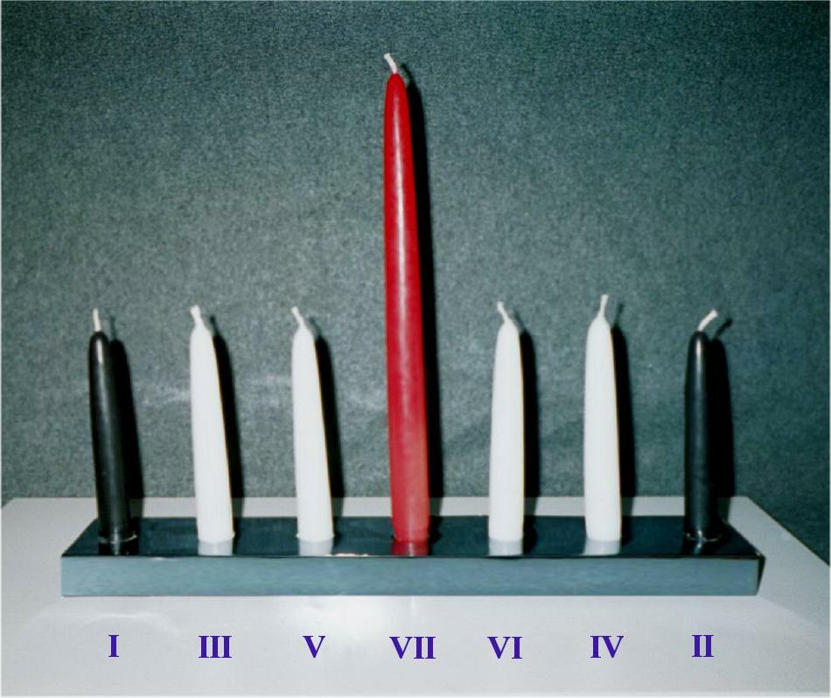 | 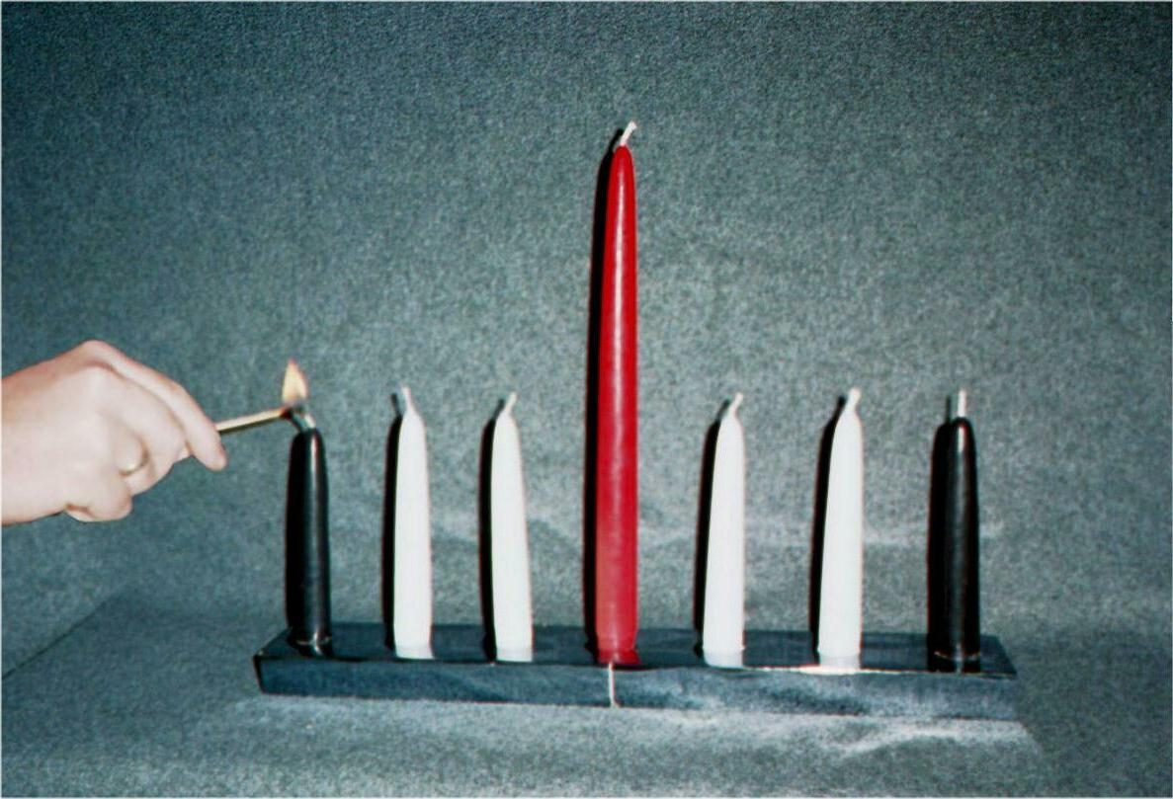
Correct placement of the candles prior to the beginning of Festum Album. | Night one: Lighting of the History candle

I | III | V | VII | VI | IV | II
(black) | (white) | (white) | (red) | (white) | (white) | (black)
History | Unity | Memorial | Purity | Law | Ingenuity | Destiny
Historia | Unitas | Memoria | Puritas | Lex | Sollertia | Fatum

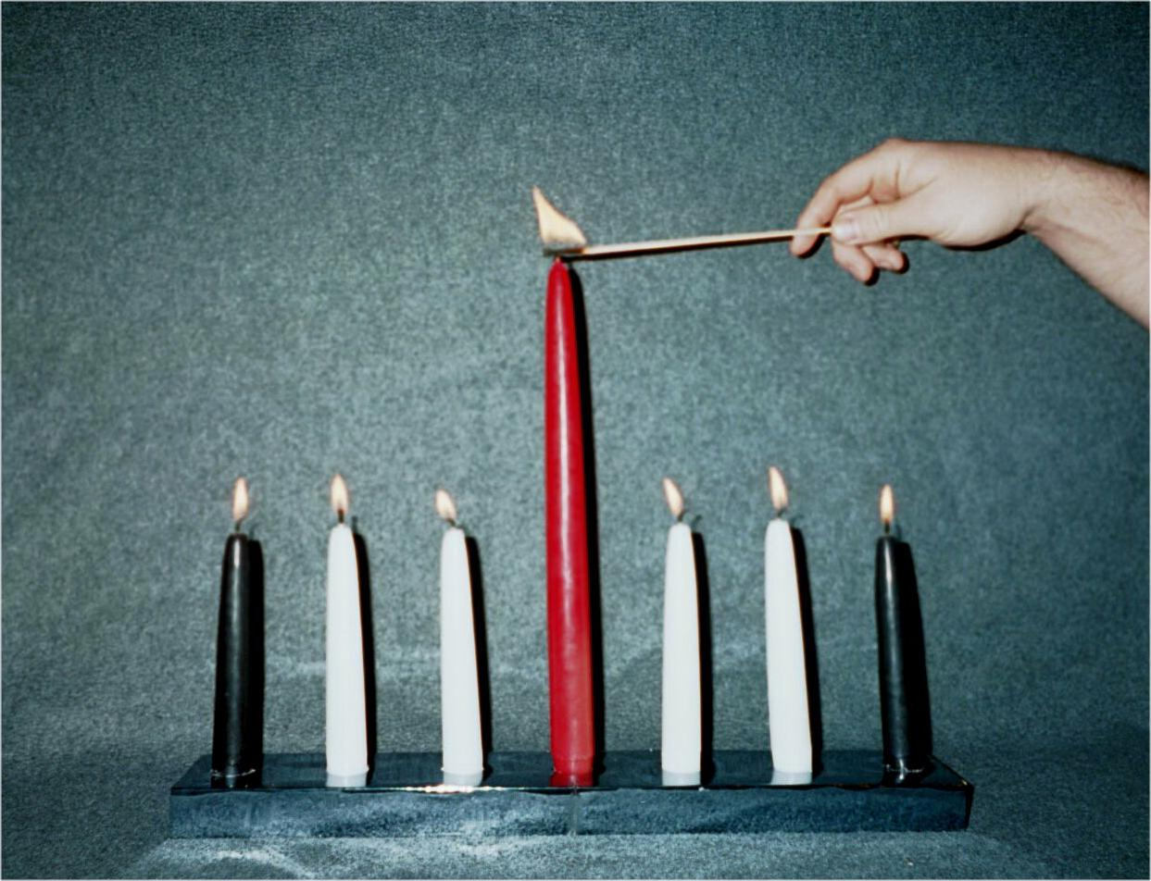 | 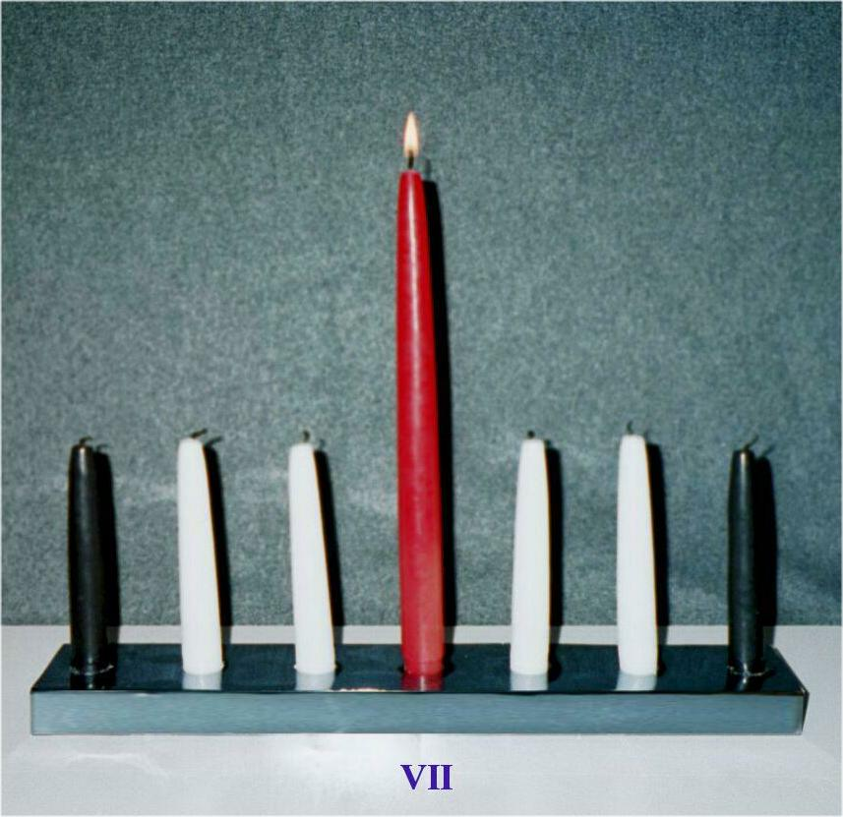
Night seven: Lighting of the red Purity Candle. | Night seven: Following the night’s Purity discussion, allow the Purity candle to burn one hour alone.

III. Nightly Candle Lighting Ceremony

- The candle lighting ceremony shall take place after sunset
- The head of the household shall lead the nightly ceremony. With all of the family gathered around the candelabra, he shall establish quiet and then say:
“Quid hoc die discendum est?”
“What is the lesson of the day?”

- Children and other family members shall then say:
“Hoc die discendum est _____________”
"The lesson of this day is ____________”

On the first day of the celebration, for example, the reply would be, “The lesson of this day is Historia.”

The Latin designation shall be used in this capacity.

d. The child is then allowed to light the candle of the day.

e. The head of the household shall than recite the text of the lesson of the day first in Latin and than in English. After this recitation, the head of the family shall talk about the importance of this lesson to other family members and children.

f. After a thorough discussion of the day's lesson, the candle shall be extinguished.

- It is suggested that parents give their children a small gift after the candle(s) is/are extinguished.

- On the first night of the celebration, the "History" candle shall be lit. On the second night, a child shall light the “History” candle first before the head of the household asks, "What is the lesson of the day?” On the 7th and last night of the celebration, all six of the black and white candles shall be lit first, in the correct order, before beginning the ceremony in honor of "Purity".

- At the close of the ceremony on the 7th day, the day of purity, the red "Purity" candle shall not be extinguished, whereas the others will. The red "Purity" candle shall be allowed to burn by itself for one hour before being extinguished

IV. Celebration Days and their Texts

Day 1. Historia = History

Hoc die Historiae, praestantissimas nostrae gentis res gestas recensemus. Memores sumus gentem nostram ductores fuisse omnis huius mundi cultus. Seu ad magnificentiam Aegypti antiquae spectaveris, seu ad altissima Imperii Romani fastigia, seu ad illum nostrum artium florentissimarum vigorem, qui Renascentia vocatur, seu ad colonias quas in longinquas terras deduximus, rebus gentis nostrae gestis magnopere superbiemus

In this day of History, we reflect upon the unparalleled historical and cultural record that our people achieved. We remember that our people were the guiding force behind every civilization in the world. From the grandeur of Ancient Egypt to heights of the Roman Empire, from our cultural blossoming in the Renaissance to our colonization of distant lands, we shall take great pride in the historical achievements of our people.

Day 2. Fatum = Destiny

Hoc die Fati, de illustrissima posteritate cogitamus, quae gentem nostram praestolatur, et peramanter ad Fatum nostrum apertum spectamus. Nos, utpote opus naturae optimum, hoc perfectum propositum complectimur, nam genti quae sine proposito est pereundum est. Fatum nostrum nobis incudendum est.

In this day of Destiny, we ponder the glorious future awaiting our people and look fondly upon our manifest destiny. As Nature's Finest Creation, we commit ourselves to this vision, for a people without vision shall perish. Our fate is what we make it.

Day 3. Unitas = Unity

Hoc die Unitatis, nos obligamus ut unum simus, quippe qui intellegamus nos, tametsi lingua vel moribus discrepemus, omnes ex eadem stripe oriundos esse. Cum ad illum quasi thesaurum communem respicimus qui ex Europa originem capit, in eo nitimur ut id superemus quod nos dividit. In unum coniuncti Fato nostro prorsus moderabimur. Coniuncti insuperabiles erimus. Coniuncti nostrum apertum Fatum consequemur quod natura nobis decrevit.

In this day of Unity, we commit ourselves to become one, realizing that regardless of our differences of language or customs, we are all part of the same racial family. We strive to overcome our differences as we look back upon our common European legacy. United as one, we will be fully in control of our destiny. United we will be invincible. United we will achieve our Manifest Destiny that Nature has so ordained unto us.

Day 4. Sollertia= Ingenuity

Hoc die Sollertiae, reveremur Creativitatem, donum quod natura sua infinita usa sapientia maximum nobis contulit. Omnes nostros magnos artifices, opifices, aedificatores, exploratores, philosophos et contemplatores colimus. Illi, sua innata freti cupidine ad nova et inaudita in omnibus ascendendi, hominum vitam ad statum omnium excultissimum propulerunt.

In this day of Ingenuity, we pay homage to creativity, the greatest gift which Nature in her infinite wisdom bestowed upon us. We honor all of our great artists, scientists, builders, explorers, philosophers, and thinkers. Because of their inborn desire to achieve new heights in every endeavor, they were able to create the highest forms of civilization ever seen upon the face of the earth.

Day 5. Memoria = Memorial

Hoc die Memoriali illos celebramus et meminimus, milites, viros et homines in republica versatos, qui, sui prodigi, totos se dederunt ut gentem nostram et patriam nostram defenderent et adiuvarent. Illorum iacturam venerantes nitimur ut eorum exemplum praeclarissimum imitemur. Illos quoque colimus, homines sine numero, qui a gentis nostrae hostibus interfecti ceciderunt. Quorum mortis atrocissimae numquam obliviscendum est, nec ultio umquam praetermittenda

In this day of Memorial, we commemorate and remember the memory of those selfless individuals, soldiers, heroes and statesmen who devoted their lives to the defense and advancement of our people and territory. We honor their sacrifice and strive to follow their heroic example. We also pay homage to those countless individuals who fell victim to the enemies of our people. Their tragic deaths shall never be forgotten and shall not go unavenged.

Day 6. Lex = Law

Hoc die Legis, aeternas naturae leges admiramur. Quas leges confitemur immutabiles esse, eumque qui eis non pareat periculum subire ne stultissimus per se pereat. Pollicemur nos iuxta principia et mandata fidei nostrae sanctae victuros esse, id est, Creativitatis, nam gentis nostrae salus et posteritas non aliter parietur

In this day of Law, we admire the Eternal Laws of Nature. We recognize that these laws are immutable and that to disobey them is to engage in the folly of self-destruction. We pledge to live our lives according to the principles and commandments of our Holy Faith, Creativity, for only by following them is our racial salvation and destiny assure

Day 7. Puritas = Purity

Hoc die Puritatis, nos promittimus sanctitatem sanguinis nostri sanctissimi servaturos esse, fontis unde oritur omnis nostra nova reperiendi vis. Docti historia omne magnum et excultum imperium perspicimus per peccatum stirpis diluendae et miscendae pessum iisse. Si sanguinis nostri integritatem servaverimus, omnia quae nobis tradiderunt maiores nostri venerabimur, et nostrae progeniei posteritatem servabimus. Intellegimus nobis, dum vivimus, mandari annulum aureum huius aeternae vitae catenae. Dum sanguinem nostrum custodimus, Divinum illud hominis custodimus

In this day of Purity, we commit ourselves to maintaining the sanctity of our sacred bloodlines, the source of our creative force. Through the lessons of history, we recognize that the sin of miscegenation brought about the fall of every great civilization. By protecting the purity of our blood, we honor the legacy of our ancestors and ensure the future of our descendants. We understand that during our lifetime, we are entrusted with the golden link in this eternal chain of life. By protecting our blood, we protect the Divine of man.

V. Technical Standards

1. The center red Purity candle shall be approximately twice as tall as the other candles.
2. Candles shall have a diameter between 1.5 cm (5/8”) and 2.5 cm (1”).
3. Festum Album shall begin on December 26 and conclude on January 1.

VI. Frequently asked Questions

1. Should we Creators celebrate Christmas? The decision to celebrate or not celebrate Christmas shall remain a private decision among Creators with the understanding that very few of the trappings of Christmas actually have anything at all to do with the mythical “Christ”. For example, neither an evergreen tree, reindeer, nor Santa Claus have anything at all to do with Palestine. In actuality, Christmas is a pagan holiday that simply has the word “Christ” in its name and in many countries, even this isn’t the case. So, it is up to the individual member whether or not to retain any of the pagan displays or celebrations of December 25th.
Further, we suggest that if you celebrate December 25^{th,} refer to it and celebrate it as “Yule” instead of “Christmas”. Yule, a variation of the Scandinavian word for ‘Jul’ (meaning ‘wheel’) was the Nordic name of the festival occurring around the time of the Winter Solstice, that time of the year where the sun reaches its lowest point in the sky. Many ancient cultures worshiped the sun due to its life sustaining attributes. Four thousand years ago the ancient Egyptians celebrated a twelve-day festival centered around the Winter Solstice in honor of the rebirth of their sun god Horus. The days becoming longer after the solstice was believed to be a sign of his rebirth. From there the sun worshiping celebration spread to Mesopotamia. The Babylonians named their celebration Zagmuk in honor of their sun god Marduk. The Romans incorporated the traditions of these earlier cultures into their solstice-celebration, Saturnalia. The days surrounding the winter solstice were seen as a battle between Jupiter, the king of the Gods and his rival, Saturn. As the sun rose in the sky following the solstice, people rejoiced in the victory of Jupiter over Saturn. Saturnalia shared many of the features of Christmas, i.e. people lit candles, sang, feasted, attended masquerade balls, and gave gifts. It was the most festive time of the Roman calendar. By the 4th century AD, the Catholic Church had gained in power and clout. Unable to overtly squash this pagan festival, the Catholic Church devised “Christianizing” Saturnalia, replacing the sun god Jupiter with the Son of God. Thus Christmas was born.
As a guideline to the celebration of Yule, we present here a number of winter traditions. Assumed (falsely) by many to be Christian, they are, in fact, purely of Pagan (native European) origin:

- Evergreen trees-because their leaves are never shed, these trees were though to possess power over the death and destruction of winter.
- Ornaments-the Germanic peoples covered their holiday evergreen trees with fruits, flowers and cookies. These symbols represented the abundance to come in with the rebirth of the sun in spring and summer.
- Gift exchange-started during the Babylonian festival of Zagmuk. Copied in the Roman Saturnalia and retained in Christmas.
- Holly-its wintertime red berries were seen as a sign of rebirth.
- Mistletoe-first used in the Greek winter festival, made popular by the Celtic Druids, a symbol of fertility among Germanic peoples.
- Santa Claus-associated with the Aryan God, Odin, Lord of the Winds. Odin was a nocturnal god, who was capable of flying through the stormiest clouds. He held the whole of magic in the palm of his hands.
- Reindeer-symbolize the abundance of the horned Celtic god Cernunnos
- Wreath-the circle was seen by Pagans as symbol of everlasting life. Its shape was also associated with the sun.

2. What should we do if city/county officials prohibit us from displaying the candelabra of Festum Album on public property (assuming they are already permitting the display of Christian, Jewish, Muslim, etc. holiday symbols)? Contact the local chapter of the ACLU immediately and bring the matter to their attention. Contact Church Headquarters and your State Leader. Carry out a peaceful and legal protest in front of city hall to draw media attention to this unconstitutional religious discrimination.

3. If we have children in public (government) schools, do we have the right to remove them from celebrations of alien holidays (Kwanzaa, Chanukah, etc) since they violate our religious teachings and beliefs? The answer is an emphatic ‘yes’. Contact your child’s principal and tell him/her that you wish to have your child “opt out” of these alien celebrations. Tell him/her that these alien celebrations are against your religious beliefs. This is your legal right as a parent. It might be helpful to visit your child’s school in December to see if they’re having children color Kwanzaa and Chanukah pictures. Unless you take a pro-active approach in your child’s education and visit his/her school to see what’s going on in the classroom, the anti-White Educrats will impregnate your child’s mind with this alien filth.

4. Is there precedent for creating a White Racial festival? From a racial standpoint, the answer is ‘yes’. Many of the mud races already have their own racial pride festivals. Chanukah and Kwanzaa are at the top of this filthy list. In America, Liberals often speak of the concept of ‘Fairness’. Out of ‘fairness’, we establish Festum Album for our race, since it hitherto lacked its own racial festival. From a religious viewpoint, the answer is ‘yes’. No religious movement was ever conceived in its entirety overnight. All religions, including Creativity, are in a state of constant evolution. The celebration of Festum Album adds to the existing liturgy of our Holy Faith.

5. What if someone was to assert that Festum Album is not divinely inspired but in fact man-made? Since there is no evidence of a deity/deities, we assert that all ‘religious’ holidays (be it Christmas, Easter, Chanukah, etc) are man-made. They were designed by certain individuals at some point during the evolution and development of said religious movements. Unlike other ‘theistic’ religions, we the members of the World Church of the Creator make no attempt at deceiving the public by claiming our holiday was ordained by spooks in the sky. We created Festum Album because the White Race needs, deserves and is entitled to a week of self-reflection and celebration.

VII. Suggestions for Discussion during the various Festival nights

The following guidelines are just suggestions for your nightly Creativity discussion. Think of them as a framework.

HISTORY

- The White civilization of Ancient Egypt
- The Aryan invasion of the Indian subcontinent
- The ancient Greek city-states
- The grandeur and culture of the Roman Empire
- The Celtic civilization
- The Germanic migrations and the fall of Rome
- Greek, Roman, Nordic, Slavic and Celtic mythology
- The Crusades
- The Magna Carta
- The Renaissance
- The Enlightenment
- The Colonization of the New World and founding of the US
- The Napoleonic era
- The Russian, Austro-Hungarian and German Empires
- The Industrial Revolution
- The Third Reich
- The Information Age

DESTINY

- The reversal of the present-day trend toward White racial extinction.
- The reclaiming of our White homelands and cities from the Mud Races.
- The self-determination of the White Race.
- The defense of our racial stock against psychological and physical warfare.
- The neutralization of all tangible threats to the White Race.
- The achievement of worldwide White racial consciousness.
- The subordination of national loyalties to White racial loyalty.
- The improvement our racial stock through Eugenics.

UNITY

The horrific human carnage that has occurred time and time again, when the White Race was splintered into hostile, competing camps and nation states. The inevitable result of White disunity has been numerous fratricidal wars i.e. WWI, WWII and the American Civil War, where the best of White young men have killed each other over the most senseless of reasons.
A recognition that we as members of the White Race are brothers and sisters no matter which language we speak or where we reside. Our only loyalty is to our Race, regardless of our native tongue or our place of residence.
An appreciation of the cooperation and stability between various White ethnic (linguistic) groups shown today in Switzerland (4 official languages) and in the pre-1918 Austro-Hungarian Empire (more than a dozen nationalities). May these lands provide us inspiration for a future of White cooperation.
The Waffen SS: hundreds of thousands of men from numerous countries, esp. Finland, Belgium, France, Poland and Holland, put the best interests of the White Race ahead of all other interests to fight against jewish Soviet Communism in WWII.
An appreciation of how Christianity has been an agent of Disunity within the white world. Throughout the last thousand years, numerous wars have been fought between various White Christian groups. The worst example of this was the Thirty Years War (1618-1648) in which Protestant nations fought against Catholic nations. As this war was fought in Germany, one quarter of the German civilian population was killed as collateral damage.
The avowed aim of the World Church of the Creator to bring about White unity worldwide through our powerful religious creed.
The Manifest Destiny and invincibility that awaits our Race, once a single world wide White consciousness comes into being as result of the spread of the Good News of Creativity.

INGENUITY

Famous White Inventors … Bell, telephone; Edison, light bulb & phonograph, Janssen, microscope; Fulton, steam engine; Marconi, radio; Baird, color television; Benz, internal combustion engine; Orville & Wilbur Wright, air plane; Whittle, jet engine; Shockley, transistor; Galileo, telescope & thermometer; Zeppelin, air ship; Goddard, rocket engine; Tesla, AC motor; Volta, battery; Morse, telegraph

Famous White Scientists ... Galileo, founded modern science of motion; Copernicus, heliocentric model of the solar system; Newton, laws of gravitation and calculus; Harvey, discovered circulation of blood; Heisenberg, uncertainty principle; Mendeleyev, periodic table; Pasteur, germ theory; Kepler, planetary laws of motion; Bohr, founded quantum mechanics; Dalton, formulated atomic theory; Watson & Crick, discovered DNA; Mendel, father of Genetics; Darwin, evolution & natural selection; Planck, quantum theory; Gay-Lussac, laws of gases; Rutherford, identified the atomic nucleus; Binet, IQ testing; Wilmut, cloned mammals; Roentgen, discovered the X-ray; Fermi, nuclear fission; Barnard, 1st heart transplant.

Famous White Composers: Bach, Beethoven, Berlioz, Brahms, Chopin, Dvorak, Handel, Haydn, Holst, Liszt, Mozart, Pachelbel, Rossini, Schubert, Tchaikovsky, Verdi, Vivaldi.

Famous White Artists: Michelangelo, DaVinci, Donatello, Cézanne, Degas, Leighton, Monet, Delacroix, Renoir, Rodin, Rembrandt, Rubens, van Gogh, Bruegel, Mondrian, Dürer, van Sluyterman, N. Rockwell, Velazquez, Cassatt.

Famous White Explorers: Leif Ericson, reached Newfoundland; Columbus, discovered West Indies; LaSalle, Mississippi river; Cortez, conquered Mexico; Magellan, explored Tierra del Fuego; Lewis & Clark, explored Rocky Mountains; Cousteau, oceanographer; Armstrong, first man on moon; Amundsen, reached south pole; Hillary, climbed Mt. Everest.

Famous White Writers: Plato, Aristotle, Socrates, Cicero, Hugo, Balzac, Comte, Descartes, Diderot, Dumas, Pascal, Rabelais, Erasmus, Cervantes, Goethe, Grimm, Herder, Nietzsche, Schiller, A. Rosenberg, Boccaccio, Machiavelli, Bronte, Chaucer, Dickens, Kipling, Locke, Pound, Ibsen, Milton, Orwell, Klassen, Twain, W. Pierce, Shakespeare, Poe, Huxley, Thoreau, Defoe, Joyce, Dostoyevsky.

MEMORIAL

Heroes

- The winning of the American west under President James Polk.
- The life of Queen Isabella of Spain.
- The lives of Adolf Hitler, Rudolf Hess and Leon Degrelle.
- Charles Martel and the Battle of Tours.
- El Cid and the expulsion of the Arab Moors from Spain.
- Early American Patriots: Washington, Jefferson, Franklin, Henry, etc.

Victims

- Czar Nicholas II of Russia and his family murdered by Jewish Bolsheviks
- The 20 Million White Russians killed by the Jewish Bolshevik regime in Russia
- The destruction of Dresden by firebombing during WWII
- The post WWII expulsion of 15 million German civilians from the German eastern provinces. 3 million were murdered or died of cold exposure.
- The tens of thousands of White People who have been killed through Negro Hate crimes in America, Europe and Australia.
- The Katyn Forest massacre of Poles at the hands of Jewish Bolsheviks.
- White Loyalist political prisoners in various European "democracies" for daring to speak the truth up for our cause and the truth about the “Holocaust.”
- The Fratricidal Carnage of the American Civil War, WWI, and WWII.
- The extermination of the French in Santo Domingo (Haiti).
- Racial violence against the White minority in Zimbabwe (Rhodesia).

LAW

- The 5 Principles of Creativity.
- The 16 Commandments of Creativity.
- The importance of marriage as the basic building block of White civilization.
- The Eternal laws of Nature, evolution, and survival of the fittest.
- The right to personal property.
- The right to free expression and free research.
- The use of the present-day legal system to redress violations of our Rights.

PURITY

- The Eugenics movement of the early 20th century.
- The racial research of Dr. W. Shockley and Dr. Carleton Coon.
- The prevention of miscegenation.
- The refuting and condemnation of Jewish race mixing propaganda.
- The White Race’s position as Nature’s Elite.

