1948 War of Independence
On 14 May 1948 the State of Israel was proclaimed according to the UN partition plan (1947). Less than 24 hours later, the regular armies of Egypt, Jordan, Syria, Lebanon and Iraq invaded the country, forcing Israel to defend the sovereignty it had regained in its ancestral homeland. In what became known as Israel's War of Independence, the newly formed, poorly equipped Israel Defense Forces (IDF) repulsed the invaders in fierce intermittent fighting, which lasted some 15 months and claimed over 6,000 Israeli lives (nearly one percent of the country's Jewish population at the time).

  During the first few months of 1949, direct negotiations were conducted under UN auspices between Israel and each of the invading countries (except Iraq which has refused to negotiate with Israel to date), resulting in armistice agreements which reflected the situation at the end of the fighting. Accordingly, the coastal plain, Galilee and the entire Negev were within Israel's sovereignty, Judea and Samaria (the West Bank) came under Jordanian rule, the Gaza Strip came under Egyptian administration, and the city of Jerusalem was divided, with Jordan controlling the eastern part, including the Old City, and Israel the western sector.
  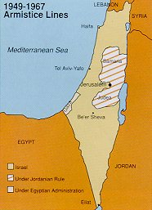

  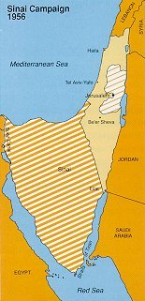
  1956 Sinai Campaign
  The 1949 armistice agreements had not only failed to pave the way to permanent peace, but were also constantly violated. In contradiction to the UN Security Council resolution of 1 September 1951, Israeli and Israel-bound shipping was prevented from passing through the Suez Canal; the blockade of the Straits of Tiran was tightened; incursions into Israel of terrorist squads from neighboring Arab countries for murder and sabotage occurred with increasing frequency; and the Sinai peninsula was gradually converted into a huge Egyptian military base.
  Upon the signing of a tripartate military alliance by Egypt, Syria and Jordan (October 1956), the imminent threat to Israel's existence was intensified. In the course of an eight-day campaign, the IDF captured the Gaza Strip and the entire Sinai peninsula, halting 10 miles (16 km.) east of the Suez Canal.

A United Nations decision to station a UN Emergency Force (UNEF) along the Egypt-Israel border and Egyptian assurances of free navigation in the Gulf of Eilat led Israel to agree to withdraw in stages (November 1956 - March 1957) from the areas taken a few weeks earlier. Consequently, the Straits of Tiran were opened, enabling the development of trade with Asian and East African countries as well as oil imports from the Persian Gulf.

  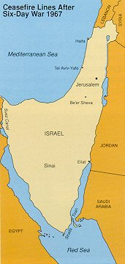
  1967 Six-Day War
  Hopes for another decade of relative tranquillity were dashed with the escalation of Arab terrorist raids across the Egyptian and Jordanian borders, persistent Syrian artillery bombardment of agricultural settlements in northern Galilee and massive military build-ups by the neighboring Arab states. When Egypt again moved large numbers of troops into the Sinai desert (May 1967), ordered the UN peacekeeping forces (deployed since 1957) out of the area, reimposed the blockade of the Straits of Tiran and entered into a military alliance with Jordan, Israel found itself faced by hostile Arab armies on all fronts. As Egypt had violated the arrangements agreed upon following the 1956 Sinai Campaign, Israel invoked its inherent right of self-defense, launching a preemptive strike (5 June 1967) against Egypt in the south, followed by a counterattack against Jordan in the east and the routing of Syrian forces entrenched on the Golan Heights in the north.

At the end of six days of fighting, previous cease-fire lines were replaced by new ones, with Judea, Samaria, Gaza, the Sinai peninsula and the Golan Heights under Israel's control. As a result, the northern villages were freed from 19 years of recurrent Syrian shelling; the passage of Israeli and Israel-bound shipping through the Straits of Tiran was ensured; and Jerusalem, which had been divided under Israeli and Jordanian rule since 1949, was reunified under Israel's authority.

  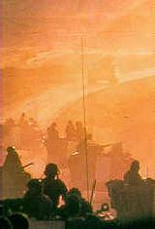
  From War to War
  The war over, Israel's diplomatic challenge was to translate its military gains into a permanent peace based on UN Security Council Resolution 242, which called for "acknowledgment of the sovereignty, territorial integrity and political independence of every state in the area and their right to live in peace within secure and recognized boundaries free from threats or acts of force." However, the Arab position, as formulated at the Khartoum Summit Conference (August 1967) called for "no peace with Israel, no negotiations with Israel and no recognition of Israel." In September 1968, Egypt initiated a 'war of attrition,' with sporadic, static actions along the banks of the Suez Canal, which escalated into full-scale, localized fighting, causing heavy casualties on both sides. Hostilities ended in 1970 when Egypt and Israel accepted a renewed cease-fire along the Suez Canal.

  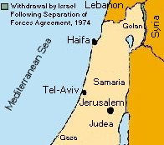
  1973 Yom Kippur War
  Three years of relative calm along the borders were shattered on Yom Kippur (Day of Atonement), the holiest day of the Jewish year, when Egypt and Syria launched a coordinated surprise assault against Israel (6 October 1973), with the Egyptian army crossing the Suez Canal and Syrian troops penetrating the Golan Heights.

During the next three weeks, the Israel Defense Forces turned the tide of battle and repulsed the attackers, crossing the Suez Canal into Egypt and advancing to within 20 miles (32 km.) of the Syrian capital, Damascus. Two years of difficult negotiations between Israel and Egypt and between Israel and Syria resulted in disengagement agreements, according to which Israel withdrew from parts of the territories captured during the war.

  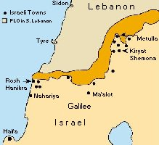
  1982 Operation Peace for Galilee
  The international boundary line with Lebanon has never been challenged by either side. However, when the Palestine Liberation Organization (PLO) redeployed itself in southern Lebanon after being expelled from Jordan (1970) and perpetrated repeated terrorist actions against the towns and villages of northern Israel (Galilee), which caused many casualties and much damage, the Israel Defense Forces crossed the border into Lebanon (1982).

"Operation Peace for Galilee" resulted in removing the bulk of the PLO's organizational and military infrastructure from the area. Since then, Israel has maintained a small security zone in southern Lebanon adjacent to its northern border to safeguard its population in Galilee against continued attacks by hostile elements.

