D15: Report on the interpretation of palaeodata using climate simulations

J. Guiot, A. Nicault, S. Brewer, and S. Alleaume, UDESAM

Test of the Mediterranean drought fluctuation recontruction (summer PDSI) based on tree-ring data (Nicault et al., in prep)

The climatic reconstruction was done over a 2.5° grid covering the whole Mediterranean region (32.5°/47.5°N 10°W/50°E). The period extends from 1350 to 2000, with a calibration period from 1901 to 2000. The PDSI was reconstructed using a combination of an analogue technique, which is able to deal with missing data, coupled to an artificial neural network technique for an optimal non-linear calibration (Guiot et al., 2005). A bootstrap technique for calculating error bars of the reconstruction. The proxy data are 136 sites over the Mediterranean basin from the DENDRODB Relational European tree-ring database (http://servpal.cerege.fr/webdbdendro/). Only series longer than 300 years (i.e. starting before 1700) were retained. Tree-ring measurements used in this study were the total ring width (RW), the final (or late) width (LW) and the maximal density (MD) as they are more related to the summer drought conditions. This gives 165 tree-rings series. Figure 1 shows the mean series for the whole Mediterranean region.
The first test follows Zorita et al (2003). The objective is to test the weakness of the reconstructions when the number of proxies is low in particular in the early times (before 1700 AD). We used the simulation “ECHO-G-all forcings” (Erik the Red). The outputs of ECHO-G-all are transformed into summer PDSI to be comparable with the reconstructions. We attributed to each tree-ring series the closest simulated PDSI (pseudo-proxy). The predictors are then model gridpoints assigned to tree-ring sites and predictands are model gridpoints interpolated at the 2.5x2.5° grid. We have established a reconstruction using all the 165 predictors (available from 1700 AD), another one with the 68 predictors available from 1600 AD, another one with the 25 predictors available from 1500 AD and the last one with the 7 series available from 1350 AD. Figure 2 shows the calibration correlation which is above 0.9 at locations where pseudoproxies are available but falls below 0.5 when now ones are. The error bars strongly increase when the number of proxies decreases (Figure 3), but for the mean PDSI, calculated on the whole regions, the calibration correlation varies only from 0.92 (165 proxies) to 0.78 (7 proxies). This figure shows also that it seems to have enough proxies until to 1600 AD but before, a large part of the region has not enough information. Figure 3 shows that the four reconstructions are quite similar in mean on the whole period. The main effect of the rarefaction of the predictors is then on the error bars and on regions with low information, but is relatively limited on the mean reconstruction.
The previous test considers that the signal of the proxies is perfect. In the second test (Von Storch et al, 2004), we consider the situation when the signal is degraded. For each set of pseudo proxies, a noise of variance equal to pseudo-proxy variance multiplied by a coefficient of 0.5, 1, 2 and 3 is added to them. These reconstructions are compared to the perfect ECHOG PDSI (Fig. 4). As expected, the correlations between the reconstructions and perfect curve decrease with the noise variance (from r=0.86 to r=0.73), but they remain highly significant. Moreover, the variance of noisy reconstructions is always lower then the perfect curve variance: Fig.4 shows that the noisy curves are flater than the ECHO-G series. The same figure shows, however, that the intermediate frequencies are relatively well preserved (the same type of fluctuations is recognised for all the curves). High correlations proves that the high frequencies are also well reconstructed. The question now is to understand if the low frequency component of our series have an underestimated variance or not. The comparison of Fig.1, based on tree-rings, and Fig. 4, based on pseudo-proxies, shows that, at the exception of the last 50 years very sensitive to the CO2 increase, the ranges of variation are comparable: from -1 to 1.2 with ECHO-G-all (Fig.4) and from -1.2 to 1.2 with tree-ring data (Fig.1). This tends to proves a good long-term behaviour at least from the statistical point of view.
The important conclusion of these tests is that white noise, which is by definition a high frequency component has a major effect on the low frequencies of the signal and then climatic reconstructions from much noisy proxies may lead to underestimate the long-term variations of the climate. The pseudo-proxy approach is a good way to understand the effect of the imperfections and biases of our proxy series on the final reconstructions. If we except the recent changes where model is likely too sensitive to CO2 forcing, we can tell that our reconstruction has an acceptable behaviour in the low frequency domain.

Article in preparation:
Nicault, A., Alleaume, S., Brewer, S. and Guiot, J., in prep. Mediterranean drought fluctuation during the last 650 years based on tree-ring data.

Other references:
J. Guiot, A. Nicault, C. Rathgeber, J.L. Edouard, F. Guibal, G. Pichard and C. Till. Last-millennium summer-temperature variations in western Europe based on proxy data. The Holocene 15,4 (2005) pp. 1-12.
Zorita E, Gonzalez-Rouco F and Legutke S (2003) Testing the Mann et al. (1998) approach to paleoclimate reconstructions in the context of a 1000-year control simulation with the ECHO-G coupled climate model. J. Climate 16, 1368-1390.

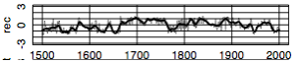
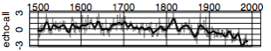

Figure 1. Mean reconstruction of the summer PDSI and its simulation by ECHO-G-all forcings

Figure 2. Reconstruction of the summer PDSI using pseudoproxies: correlation between simulated PDSI by ECHO-G-all at 2.5x2.5° gridpoints and their estimates using pseudo-proxies. White points indicate the position of the pseudo-proxies. The four graphics correspond to the four calibrations implying each a different number of predictors (see text).

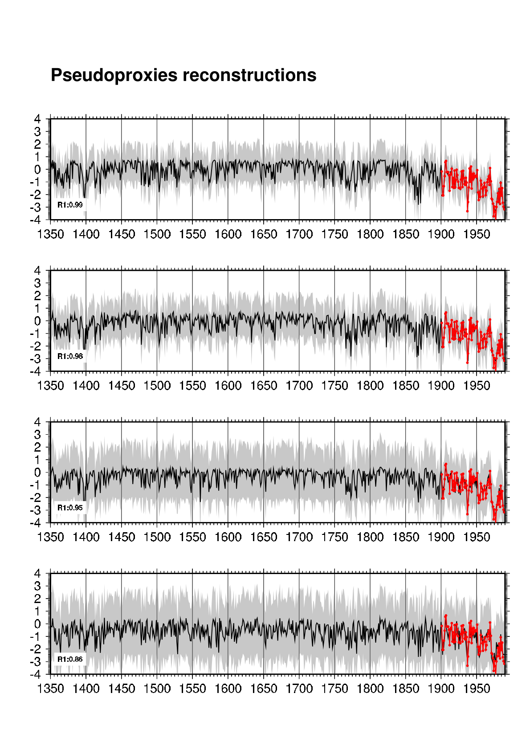
Figure 3. Reconstruction of the mean summer PDSI (all Mediterranean region) based on a different number of pseudo-proxies: from 136 (above) to 7 (below) (see text)

Figure 4. Reconstruction of mean summer PDSI using noisy pseudo-proxies with a proportion of 0.5, 1, 2 and 3 of white noise variance as compared with the mean ECHO-G simulation.

