Testing the reconstruction of Luterbacher et al. (2004) in the surrogate climate of ECHO-G and HadCM3

M. Küttel¹, J. Luterbacher¹, E. Xoplaki¹, H. Wanner¹ and E. Zorita².

¹ Institute of Geography, University of Bern
² GKSS Research Centre, Geesthacht

Pseudoproxies have become a common tool in climate science to test reconstructions of past climate in the surrogate climate of climate models. E.g. von Storch et al. (2004) tested the reconstruction of Mann et al. (1998) with the AOGCMs ECHO-G and HadCM3. Their study found a significant underestimation of the low frequency temperature variability in the reconstruction and proposed that this feature may be inherent to reconstruction methods.

In order to evaluate this suggestion and additionally test a reconstruction on the regional scale, the same approach was applied to the reconstruction of European continental temperature over the last 500 years by Luterbacher et al. (2004). As surrogate climate ECHO-G and HadCM3 were used. Besides testing the skill of the reconstruction method, a multivariate principal component regression, itself, the dependency on the quality of the predictors as well as the dependency on the availability over time and space was tested by using different sets of predictors. The set representing the predictors used by Luterbacher et al. (2004) best is based on pseudoproxies with approximately the same signal-to-noise ratio as the real world proxies and with the same availability over time and space.

Results indicate some significant differences to von Storch et al. (2004). Since reconstructions based on perfect pseudoproxies, i.e. no added noise, show no or very little underestimation of the temperature variability, the suggestion by von Storch et al. (2004) that an underestimation of low-frequency variability is inherent to reconstruction method, can not be confirmed. A dependency of the reconstruction skill on the availability over time and space as well as on the quality of the predictors was though clearly found (compare Figure 1 and 2). This dependency though appears only when using predictor sets with non-continuous temporal availability as in the reconstruction of Luterbacher et al. (2004) and primarily before 1800, being the period with decreasing predictor density in the reconstruction of Luterbacher et al. (2004). Especially the reconstructions based on predictors representing the ones used by Luterbacher et al. (2004) best shows in this case a significant underestimation of the variability, especially cold anomalies as the Maunder Minimum are not well captured. Adding three additional predictors in regions of low predictor density before the mid-17th century significantly improves the reconstruction skill. It is very interesting that all these findings are clearly more important in ECHO-G than in HadCM3 (compare Figure 1 and 2). This might be related to the larger variability of ECHO-G.

It thus can be concluded that the largest uncertainty in the reconstruction of Luterbacher et al. (2004) do not arise from the methodology but rather from uncertainties in the predictors themselves and in their temporal and spatial availability. It is suggested that this approach in model-reconstruction comparison is used in future reconstructions, being considered as an important part in the improvement process.

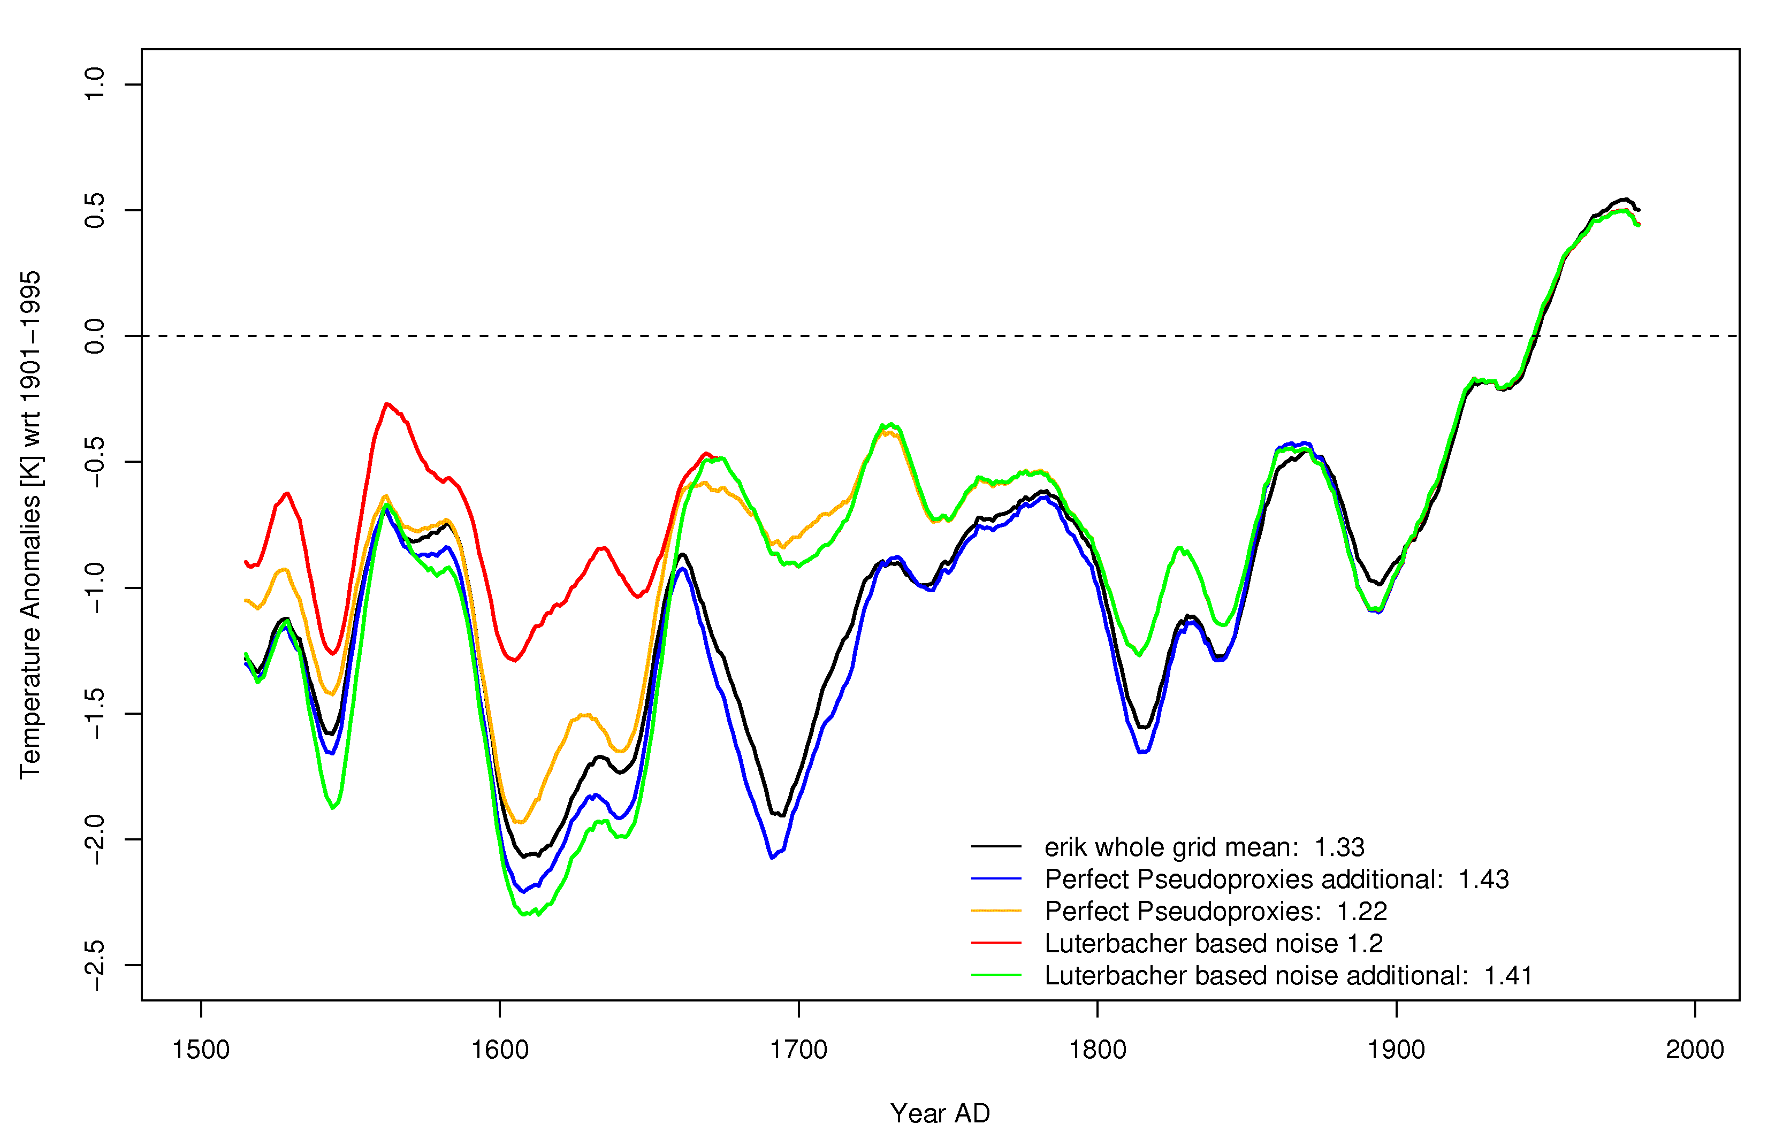
Fig. 1: Reconstructions of the European continental winter temperature over the period 1500-2000, smoothed with a 30 year gaussian low-pass filter based on the ECHO-G simulation. The black curve represents the grid mean while the different colours represent reconstructions based on different predictor sets: the yellow curve is based on perfect pseudoproxies with the same availability over time and space as in the reconstruction of Luterbacher et al. (2004) while the red curve is based on predictors with the same quality as well as temporal and spatial availability as the predictors of Luterbacher et al. (2004). The blue and green curves have three additional predictors over the period 1500-1658 in regions of low proxy-density. The standard deviation of the different reconstruction is indicated in the legend.

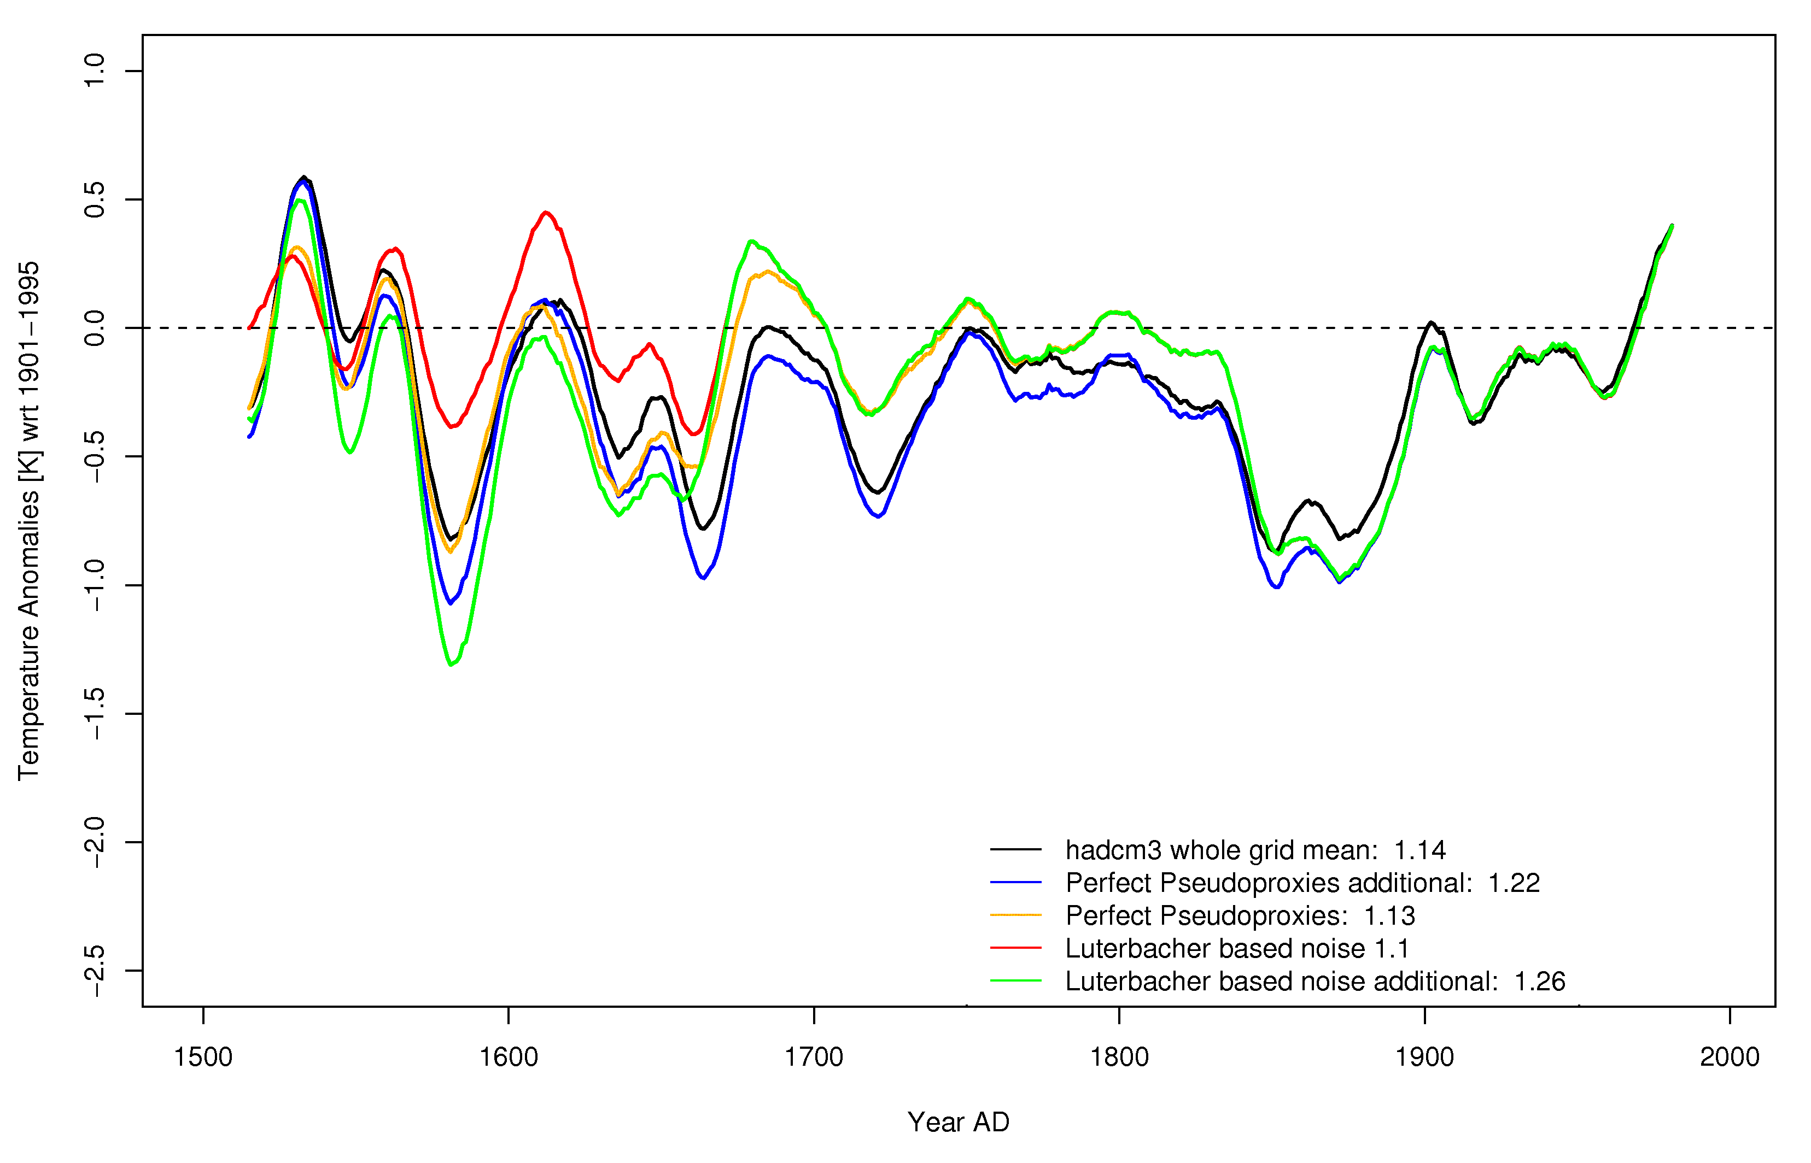

Fig. 2: the same as figure 1 but for HadCM3

References

Küttel, M, 2006: A comparison of modeled and reconstructed European surface temperatures AD1500-2000. Master’s thesis, University of Bern, Institute of Geography, in preparation,

Luterbacher, J., D. Dietrich, E. Xoplaki, M. Grosjean, and H. Wanner, 2004: European seasonal and annual temperature variability, trends and extremes since 1500, Science, 303, 1499-1503.

Storch, H. von, E. Zorita, J. M. Jones, Y. Dmitriev and S. F. B. Tett, 2004. Reconstructing past climate from noisy data. Science, 306, 679-682

