Where should we put our hunger issues?

Quay County Health Profile

Introduction—Alida will work on this
The Quay County Maternal Child & Community Health Council was developed through the combining of the Quay County MCH Council and the Quay County Health Planning Council in June 2001. The Council’s mission is affecting change to improve the quality of life and health of Quay County citizens. The Quay County Board of Commissioners appointed the members of the newly created Quay County MCCH Council in July 2001. Members will continue to be appointed annually.
We need to discuss where this Profile came from, who approved it, when, relationship to the Plan, etc.

Statistical Profile

Definition of Community

Geographic Definition
Quay County , which is a land area of 2, 874 square miles, is located in the north-central region of New Mexico’s eastern border with Texas. The service area considered is Quay County and adjacent areas of six other counties. Residents from other counties are included because of their close proximity to and relationship with Quay County towns where their children often attend school (such as, the children from Conchas Dam, San Miguel County).

Population Definition/Description
The population of Quay County is 10,155, a –6.2% change since the 1990 Census. It is projected that the population of Quay County will decrease to 9,393 in 2010 (NMDOH). The population density of Quay County is 3.5 persons per square mile.
I guess this is okay. OK, I am thinking about the poor soul who needs to maintain this information, including the graphs. Are we going to be able to add to these graphs or was it perhaps a bad idea to lift them from the DOH stuff, especially if they are just a picture? Talk to me.
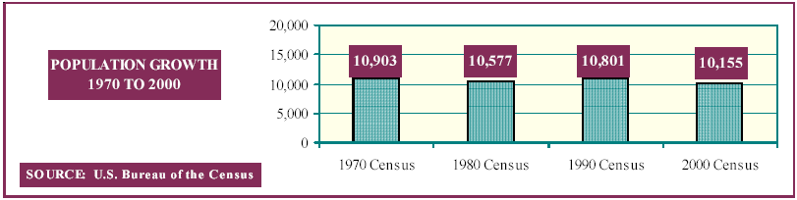
Statement here that there was a 2.7% drop from 2000-2002 and whatever % drop there was from 1990-2000. I think we need to be sure to include easily assessable statements like that so people do not have to do the math. I am trying to remember that these graphs are for Wanda and have absolutely nothing to do with people actually using this document.
Tucumcari, New Mexico, the largest town in Quay County (pop. 6,831 in 1990 and 5,989 in 2000), is the county seat. The county is predominately rural with an economy primarily supported by government funding (state, city, county, villages, schools), ranching/farming, and service industry (motels, restaurants).

Age & Gender
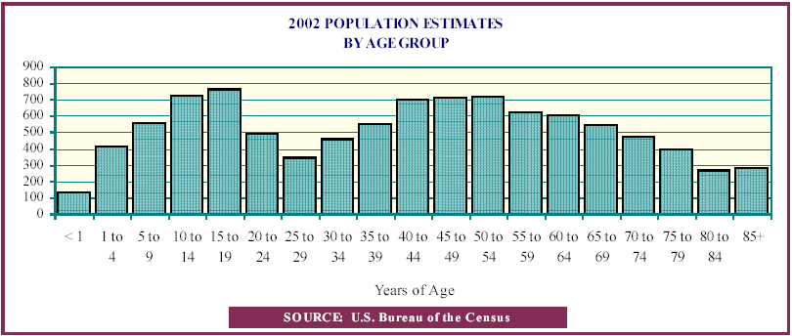
We might also talk here about how many people are in certain significant categories: under 18 yrs, 65 and over, and whatever others we might think are important. This would be about all groups and gender unspecific. Again, ease in planning. The charts are probably, but would actually be seldom used in planning or proposal writing.
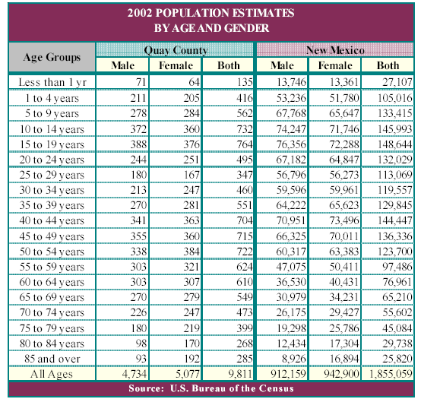

Race/Ethnicity I am not sure this chart is valuable. Most people in NM don’t concern themselves with race, but ethnicity.—esp. in Quay where we are looking at Hispanic or Anglo primarily. Is there information somewhere that describes the breakdown of Hispanic and Anglo by age?
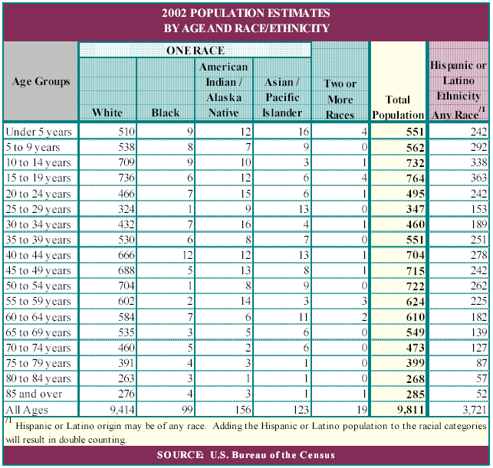
I am wondering about the “Not Hispanic, etc. Would it be better to use the same identifying phase as is used by the Census Bureau?—like I cannot remember, but something else, I thought. Now that I look at it—it appears that this may be what they actually use. ??! What are the actual population numbers here?

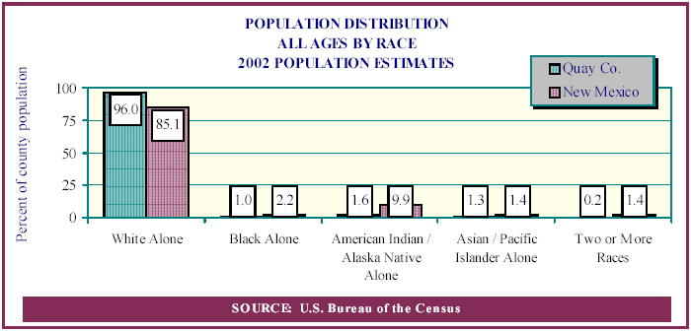
Income/Poverty--
As noted in the 1999 Quay County MCH Plan Update, income levels are lower and poverty levels are higher in Quay County than in New Mexico and the United States. In 2000, the median family income in Quay County is $23,105.00 (an increase from 1990 at $18,104) while in New Mexico it is $30,836 (NM is currently 80% of the US average).

According to 2000 Census Bureau data, of the families residing in Quay County, 26.5% (up from 22.4% in 1990) are living below federal poverty level. This compares with 27.5% in New Mexico and 11.8% in the United States. 37% of children in Quay County are living in poverty, ranking 18th among the 33 New Mexico counties.

80% of Quay County families living in poverty had income from employment (at least one parent was working). Job growth (non-farm) since 1990 in Quay County has decreased 3.5%. While the nation had a 20.1% job growth in 2000, Quay County had a 0% job growth (Kid’s Count 2000).

Another means of looking at county income standing is by looking at income disparity. According to 1998 income tax information, Quay County has a coefficient of .445, while New Mexico is .485. A coefficient of 0 indicates perfect equality of income among all groups, while 1 means one group receives all the income with none for the rest. New Mexico has a 6% higher coefficient than the US (est. US Census).
Regarding the Bare Bones Project…hardly anyone has a clue what it is, who did it, when, and what the result mean. So, we need to include an explanation and compare the results with Federal Poverty levels. And it likely should go above the preceding paragraph.

Education

Primary and Secondary Education (New Mexico Public Education Department)

Public School Districts | Attendance (NMPED 2003-04) | Students Living in Poverty (NMPED 1995) |  | Dropout Rates (NMPED 1999-2000)
Public School Districts | Attendance (NMPED 2003-04) | percent | rank | Anglo | Hispanic
Tucumcari | 1148 | 41.3% | 21 | 3.11% | 3.14%
Logan | 218 | 26.94% | 65 | 1.18% | 0%
San Jon | 173 | 42.38% | 17 | 0% | 0%
House | 160 | 29.23% | 56 | 11.46% | 10.81%
San Jon Middle and High School and Logan High School exceed state standards; Tucumcari Middle School under probation; all others meet state standards (NM-PED 2003). One alternative high school is available in Quay County in House, which is 45 miles from Tucumcari, ?????? from Logan, and ?????????from San Jon.

Post-Secondary Education
Mesalands Community College: enrollment of 600 in 2002-2003 school year. (self-declared)

Educational Attainment (Census 2000)
Quay County | Number |  | Percent
Population 25 years and over | 6970 | 100.0%
Less than 9th grade | 513 | 7.4%
9th to 12th grade, no diploma | 1312 | 18.8%
High school graduate (+ equiv) | 2562 | 36.8%
Some college, no degree | 1392 | 20.0%
Associate degree | 237 | 3.4%
Bachelor’s degree | 583 | 8.4%
Graduate or Professional degree | 371 | 5.3%

Depending upon what info is available for each school district—we need to stick that information here under a heading for each school district—what do you think?

Languages Spoken
27.3% of Quay County residents speak a language other than English (25.8% Spanish; 1.5% Others) (Census 2000).
7% of Quay County residents speak English less than “very well” (Census 2000).

Unemployment
Of the 4,278 people in the labor force, 224 are considered unemployed. Do we know how unemployed is defined. Also, is there any information about underemployment, fulltime vs. parttime. Anything that can make this a clearer picture of our employment situation? This is 2.8% of the population 16 years and older (Census 2000). We need to compare here to NM & USA

Childcare Call CYFD for a better count and trend on licensed.

Licensed Child Care
 | March 2001 | June 2002
Licensed slots | 193 | 249
% Head Start | 31.1% | 24.1%

Source: New Mexico 2002 KIDS COUNT Data Book, New Mexico VOICES FOR CHILDREN

Children younger than 3 years
There is no center-based infant/toddler care centers in Quay County. All infant/toddler care is provided by relatives or registered, unlicensed caregivers in a home. Early Head Start serves 20 families as of February 3, 2004 with a waiting list of 40 families.

Children 3 years and older
There is one private childcare center and, for TANF families, an all-day Head Start classroom. Most childcare takes place in homes of relatives. Families without relatives available have a very hard time finding consistent quality care. Quay County’s use of subsidized care is higher than New Mexico’s—18.7% compared with 13%. New Mexico Kids Count data book 2002

Female Householders
Female householders with no husband present increased 16.5% (from 428 households to 503 households) from 1990 to 2000.

Single Mothers
This type of household with children under 18 yrs. has increased 8.2% over the same period.
51.3% (2001) of births to single moms and approximately how many that means per year. Perhaps a graph here?

Housing
The housing market right now in Quay County is a buyer’s market. Low housing prices are one of the reasons that Quay County is considered to be a low cost living area. (Who considers it a low-cost living area? Does Bare Bone Project?) Pacheco at Housing has our local numbers.) However due to low income, many families are in need of housing subsidies. Currently, there is adequate supply of low-income housing. Discussions with Tucumcari Housing Authority, Eastern Plains Council of Government, and Adult Services—CYFD indicate that Quay County has no major housing problem. Only in Tucumcari did Mr. Pacheco, Directory Tucumcari Housing Authority, indicate that there are not enough vouchers for rental assistance. He is currently writing grants to increase that assistance. (Did you check out the status of that situation now?) In the rest of Quay County there are no waiting lists for housing assistance. Quay County CYFD indicates that housing is not a problem for most Quay County Seniors. ( Is this still true?)

Health Conditions Identified

Births

Provisional 2003 Birth Data
 | Quay County | New Mexico
Low birth weight | 8% | 8.3%
Births to Single Mothers | 45.5% | 48%
Birth to teens 15-17 | 4.5% | 5.8%
Birth to teens 18-19 | 11.6% | 10.4%
High/Mid level of prenatal care | 87.5% | 81.6%
Began Care in first trimester | 56.3% | 65.6%
(source: Department of Health, 2004)

Low Birth Weight
Low birth weight runs very close to New Mexico rates: 8.8% (1990-1992) to 7.6% (2000 Provisional) compared with New Mexico’s 7.7% (2000 Provisional). Healthy People 2010 Targets for these indicators are 90% for high levels of prenatal care and 5% for low birth weight. Quay County has a long way to go to meet these national goals.

Births to Teens
The estimated gross gain from delaying childbirth among young teenagers is $12,305 in year 2000 dollars. The estimated public assistance cost of families started by teenage mothers in New Mexico is $152 million in 2000. NM DOH (gandini.unm.edu/research/Papers/NMDoH_FIN.pdf)

Births to Single Mothers

Prenatal care
Quay County has comparatively good rates of prenatal care and birth weight. Births with low or no prenatal care have a lower average (10.5%) than New Mexico (13.5%). Births with high levels of prenatal care are significantly higher in Quay County (60.5%) than New Mexico (49.5%).

Deaths

Causes of death
Causes of Death  (Source: NMDOH 2001) | Number of deaths in Quay County | Percentage of total deaths
Causes of Death  (Source: NMDOH 2001) | Number of deaths in Quay County | Quay County | New Mexico
Diseases of Heart | 42 | 31.6% | 23.8%
Malignant neoplasms | 30 | 22.6% | 20.7%
Accidents (unintentional) | 6 | 4.5% | 6.8%
Cerebrovascular diseases | 5 | 3.8% | 5.8%
Chronic lower respiratory diseases | 11 | 8.3% | 5.8%
Diabetes mellitus | - | - | 3.9%
Influenza and pneumonia | - | - | 2.7%
Intentional self-harm (suicide) | - | - | 2.6%
Chronic liver disease and cirrhosis | - | - | 2.3%
Alzheimer’s disease | 0 | 0.0% | 2.2%
Nephritis, nephrotic syndromw and nephrosis | - | - | 1.3%
Atherosclerosis | - | - | 0.9%
Parkinsons’s disease | 0 | 0.0% | 0.9%
Assault (homicide) | 0 | 0.0% | 0.9%
Septicemia | 0 | 0.0% | 0.9%
All other causes | 21 | 15.8% | 18.2%
Primary causes of death in Quay County are: #1 Heart disease, #2 Cancer, #3 Cerebrovascular, #4 Chronic Obstructive Pulmonary Disease. Among the cancers, Quay County ranks 11th in the state for female breast cancer and 8th for lung/bronchial cancer (male). Quay County has a low (5 per 100,000—1998-2000) death rate from motor-vehicle crashes compared with NM (24.8 per 100,000).

Suicide
Compared with the US, Quay County suicide rate (15.4/100,000 in 1998-2000) is quite high. The US rate is 11.4 per 100,000, while the Healthy People 2010 target is 5 per 100,000.

Infant mortality
Infant mortality averages 5.3/1,000 (from 1990 to 1999). This compares reasonably with the Healthy People 2010 goal of 4.5/1000.
There were 4 infants deaths in 2003. All four were neonatal deaths. Source: DOH.

Drug-induced
The average drug-induce death rate from 1993-1995 is 9.6 per 100,000 and from 2000-2002 is 10.2 per 100,000 (1 death in 2001 and 2 deaths in 2002). _{NM DOH} The New Mexico rate is 11.6 per 100,000 and the US rate is 5.4 per 100,000. _{US HHS}

Morbidity
AIDS, measles, TB, syphilis, Hepatitis B: Quay County ranks 5th highest in New Mexico for Hepatitis B (1998-2000) with 16.6 cases per 100,000. In 1998 there was no reported syphilis or tuberculosis. 2002 rate acute HepB 41 per 100,000, state rate 7.8 per 100,000 (county rate 5x state)

Infectious Disease
There were four cases of acute hepatitis B in 2002. _{NM DOH}
There were 22 positive tests for hepatitis C from 1999 through 2002. _{NM DOH}

Immunization
Immunizations through 2 yrs. of age are very low for Quay County (40.7%). Overall New Mexico’s immunization rate is at 69%. New Mexico ranked 46th in the nation.
Vaccination Coverage: 4 DTaP–3 Polio–1 MMR–3 Hib# -- National Immunization Survey – 2000: NM 68.2% -- US 76.2%.

Chronic Disease

Diabetes
2002 estimated Diabetes prevalence among adults: 646 (8.6% of total adult population compared with 8.9% prevalence in NM.) NM DOH Diabetes Prevention and Control Program
Healthy People 2010 Goal: 25 overall cases per 1,000 population.

Childhood Obesity
Lack of well-rounded recreation services and regular activity in the schools contribute to this problem.

Injury

Family Violence
Quay County has a very high level of family violence. Substantiated child abuse and neglect rates in Quay County (22 per 1,000 population) are almost three times the rate in New Mexico (8 per 1,000). Quay County ranks 3rd highest in the state from 1998-2000. Healthy People 2010 target: 10.3 per 1000 pop. Quay County ranks #1 in substantiated adult abuse and neglect (1999-2000)! The rate is 540 per 100,000. Domestic Violence rates for Quay County is 12.8 per 1,000 while in the US the rate is 4.4/1000. Quay also ranked 7th highest among the 22 reporting counties in New Mexico. Healthy People 2010 Target: 3.3 per 1000 pop. Work on this and perhaps put somewhere else.

Behavioral Risk Factors

Self-reported health status, including mental health
Ten percent of high school youth respondents to the Community Needs Assessment 2002 reported that they were unhappy or very unhappy with their lives. These youth were most likely to be 15-17 years of age, unemployed and did not believe their families listen to them. 21% of these respondents felt they were moderately to very inactive in trying to stay healthy.
90% of adult respondents indicated that they had a very healthy or moderately healthy mental out look on life. On the other hand, 22% of these same respondents believe that those around them do not have such a positive outlook!

Resiliency and Positive Health Behaviors

Behavioral Health

Substance Abuse
Quay County has a very high rate of substance abuse, including its young population. Among the statistics available:
DWI rates of arrest (ages 16-79), Quay County ranks 4th of 32 counties
Alcohol-related crash fatalities: 10th of 32 NM counties (20 per 100,000)
Juveniles referred to JPPO for substance abuse rose from 6.8% to 18.8% of all referrals (1993 to 1999)

Disability
Disability for Civilian Noninstitutionalized Population 5 years and over
 | Males |  |  |  | Females
 | 5-15 yrs | 16-20 yrs | 21-64 yrs | 65+ yrs | 5-15 yrs | 16-20 yrs | 21-64 yrs | 65+ yrs
With one type of disability | 103 | 19 | 433 | 125 | 22 | 41 | 351 | 359
Sensory disability | 3 | 0 | 90 | 11 | 3 | 0 | 22 | 67
Physical disability | 0 | 3 | 99 | 71 | 0 | 0 | 122 | 208
Mental disability | 100 | 0 | 32 | 4 | 9 | 10 | 18 | 30
Self-care disability | 0 | 4 | 0 | 2 | 0 | 0 | 0 | 0
Go-outside-home disability |  | 0 | 24 | 37 |  | 12 | 38 | 54
Employment disability |  | 12 | 188 |  |  | 19 | 161
With two or more types of disability | 14 | 20 | 352 | 204 | 1 | 18 | 287 | 242
Includes self-care disability | 12 | 0 | 37 | 32 | 1 | 0 | 74 | 99
Source: 2000 Census.

Environmental Health

Air and water quality
Quay County had 33 known cases of ground water contamination. _{NM Department of Environment}
Environmental concerns are not troubling to Quay County residents according to the New Mexico Department of Health. All the municipal water systems meet national guidelines for water quality. According to these reports, there is no industrial air pollution in Quay County.

Lead Poisoning
Quay County is considered to have a higher than average risk for lead poisoning of children due to the older age of many houses and the county rate of poverty. NM Childhood Lead Poisoning Prevention Program

Injury

Dental Health
9% of youth reported poor to very poor dental health, while 55% reported their dental health to be moderately well.
Recent poor health, including poor mental health: 10% of youth responding reported poor to very poor overall health, while 55% reported their overall health to be moderate. On the other hand, the majority of adults view their children as very healthy.

Assessing Needs from Resident’s Perspectives

 |  | Prenatal | Birth-5 years | 6-12 years |  | 13-17 years | 18-30 years | 31-60 years | 61+ years | Women Only
Early Identification | Early Identification / Risk Assessment | PHO EHS FAMF JFAI | TDVP TPS SJPS QCMC LPS ASAP CMS RAIN NGU PHO TEAM LFHC EHS SALT FAMF EPHS JFAI | TDVP QCMC ASAP RAIN NGU TEAM LFHC SALT JFAI |  | TDVP QCMC ASAP RAIN HELP NGU TEAM LFHC SALT JFAI | TDVP QCMC THA ASAP NGU MHR LFHC SALT JFAI | TDVP QCMC THA NGU MHR LFHC SALT | TDVP QCMC THA NGU MHR LFHC SALT
Early Identification | Developmental Screening | QCMC PHO EHS | QCMC LPS CMS RAIN NGU PHO LFHC EHS SALT FAMF EPHS JFAI | QCMC RAIN NGU LFHC SALT JFAI |  | QCMC RAIN NGU LFHC SALT JFAI | QCMC NGU SALT | QCMC NGU SALT | QCMC NGU SALT
Health Promotion | Health Promotion / Health Education | PHO EHS THH TRIG FAMF JFAI | TPS SJPS QCMC LPS ASAP CMS NGU PHO LFHC EHS THH SALT TRIG FAMF EPHS JFAI | QCMC ASAP CMS RAIN NGU PHO LFHC THH SALT TRIG JFAI |  | QCMC ASAP CMS RAIN NGU PHO LFHC THH SALT TRIG JFAI | QCMC ASAP CMS NGU PHO LFHC THH SALT TRIG JFAI | QCMC NGU PHO LFHC THH SALT TRIG JFAI | QCMC NGU PHO LFHC THH SALT TRIG JFAI
Access to Care | Home Visits | H&H PHO EHS THH SALT FAMF | QCMC H&H CMS PHO EHS THH SALT TRIG FAMF EPHS | QCMC H&H CMS THH SALT TRIG |  | QCMC H&H CMS THH SALT TRIG | QCMC H&H MNM CMS VHH THH SALT CHC TRIG | QCMC H&H MNM HHH VHH THH SALT CHC TRIG | QCMC H&H MNM HHH VHH THH SALT CHC TRIG
Access to Care | Referrals | PHO EHS SALT FAMF JFAI | TDVP QCMC LPS ASAP CMS RAIN NGU PHO LFHC EHS NBAD SALT SOT TRIG FAMF EPHS JFAI | TDVP QCMC ASAP CMS RAIN NGU PHO LFHC NBAD SALT SOT TRIG JFAI |  | TDVP QCMC ASAP CMS RAIN HELP NGU PHO ZERO LFHC NBAD SALT SOT TRIG JFAI | TDVP QCDWI QCMC ASAP CMS NGU PHO MHR VHH LFHC NBAD SALT SOT CHC TRIG JFAI | TDVP QCMC QCDWI NGU PHO MHR VHH LFHC NBAD SALT SOT CHC TRIG JFAI | TDVP QCDWI QCMC NGU PHO MHR VHH LFHC NBAD SALT SOT CHC TRIG JFAI
Access to Care | Pharmaceutical Financial Assistance | STVP QCMC LFHC JFAI | STVP QCMC LFHC SALT JFAI | STVP QCMC LFHC SALT JFAI |  | STVP QCMC LFHC SALT JFAI | STVP QCMC MNM MHR LFHC SALT JFAI | STVP QCMC MNM MHR LFHC SALT JFAI | STVP QCMC MNM MHR LFHC SALT QUAI JFAI
Access to Care | Case Management / Service Coordination | PHO FAMF | TDVP TPS QCMC ASAP CMS RAIN NGU PHO TEAM LFHC SALT FAMF EPHS | TDVP QCMC ASAP CMS RAIN NGU TEAM LFHC SALT |  | TDVP QCMC ASAP CMS RAIN HELP NGU TEAM LFHC SALT | TDVP ASAP QCDWI QCMC THA CMS NGU MHR LFHC SALT CHC | TDVP QCDWI QCMC THA NGU MHR LFHC SALT CHC | TDVP QCDWI QCMC THA NGU MHR LFHC SALT CHC
Access to Care | Medicaid Enrollment | PHO | CMS RAIN PHO LFHC SALT | CMS RAIN PHO LFHC SALT |  | CMS RAIN PHO LFHC SALT | MNM CMS LFHC SALT | MNM LFHC SALT | MNM SALT
Intervention | Well-person checkups | EHS JFAI | QCMC LPS NGU LFHC EHS NBAD SALT EPHS JFAI VICK | QCMC NGU LFHC NBAD SALT JFAI VICK |  | QCMC NGU LFHC NBAD SALT JFAI VICK | QCMC NGU LFHC NBAD SALT JFAI VICK | QCMC NGU LFHC NBAD SALT JFAI VICK | QCMC NGU LFHC NBAD SALT QUAI JFAI VICK
Intervention | Specialty Care | POW NBAD | TDVP CMS POW NBAD SOT | TDVP DIMM PHG CMS POW NBAD SOT |  | TDVP DIMM PHG CMS POW ZERO LFHC NBAD SOT | TDVP QCDWI DIMM SANH PHG MNM CMS POW VHH LFHC NBAD SOT LAUR | TDVP QCDWI DIMM SANH PHG MNM POW HHH VHH LFHC NBAD SOT LAUR | TDVP QCDWI DIMM SANH PHG MNM POW HHH VHH LFHC NBAD SOT LAUR
Intervention | Mental Health Services | EHS | RAIN TEAM EHS SALT EPHS | RAIN TEAM SALT |  | RAIN TEAM SALT | MHR SALT | MHR SALT | MHR SALT
Intervention | Food and Nutrition Services | HFP QCMC LCAS EHS TRIG JFAI | HFP QCMC LPS CMS RAIN LCAS EHS SALT TRIG EPHS JFAI | HFP QCMC CMS RAIN LCAS SALT TRIG JFAI |  | HFP QCMC CMS RAIN LCAS SALT TRIG JFAI | HFP QCMC CMS LCAS SALT TRIG JFAI | HFP QCMC LCAS SALT TRIG JFAI | HFP QCMC LSC HSC LCAS SALT SNP TRIG JFAI
Follow-up | Follow-up Care | QCMC NGU LFHC JFAI | QCMC NGU PHO LFHC NBAD SALT SOT EPHS JFAI | QCMC NGU PHO LFHC NBAD SALT SOT JFAI |  | QCMC NGU PHO LFHC NBAD SALT SOT JFAI | QCMC NGU PHO MHR LFHC NBAD SALT SOT JFAI | QCMC NGU PHO MHR LFHC NBAD SALT SOT JFAI | QCMC NGU PHO MHR LFHC NBAD SALT SOT JFAI
TDVP – Tucumcari Domestic Violence Program: Specialty Care – Life and Social Skills, DV education, batters intervention, sexual assault, teen dating violence.  QCDWI – Quay County DWI Program: Specialty Care – Treatment.  STVP – Saint Vincent de Paul Society.  HFP – House Food Pantry.  TPS – Tucumcari Preschool.  SJPS – San Jon Preschool.  HPS – House Preschool.  LPS – Logan Preschool.  DIMM – Dr. Dimmette: Specialty Care – Neurology.  SANH – Sandia Hearing: Specialty Care – Hearing and Audiology.  QCMC – Quay County Medical Clinic.  THA – Tucumcari Housing Authority.  AHH – American Home Health.  CAA – Eastern Plains Community Action Agency.  ECS – ENMRSH Inc. Early Childhood Services.  EYE – Eye Associates.  PHG – Presbyterian Heart Group: Specialty Care – Cardiac Care.  PRO – Parents Reaching Out.  HRP – Housing Rehab Program.  LSC – Logan Senior Citizens Center.  HSC – House Senior Citizens Center.  H&H – New Mexico Home and Health.  VSC – New Mexico Veterans Service Commission.  PAIN – Pain Clinic.  MNM – Mentor New Mexico: Specialty Care – Personal Care Option.  ASAP – Quay County ASAP Coalition.  FITZ – C. Bernard Fitzner, DDS.  CMS – Children’s Medical Services, NMDOH: Specialty Care – Outreach Clinics.  RAIN – Raindancer Youth Services.  VICK – Jina Vick. |  |  |  |  | HELP – Home Education Livelihood Program.  NGU – Thanh Van Nguyen, MD.  POW – Powers Chiropractic: Specialty Care - Chiropractic.  LCAS – La Casa de la Hope.  VICT – Victory Royal Express.  PHO – Quay County Public Health Office.  ZERO – Zero Gravity Youth Center: Specialty Care – Parenting Classes.  MHR – Mental Health Resources.  MCC – Dr. J. R. McCausland, Optometrist.  HHH – Helping Hands Hospice: Specialty Care – Palliative, Terminal.  TEAM – Teambuilders Inc.  CDC – Teambuilders Child Development Center.  VHH – Victory Home Health: Specialty Care – Medicaid patient one21.  LFHC – Logan Family Health Center: Specialty Care – Family Planning, STD, B&CC  EHS – Early Head Start.  NBAD – Dr. Nur Badshah: Specialty Care – Surgical.  THH – Tucumcari Home Health Agency/Dan C. Trigg.  SALT – Dr. James E. Saltz Jr.  SOT – Dr. Sotelo: Specialty Care – Podiatry.  CHC – Community Home Care.  LAUR – Laurel Hills: Specialty Care – 24 hour Skilled Nursing Care.  SNP – Senior Nutrition Program.  MESA – Mesa Counseling.  SAFE – Safe Ride.  TRIG – Dr. Dan C. Trigg Hospital.  FAMF – Families First Program.  AUT – Autumn Blessings.  QUAI – Quail Ridge.  EPHS – Eastern Plains Head Start.  JFAI – Dr. John L. Faith MD.

Continuum Assessment Categories

Community Risk Profile: QUALITY OF LIFE

The quality of Quay County life is very satisfying for 41% of the adult respondents to the recent Community Needs Assessment 2002. Only 6% were dissatisfied or very dissatisfied. 37% believed they have a moderate level of support from family, friends and neighbors. 23% feel that they have a low level of support or no support.
Nearly one-half of the respondents believe that the community has inadequate resources to support:

- low-income children (40%)
- low-income Senior citizens (49%)
- low-income families (44%)

This is interesting in light of the fact that the survey reflected the county in all the demographic characteristics. None of the above groups was over-represented. 42% also indicated that they did not believe that their community supports a positive mental outlook.

Prenatal

Early Identification

Health Promotion

Access to Care

Intervention

Follow-up

Child

Early Identification

Health Promotion

Access to Care

Intervention

Follow-up

Adolescent

Early Identification

Health Promotion

Access to Care

Intervention

Follow-up

Adult

Early Identification

Health Promotion

Access to Care

Intervention

Follow-up

Senior Adult

Early Identification

Health Promotion

Access to Care

Intervention

Follow-up

Asset & Resource Assessment

Health Care Resource Consumption

Health Insurance
According to the Community Needs Assessment 2002, 19% of Quay County residents with 14% of the children are uninsured. 21.9% of New Mexicans children are uninsured, so Quay County compares quite favorably to that figure. However, New Mexico ranks 47th in the nation in the percentage of uninsured kids! Groups most likely to be uninsured in Quay County are:
- Small business employees
- Farmers/ranchers
- Clergy
- Adult students
- Persons reporting income of $10,000 to $25,000 for three or more
- Persons reporting income of $25,000 to $40,000 for four or more

Health Care System
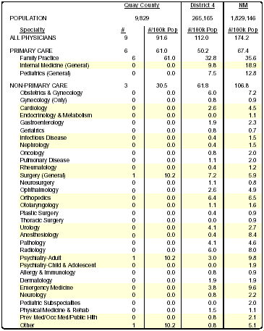
(source: Physician Supply and Distribution in New Mexico, 2001. The Center for Health Workforce Studies, University at Albany, State University of New York, 2003.)
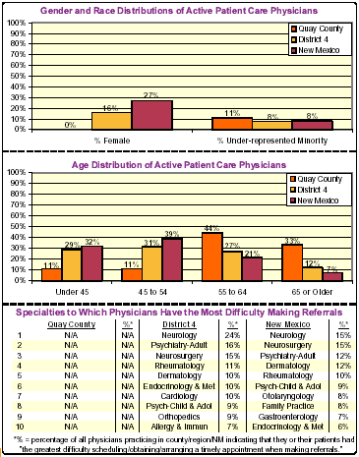
(source: Physician Supply and Distribution in New Mexico, 2001. The Center for Health Workforce Studies, University at Albany, State University of New York, 2003.)

24% of the respondents to the survey indicated that the local health care system was not easy to use. Additionally, 52% indicated that they believe that local health and health-related services providers do not coordinate services with each other. 12% indicated that the referral system was poor in Quay County.

Medicaid Enrollment
It is estimated that 65% of children eligible for Medicaid are enrolled. That compares with 66% of children statewide.
Asset & Resource Assessment: This may includes provider surveys, consumer surveys to map existing formal and informal resources.
Analysis of the statistical profile, the residents’ perspective and the asset/resources as a summary of the health profile.

Health Care Services
Most residents in Quay County depend upon health care services provided in Tucumcari. Four family practice private physicians and one mid-level provider and one surgeon are currently practicing medicine in Tucumcari. One Tucumcari physician is currently offering sliding fee services. Specialty care in Tucumcari includes specialty clinics brought monthly to Tucumcari by Dan Trigg Hospital. Physician-level OB/GYN prenatal services are offered monthly in Tucumcari and Logan with delivery taking place in Clovis. Logan Family Health Center (located in Logan) and Quay County Family Health Center (located in Tucumcari) offer family health services on a sliding scale. Dr. Dan C. Trigg Memorial Hospital is an acute care facility located in Tucumcari. Two home health agencies provide skilled nursing services for homebound clients. Quay County has a two-nurse Public Health Field Office to serve 10,155 county residents. Helping Hands Hospice provides services to residents of Quay County and surrounding areas.
Dental care of provided by two dentists located in Tucumcari; one of which accepts a limited number of Medicaid patients and some patients of the Quay County Family Health Center by contract. Optometry services are provided by two optometrists located in Tucumcari and by Ophthalmology Clinics once a month through the hospital. Two chiropractors provide services in Tucumcari.
Quay County is designated a psychiatric manpower shortage area. Mental Health Resource, Inc. and TeamBuilders, Inc., both located in Tucumcari, provide mental health services to county residents. Additionally, MCH funding through the New Mexico Department of Health provides school-based mental health counseling and health case management services to students and families in the four Quay County school districts.

Summary Analysis

