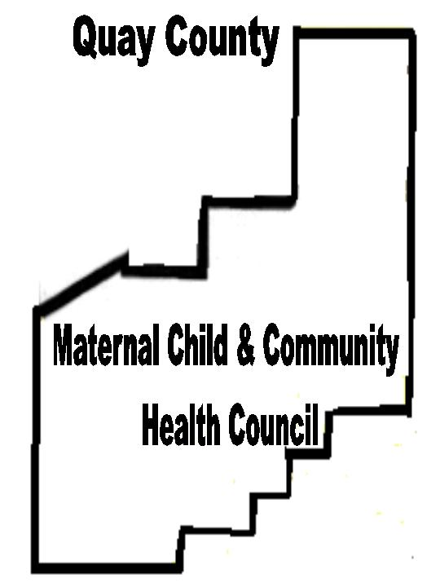

QUAY COUNTY
Affecting Change to Improve the Quality of Life and Health of Quay County Residents.

MATERNAL CHILD &COMMUNITY

HEALTH COUNCIL

January 18, 2004

Mental Health Resources:

Attached is a survey of your agency/program that was done two years ago. Please take a moment to update the information. We are interested not only in what has changed within your service protocol, but also are interested in providing an online resource directory at quaymcch.com. This directory will be advertised and made available to the public. This information will also be provided to participants at the Quay County Wellness Fair 2004 (May 8th). We encourage you to be a part of this important community service.

In addition, we are currently updating our community profile of services, which we use in the Quay County MCCH Plan Update each year. Please answer the following questions. We appreciate your help.

Sincerely,

Alida W. Brown
Coordinator
Health Service Grid  Please put an ‘X’ at the intersection of service you provide and the age groups you provide that service to. | Prenatal | Birth – 5 yrs | 6 – 12 yrs | 13 – 17 yrs | 18 – 30 yrs | 31 – 60 yrs | 61 yrs - up | Women only
Early indentification / risk assessment
Case management / service coordination
Health education
Well-person checkups
Home visits
Referrals
Specialty care
specify:
Follow-up care
Pharmaceutical assistance
Medicaid enrollment
Developmental screening
Mental health services
Food and Nutrition Services

Do you have the capacity to serve more clients/patients? ______yes ______no

Do you maintain a waiting list for clients/patients? ____ no ______yes. If so, how many are currently on the list? ________________

