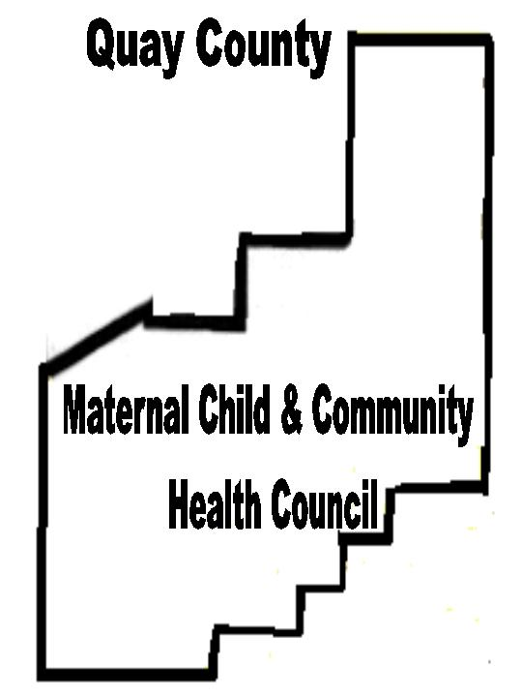

Affecting Change to Improve the Quality of Life and Health of Quay County Residents.

Substance Abuse
Prevention in
Quay County
2003

Vision:
Optimal Quality of Life for Quay County Residents

Mission:
Affecting Change to Improve the Quality of Life and Health of Quay County Residents
Substance Abuse Committee Membership

Noreen Hendrickson, Chair
DWI Task Force Coordinator

Dee Reed
Public Health Nurse Manager

Gail Cook, RN, LADAC
PMS Clinic Administrator

Susan Lease
ASAP Project Director

Tim Gutierrez
Community Member

Lt. Nathan Wallace
New Mexico State Police

Alan Angel
Teambuilders Project Coordinator

George Arguello
Juvenile Probation Officer

Edna Cleary
Family Self-sufficiency Coordinator

Phil Teakell
Health Promotion Department of Health
Quay County
Maternal Child
And Community
Health Council
Affecting Change to Improve the Quality of Life and Health of Quay County Residents.

PO Box 282
Tucumcari, NM 88401
(505) 461-4218
http://www.quaymcch.com

Alida Brown, Coordinator

This booklet was made possible with funding from the New Mexico Department of Health
Improving Health Initiative

