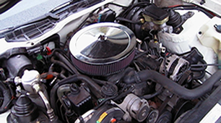
Open Element Instructions: Skill level = NONE REQUIRED
Written by: Snflupigus

Step 1 – The easy part: Removing your stock air cleaner housing

- Remove the screws that are on the front of the plastic snorkel, (which is located at the front right of the engine bay) and pull it off of the metal air cleaner base's spout.

- Take off the wing nut that is on top of your air cleaner lid, pull off the lid, and take out the filter.

- See the little filter, inside, on the passenger side of the stock air cleaner base? That is the breather filter. Remove the retainer clip holding it onto the breather tube; twist, wiggle, and slide it off.

- Lift the stock air cleaner base up as far as you can.

- There is a rubber vacuum hose that goes from the Thermac, on the bottom of the stock air cleaner base, to the TBI. Disconnect this from the TBI.

- Unplug the wires coming off of the IAT Sensor, which is located near the middle of the bottom of the stock air cleaner base.

- There is a metal hose that is coming up from the driver’s side manifold-cover and is going to the stock air cleaner base's spout. Remove this. Throw it away.

Step 2 – The other easy part: Installing your new air cleaner
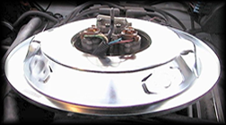
- If you have purchased or acquired a "NONDROP-base" aftermarket air cleaner, you will usually need to remove the spacer ring that resides atop the TBI before installing to allow for adequate hood clearance. However, if you have a "DROP-base" aftermarket air cleaner you will need to leave the air cleaner spacer ring in place to allow your new air cleaner to properly clear your throttle linkage, distributor and or coil wires.

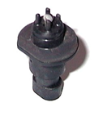
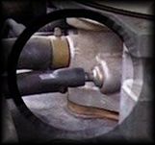
- Use a vacuum cap to plug the metal tube coming out of your TBI where your thermac's vacuum line was previously removed. You may also insert a screw into one end of the vacuum line you removed and place the other back on the TBI. Either way, make sure that you have sealed the vacuum line.

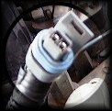
- Remove the IAT from the factory air cleaner base and plug it back into the wires your previously removed it from. Place it anywhere that it is not in the way or in contact with hot metal.

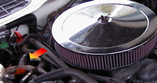
- The Breather. You can either put the breather filter back on the breather tube using your stock breather, letting it stand freely, or you can purchase an aftermarket one and replace the breather tube with it.

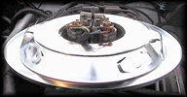
- Now, take your aftermarket air cleaner base and place it either on top of the TBI, or the spacer ring. Take note now to confirm that the air cleaner base is not coming in contact with the coil wires. If it is simply bend the coil bracket away from the air cleaner base, and or place extra electrical tape around these wires. By the way, this is RED for a reason. If your air cleaner base rubs through your 12 volt positive coil wire, it will arc, and spark, and burn your car down. Ok, if you are lucky it will only blow your fusible links, and a few fuses, but it could completely destroy your car in minutes.

MAKE SURE ITS NOT TOUCHING THE COIL WIRES. AT ALL!!

- Place your air cleaner on the aftermarket air cleaner base, and then put the aftermarket air cleaner lid on top of it. Tighten down the wing nut and slowly proceed to lower the hood, being very careful, monitoring clearance until the hood is fully closed. In most cases, on a stock intake, a 2.5" filter element will always fit under the hood, and if using a DROP-base a 3" filter should fit. In any case, obviously, the filter top should not be taller than the height of the center bolt.

- Now that you are finished with that, disconnect your negative battery cable for about 30 seconds to reset your computer. Hook it back up, and then start your car. If you’ve done everything correctly, you will not get a check engine light. Rev your motor. WOW! you'll say, that sounds sweet! If you do get a light, double check that your IAT is plugged in, and that your vacuum line is plugged completely. If you still have problems, email me at snflupigus@hotmail.com. I hope this all helps and was easy to understand. Please take some pictures while you do it, if they are better than what I have here I will use them. Also, please email me with any comments or additions you have to add to this reference. Thanks for visiting, Send me some pictures of your car, you and info on both and I will add it to my page.

Note: These are instructions, not recommendations. Don’t ask why, just trust me, this is how you do it. If for some reason you find yourself asking why you would do something, don’t. Trust me! If you can’t stand not knowing why or you truly doubt and don’t trust me, write me at snflupigus@hotmail.com. You can also IM me at the same name on MSN, Yahoo, or AIM and I will explain.

FINAL WARNING!

PLEASE MAKE SURE YOUR COIL ISNT TOUCHING THE BOTTOM OF YOUR AIR CLEANER LID. BEND THE BRACKET BACKWARDS TOWARDS THE FIREWALL. TRUST ME ON THIS; IT WILL SAVE YOUR CAR AND MAYBE YOU.

Originally Created for:



