The Emotional Tone Scale — Introduction
How often have you heard someone say, “I don’t understand him”? Sometimes irrational, unforeseen acts seem to be the norm among our fellows. The fact is, there has never been a workable method to invariably predict human behavior—until now.
L. Ron Hubbard developed just such a method, and it is applicable to all men, without exception.
With this data, it is possible to accurately predict the behavior of a potential spouse, a business partner, employee or friend – before you commit to a relationship. The risks involved in human interaction can be avoided entirely or minimized when you can infallibly predict how people will behave.
By understanding and using this information, all aspects of human relationships will become more productive and more fulfilling. You’ll know who to associate with, who to avoid, and you will be able to help those who are mired in uncomfortable situations with others. Imagine knowing, after a very short time, how people will behave in any given circumstance. You can. Each and every time.

The Tone Scale — Overview
The Tone Scale—a vital tool for any aspect of life involving one’s fellows—is a scale which shows the successive emotional tones a person can experience. By “tone” is meant the momentary or continuing emotional state of a person. Emotions such as fear, anger, grief, enthusiasm and others which people experience are shown on this graduated scale.
Skillful use of this scale enables one to both predict and understand human behavior in all its manifestations.
This Tone Scale plots the descending spiral of life from full vitality and consciousness through half-vitality and half-consciousness down to death.
By various calculations about the energy of life, by observation and by test, this Tone Scale is able to give levels of behavior as life declines.
These various levels are common to all men.
When a man is nearly dead, he can be said to be in a chronic apathy. And he behaves in a certain way about other things. This is 0.05 on the Tone Scale.
When a man is chronically in grief about his losses, he is in grief. And he behaves certain ways about many things. This is 0.5 on the scale.
When a person is not yet so low as grief but realizes losses are impending, or is fixed chronically at this level by past losses, he can be said to be in fear. This is around 1.0 on the scale.
An individual who is fighting against threatened losses is in anger. And he manifests other aspects of behavior. This is 1.5.
The person who is merely suspicious that loss may take place or who has become fixed at this level is resentful. He can be said to be in antagonism. This is 2.0 on the scale.
Above antagonism, the situation of a person is not so good that he is enthusiastic, not so bad that he is resentful. He has lost some goals and cannot immediately locate others. He is said to be in boredom, or at 2.5 on the Tone Scale.
At 3.0 on the scale, a person has a conservative, cautious aspect toward life but is reaching his goals.
At 4.0 the individual is enthusiastic, happy and vital.
Very few people are natural 4.0s. A charitable average is probably around 2.8.

The Tone Scale — Examples
You have watched this scale in operation before now. Have you ever seen a child trying to acquire, let us say, a nickel? At first he is happy. He simply wants a nickel. If refused, he then explains why he wants it. If he fails to get it and did not want it badly, he becomes bored and goes away. But if he wants it badly, he will get antagonistic about it. Then he will become angry. Then, that failing, he may lie about why he wants it. That failing, he goes into grief. And if he is still refused, he finally sinks into apathy and says he doesn’t want it. This is negation.
A child threatened by danger also dwindles down the scale. At first he does not appreciate that the danger is posed at him and he is quite cheerful. Then the danger, let us say it is a dog, starts to approach him. The child sees the danger but still does not believe it is for him and keeps on with his business. But his playthings “bore” him for the moment. He is a little apprehensive and not sure. Then the dog comes nearer. The child “resents him” or shows some antagonism. The dog comes nearer still. The child becomes angry and makes some effort to injure the dog. The dog comes still nearer and is more threatening. The child becomes afraid. Fear unavailing, the child cries. If the dog still threatens him, the child may go into an apathy and simply wait to be bitten.
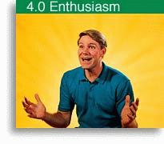 | 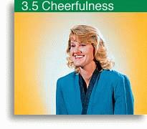
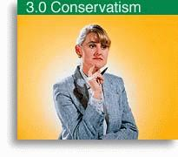 | 
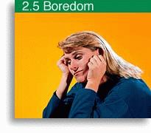 | 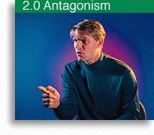
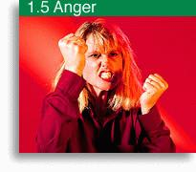 | 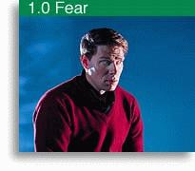
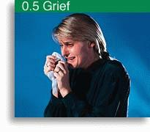 | 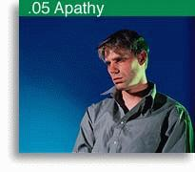
Every person has a chronic or habitual tone. He or she moves up or down the Tone Scale as he experiences success or failure. These are temporary, or acute, tone levels. A primary goal of Scientology is to raise a person’s chronic position on the Tone Scale.
Objects or animals or people which assist survival, as they become inaccessible to the individual, bring him down the Tone Scale.
Objects, animals or people which threaten survival, as they approach the individual, bring him down the Tone Scale.
This scale has a chronic or an acute aspect. A person can be brought down the Tone Scale to a low level for ten minutes and then go back up, or he can be brought down it for ten years and not go back up.
A man who has suffered too many losses, too much pain, tends to become fixed at some lower level of the scale and, with only slight fluctuations, stays there. Then his general and common behavior will be at that level of the Tone Scale.
Just as a 0.5 moment of grief can cause a child to act along the grief band for a short while, so can a 0.5 fixation cause an individual to act 0.5 toward most things in his life.
There is momentary behavior or fixed behavior.

The Tone Scale in Full
The full Tone Scale starts well below apathy. In other words, a person is feeling no emotion about a subject at all. An example of this was the American attitude concerning the atomic bomb; something about which they should have been very concerned was so far beyond their ability to control and so likely to end their existence that they were below apathy about it. They actually did not even feel that it was very much of a problem.
Feeling apathetic about the atomic bomb would be an advance over the feeling of no emotion whatsoever on a subject which should intimately concern a person. In other words, on many subjects and problems people are actually well below apathy. There the Tone Scale starts, on utter, dead null far below death itself.
Going up into improved tones one encounters the level of body death, apathy, grief, fear, anger, antagonism, boredom, enthusiasm and serenity, in that order. There are many small stops between these tones, but one knowing anything about human beings should definitely know these particular emotions. A person who is in apathy, when his tone is improved, feels grief. A person in grief, when his tone improves, feels fear. A person in fear, when his tone improves, feels anger. A person in anger, when his tone improves, feels antagonism. A person in antagonism, when his tone improves, feels boredom. When a person in boredom improves his tone, he is enthusiastic. When an enthusiastic person improves his tone, he feels serenity. Actually the below apathy level is so low as to constitute a no-affinity, no-emotion, no-problem, no-consequence state of mind on things which are actually tremendously important.
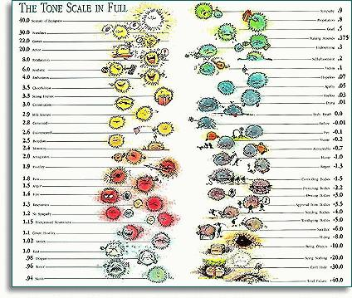

Characteristics on the Tone Scale
The area below apathy is an area without pain, interest, or anything else that matters to anyone, but it is an area of grave danger since one is below the level of being able to respond to anything and may accordingly lose everything without apparently noticing it.
A workman who is in very bad condition and who is actually a liability to the organization may not be capable of experiencing pain or any emotion on any subject. He is below apathy. We have seen workmen who would hurt their hand and think nothing of it and go right on working even though their hand was very badly injured. People working in medical offices and hospitals in industrial areas are quite amazed sometimes to discover how little attention some workmen pay to their own injuries. It is an ugly fact that people who pay no attention to their own injuries and who are not even feeling pain from those injuries are not and never will be, without some attention from a Scientologist, efficient people. They are liabilities to have around. They do not respond properly. If such a person is working a crane and the crane suddenly goes out of control to dump its load on a group of men, that subapathy crane operator will simply let the crane drop its load. In other words, he is a potential murderer. He cannot stop anything, he cannot change anything and he cannot start anything and yet, on some automatic response basis, he manages some of the time to hold down a job, but the moment a real emergency confronts him he is not likely to respond properly and accidents result.
Where there are accidents in industry they stem from these people in the subapathy tone range. Where bad mistakes are made in offices which cost firms a great deal of money, lost time and cause other personnel difficulties, such mistakes are found rather uniformly to stem from these subapathy people. So do not think that one of these states of being unable to feel anything, of being numb, of being incapable of pain or joy is any use to anyone. It is not. A person who is in this condition cannot control things and in actuality is not there sufficiently to be controlled by anyone else and does strange and unpredictable things.
Just as a person can be chronically in subapathy, so a person can be in apathy. This is dangerous enough but is at least expressed. Communication from the person himself, not from some training pattern is to be expected. People can be chronically in grief, chronically in fear, chronically in anger, or in antagonism, or boredom, or actually can be “stuck in enthusiasm.” A person who is truly able is normally fairly serene about things. He can, however, express other emotions. It is a mistake to believe that a total serenity is of any real value. When a situation which demands tears cannot be cried about, one is not in serenity as a chronic tone. Serenity can be mistaken rather easily for subapathy, but of course only by a very untrained observer. One glance at the physical condition of the person is enough to differentiate. People who are in subapathy are normally quite ill.
On the level of each of the emotions we have a communication factor. In subapathy an individual is not really communicating at all. Some social response or training pattern or, as we say, “circuit” is communicating. The person himself does not seem to be there and isn’t really talking. Therefore his communications are sometimes strange to say the least. He does the wrong things at the wrong time. He says the wrong things at the wrong time.
Naturally when a person is stuck on any of the bands of the Tone Scale-subapathy, apathy, grief, fear, anger, antagonism, boredom, enthusiasm or serenity-he voices communications with that emotional tone. A person who is always angry about something is stuck in anger. Such a person is not as bad off as somebody in subapathy, but he is still rather dangerous to have around since he will make trouble, and a person who is angry does not control things well. The communication characteristics of people at these various levels on the Tone Scale are quite fascinating. They say things and handle communication each in a distinct characteristic fashion for each level of the Tone Scale.
There is also a level of reality for each of the levels of the Tone Scale. Reality is an intensely interesting subject since it has to do, in the main, with relative solids. In other words, the solidity of things and the emotional tone of people have a definite connection. People low on the Tone Scale cannot tolerate solids. They cannot tolerate a solid object. The thing is not real to them; it is thin or lacking weight. As they come up scale, the same object becomes more and more solid and they can finally see it in its true level of solidity. In other words, these people have a definite reaction to mass at various points on the scale. Things are bright to them or very, very dull. If you could look through the eyes of the person in subapathy you would see a very watery, thin, dreamy, misty, unreal world indeed. If you looked through the eyes of an angry man you would see a world which was menacingly solid, where all the solids posed a brutality toward him, but they still would not be sufficiently solid or sufficiently real or visible for a person in good condition. A person in serenity can see solids as they are, as bright as they are, and can tolerate an enormous heaviness or solidity without reacting to it. In other words, as we go up the Tone Scale from the lowest to the highest, things can get more and more solid and more and more real.

Observing the Obvious
The Tone Scale is an extremely useful tool to help predict the characteristics and behavior of a person. But to do this well you must be able to recognize a person’s position on the scale at a glance.
The Tone Scale is very easy to apply on a casual basis for some acute tone. “Joe was on a 1.5 kick last night.” Sure, he turned red as a beet and threw a book at your head. Simple. Mary breaks into sobs, and grabs for the Kleenex, easily recognizable as grief. But how about a person’s chronic tone level? This can be masked by a thin veneer of social training and responses. Such is called a social tone. It is neither chronic, nor acute, but is a reflection of the person’s social education and mannerisms adopted to present himself to others. How sharp and how certain are you about that? Take a person that you are familiar with. What, exactly, is his chronic tone?
There is a word “obnosis” which has been put together from the phrase, “observing the obvious.” The art of observing the obvious is strenuously neglected in our society at this time. Pity. It’s the only way you ever see anything; you observe the obvious. You look at the isness of something, at what is actually there. Fortunately for us, the ability to obnose is not in any sense “inborn” or mystical. But it is being taught that way by people outside of Scientology.
How do you teach somebody to see what is there? Well, you put up something for him to look at, and have him tell you what he sees. An individual can practice this on his own or in a group situation, such as a class. One simply selects a person or object and observes what is there. In a classroom situation, for instance, a student is asked to stand up in the front of the room and be looked at by the rest of the students. An instructor stands by, and asks the students:
“What do you see?”
The first responses run about like this:
“Well, I can see he’s had a lot of experience.”
“Oh, can you? Can you really see his experience? What do you see there?”
“Well, I can tell from the wrinkles around his eyes and mouth that he’s had lots of experience.”
“All right, but what do you see?”
“Oh, I get you. I see wrinkles around his eyes and mouth.”
“Good!”
The instructor accepts nothing that is not plainly visible.
A student starts to catch on and says, “Well, I can really see he’s got ears.”
“All right, but from where you’re sitting can you see both ears right now as you’re looking at him?”
“Well, no.”
“Okay. What do you see?”
“I see he’s got a left ear.”
“Fine!”
No guesses, no assumptions will do. For example, “He’s got good posture.”
“Good posture by comparison with what?”
“Well, he’s standing straighter than most people I’ve seen.”
“Are they here now?”
“Well, no, but I’ve got memories of them.”
“Come on. Good posture in relation to what, that you can see right now.”
“Well, he’s standing straighter than you are. You’re a little slouched.”
“Right this minute?”
“Yes.”
“Very good.”
The goal of such drilling is to get a student to the point where he can look at another person, or an object, and see exactly what is there. Not a deduction of what might be there from what he does see there. Just what is there, visible and plain to the eye. It’s so simple, it hurts.
You can get a good tip on chronic tone from what a person does with his eyes. At apathy, he will give the appearance of looking fixedly, for minutes on end, at a particular object. The only thing is, he doesn’t see it. He isn’t aware of the object at all. If you dropped a bag over his head, the focus of his eyes would probably remain the same.
Moving up to grief, the person does look “downcast.” A person in chronic grief tends to focus his eyes down in the direction of the floor a good bit. In the lower ranges of grief, his attention will be fairly fixed, as in apathy. As he starts moving up into the fear band, you get the focus shifting around, but still directed downward.
At fear itself, the very obvious characteristic is that the person can’t look at you. People are too dangerous to look at. He’s supposedly talking to you, but he’s looking over in left field. Then he glances at your feet briefly, then over your head (you get the impression a plane’s passing over), but now he’s looking back over his shoulder. Flick, flick, flick. In short, he’ll look anywhere but at you.
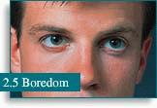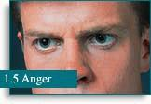

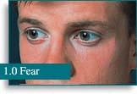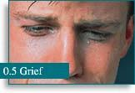

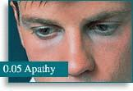
What a person does with his eyes can help you spot his position on the Tone Scale.
Then, in the lower band of anger, he will look away from you, deliberately. He looks away from you; it’s an overt communication break. A little further up the line and he’ll look directly at you all right, but not very pleasantly. He wants to locate you-as a target.
Then, at boredom, you get the eyes wandering around again, but not frantically as in fear. Also, he won’t be avoiding looking at you. He’ll include you among the things he looks at.
Equipped with data of this sort, and having gained some proficiency in the obnosis of people, a person can next go out into the public to talk to strangers and spot them on the Tone Scale. Usually, but only as a slight crutch in approaching people, a person doing this should have a series of questions to ask each person, and a clipboard for jotting down the answers, notes, etc. The real purpose of their talking to people at all is to spot them on the Tone Scale, chronic tone and social tone. They are given questions calculated to produce lags and break through social training and education, so that the chronic tone juts out.
Here are some sample questions used for this drill: “What’s the most obvious thing about me?” “When was the last time you had your hair cut?” “Do you think people do as much work now as they did fifty years ago?”
At first, the persons doing this merely spot the tone of the person they are interviewing-and many and various are the adventures they have while doing this! Later, as they gain some assurance about stopping strangers and asking them questions, these instructions are added: “Interview at least fifteen people. With the first five, match their tone, as soon as you’ve spotted it. The next five, you drop below their chronic tone, and see what happens. For the last five, put on a higher tone than theirs.”
What can a person gain from these exercises? A willingness to communicate with anyone, for one thing. To begin with, a person can be highly selective about the sort of people he stops. Only old ladies. No one who looks angry. Or only people who look clean. Finally, they just stop the next person who comes along, even though he looks leprous and armed to the teeth. Their ability to confront people has come way up, and a person is just somebody else to talk to. They become willing to pinpoint a person on the scale, without wavering or hesitating.
They also become quite gifted and flexible at assuming tones at will, and putting them across convincingly, which is very useful in many situations, and lots of fun to do.
Being able to recognize the tone level of people at a single glance is an ability which can give a tremendous advantage in one’s dealings with others. It is a skill well worth the time and effort to acquire.

