HUBBARD COMMUNICATIONS OFFICE
Saint Hill Manor, East Grinstead, Sussex
HCO BULLETIN OF 16 OCTOBER AD13

Central Orgs
Franchise

R3SC SLOW ASSESSMENT

Ian Tampion of the Melbourne Org, just completing the SHSBC, reports on Itsa and Slow Assessment.

Dear Ron,
Over the past couple of weeks I have had some good wins auditing pcs on R3SC Slow Assessment so I thought I’d write out what I’ve learned about it from your lectures, bulletins, Mary Sue’s talks and D of P instructions and from my experience in Auditing. My only doubt about what I’ve done is that I may have been combining R1C (Itsa Line) with R3SC but anyway it worked so if I’ve got my data straight you may like to pass it on to other auditors. Here it is:
Aim: To keep the pc talking (Itsa-ing) about his present time environment, getting as much TA action as possible, for as long as possible without finding and running a “glum area” that makes the TA rise.
To do this an Auditor should be aware of, and able to use the following definitions:
Pc “Itsa-ing”: Pc saying what is, what is there, who is there, where it is, what it looks like, ideas about, decisions about, solutions to, things in his environment. The pc talking continuously about problems or puzzlements or wondering about things in his environment is not “Itsaing”.
Present Time Environment: The whole area covering the pc’s life and livingness over a definite period. It may be the last day, the last week, the last year, depending on the pc.
A Glum Area: That area which when the pc is supposedly “Itsa-ing” about it, makes him glum and the TA rise, indicating that a Service Facsimile is doing the confronting on that area and not the pc.
The following diagram and the explanation below illustrate just what is taking place in a Slow Assessment and how the definitions given above apply.
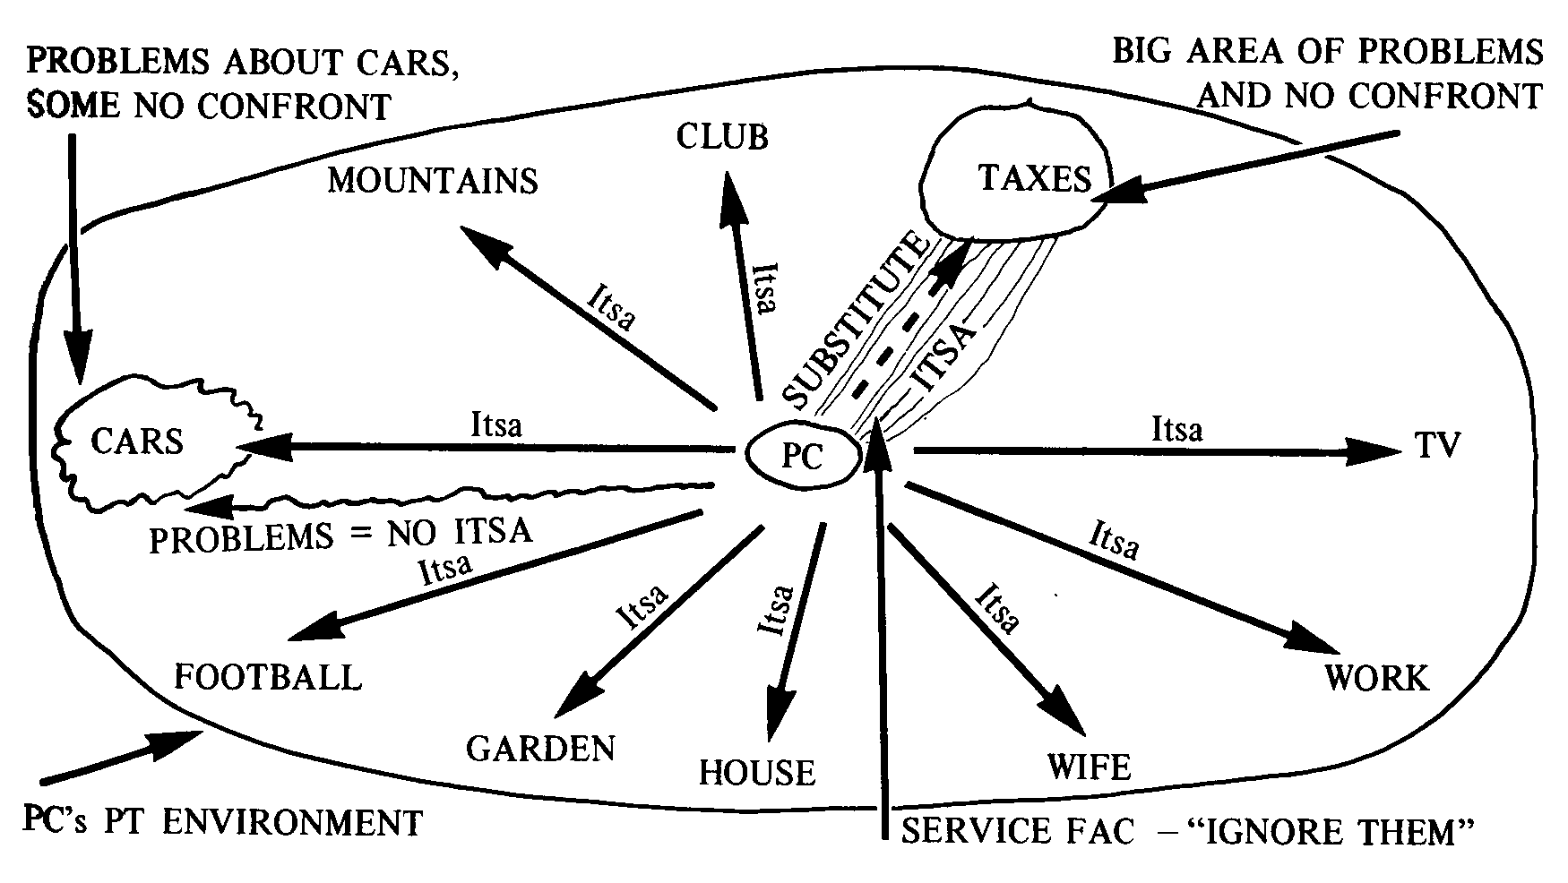

While the pc is talking about football he can say Itsa game, Itsa played by two teams, Itsa played on a field, etc, etc, etc. The same applies to the areas TV, Work, Wife, Club, Garden, House and Mountains. All this will give nice TA action and good gains for the pc.
Now, when he starts talking about cars he will say, “I often have punctures,” “I wonder why my car will only do 100 mph,” etc, etc. While he’s talking like this there will be no TA action or a rising TA and if the auditor lets the pc continue, he will get steadily worse. So, the auditor must put in an Itsa line – e.g. “What have you done about this?” and the TA will start moving again and the pc will get brighter as now he is “Itsa-ing”, before he wasn’t.
Later, or earlier, the pc will start talking about Taxes, his problems, worries, puzzlements, wonders about Taxes – the TA will rise and the pc will become glum. Then, even though the auditor puts in an Itsa line as with the subject of cars, the TA continues to rise and the pc remains glum. This is because the pc can’t Itsa this area – he’s “got it all made” – ”IGNORE THEM” and this does all his confronting for him. In other words, the Service Fac is a substitute confront and so the TA rises (Note the old rule about rising needle equals no confront!). This is a glum area so the auditor lists “In this lifetime what would be a safe solution regarding Taxes?”, completes the list, nulls it, gets the Service Fac “Ignore them”, runs it on R3SC and soon the pc will be able to Itsa on the subject of Taxes. This area could be found in the first 5 minutes in which case it may be possible to just note it down and get the pc on to areas he can confront and come back to this one later.
The assessment should go on for hours and hours and hours with excellent TA action and the pc gaining in his ability to Itsa all the time. However it won’t go that way if the auditor doesn’t get the pc to really Itsa what is in his environment, e.g. the auditor shouldn’t be content to have the pc say he lives “out in the suburbs”, he wants the address, its distance from the city, the type of house, how many rooms, what the street looks like, the names of the houses, occupants, who the neighbours are, etc, etc, etc. Itsa! Itsa! Itsa! Also, it won’t go that way if the auditor tries to list safe solutions every time the pc starts talking about his problems in an area as in the example given above with the car. Problems are not Itsa.
Itsa! Itsa! Itsa! Equals TA action! TA action! TA action! Equals Pc better! Pc better! Pc better! Good gains!!
I hope you find this all okay and pass it on Ron as it’s sure a doll of an auditing activity.
Very best,
Ian Tampion

P.S. I found out how most of this goes in auditing by making mistakes first so I learnt the hard way.

L. RON HUBBARD

LRH:dw.rd

