HUBBARD COMMUNICATIONS OFFICE
Saint Hill Manor, East Grinstead, Sussex
HCO BULLETIN OF 31 AUGUST 1971
REVISED
Remimeo

Word Clearing Series 16 R

CONFUSED IDEAS

Whenever a person has a confused idea of something or believes there is some conflict of ideas IT IS ALWAYS TRUE THAT A MISUNDERSTOOD WORD EXISTS AT THE BOTTOM OF THAT CONFUSION.
Example: “I just don’t understand this idea of opposing forces. I think it all ought to be rewritten and....”
Method 2 Word Clearer: “Is there any word there you don’t understand?” READ! STUDENT: “Oh no, I understand all the words. It’s....” “What word is this that’s reading on the meter?” “Er... ah... Forces?” “Yes, that reads and blows down. Let’s look it up.” “Oh no, I know what it means. It’s the idea that....” “Let’s look it up!” “Well, all right. Let’s see D... E... F... FO... FORCES. Here it is. ‘That which changes the motion of a body on which it acts.’ “ WD CLEARER: ‘‘Use it in a sentence several times.’’ Student does. “... er... ah. I’ve got it. Hell I thought it meant police brutality! Couldn’t figure out why two police forces would fight!” Word Clearer: “Now how do you feel about this idea of opposing forces?” “Oh, let’s see. Why that’s clear enough. Just like I’d never read it before!” METER: F/N.
Every green body of students will argue and fuss about ideas or confusions in the directions or material they are given to read.
They will generate weird ideas and erroneous concepts of what the text says. They do wrong things and say the text said to. They ask strange ideas of their instructors. They clamor for “clarifications”.
AND AT THE BOTTOM OF ALL THIS IS SIMPLY MISUNDERSTOOD WORDS.
There is not also misunderstood ideas. There is only the misunderstood word which breeds, then, huge towering wrong ideas.
A MISUNDERSTOOD WORD BREEDS STRANGE IDEAS.
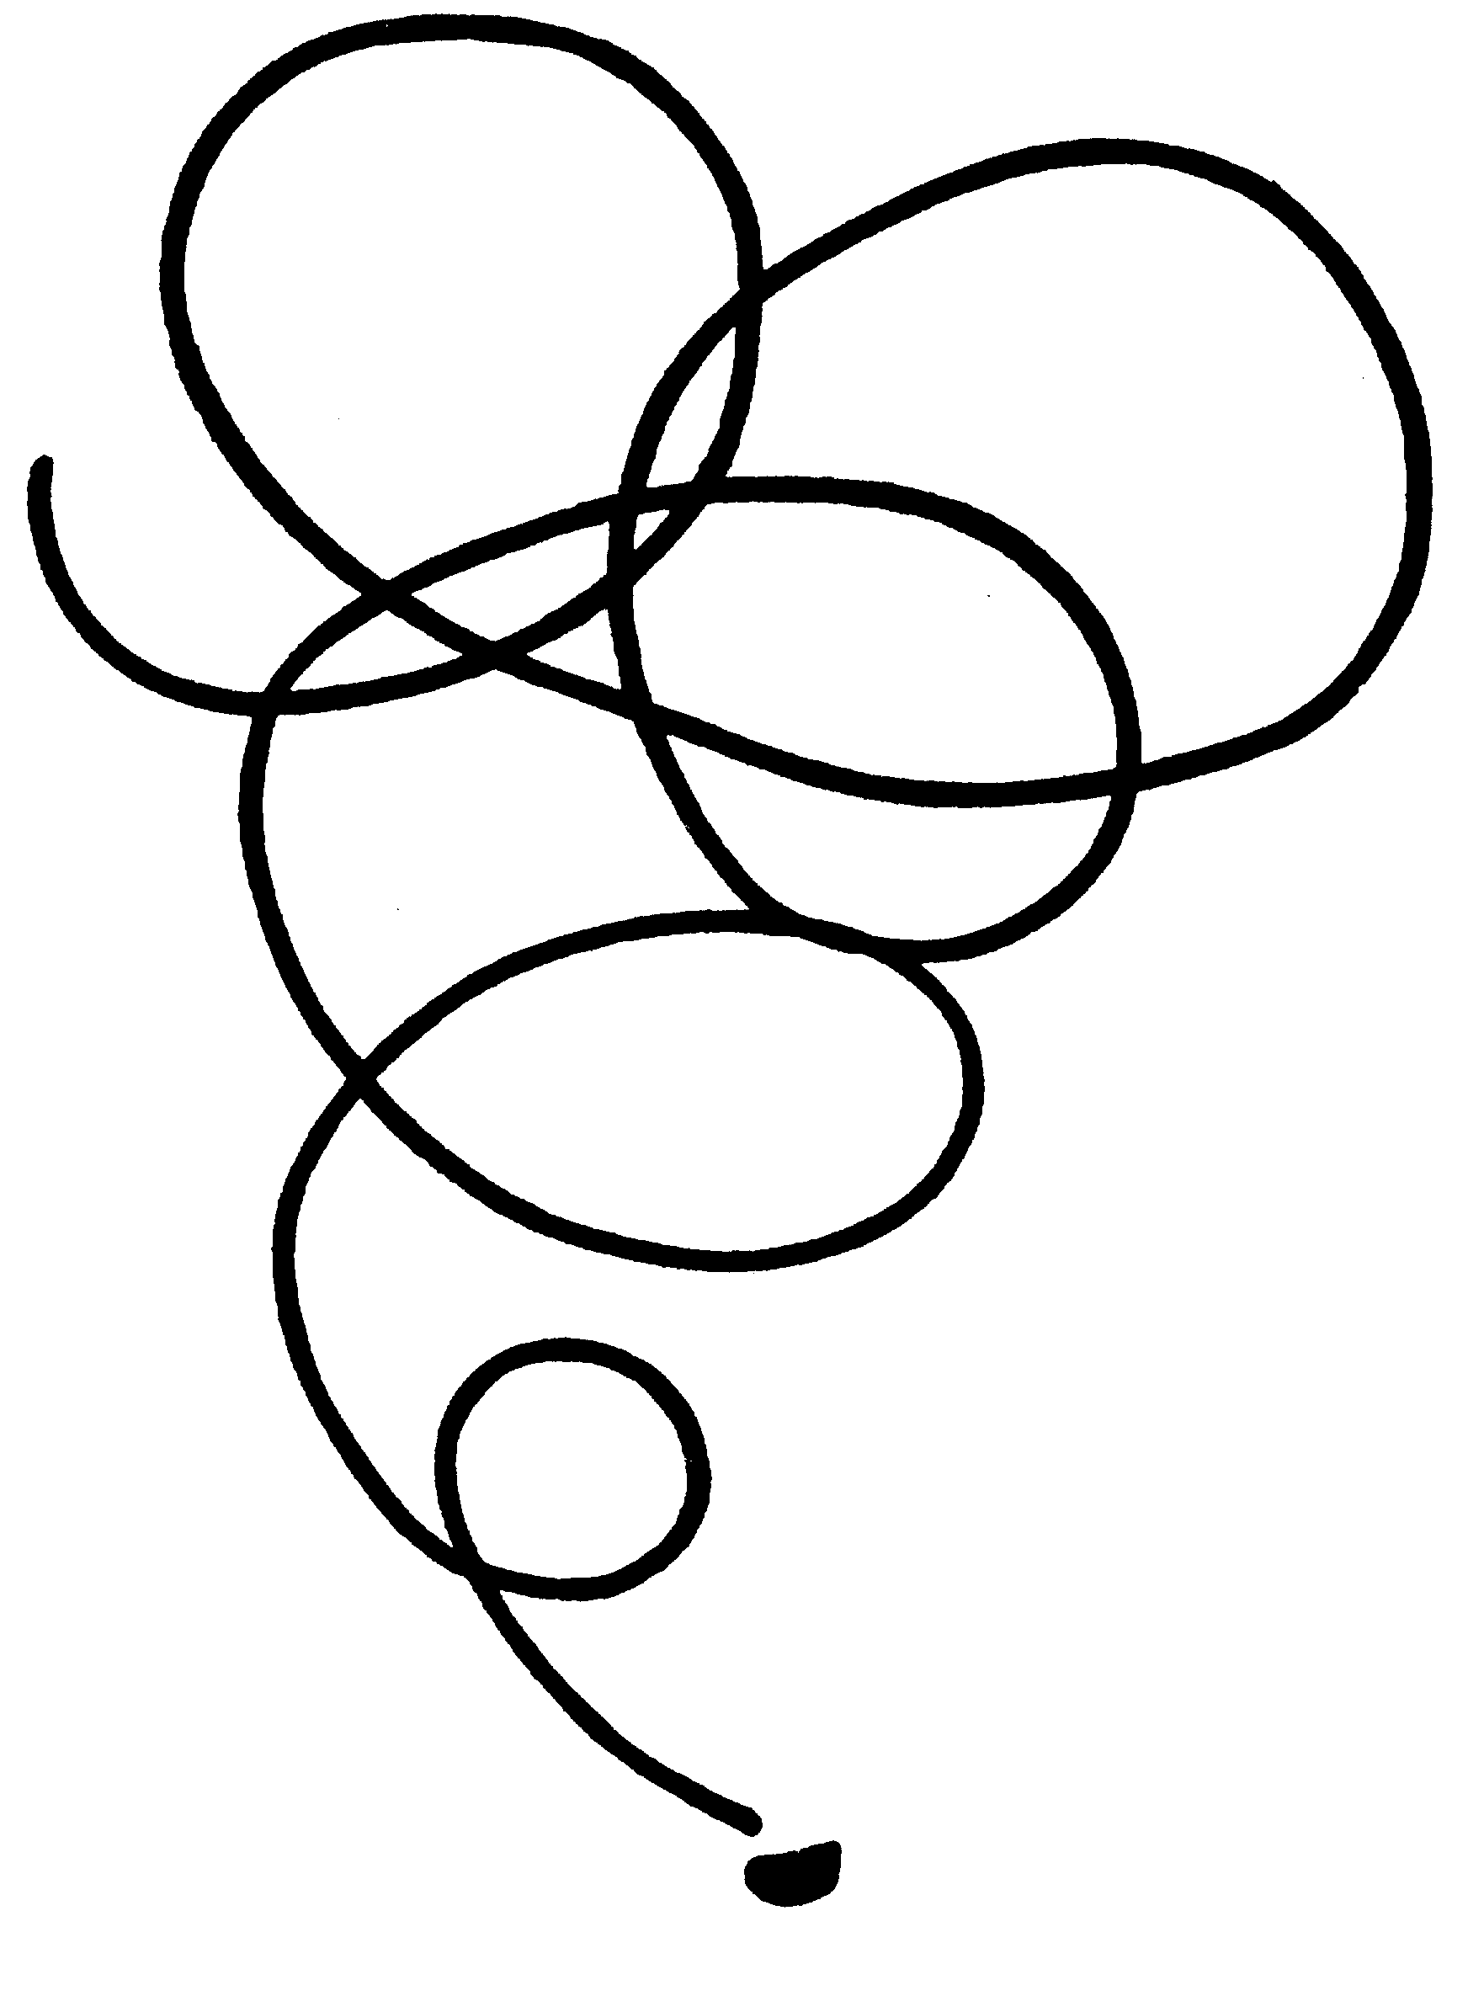
Picture of a
Students Mind

L. RON HUBBARD
FOUNDER
LRH:nt.rd

