BOARD TECHNICAL BULLETIN
12 SEPTEMBER 1963R
REVISED & REISSUED 7 SEPTEMBER 1974 AS BTB
(REVISION IN SCRIPT)
Remimeo
CANCELS
HCO BULLETIN OF 12 SEPTEMBER 1963
SAME TITLE

CCH’s DATA

The CCHs are a highly workable set of Processes starting with Control, going to Communication and leading to Havingness, in that order. The CCHs are auditing specifically aimed at and using all the parts of the Two Way Comm Formula.
CONTROL is the first action of the CCHs and is highlighted by being done Tone 40 for the first two CCHs (CCH 1 and CCH 2).
The reason for Control being the main point is simply to bring about an awareness of Terminals to which communication will be possible; this is done by A. bringing to the PC’s awareness that his body and he are being controlled from a particular KNOWN SOURCE POINT and B. that he also is a Source Point of Control with Control over self and body, all of which is accomplished with CCH 1. i.e. Awareness of two known terminals:
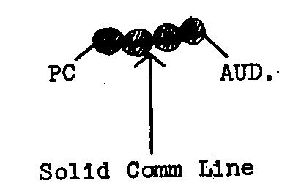
Once the above has been done with CCH 1, the gains can be developed further with CCH 2 by finding for the PC more known points (environment) and familiarity in this “new” environment plus the beginnings of the next major step forward in this development of Communication, the awareness of distance, i.e.
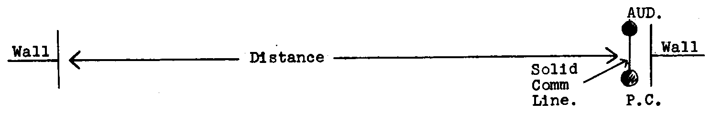
COMMUNICATION (CCH3) is the next major step forward in the rehabilitation of your PC. Tone 40 is used in the next step but only on the motion. Communication is encouraged. The type of Communication practised by the actual auditing actions is that of “one way communication” i.e. Cause-distance-effect with intention, attention, duplication and understanding, plus the first glimmerings of cause being given to the PC by Auditor receiving PC’s comm and then getting the PC to get the idea of contributing to the motion. In this section you are also going to develop the PC’s ability to reach by showing him it is safe to reach across a distance (hand contact mimicry) and then reduce his dependency on YES? and increase his reach even more (hand space mimicry). i.e.
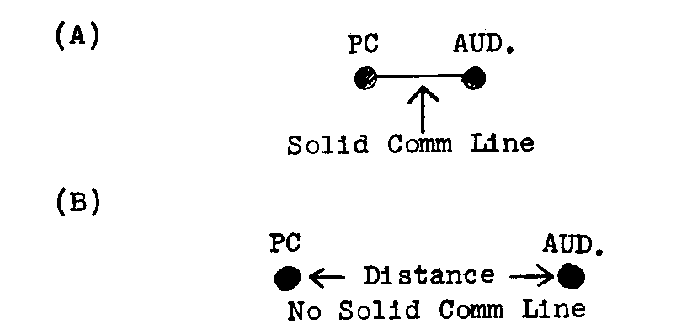
As an added bonus to the above you are also on the beginning step of Havingness (Duplication) as you will be teaching the person to duplicate as a being in two way communication and not as a body with reference to body Right and body Left.
HAVINGNESS is the final step in this portion of the CCH formula (full formula CCHCACTCH where A = attention (control) T = Thinkingness (control)). This step of CCH 4 is the final culmination point which restores the PC’s ability to be in good two way communication with a high level of Havingness. By the use of Duplication, the full Two Way Communication Formula is practised in a physical manner with the result that you will have travelled a very very steep case gain from No Comm as a Thetan to full Two Way Communication as a Thetan with lots of Havingness. i.e. The emanation of an impulse or particle (Book and Motion) from Source Point across a distance to Receipt Point with the intention of bringing about at Receipt Point a Duplication and understanding of that which emanated from the Source Point, with Receipt Point then becoming the Source Point back across the distance to the Source Point which has now become the Receipt Point with intention, attention, duplication and understanding.
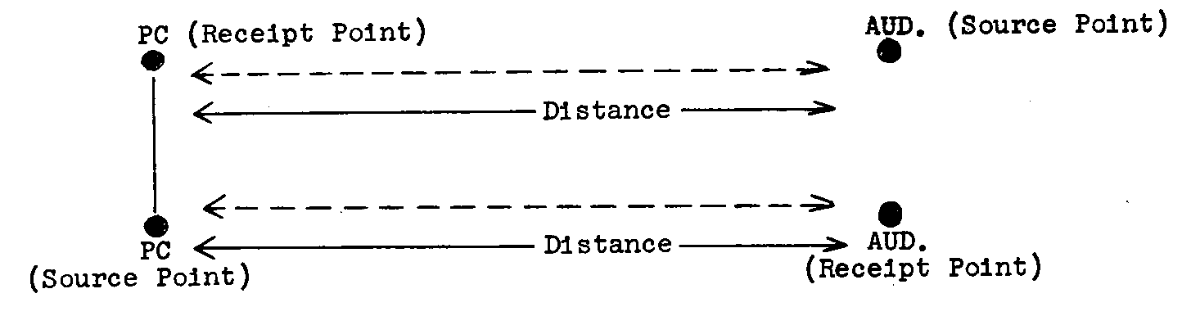

OBSERVED GENERAL ERRORS
1. Not knowing how to change from Hand Contact Mimicry to Hand Space Mimicry.
ANS. The change occurs on the run through the CCHs after Hand Contact Mimicry is flat with no change, i.e. CCH 1, 2, 3 (HCM with change), 4,1,2,3 (HCM with change) 4, 2, 1, 2, 3 (HCM 5 commands only, no change), 4, 1, 2, 3 (Hand Space Mimicry).
2. Trying to handle “verbal originations” on Tone 40 CCH 1 and 2.
ANS. Tone 40 is used to overcome revolt of circuits, Body Originations are handled, circuits are not validated.
3. Overwhelming PC with very slow, very fast or continuously varying speeds of movements.
ANS. An overwhelm is always wrong. Velocity plays an important role in being part of the Comm Formula. By all means experiment with it but pay close attention to PC, make for wins and increase tolerance, not losses and decrease tolerance.
4. Interrupting PC to handle a Body Origination.
ANS. Body Originations must be picked up when they occurs. In deciding to pick up a Body Origination the Auditor should bear in mind that it is against the Auditor’s Code to prevent a PC from carrying out a command.
5. While doing CCH 4 Auditor tells PC to do it Mirror-image-wise.
ANS. When the process is being done as per the Two Way Communication Formula you will see that the PC will be executing the command “mirror-image-wise” (the receipt point has become the source point). However, to tell the PC to do it mirror-image-wise is absolutely wrong as such a direction will prevent the PC from looking and put him on a self-audit.
6. Not being sure of a CCH flat point.
ANS. Flat Point = 3 cycles with no change in Comm Lag, no physically observed change and the PC doing it.
7. Imprecise Body movements of Auditor on CCH 2.
ANS. Auditor on right side of PC (PC on Auditor’s left) with Auditor slightly in front of PC except on “Turn around”.
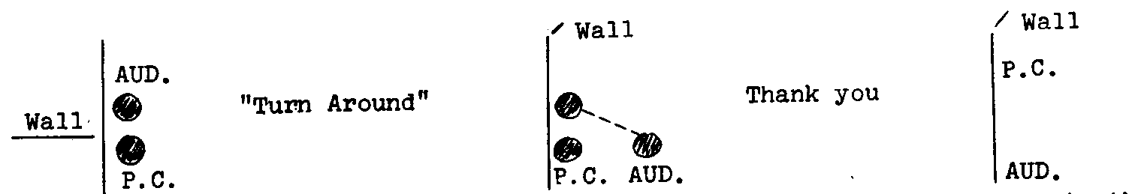
The change of position is achieved by moving the left leg one pace to the left and forward in each case.
H. G. Parkhouse

Revised & Reissued as BTB
by Flag Mission 1234

I/C: CPO Andrea Lewis
2nd: Molly Harlow
Authorized by AVU

for the

BOARDS OF DIRECTORS
CHURCHES OF SCIENTOLOGY

BDCS:SW:AL:MH:HP:mh

