SUPPLEMENT NO. 1 to SCIENCE OF SURVIVAL
September, 1951

From
The Hubbard Dianetic Foundation, Inc.
Wichita, Kansas

All Possible Aberrations

From a Lecture by
L. Ron Hubbard

The Central Dynamic of the individual is the urge toward survival. As the urge is influenced by outside forces it either becomes suppressed or alloyed with the purposes of other persons who are forcing their wills upon it, thus becoming, to some degree, enturbulated.
A large vertical arrow serves to represent this Central Dynamic. As the dynamic is cut back or entered upon by suppressing influences such as the lack of the necessities of life – food, clothing and shelter – the arrow becomes more and more bent and warped until it is headed toward succumb, in the opposite direction. This is the direction of death. When the arrow points toward death it does so in the same ratio that the dynamic is enturbulated, and when it points toward survival it does so in the ratio that the dynamic is clean and clear. When pointing toward survival it reaches up into the high ranges of the Tone Scale.
Suppose we inspect this dynamic through a “magnifying glass. “ We find that the arrow is in reality composed of eight arrows, that the Central Dynamic is subdivided into eight parts; that is, SURVIVAL may be considered in terms of (l) Self, (2) Sex and Future Generations, (3) Groups, (4) Man as a Species, (5) Life (in any of its many forms), (6) MEST, the Physical Universe, (7) Theta (thought), and (8) The Creator.
The First Dynamic is man’s urge for survival for himself as an individual organism. Past philosophies were worked out on the basis that each man was a separate entity and that everything was done by him out of motives of selfishness, and that this First Dynamic was the only dynamic. Arranging everything in terms of receiving an individual reward for helping groups, mankind and life is a clumsy and unnecessary procedure.
The Second Dynamic is man’s urge toward survival as a future generation. Through sex he creates other individuals, expressing through children the urge to survive. Past therapies and philosophies dealt exclusively with the Second Dynamic, attributing every motive man had solely to sex. These philosophies and therapies decayed with the passage of time. Because they attributed all evil to sex and declared sex to be evil, their proponents did not procreate and so are not with us any more.

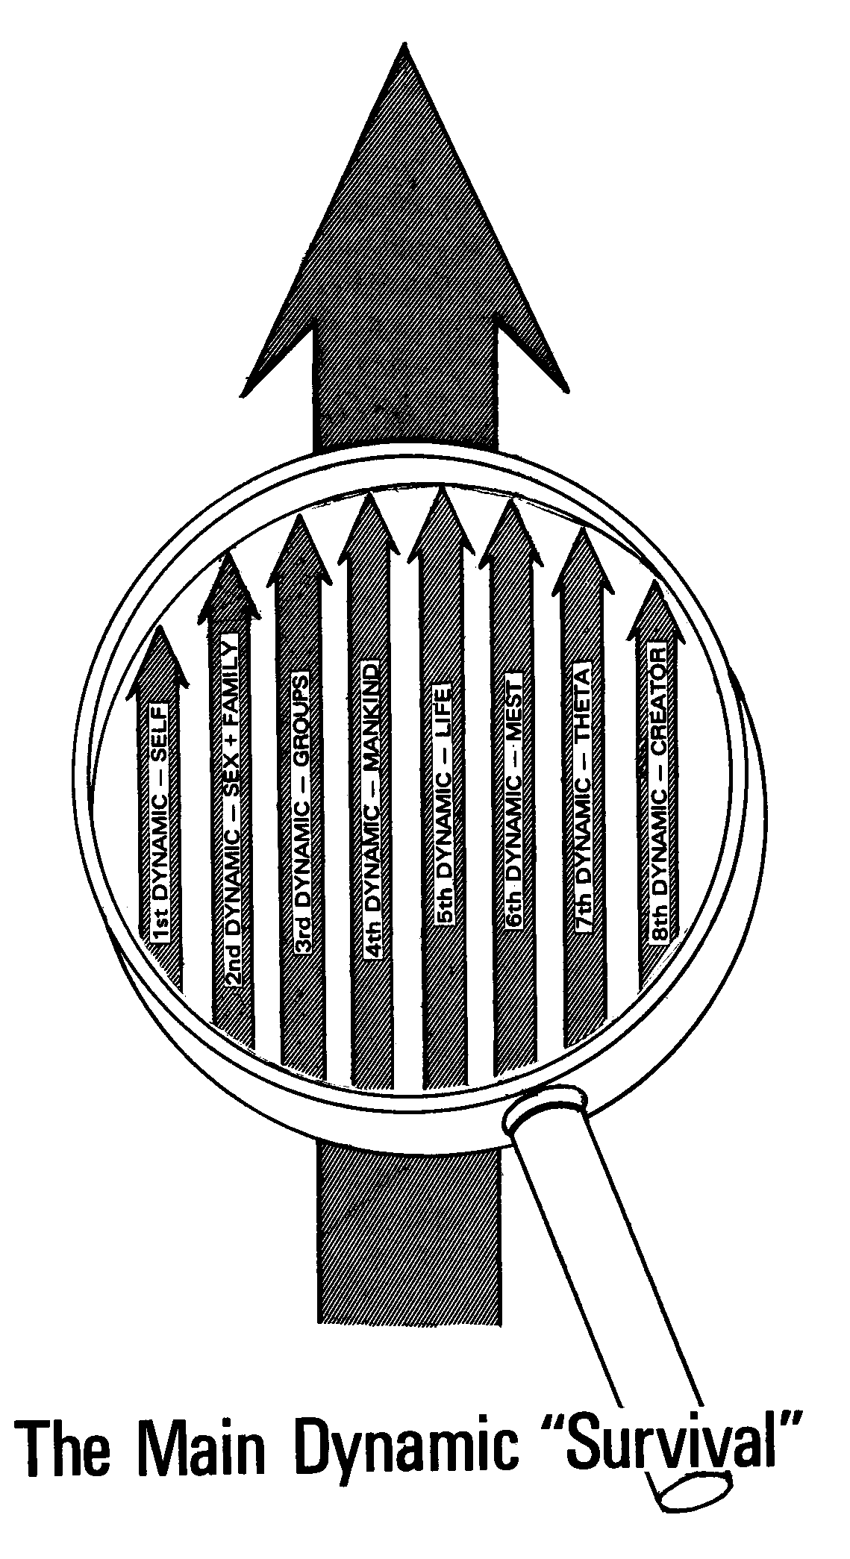
Then Marx propounded a theory that the only important thing is the group. Entire nations operate on this one dynamic alone. They do a thorough job of working out everything in terms of the Third Dynamic, but it leads to a rather unbalanced situation, wherein the individual has no importance and the family is absorbed by the state. Mankind is scheduled for annexation by the state. Life and MEST belong to the state, spirituality is denied by the state, and the Supreme Being is replaced by the state.
Currently there is in California a philosophy which teaches that everything is attributable to man as a species, the Fourth Dynamic. It advocates that nations, groups and sub-groups should not exist as such – only man should exist. It stresses that the only urge man has to survive is as a species.
Man’s urge to survive as Life and to cause all life to survive may be considered the Fifth Dynamic. He may erect bird havens, raise Pekinese dogs, or go to extraordinary lengths such as a certain cult in India which lives by the idea that the Fifth Dynamic is the only one. The members of this cult would never step on a cockroach because they believe the cockroach is Life, and that Life should never be subdivided into anything smaller.
The Sixth Dynamic embraces the urge to survive for the physical universe, or MEST. The “Cartoon Capitalist” falls into the category of a group believing that the most important thing in the universe is MEST. “Can I see it? Can I feel it? Can it be measured? Well, then it exists.” He holds that man exists solely by virtue of mud having one day become animated. Such a materialist is often found in the scientific laboratory. He uses Boyle’s Law, and can make tractors and atomic bombs and can even control the atomic bombs so precisely that when he pushes a button they go BANG! but somehow he has never learned how to control the thumb that pushes the button. The mud-to-man theory has been applicable solely to mud. The idea that structure controls function has failed to predict or control any function.
The postulate that function controls structure brings us to the Seventh Dynamic. This is the urge of the individual to survive as thought, or theta. Some day man may be able to start a flow of theta from one point to another, but even now it works well as a theory. Through use of the theta postulate human beings can be rather rapidly de-aberrated. Theta plus MEST equals life. Theta energy, whether from a divine Creator or from a battery somewhere in the sky, is not physical universe energy.
For a long time people have been talking about and fighting for and dying because of the Eighth Dynamic. Every Sunday morning people go to church to express their belief that the universe was created. Two or three thousand years ago the Greeks were talking about the Prime Mover, Unmoved. Every time the problem of the origin of the physical universe comes up we have to postulate a Creator or else have no answer to give.
These eight dynamics are all part of the Main Dynamic. The same thing can happen to each one of the divisions that can happen to the Main Dynamic. Just as the Main Dynamic can be hit, interfered with and suppressed until it changes polarity and goes toward Succumb, so may any one of the eight divisions be enturbulated and have less survival value. The eight dynamics are usually selectively aberrated. One’s Second Dynamic can be pretty well out and his Fourth Dynamic practically nonexistent (but the rest of them functioning all right) and he’ll get by. He could even have half of the First, Second and Third and all of the Fourth gone, and still pass for normal.
An individual has the urge to survive along each one of these lines. Life suppresses one after the other, and a changed pattern of overall survival appears. For example, suppose someone suddenly becomes afraid to own anything: he has had the Sixth Dynamic selectively suppressed. Another person believes that there is no divine Creator, and that life is just an accident: he is selectively blocked on the Eighth Dynamic.
Any of the dynamics may be suppressed in two ways. The first is the suppression which says “No!” A person who has been told since he was a child that he was worth nothing, that he was no good and that he would never be able to do anything is likely to have little or no First Dynamic. The First Dynamic changes polarity and starts pointing toward death. This person is capable of committing suicide, unless he is very strong on the Third Dynamic and can live for the group. He may, however, needlessly sacrifice his life for the group. This represents a suppression of the dynamic – the survival urge of the First Dynamic is not sublimated over into the Third; the Third is only more visible because the First has been suppressed toward death.
The second way of suppressing a dynamic is by enforcement: “You’ve got to be a good girl! You have to amount to something! We expect you to be a credit to your family!” After a few years of such commanding the girl who has been forced to be a great credit to her family is unable to do anything. She has been interfered with. Mama has entered her own dynamics into the dynamics of the child, with the resultant blunting of the child’s dynamics. If any dynamic is inhibited, it enturbulates, and if it is enforced, it enturbulates. Either way, it is pushed toward death.
The principle of self-determinism, to be workable, dictates that a dynamic should neither be suppressed nor too thoroughly enforced. On a spectrum from shut off completely to center to maximum enforcement, self-determinism would be found at the center. The individual who is surviving best is exercising all possible rational self-determinism in an environment which allows a maximum of self-determinism. In Europe, for instance, there is much talk of liberty, but the environment has been for so long so suppressive on both the First and Third Dynamics that the European’s idea of liberty is not nearly so expansive and all-inclusive as is ours. Self-determinism is a relative state of being – the more rational an individual is, the more self-determinism he will be able to exert and the more he must be allowed to exert within the limits of his environment. Of course, the more rational he is, the easier he will be to get along with and the better he will handle MEST. An individual whose dynamic has not been enturbulated is in full agreement and affinity with the world, and is in good communication with the MEST universe (sight, sound, smell, touch, etc.).
Anything that aberrates the individual’s urge toward survival will aberrate his self-determinism. This is the basic form of aberration. But how many manifestations does the basic aberration have? To answer this it is necessary to examine the component parts of theta: affinity, communication and reality. Theta must remain in affinity with, communicate with, and have agreement with other theta in its vicinity. All three together make for understanding. Computation, understanding, thought and education all depend on affinity, reality and communication.
A graphic representation of aberration would be particularly valuable if it could be seen to contain all possible aberrations. To provide this representation a chart, based on the eight dynamics, is drawn with an A-R-C triangle below, floating at some point on the tone scale, and the eight dynamics with their A-R-C relationships listed above. Lines connect the lower triangle with the dynamics above, representing suppressions of the lower triangle down the tone scale.
By use of this chart, and by following the line of reasoning suggested by the statement that both “inhibition” and “enforcement” suppress a dynamic on the tone scale, the auditor can predict any possible aberration that a preclear might have. Any seven of the dynamics may suppress or enforce the remaining one in an individual. The technique which has evolved from the use of the chart is called Dynamic Straight Wire. *
* This is the next advance over Hurdy-Gurdy Straight Wire, which is outlined in SCIENCE OF SURVIVAL: Simplified, Faster, Dianetic Techniques.

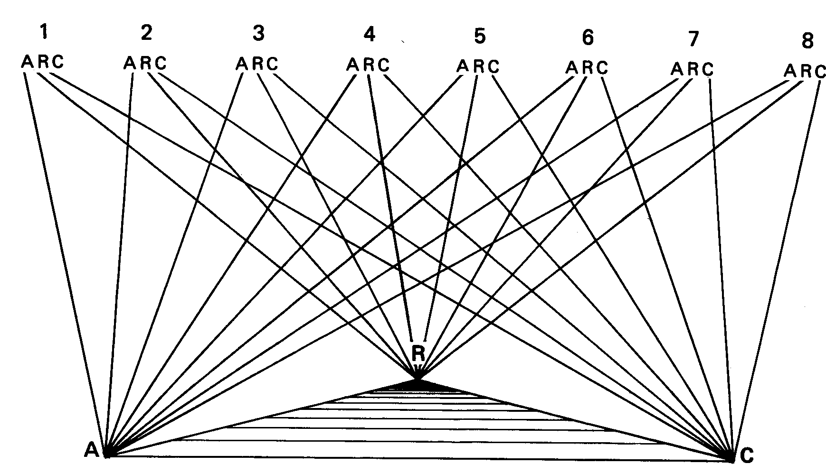

Dynamic Straight Wire
Consider the suppression of the Second Dynamic by the Third Dynamic: what does the group think about sex? The first group which might come to mind is the family. The family’s affinity on the Second Dynamic, when measured by the basic aberration that plagues society at the present time, is very low. Sex is not quite nice and certainly not to be considered as a communicable subject. Agreement within the family concerning attitude toward sex is rare indeed. What is it for? What is it like? When is it proper? Without agreement there can be little basis for reality.
If an individual has been or is a member of a church group which is selectively “thumbs down” on sex, he has been suppressed on the Second Dynamic by the Third. The auditor is interested in finding how a group affected this individual’s Second Dynamic. He seeks to find incidents which enforced the dynamic, and incidents which inhibited it. “What did your family think about children?” It is not always necessary that an attack be made against an individual for aberration to manifest – the statements and attitudes of the persons around the preclear might easily have upset him, even though they were not directly aimed at him.
If the preclear has served a term in the army the auditor will have a broad field for exploration of aberration along the Second Dynamic. “What did the army think about sex?” This one is always productive of results. “Did you ever go on a three-day pass and find an ‘off limits’ sign in the choicest section of the city?” There are few occupied cities which do not contain a rash of “off limits” signs. “Did you ever attend an army lecture about venereal disease?” Of course he did, and if the usual gentle and genteel service communications on venereal disease were given, the preclear will have many locks on the subject.
One case was opened by working with the Second Dynamic as it related to the group in this way: A young man had been raised in a very self-righteous family, and attended church from earliest childhood. As he grew older a very likeable preacher became the man he most wanted to emulate, and one of this preacher’s pet sermons was to call hellfire and damnation down upon the head of anyone who would think or talk about sex. When the young man went into the army he began to hear and see as a common occurrence those very things which his preacher had called down. The general attitude on sex in the army was so radically different from what he had been used to that the difference between the inhibition of one group and the enforcement of the other made him almost psychotic. The auditor used straight wire on both the enforcements and inhibitions on sex, and rapidly raised the young man’s reality and general tone.
Sometimes a girl tells her auditor how nice her dear little pussycats are, but that men and women are awfully nasty. She says that if men and women were only as nice and considerate as her little pets everything would be all right. Somebody in this girl’s vicinity has been talking about how bad people are, and demanding her agreement on the subject. Straight wire in search of such locks will soon relegate her pussycat to its rightful place in her life.
What of the suppressing effect of the First Dynamic on the Second? If an individual has been told that he doesn’t love anybody and can’t love anybody, he will have a hard time with his affinity for his children. If he has been told that he has to be right all the time and that he has to make other people do the right thing, his agreement with his children will come chronically down to 1.5 on the tone scale. He will dominate the children, or try to. If he has been told that he must talk, his children will have a hard time attracting his attention to their ideas. In considering the things in general that the preclear thinks about children and sex, the auditor is considering the suppressing effect of the entheta of the Second Dynamic on the theta of the Second Dynamic. He can in this way determine that the Second Dynamic is suppressing the Second Dynamic. With this in mind, the auditor immediately sees a set of questions to ask.
Suppression of the Second by the Fourth Dynamic is found in the teaching of sections of biology about man, what man is and what sex is in relation to man. Anthropological studies and the disagreements about children and sex in the societies studied may cause enturbulation.
As to the suppression of the Second by the Fifth Dynamic, a preclear from the farm has the subject of animal husbandry. One little girl had been standing unnoticed while her father was talking to a neighbor about breeding a prize cow. He was describing the procedure in great detail, when suddenly mama discovered that the little girl was there, listening. Mama violently scolded papa and sent the girl to bed. The girl was taken completely by surprise and utterly bewildered. Why should she be scolded and suddenly sent to bed and mama and papa have a fight? She worried over this for a long time, eventually becoming thoroughly frightened of animals. It was a relatively simple matter for the auditor to get considerable grief off the case concerning this one incident alone.
Suppression by the Sixth Dynamic is usually heavy because it is caused by MEST, producing engrams of physical pain, the basic cause of aberration. An engram is a break between Dynamic Seven and Dynamic Six, or theta hitting MEST too hard. Or it is a separation of Seven and Six, causing grief due to loss.
How does MEST influence the Second Dynamic? Many wealthy individuals have a prodigious amount of MEST under their control. The pretty girls who tag along with them advertise that MEST has an effect on the Second Dynamic. One of these individuals takes his beautiful admirers for rides in his automobile and has a wonderful time, but one day the automobile is stolen. There will be grief from this break between Six and Two. Or perhaps the same fellow wants children, but has lost his property and home. He feels that he can’t support children without MEST, causing a break on the Second Dynamic. Physical injury affecting the Second Dynamic also comes in this category.
Communication comes in for a share of the breaks on Dynamic Two. One just doesn’t talk about religion and sex in the same breath, for instance. Actually, in this society, communication about sex is inhibited in relation to every dynamic. Anyone who does not talk naturally and easily about sex has been inhibited, even if only by the general social aberrations on the subject. The use of Dynamic Straight Wire on the times a person has been cautioned not to speak of sex will uncover many suppressions of communication.
There are suppressions of the First Dynamic by the Third; for example the fellow who is self-conscious, who won’t join a group because he feels uncomfortable in a group. This also works the other way, by suppressing his normal Third Dynamic by his First. Find out what this type of preclear has been told about groups. It might be that he had to form a group before he could even look at a woman. “You have to be married before you can go around with a woman,” is a common example of the Third blocking the First.
The Third Dynamic may be blocked by the Third because other baseball teams beat the preclear’s baseball team. Each time his ball team is defeated when he is a member of the team his Third Dynamic is enturbulated.
On the Fourth Dynamic, there are races in the world today which consider themselves suppressed by man. Somebody who had something to gain has convinced these groups that they are minorities, and as a consequence their ideas about the Fourth Dynamic are aberrating the Fourth.
An auditor processed a young Jewish boy by straight wire just on the basis of locks on the Third, Fourth and Fifth Dynamics. He came up the tone scale very markedly after running a few locks and secondaries from childhood in which somebody said, “I can lick you – you’re a Jew, and Jews can’t fight, and you don’t belong to this club anyhow.” His mother had taught him that he must get along with the rest of the human race, and that he must learn to be nice to people, and yet they delighted in kicking him around.
The Dynamic Straight Wire chart indicates every possible type of aberration that a human being can have. Each Dynamic can selectively aberrate every other Dynamic. Select each Dynamic in turn and place it at the bottom of the chart, and question the affinity, communication, and reality of each of the Dynamics in relation to the one at the bottom.
What would an auditor do about a preclear who is aberrated on the Eighth Dynamic? He would place Dynamic Eight at the bottom of the chart and find out how each of the dynamics has acted to influence the Eighth. To begin with, he inquires as to the affinity enforcement between One and Eight, the reality enforcement, and the communication enforcement; and then the affinity inhibition, reality inhibition, and the communication inhibition.
An auditor asks: “What is God going to do to you?” Answers appear such as, “God’s going to take my soul.”
Mama has said to him, “You know, dear, an angel will come to you in your sleep.”
“He will?” the child answers. “Well. . . I don’t know if I want to see an angel. What’s this angel liable to do?”
“Oh, nothing, dear. All angels are good, except the ones that give you bad dreams.”
“But I thought you said angels were good.”
“Well, most angels are good, but some of them are bad,” mama continues. “You know that angels exist.”
“But Tommy says there aren’t any angels, and Grandpa Dooley says there aren’t any.”
It is little wonder that there is considerable confusion between Dynamics Eight and One.
By using Dynamic Straight Wire a case may be unburdened of irrationalities and miscomputations which are aberrative, and be put into shape to run secondaries and engrams. It is a system for predicting all possible aberrations caused by the suppression of the Dynamics. Any Dynamic is capable of suppressing any other Dynamic. Many auditors have been restricting themselves to the effect of the First Dynamic aberrations on the First Dynamic, or the effect of the Third Dynamic aberrations on the First Dynamic, but these are only a small fraction of the aberrations which the preclear can have. All of the Dynamics in all of their combinations of aberration should be considered. Find entheta wherever it is and convert it to theta. What papa and mama have said around baby is very important, but it is very very far from being the only thing in the case. The preclear has gone to school, has belonged to the Boy Scouts or been in the army; he has belonged to a church and he has suffered through a summer camp. And often he has been hammered by some cynical atheistic fellow who tried to convince him that his religious beliefs are all wrong. All these things are discovered when using Dynamic Straight Wire. By using Dynamic Straight Wire an auditor can question a preclear on a much broader, more thorough basis than before.

