Remimeo
HUBBARD COMMUNICATIONS OFFICE Saint Hill Manor, East Grinstead, Sussex
HCO POLICY LETTER OF 23 OCTOBER 1981
(Originally published in 1952 as Booklet 29 of the Professional Course Lecture Summary series. Reissued as HCO PL for use in a Dept 17B course.)
DYNAMICS AND THE TONE SCALE
(Note: This is a summarization of an LRH taped lecture, compiled in written form by D. Folgere.)
As an individual goes up the tone scale, he IS more and more of the dynamics and he IS more in each dynamic.
Figure I shows the parallel development of the regular tone scale and the expanding scale of BEING the dynamics* We see that an individual must go up the tone scale through all the lower ranges and even through 3.5, 4.0 and 8.0 before he succeeds in BEING even the first dynamic. He must be at 8.0 before he can BE "himself."
Whereas formerly 4.0 was held to be the end and goal of processing, now it is shown to be only the beginning of the beginning in terms of BEING. Four-point-0 is good survival, but it is very limited BEING.
The idea of this scale is a very interesting one: That an Individual IS the dynamics additively as he ascends the tone scale. However, qualifications must be presented immediately, so that the student will not think that he must take this scale literally, number for number.
In the last series of compilations, the Summary Course series, the idea was presented that the tone scale might be extended from 40.0 to 400.0 and from 400.0 to 4000.0 and that God was to be found at 4000.0 because that was as far as the scale went. This is a perfectly valid idea, and it is men-tioned here to indicate that making the eighth dynamic, or the BEINGness of all, equivalent to 40.0 on the tone scale is merely an arbitrary assignment of value.
Also, the tone value for the BEING of each dynamic has been chosen arbitrarily, though not without some deliberation.

HCO PL 23. 10.81
- 2 -
Twenty-two-point-0 is assigned as the point of BEING the sixth dynamic, since 22.0 represents optimum randomity. In other words, motion is considered to be in its most harmonious relationship with theta at that point, and so that point is the obvious choice for the sixth dynamic, which is purely motion.
8
7
y
6
5 n
4
3
2 m
d
a
c
s
40.0
32.0
22.0
15.0
4.0
2.0
1.5
0.5
0
TO BE
o
n
e
Not TO BE
Figure I
It should be obvious to the student that there is no intention to imply by this scale that the individual does not begin to BE the third dynamic until he reaches 12.0, and that he does not begin to be the fourth until he reaches 15.0. It is reasonable to assume that the individual begins to be all dynamics even at 0.5 on the tone scale. The idea which is

HCO PL 23.10.81 – 3
meant to be implied by the scale is that the individual does not succeed in BEING effectively upon the various dynamics until he has reached various points on the scale, and it is thought that these points correspond to the tone scale roughly as shown in figure I.
In order to BE the fifth dynamic, the individual must already have made a success of BEING the fourth. In order to BE the fourth, he must already have made a success of BEING the third, and so on.
Let us examine what is meant by BEING the dynamics.
Let us suppose that an individual decides to take part in the MEST universe and that he is unfortunately so low on the tone scale, through having met with certain unnamed and unthinkable experiences, that he is able to BE only a small portion of the back of his own neck. He has nominal control of an entire individual human organism, but he feels out of touch and out of control with all of it but a small portion of the back of its neck. We might expect to find such an
individual near apathy on the tone scale.
/
A course of processing brings the self-determinism of this person up to a point where he is thoroughly capable of controlling his body and using it, where he feels completely in affinity, communication, and agreement with it, where it does nothing which he does not want it to do and does everything which he does want it to do. We might be justified in saying then that this individual was BEING himself, as an organism. We might say that he was successfully BEING the first dynamic.
We might also say, however, that he had not yet succeeded in BEING any other dynamic but the first.
How would he go about BEING another dynamic?
The next dynamic in order is the second dynamic. He will next succeed in BEING the second dynamic.
Of course, if this individual has succeeded in BEING the first dynamic, he will be surviving very well along the second, third, fourth, fifth, sixth, and seventh dynamics. But surviving is not the activity which we are considering now. We are considering BEING.
How is an individual able to BE the second dynamic?
We are quite used to the idea that a person IS his individual organism. In fact, we are too used to it. In our present culture, the statement "A person is his individual organism" means "A person equals his individual organism.^{n} In other words, he is just that organism, and he is no more than that organism. In Scientology, we have seen the fallacy of this idea. In Scientology, the statement "A person is his organism,^{u} means that some individual has achieved complete BEING within his organism, so that he is CAUSE within it.

HCO PL 23.10.81 – 4
When we recognize the fact that BEING the organism does not mean being equal to the organism, we can see more easily how an individual might BE the other dynamics as well as the first.
BEING the organism means being CAUSE within the organism. BEING the other dynamics means being CAUSE within the other dynamics. Of course, it also means KNOWING, TRUSTING, WINNING, BEING FREE, and all the other parts of BEING which are enumerated along the top of the tone scale.
BEING the second dynamic means KNOWING, TRUSTING, WINNING, BEING FREE, and all the rest, along the second dynamic.
There is no particular significance to the boundary which we artificially place around BEING by recognizing the physical body as a thing of importance. But this boundary can be very aberrative. naturally, if a person believes that he is equal to his body, he need only observe the failings of the body to which he is equal to see that he is rather a poor thing. If he is equal to his body, then there is very little hope for him. The body is a certain size, a certain weight, a certain texture. It has a little strength. It has a little beauty or a little ugliness, or both. It knows pleasure and pain, stimulus and response. It is MEST, therefore he also must be MEST.
If, on the other hand, a man knows that he is not equal to his body, but is CAUSE within his body, then he may aspire to be better CAUSE and to be CAUSE on a wider scale than just his body. He may desire to move out into the other dynamics, to BE the other dynamics.
When he has become his organism, so that he IS his organism, he then goes on to the second dynamic.
In its first stages, the second dynamic is concerned with a close physical and non-physical relationship with an individual of the opposite sex. The outward form and appearance of this relationship, as it is practised in the present culture, is familiar to all of us. When it is new it is sometimes called "love." When it is a little older it is called "marriage." When it is finished it is sometimes called "widowhood" and sometimes "divorce." It is praised by some and condemned by others. The majority of both sides profess not to understand its mysteries.
What is the secret of love? What is the way to a happy marriage? These are questions which have been asked and answered many times. From Ovid to Mr. Anthony, answers have boiled up in the turbulent cauldrons of human culture. Some of the answers have been wise, many stupid. Most of them have concerned themselves with trifling details, whether of bedroom or (in the United States) of breakfast table. Few of them have shown the way to being happy in love and in marriage, since few of them have said anything which would lead to BEING.

HCO PL 23.10.81 – 5
If we were to try to enunciate the simplest possible rule for happiness in love and in marriage, we might say something like this: The successful sex relationship depends upon man and woman reaching a high degree of agreement on immediate and long-term goals and maintaining that agreement without establishing a CAUSE and EFFECT relationship. Both individuals must be CAUSE within the sex relationship, or it will degenerate into a mere master-slave relationship or a domination-nullification relationship.
This does not mean that there should be no difference between a man and a woman, or that they should squabble over how to boil an egg or chop down a tree. It means that if an agreement is reached as to the division of labor within the relationship, then each individual should be CAUSE directly in his own division and should be CAUSE, indirectly through the other individual, in the other's division.
And how can one individual be the CAUSE of another's actions without making that other individual into an effect? Can this be done?
The way to become CAUSE of another's actions is to assume responsibility for them without controlling the other's execution of them.
If all married persons would begin to assume responsibility for each other's actions and would treat those actions as their own, most of the trouble in marriage would be eliminated. Of course, this would call for a large degree of agreement on what goals were desirable and what methods should be used to reach those goals. But this large degree of agreement is not difficult to reach. Any two intelligent and relatively unaberrated people can reach such an agreement (or fail conclusively to reach it) before marriage. The difficult part, in this society which teaches that in the biblical phrase which urges each of us to be his brother's "keeper" the word "keeper" means "animal trainer"—the difficult part is maintaining that agreement without establishing a CAUSE-and-EFFECT relationship instead of a CAUSE relationship.
What are the advantages of a CAUSE relationship?
The simplest and most inclusive expression of these advantages is that since a human being is CAUSE, a CAUSE relationship will allow him to be a human being, whereas a CAUSE-and-EFFECT relationship will make him an EFFECT and so prevent him from being a human being. This is true even of the individual who begins the CAUSE-and-EFFECT relationship in the CAUSE role. The process of making an EFFECT out of another human being is a very dangerous one. It leads to making an EFFECT out of the perpetrator also. After a while, aCAUSE-and-EFFECT relationship degenerates into a simple EFFECT relationship, with both individuals in apathy. This is normally considered "a good adjustment," and the victims are said to have learned to be tolerant of each other and to live with each other's faults.

HCO PL 23.10.81 – 6 -
Society, in 1952, frowns on a CAUSE-and-EFFECT relationship, although in the Victorian days it was held quite proper that the man should be CAUSE and the woman EFFECT. Society in 1952 much prefers an EFFECT relationship, and most marital counseling is aimed toward such a relationship. The clients are urged to make allowances for each other. They are taught tricks of controlling their tempers, and they are advised to trade tolerations. If Mary burns the toast, John is supposed to remember that this gives him the right to get mud on the floor. Tit for tat. A good bargain. The clients are urged to accept the fact that all people have faults and that no one is perfect and no one can be perfect. Their hope for a satisfactory relationship is removed, and an iron cage of well-adjusted apathy is substituted. They are told that this is the best that can be expected.
It is not.
Instead of going down the tone scale from the Victorian CAUSE-and-EFFECT relationship to the modern EFFECT relationship, it is possible to go up the tone scale to a CAUSE relationship, in which both partners feel responsible for each other's acts and in which each partner feels that the other is acting for him. If Mary burns the toast, John accepts responsibility for this action. This does not mean that he assumes all the responsibility and leaves none for Mary. It means that he assumes all the responsibility and that Mary assumes all the responsibility, too. They both assume all the responsibility. Under such an arrangement, no one can be blamed. All their attention goes into doing better with the toast, and none of it is wasted in blame.
It is perfectly obvious to John that Mary did not want to burn the toast. Even if she is suffering from an aberra-tive compulsion to burn the toast, John knows that she does not want to burn it except as she acts under this compulsion. He knows also that the only way to release her from the compulsion is to bring her up the tone scale, and he knows that he cannot bring her up the tone scale by blaming her and making her an EFFECT, but only by accepting her effort as his own, by making her CAUSE.
It may seem odd that Mary can be CAUSE if John accepts her effort as his own, but that does not mean that he takes her effort away from her—it means that he allows his BEING to flow into that effort. He validates her effort by letting it be a part of him. He does not invalidate it as itself by refusing responsibility for it. He does not invalidate it as her effort by interfering with her performance of it. He validates the effort by being responsible for it, and he validates Mary by letting her be the one to control the effort. He does not try to control her efforts, and she does not try to control his, but each of them assumes responsibility for the efforts of the other.
We may be able to see more clearly how this works if we hypothetize an outside individual who is temporarily hostile to John and Mary.

HCO PL 23.10.81 – 7
Mary runs the family automobile into the neighbor's gate. The neighbor rushes over in a huff and encounters John in the front yard. The neighbor says, "You just ruined my gate!" John goes with the neighbor to look at the gate and at the car. Sure enough, there is blue paint on the gate and white paint on the car. The evidence is conclusive. John agrees with the neighbor that the gate has been damaged by John's car and he asks the neighbor to have it repaired and send him the bill. The neighbor says that the damage is not very great and so he will repair it himself. John lends him the tools and helps him to repair the gate. John insists on buying a can of white paint, and the neighbor says he will enjoy painting the gate on Sunday. He apologizes for being so excited at first. They shake hands.
John goes into the house, and Mary says, "Dear, I hit the Jones's gate with the car." John says, "Yes, I know. We've already repaired it." Mary says, "I'm sorry. I was thinking about the bathroom curtains." John says, "That's all right. What about the bathroom curtains?" Mary says, "I want to dye them blue." John says, "That's a good idea."
If nobody is to blame for the damage to the gate, a constructive subject like dyeing the curtains will immediately attract John's and Mary's attention, since it represents future action.
Now, the reader may say, "But what if Mary runs into the neighbor's gate every week—just like in the funny papers?"
The answer is easy: It is not necessary to live as though one were living in the funny papers. Two possibilities arise. Either Mary has some aberration which makes good driving impossible for her, or she has not. The chances of the first are very slight. If she can walk, she should be able to drive the car—PROVIDED she can drive the car as CAUSE and not as EFFECT. If Mary's vision is such that she cannot see the neighbor's gate, then an agreement must be reached whereby she does not drive the car. But if she merely runs into the gate "through carelessness," it is ten-to-one that someone is interfering with her self-determinism about driving the car. John's most constructive course is to let her go on driving the car and running into the gate and to assume responsibility for her actions. Of course, he may have to pay out two or three hundred dollars for new fenders and new gates, but that is a very small price to pay for bringing his wife up the tone scale to the point at which she can operate the machine rationally. The moment Mary realizes that she is CAUSE when driving the car and that no one is interfering with her, she will not hit the gate.
It must be admitted that the hidden memory of past interference with her driving may act in present time to aberrate Mary's driving even though John keeps his hands off and is truly responsible for her actions. In this case, it may be decided that Mary should not drive, or it may be decided to try, by auditing or simple discussion, to clear up the aberra-

HCO PL 23.10.81 – 8
tion stemming from past interference. no matter what is decided, however, Mary is not to blame for hitting the gate. Her not driving is not a punishment, it is only a method of preserving the gate.
The foregoing discussion of John and Mary is meant to illustrate what it will be possible for John to accomplish in his marital relationship in the way of construction if he is BEING the second dynamic and is not just managing a bare survival along the second dynamic. If he IS the second dynamic, then he IS Mary. Her efforts are his efforts. Her responsibility is his responsibility. Her gain is his gain.
This does not mean, in the slightest particular, that John is not himself. He is not less himself because he IS Nary. He does not give up the first dynamic in order to take on the second, he adds the second dynamic to the first. Having become CAUSE within his own organism, he now extends his causation to another organism, but since this other organism already contains a first-dynamic CAUSE, he becomes the second-dynamic CAUSE of this organism. He assumes the efforts of this organism as his own efforts WITHOUT assuming control of those efforts—or, at least, without in any way interfering with Mary's control of those efforts.
This is what is meant by the many forms of the statement that a man or a woman alone are but half a person, that a complete person is made up of a man and a woman. We think that this statement does not go far enough, since a complete person is made up, not only of the first and second dynamics, but also of the third, fourth, fifth, sixth, seventh, and eighth dynamics—but the first and second are a good and indispensable start to becoming a complete person.
Most people have not yet begun to reach the first.
A complete person is BEING at least seven dynamics. Such a person would be a god compared to normal human beings, but there seems to be no reason why there should not be such a person. There may be a lot of work involved in becoming such a person, but there was a lot of work involved in building the pyramids, too, and there they are.
Figure II shows the expanding BEING in terms of an ever-wider area of space.
This figure is included to correct the possible impression that various dynamics lie exclusively at certain points on the tone scale. We see here that in order to reach the borderline of the second dynamic, we first must pass the borderline of the first. However, the second does not begin at "I," it begins at "O." All the dynamics begin at "O." The first begins at "O." The second begins at "O." And so do the third, fourth, fifth, sixth, and seventh. The boundary lines express rather the accomplishment of BEING those dynamics. They show that one has to accomplish a little to BE the first dynamic, more to BE

HCO PL 23.10.81
9
the second, more to BE the third and so on. But we might infer from the figure that when one had reached the second, one would have succeeded half way in BEING the fourth. This inference, while uncertain as to proportion, is correct in principle. The achievement of BEING the first and second dynamics is part of the achievement of BEING the fourth dynamic. This is the accumulation of BEINGness, which was mentioned in the last section. We shall see in the next section what happens when the accumulation of BEINGness is disregarded in the journey outward to the edge of the circle.
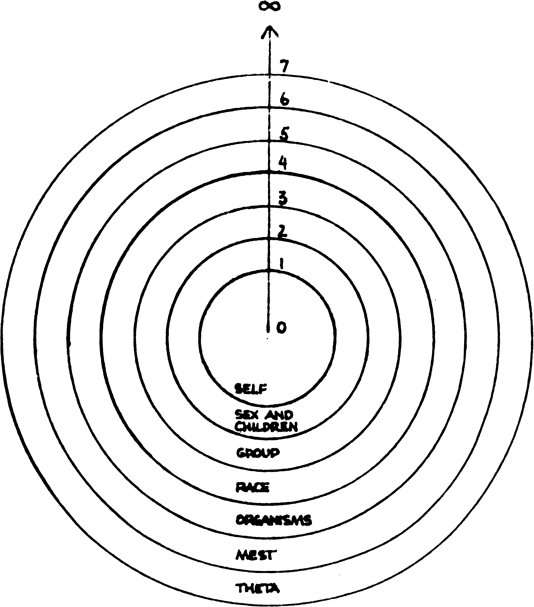
Figure II
If we turn this circle of dynamics so that we view it more from the edge, we have (in figure III) a representation of what happens at the top and at the bottom of the tone scale and of the relationship between zero and infinity on the tone scale.

HCO PL 23.10.81
10 -
The solid line shows the progress of the scale through the concentric circles which mark the boundaries of the various dynamics.
The dotted line shows an arbitrary passage through the "space" outside the seven dynamics. This dotted line enters the dynamic circle either at zero or at infinity, either at the edge of the circle or at the center of the circle.
Therefore, an individual who is going to depart from the material universe may do so at the edge of the circle or at the center, but according to the diagram he will be in the same "place" no matter which exit he uses.
Just what factors determine the entry of the individual into the circle at either one of these two points cannot be indicated in this diagram, since they are unknown to the writer.
Looking again at figure II, we see that the fourth dynamic is labeled "race." This dynamic used to be labeled "mankind." The word "race" has been substituted because it may very well be that the development which we shall experience in the immediate future will take us beyond the boundaries of that area of life which we now label "mankind." We have been in the past and we may be in the future creatures quite different from those we now think of as "mankind."
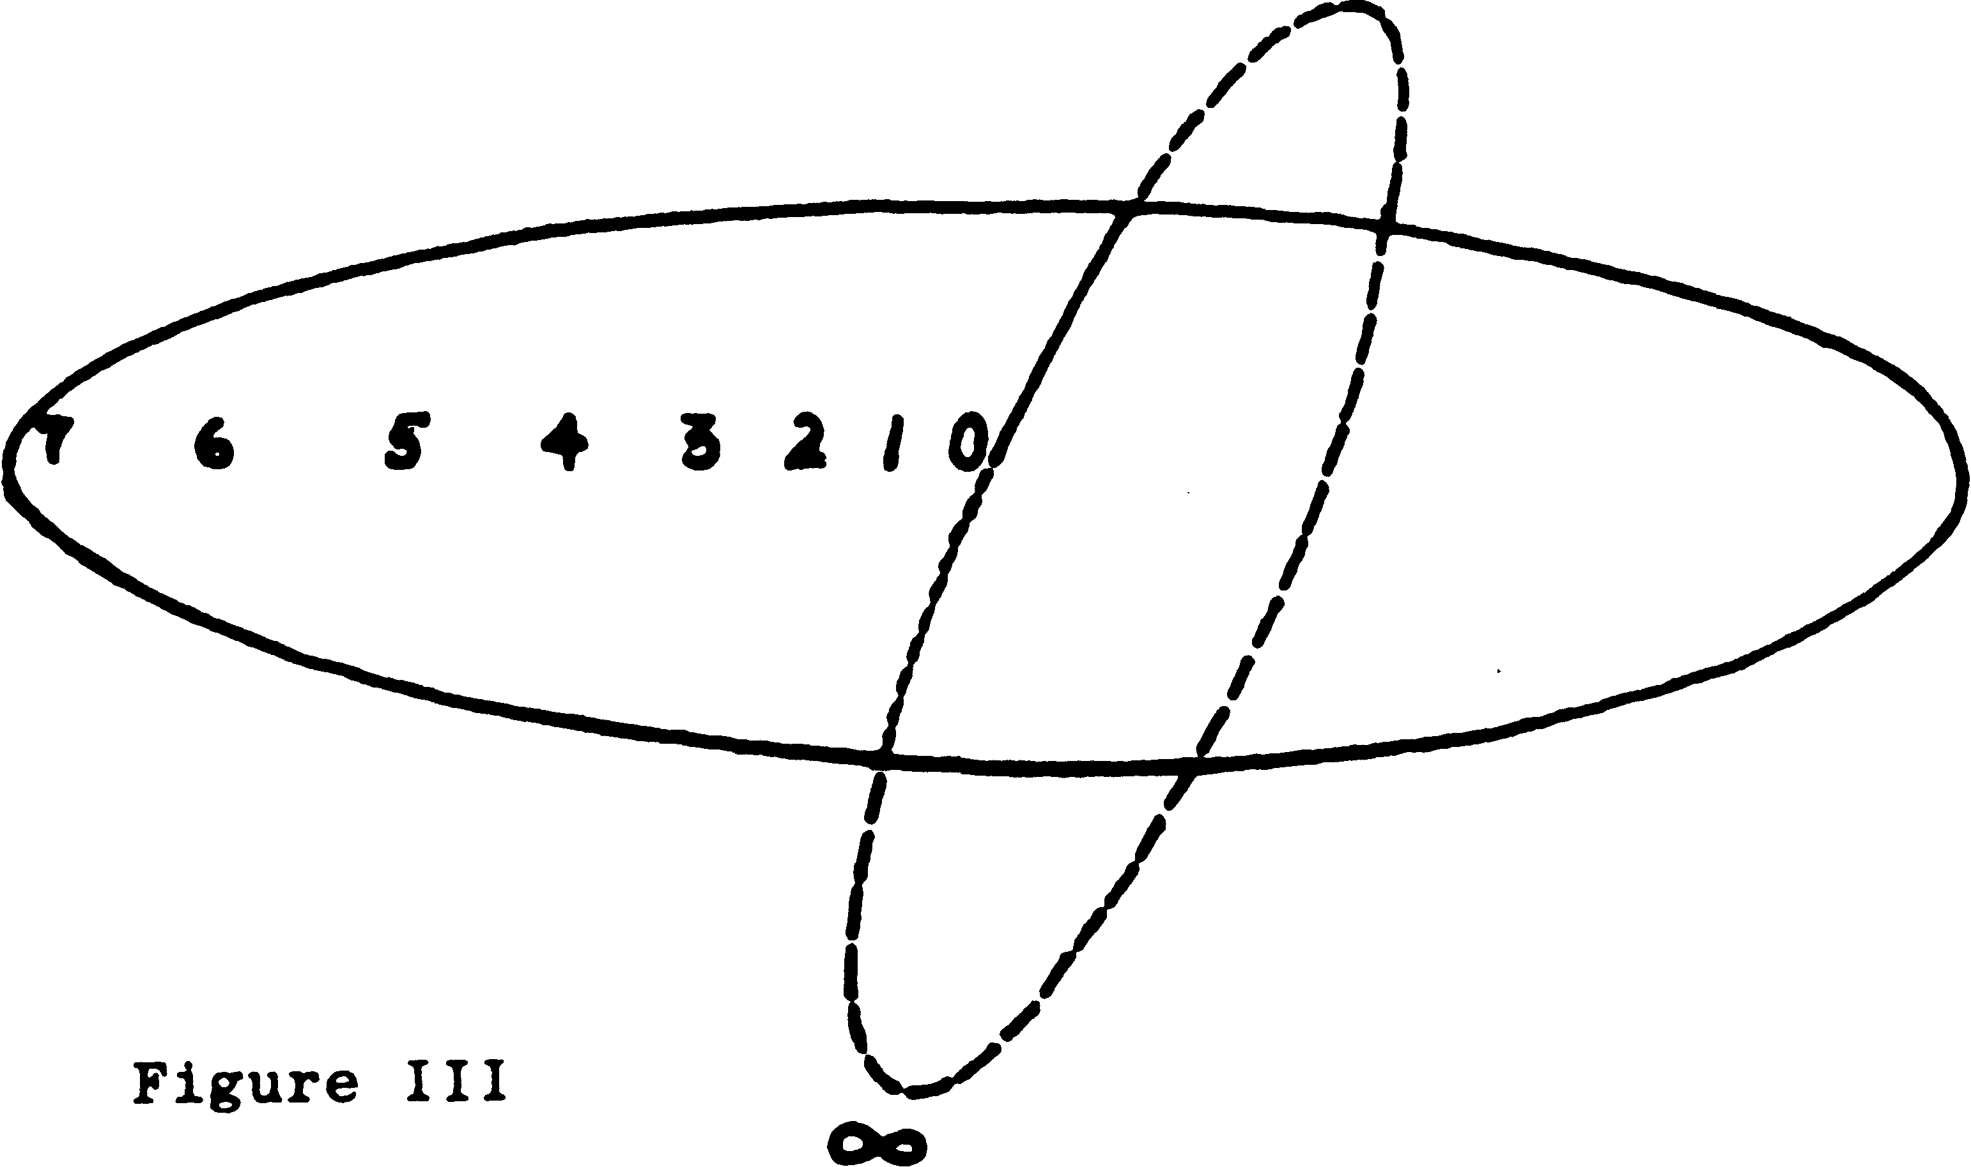
A future is conceivable in which all those beings who wish to remain as men upon this planet may call themselves the group of mankind. This group may be all the third dynamic there is, the social order having been so creatively and harmoniously worked out as to make subordinate groups unnecessary and unwanted. This would be the brotherhood of mankind which has been set forth in the literature of religion.

HCOPL23.10.81 – 11 -
The race dynamic might then include not only mankind but also those beings who did not wish to be confined to a planetary or an earthly or a physical existence, beings who might roam the spaces and the non-spaces at will, in search of adventures which we can hardly name, much less envision.
L. RON HUBBARD FOUNDER
Issued at the request of the Public Services Project
Accepted by the
BOARD OF DIRECTORS of the
CHURCH OF SCIENTOLOGY of CALIFORNIA
BDCSC:LRH:PSP:bk Copyright 0 1952, 1981 by L. Ron Hubbard ALL RIGHTS RESERVED

