HUBBARD COMMUNICATIONS OFFICE
Saint Hill Manor, East Grinstead, Sussex
HCO POLICY LETTER OF 3 APRIL 1972

Remimeo

Establishment Officer Series 13

DOING WORK
The basic Esto problem is getting somebody to do his job.
This is not just executives nor „bad staff.“ It tends to be rather prevalent in our modern culture.
The basic question really is „Why can’t you do what you are supposed to be doing?“
An Esto will find many people „busy,“ but really not doing their post hat.
As the Esto’s own stat depends on people actually doing their jobs, and as the pay and well-being of those people also depend on it, it amounts to quite a problem.
You can do a Product Rundown to cognitions. But then in some cases nothing happens.
You hat and still nothing happens.

ABERRATION
To understand this you have to understand „aberration.“
Get the idea of a being doing wholly what he is doing. You get this:

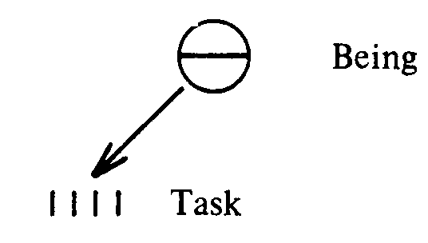
A.

It is a straight line of attention.
Now get the idea of somebody „doing a job that is not doing what he is doing.“
We get
B.
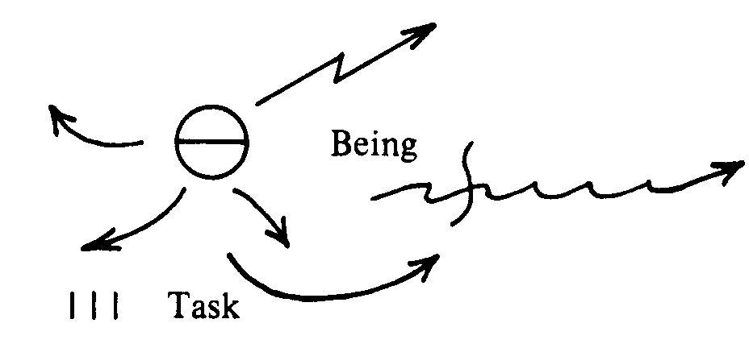

This is aberration. Which means „not in a straight line.“
So in example A, the person does what he is doing.
In example B, he is doing but he is not doing what he is doing mentally. Mentally he is doing something else while he is doing what he seems to be doing.

SCHIZOPHRENIA
The most prevalent „mental disorder“ is supposed to be schizophrenia. This means „SCISSORS“ or 2 plus „head.“ A two-head in other words. And in this case two heads are not better than one (joke).
You see this in institutions. A person is changing valences (personalities) clickclick-click, one to the next.
But the condition is a gradient one that worsens between sanity and the bottom of the scale.
Midway, the condition is common but almost never noticed. It is so common today that it passes as normal humanoid.
The person is not doing what he is doing.
Examples of this are-people who do not like a job with responsibility because they „like to do mechanical things so they can dream of something else while working“; persons who „have to do something else before they can ________”; persons who are out of area; persons who continually make dev-t.
There is also the person who rams sideways into the work of others with „mistakes,“ „demands,“ and prevents them from doing what they are doing while himself not doing what he is doing.
One can’t say these people are crazy. Not today. But one can say they make problems which are very difficult unless you know how to unlock the riddle.

BARRIERS
Study Series No. 2 HCOB 2 June 1971 Issue I „Confronting“ and the drills given in the Esto tape series can push their way through an astonishing mass of barriers.
For this is what the condition is-an effort to get through barriers.
The reason example B above occurs is that the person’s attention is misdirected by mental barriers each time he tries to do A above.
Yet only if he can do A will he have any self-determinism and power.
It does not mean he is crazy. It means he is incapable of directing his attention straight. Each time he does, he hits something that deflects it (sends it off at an angle).
All this will seem very reasonable to him because it is the way it has always been. And like the little girl who never knew she had had a headache from the time of birth, and only knew it when it quit suddenly, such a person does not realize he cannot control his attention.
Such think about lots of other things while apparently thinking about what they are doing. And they do lots of other things.

MISUNDERSTOODS
Misunderstood words prevent them being in communication with materials or others. Thus they do not read or listen. They maunder (which means wander about mentally).
This is the inflow side of it.
The outflow side are barriers of odd fears and peculiar ideas.
Such people appear rather weak and dispersed. Or too heavy and stubborn to make up for it.
They have fixed ideas and other outpoints because their thoughts detour instead of running along a highway.

HAPPINESS
To get someone to actually do what he is doing when he is doing it will sound cruel to some people. That’s because they find it painful to confront and would rather withdraw and maunder, sort of self-audit themselves through life.
They are not happy.
Happiness comes from self- determinism, production, and pride.
Happiness is power and power is being able to do what one is doing when one is doing it.

COMPETENCE
When a person is competent, nothing can shake his pride. The world can yell. But it doesn’t shake him.
Competence is not a question of one being being more clever than another. It is one being being more able to do what he is doing than another is.
Example A is competence.
Example B is incompetence.

MORE THERE
You could say a competent person was „more there.“ But this is really „more able to put his attention on what he has his attention on.“

WHY
Anyone who is not a fireball on his post could be described by this Why:
Unable to do his post for an individual Why for each person.
Thus there are two ready remedies an Esto can use.
1. He can find the Why a person cannot do his post and then handle it.
2. He can do Esto drills on the person.
In finding the Why the observation itself that his stats are low may find the person a bit defensive.
It just could be that he does do what he is doing. But if so his stats would be high and he would be moving fast.
Thus one has to find his personal Why. If it is the right one he should have very good indicators and speed up and do his job. If it is not quite the right one he may feel degraded or ashamed.
The test of any right Why is does it raise the existing scene toward the ideal with existing resources.
Thus you can get a Why that is not wholly acceptable until handled. But if you really are spot on it should blow a lot of the barriers.
Thus a real Why blows a lot of the barriers, when handled, between the being and his job.
The drills then push it on through.
The drills sometimes blow through the Why. The Why sometimes blows right through any need of drills.
So these two actions interact.
If you see someone feeling very guilty after the Why „is found,“ better check it over. It could be a wrong Why and in this case, just find a new one.

THIRD ACTION
The Primary Rundown, HCOB 30 Mar 72. should be done on a staff member thoroughly.
Otherwise he will remain to some degree out of comm. He will not be able to take in data quickly if he cannot communicate with words.

PROCESSING
Of course processing removes all the barriers eventually. But it is not necessarily aimed at doing a job.
Ability potential is enormously increased by processing.
But traditionally we do not rely on processing to handle staff.
We handle people and we handle cases.
But auditors and staff members, simply because we do handle people and cases, must not have cases on post. We do not admit that they have cases. This raises necessity level.
And it is quite amazing how high that necessity level can be raised and how a person can function despite his case.
If we admitted that staff had cases we couldn’t handle public cases. It’s that simple.
So an Esto does not advise or use auditing on staff members as a post remedy nor accept case as a Why.
Of course „case“ is a Why. But when you accept it you retreat from example A above and at once get a B.
You will be amazed how a person can begin to do what he is doing by finding his Why and doing drills.
And of course you also have to handle the fellows who jam in from the side at every turn and disperse the staff member’s attention. He too (and especially) isn’t doing what he is doing.
The same procedure (Why and drills) handles him as well.
____________

In sum, if a staff member isn’t doing what he is doing he is doing something else. They never do nothing.
Ask „What is the reason you do not fully do your post?“ or any such version. Find the real Why. And handle the person.
That’s the major part of an Esto’s job.
And don’t be surprised if you get a cheerful „but I am!“ And find he is.
But his stats and speed tell the whole story.

L. RON HUBBARD
Founder

