SELF ANALYSIS
by
L. Ron Hubbard
A Simple Self-Help Volume of Tests and Processes Based on the Discoveries Contained in Dianetics.
To those hundreds of thousands of ardent Dianetics supporters who have carried the guidon of sanity against the crumbling citadels of superstition and who have succeeded in rallying to their standard the hopes of Man.
Do not harken too well to he who would tell you this system will not work. He would not feel safe if people around him grew too strong. The wise man tests before he talks. The critic but follows the fad of a cynical and apathetic age. You have a right to your own opinion. This system works or it doesn’t according to your experience. Not all the authorities in Christendom can alter natural law.

PREFACE ............................................................................................ 1
INTRODUCTION .................................................................................. 3
CHAPTER ONE .................................................................................... 6
CHAPTER TWO .................................................................................... 8
CHAPTER THREE ................................................................................. 10
CHAPTER FOUR .................................................................................. 12
CHAPTER FIVE .................................................................................... 16
CHAPTER SIX ..................................................................................... 18
THE HUBBARD CHART OF HUMAN EVALUATION ..................................... 22
TEST NUMBER ONE ............................................................................. 31
TEST NUMBER TWO ............................................................................. 33
TEST NUMBER THREE .......................................................................... 34
HOW TO USE THE DISC ......................................................................... 37
PROCESSING SECTION ......................................................................... 39
LIST 1 ................................................................................................ 44
LIST 2 ................................................................................................ 47
LIST 3 ................................................................................................ 50
LIST 4 ................................................................................................ 81
LIST 5 ................................................................................................ 85
LIST 6 ................................................................................................ 88
LIST 7 ................................................................................................ 92
LIST 8 ................................................................................................ 98
LIST 9 ................................................................................................ 99
LIST 10 ............................................................................................... 102
LIST 11 ............................................................................................... 105
LIST 12 ............................................................................................... 108
SPECIAL SESSION LISTS ....................................................................... 110
The simplicity of this volume is matched only by its effectiveness. It is not necessary to study the introductory chapters in order to get started in Self Analysis. The reader may turn at once to page 39 and follow the simple directions there and begin immediately upon self processing.
Or the reader may turn first to page 31 and take the first test and by it learn accurately his potentials and future and so be able to measure, by taking these tests from time to time, his improvement under the processing section.
Or he may begin at the beginning and find out such interesting things as the basic goal of life, the role language plays in existence, and the basics of human behavior as well as the mechanisms of the human mind.
This volume includes an explanation of the principles involved, a set of examinations which the reader administers to himself, a tone scale which delineates the classes of human personality into which all human beings fall, and the selfprocessing section.
Simply by answering the questions contained in the various processing sections, the concerns and worries of the individual’s life resolve automatically.
A card is provided for the readers use which he rotates from question to question and which tells him what sense perception to give attention to in the memories revoked.
Self Analysis is simple and easy. Only a vast and complete understanding of the human mind such as that possessed by L. Ron Hubbard could evolve such a system. For although the reader may never be aware of it, an enormous amount of technical knowledge and experience underlies Dianetic Self Analysis.
In using Self Analysis the reader will experience things he had not thought possible. For anything as fundamental as this system, capable of producing the results it produces, could not be otherwise than powerful.
A system such as Self Analysis has never before been possible for the basic laws of human thought and behavior were not known until L. Ron Hubbard applied his brilliance and his trainir.g in the field of atomic and molecular phenomena to the field of human thought.
His discoveries and the results he has achieved with them have rocked the savants and old schools of thought to their roots, leaving Dianetics the only validated method of increasing sanity and happiness known to man.
It is not necessary for you to take anyone’s statement for it. Apply Self Analysis for a short time and feel the results for yourself. If you are truly skeptical have yourself tested thoroughly by doctors and psychometrists, use the self-processing section for half an hour a day for a month and then cause the tests to be repeated. If you have been faithful to your task, the change in you should be sufflciently marked to cause a considerable stir. Things like this have simply never happened before—increased intelligence, faster reaction time, improved physical condition, a happier outlook on life and much more likely to be liked by your friends.
After their initial antagonism—understandable because Dianetics thoroughly invalidated their beliefs and teachings— leadingauthoritiesnowadmit that Dianetics accomplishes things never before possible in the humanities.
Self Analysis and its organization is in itself a triumph, for it gives the benefits of Dianetics to everyone. The scholarly and very intelligent reader can pursue the explanations and axioms contained herein and explore the whole of Dianetics through more basic tests on the
This volume and its system of Self Analysis is not intended for the severely neurotic or psychotic person but only for the reasonably stable individual, to increase his ability, efficiency, well-being and longevity.
THE EDITORS
Self Analysis cannot revive the dead.
Self Analysis will not empty insane asylums or stop war. These are the tasks of the Dianetic Auditor and the Group Dianetic Techniaan.
But Se]f Analysis will conduct you on the most interesting adventure in your life. The adventure of you.
How efficient are you? What are your potentials? How much can you improve ? Well, basically your intentions toward yourself and your fellow man are good. Basically, if sometimes clouded over with the not so pale cast of bad experience, your potentialities are a great deal better than anyone ever permitted you to believe.
Take your memory, a small part of your total assets. Is it perfect? Can you, at will, recall everything you have ever learned or heard, every phone number, every name? If you can’t you can see that there is room for improvement. Now somebody, with a half glance at the title page of this book, will try to assume that Self Analysis simply improves memory. That is like saying that all a train can do is meet schedules. It does much more. But memory is a starter. If your memory were as accurate as an IBM card index system and even faster, you would be more efficient and more comfortable and it would certainly save writing those notes you have to make. Yes, you probably couldn’t have too good a memory on things you’ve studied and things you need.
But there are a lot of things as important as memory. There’s your reaction time. Most people react too slowly in emergencies. Let’s say it, takes you half a second to pull your hand off a hot stove. That’s many times too long a period to have your hand on that stove.
Or let’s say you require a third of a second to see the car ahead stop and to start to put on your own brakes. That’s too long. A lot of accidents happen because of slow reaction time.
In the case of an athlete, reaction time is a direct index as to how capable he may be in a sport. So it assists one in many ways to be able to react quickly.
Self Analysis speeds up reaction time. Here’s a trick. Take a dollar bill, unfolded. Have somebody hold it vertically above your hand. Open your thumb and index finger just below the lower edge of the bill. Now let your friend let go. You try to close thumb and index finger on the bill. Did you miss it, snapping after it had gone all the way through? That’s very slow reaction. Did you catch it by its upper edge when it was almost gone? That’s much too slow. Did you catch it on Washington’s face? That’s fair. Or did you catch it on the lower edge, even before it really got started? That’s the way it should be. Less accidents, greater general alertness. Well, barring actual physical damage to hand or arm, Self Analysis will speed that up for you.
Do you have trouble going to sleep or getting up? Do you feel a little tired a lot of the time ? Well, that can be remedied.
As for what they call psycho-somatic illnesses—sinusitis, allergies, some heart trouble, “bizarre” aches and pains, poor eyesight, arthritis, etc., etc., etc., down through seventy per cent of man’s ills, Self Analysis should be able to help markedly.
Then there’s the matter of how young or old you may look. Self Analysis can make quite a change there.
And there’s the matter of plain ordinary ability to be happy in life and enjoy things. And there Self Analysis shines brightly for it can raise your tone fast enough, usually, so that even you will agree things can be good.
As my boyhood hero, Charles Russell, the painter, once described a certain potion, “It’d make a jack rabbit spit in a wolf’s eye”. Now maybe Self Analysis doesn’t always have this effect, but it happens regularly enough to be usual. Certain it is that the user often goes through such a period, much to the alarm of his friends. Self Analysis does have an effect as in the song: “I can lick that guy, I can kiss that girl,
“I can ride that bronc and make him whirl . . .”
The moral and caution is “Don’t pick too big a wolf”. At least not until you’ve been using this for a while and kind of get things in proportion again.
In short this is an adventure. How good can you get?
A lot depends on how good you are potentially—but you can be assured that that’s a lot better than you ever supposed. And it’s a cinch it’s better than your friends would ever tell you.
Please don’t be discouraged if you find yourself pretty low on the self-evaluation chart later on. All is not lost. The processing section can boost you up at a good rate if you keep at it.
And don’t be surprised if you suddenly begin to feel uncomfortable while you’re working on the processing section. You can expect that to happen every now and then. Just keep going. If it gets too bad, simply turn to the last section and answer those questions a few times and you should start feeling better very soon.
All I’m trying to tell you is this—adventures are dull if a little excitement doesn’t crop up. And you can expect excitement— too much in some places.
You are going to know a lot about you when you finally finish.
All this is on your own responsibility. Anything as powerful as these processes can occasionally flare. If you are fairly stable mentally there is no real danger. But I will not mislead you. If you see somebody who isn’t quite as stable as he thinks he is working with Self Analysis, coax it away from him. If he can barely stand mental chicken broth, he has no right to be dining on raw meat. Send him to see a professional auditor. And even if he does throw a wheel, a professional auditor can straighten him out. Just send for an auditor.
Don’t then, disabuse yourself of the fact that Self Analysis can send the unstable spinning.
We’re dealing here with the root stuff of why men go mad. If it isn’t explained in the text, it will be found in a standard work on Dianetics. Even so, it is doubtful if Self Analysis could create as much madness in a year as an income tax blank from our thorough if somewhat knuckle-headed government.
Now to particulars. You’ll find the tests further on . You can take the first one. It will give you a figure which will place you on the chart. Don’t blame me if it’s a low score. Blame your parents or the truant officer.
Next, it would probably interest you to read the text. It will give you a different viewpoint on things, possibly. It is regretted if it is too simple for the savant or too complex or something. It’s simply an effort to write in American a few concepts about the mind based on a lot of technical material in Dianetics but made more palatable. You’ll do better on the processing if you read the text.
The processing section has a large number of parts. You can simply work straight through or work over each one again, and again, until you feel you’ve sufficiently explored that part of your life. In any case you will go through every section many times.
To help you there is a two-sided disc in the back of the book. The directions are given later.
Thus you are prepared to go exploring into your own life. That’s an interesting adventure for anyone. I’ve done what I could to make it easier. Don’t be too harsh on me, however, if you get grounded up some long lost river and eaten by cannibals or engrams. The last section will help get you out. What’s left of you, anyway.
Don’t get faint hearted and slack off, though, when you find the going rough. It’s easy to quit. And then you’d neva know just what you really are, basically.
Going to take the whole trip? You’re a brave person. I compliment you.
May you never be the same again—
L. RON HUBBARD
Are you a friend of yours ?
Probably the most neglected friend you have is you. And yet every man, before he can be a true friend to the world must first become a friend to himself.
In this society, where aberration flourishes in the crowded cities and marts of business, few are the men who have not been subjected, on every hand, to a campaign to convince them that they are much less than they think they are.
You would fight anyone who said of your friends what is implied about you. It is time you fought for the best friend you will ever have—yourself.
The first move in striking up this friendship is to make an acquaintance with what you are and what you might become. “Know thyself !” said the ancient Greek. Until recently it was not possible to make a very wide acquaintance. Little was known about human behavior as a science. But atomic physics, in revealing new knowledge to man, has also revealed the general characteristics of the energy of life and by that a great deal can be known which was not before suspected. You do not need to know atomic physics to know yourself, but you need to know something of the apparent goal of life in general and your own goals in particular.
In a later chapter there are some questions you can answer which will give you a better insight into your capabilities as they are and what they can become—and do not be deceived, for they can become a great deal more than you ever before suspected.
Just now let’s talk about the general goal of all life. Knowing that, we can know something about the basic laws which motivate your own urges and behavior.
All problems are basically simple—once you know the fundamental answer. And this is no exception in life. For thousands of years men strove to discover the underlying drives of existence. And in an enlightened age, when exploration of the universes had already yielded enough secrets to give us A-bombs, it became possible to explore for and find the fundamental law of life. What would you do if you had this fundamental law ? How easily then would you understand all the puzzles, riddles and complexities of personality and behavior. You could understand conjurers and bank presidents, colonels, and coolies, kings, cats and coal heavers. And more important, you could easily predict what they would do in any given circumstance and you would know what to expect from anyone without any guesswork—indeed with a security diabolical in its accuracy.
“In the Beginning was the Word”, but what was the Word? What fundamental principle did it outline ? What understanding would one have if he knew it?
An ancient Persian king once made a great effort to know this Word. He tried to discover it by having his sages boil down all the knowledge of the world.
At his orders, every book written which could be obtained was collected together in an enormous library. Books were brought to that ancient city by the caravan load. And the wise men of the time worked for years condensing every piece of knowledge which was known into a single volume.
But the king wanted a better statement of the fundamental Word. And he made his sages reduce that volume to a single page. And he made them reduce it again to a sentence. And then, after many more years of study, his philosophers finally obtained that single Word, the formula which would solve all riddles.
And the city died in war and the Word was lost.
The dynamic principle of existence is: SURVIVAL!
At first glance that may seem too basic. It may seem too simple. But when we examine this Word, we find some things about it which make it possible for us to do tricks with it. And to know things which were never known before.
Knowledge could be represented by a pyramid. At the top we would have simple fact but a fact so widely embracing the universe that many facts could be known from it. From this point we could conceive descending down into greater and greater numbers of facts, represented by the broadening of the pyramid.
At any point we examine this pyramid we would find that as one descended he would find facts of wider and less related meanings. As one went up he would find greater and greater simplicities. Science is the process of starting low on the pyramid, much like the Persian king, and rising up in an effort to discover more basic facts which explain later facts. Philosophy could be said to be the operation of taking very basic facts and then leading them into explanations of greater and greater numbers of facts.
At the point of our pyramid, we have SURVIVAL !
It is as though, at some remarkably distant time, the Supreme Being gave forth a command to all life: “Survive!”. It was not said how to survive nor yet how long. All that was said was “Survive !” The reverse of Survive is “Succumb”. And that is the penalty for not engaging in survival activities.
But what of such things as morals, ideals, love? Don’t these things go above “mere survival” ? Unfortunately or fortunately, they do not.
When one thinks of survival, one is apt to make the error of thinking in terms of “barest necessity”. That is not survival. For it has no margin for loss.
The engineer when he constructs a bridge, uses something called a “factor of safety”. If a bridge is to hold ten tons, he builds it to hold fifty tons. He makes that bridge five times as strong. Then he has a margin for deterioration of materials, overloading, sudden and unforeseen stress of elements, and any accident which may occur.
In life, the only real guarantee of survival is abundance. A farmer who calculates to need twelve bushels of grain for his food for a year and plants twelve bushels has cut back his chances of survival very markedly. The fact is, he will not survive, unless some neighbor has been more prudent. For the grasshoppers will take part of the wheat. And the drought will take some. And the hail will take some. And the tax gatherer will take some. And what will he do for seed wheat if he intends to use all he plants for food ?
No, the farmer who knows he has to eat twelve bushels of wheat in the coming year had better plant a hundred. Then the grasshoppers and internal revenue people can chew away as they will. The farmer will still be able to harvest enough for his own food—except of course in a Socialism where nobody survives, at least for very long!
An individual survives or succumbs in ratio to his ability to acquire and hold the wherewithal of survival. The security of a good job, for instance, means some guarantee of survival —other threats to existence not becoming too overpowering. The man who makes twenty thousand a year can afford better clothing against the weather, a sounder and better home, medical care for himself and his family, good transportation and, what is important, the respect of his fellows. All these things are survival.
Take the man who makes ten dollars a week. He wears clothes which protect him very poorly. Thus he can easily become ill. He lives in a place which but ill defends him from the weather. He is haggard with concern. For his level of survival is so low that he has no margin, no abundance. He cannot bank anything against the day he becomes ill. And he cannot pay a doctor. And he can take no vacations. Even in a collective state his lot would be such, his regimentation so thorough that he could do little to protect his own survival.
Youth has a survival abundance over old age. For youth still has endurance. And the dreams of youth—good survival stuff, dreams—are not yet broken by failures. Youth has, in addition, a long expectancy, and that is important, for survival includes length of time to live.
As for ideals, as for honesty, as for one’s love of one’s fellow man, one cannot find good survival for one or for many where these things are absent. The criminal does not survive well. The average criminal spends the majority of his adult years caged like some wild beast and guarded from escape by the guns of good marksmen. A man who is known to be honest is awarded survival—good jobs, good friends. And the man who has his ideals, no matter how thoroughly the minions of the devil may wheedle him to desert them, survives well only so long as he is true to those ideals. Have you ever heard about a doctor who, for the sake of gain, begins to secretly attend criminals or peddle dope? That doctor does not survive long after his ideals are laid aside.
In short, the most esoteric concepts fall within this understanding of Survival. One survives so long as he is true to himself, his family, his friends, the laws of the Universe. When he fails in any respect, his survival is cut down.
The end of Survival, however, is no sharp thing. Survival is not a matter of being alive this moment and dead the next. Survival is actually a graduated scale.
Where does one cease to Survive and begin to Succumb? The point of demarkation is not death as we know it. It is marked by what one might call the death of the consciousness of the individual.
Man’s greatest weapon is his reason. Lacking the teeth, the armor-plate hide, the claws of so many other life forms, Man has relied upon his ability to reason in order to further himself in his survival.
The selection of the ability to think as a chief weapon is a fortunate one. It has awarded Man with the kingdom of Earth. Reason is an excellent weapon. The animal with his teeth, with his armor-plated hide, with his long daws, is fixed with weapons he cannot alter. He cannot adjust to a changing environment. And it is terribly important, to survive, to change when the environment changes. Every extinct species became extinct because it could not change to control a new environment. Reason remedies this failure to a marked extent. For Man can invent new tools and new weapons and a whole new environment. Reason permits him to change to fit new situations. Reason keeps him in control of new environments.
Any animal that simply adjusts itself to match its environment is doomed. Environments change rapidly. Animals which control and change the environment have the best chance of survival.
The only way you can organize a collective state is to convince men that they must adjust and adapt themselves, like animals, to a constant environment. The people must be deprived of the right to control, as individuals, their environment. Then they can be regimented and herded into groups. They become owned, not owners. Reason and the right to reason must be taken from them, for the very center of reason is the right to make up one’s own mind about one’s environment.
The elements fight Man and man fights man. The primary
target of the enemies of Man or a man is his right and ability to reason. The crude and blundering forces of the elements, storms, cold and night bear down against, challenge and then mayhap crush the Reason as well as the body.
But just as unconsciousness always precedes death, even by instants, so does the death of Reason precede the death of the organism. And this action may happen in a long span of time, even half a lifetime, even more.
Have you watched the high altertness of a young man breasting the forces which oppose life? And watched another in old age? You will find that what has suffered has been the ability to Reason. He has gained hard won experience and on this experience he seeks, from middle age on, to travel. It is a truism that youth thinks fast on little experience. And that age thinks slowly on much. The Reason of youth is very far from always right, for youth is attempting to reason without adequate data.
Suppose we had a man who had retained all his ability to reason and yet had a great deal of experience. Suppose our greybeards could think with all the enthusiasm and vitality of youth and yet had all their experience as well. Age says to youth, “You have no experience!” Youth says to age, “You have no vision, you will not accept or even examine new ideas!” Obviously an ideal arrangement would be for one to have the experience of age and the vitality and vision of youth.
You rnay have said to yourself, “With all my experience now, what wouldn’t I give for some of the enthusiasm I had once”. Or perhaps you have excused it all by saying you have “lost your illusions”. But you aren’t sure that they were illusions. Are brightness in life, quick enthusiasm, a desire and will to live, a belief in destiny, are these things illusions ? Or are they symptoms of the very stuff of which vital life is made? And isn’t their decline a symptom of death ?
Knowledge does not destroy a will to live. Pain and loss of self-determinism destroy that will. Life can be painful. The gaining of experience is often painful. The retaining of that experience is essential. But isn’t it still experience if it doesn’t yet have the pain?
Suppose you could wipe out of your life all the pain, physical and otherwise, which you have accumulated. Would it be so terrible to have to part with a broken heart or a psychosomatic illness, with fears and anxieties and dreads ?
Suppose a man had a chance again, with all he knows, to look life and the Universe in the.eye again and say it could be whipped. Do you recall a day, when you were younger, and you woke to find bright dew sparkling on the grass, the leaves, to find the golden sun bright upon a happy world? Do you recall how beautiful and fine it once was? The first sweet kiss? The warmth of true friendship? The intimacy of a moonlight ride? What made it become otherwise than a brilliant world ?
The consciousness of the world around one is not an absolute thing. One can be more conscious of color and brightness and joy at one time of life more than another. One can more easily feel the brilliant reality of things in youth than he can in age. And isn’t this something like a decline of consciousness, of awareness ?
What is it that makes one less aware of the brilliance of the world around him. Has the world changed? No, for each new generation sees the glamour and the glory, the vitality of life— the same life that age may see as dull at best. The individual changes. And what makes him change? Is it a decay of his glands and sinews ? Hardly, for all the work that has been done on glands and sinews—the structure of the body—has restored little if any of the brilliance of living.
Ah, youth, sighs the adult, if I but had your zest again! What reduced that zest ?
As one’s consciousness of the brilliance of life declines, so has declined his own consciousness. Awareness decreases exactly as consciousness decreases. The ability to perceive the world around one and the ability to draw accurate conclusions about it are, to all intents, the same thing.
Glasses are a symptom of the decline of consciousness. One needs his sight bolstered to make the world look brighter. The loss of the ability to move swiftly, as one ran when he was a child, is a decline of consciousness and ability.
Complete unconsciousness is death. Half unconsciousness is half death. A quarter unconsciousness is a quarter of death. And as one accumulates the pain attendant upon life and fails to accumulate the pleasures, one gradually loses his race with
the gentleman with the scythe. And there ensues, at last, the physical incapacity for seeing, thinking and being known, as death.
How does one accumulate this pain? And if he got rid of it would full consciousness and a full bright concept of life return? And is there a way to get rid of it ?
According to nuclear physics, matter is composed of energy such as electrons and protons. And the energy and the matter exist in space and time. All this is actually very simple. And even then we need not go very far into it to understand that the universe in which we live is composed of simple things arranged and rearranged to make many forms and manifestations.
The concrete sidewalk, the air, ice cream sodas, pay checks, cats, kings and coalheavers are basically composed of matter, energy, space and time. And where they are alive they contain another ingredient—life.
Life is an energy of a very special kind, obeying certain laws different from what we normally consider energy such as electricity. But life is an energy and it has some peculiar properties.
Life is able to collect and organize matter and energy in space and time and animate it. Life takes some matter and energy and makes an organism such as a monocell, a tree, a polar bear or a man. Then this organism, still animated by the energy called Life, futher acts upon matter and energy in space and time and further organizes and animates matter and energy into new objects and shapes.
Life could be said to be engaged upon a conquest of the physical universe. The primary urge of life has been said to be Survival. In order to accomplish Survival, Life has to continue and win in its conquest of the physical universe.
When Life or a Life form ceases to continue that conquest, it ceases to Survive and succumbs.
Here we have a gigantic action. The energy of Life vs. matter, energy, space and time.
Life vs. the physical universe.
Here is an enormous struggle. The chaotic, disorganized physical universe, capable only of force, resisting the conquest of Life, organizing and persistent, capable of Reason.
Life learns the laws of the physical universe matter, energy, space and time and then turns those laws against the physical universe to further its conquest.
Man has spent much time learning what he could of the physical universe as in the sciences of physics and chemistry but, more important even, of the daily battle of Life against the Universe. Do not think that a monocell does not manifest a knowledge of Life’s working rules, for it does. What cunning it takes to organize some chemicals and sunlight into a living unit ! The biologist stands in awe of the expertness of management of the smallest living cells. He gazes at these intricate and careful entities, these microscopic units of Life forms, and even he cannot believe that it is all an accident.
There is Life, then, a vital energy, not quite like physical Universe energy. And then there are Life forms. The Life form or the organism, such as a living human body, consists of Life plus physical Universe matter, energy, space and time. A dead body consists of physical universe matter, energy, space and time minus Life energy. Life has been there, has organized and has then withdrawn from the organism, an operation we know as the cycle of conception, birth, growth, decay and death.
Although there are answers as to where Life goes when it withdraws and what it then does, we need not examine that now. The important thing to a living organism is the fact that it
Stated simply, Life must first accumulate enough matter and energy to make up an organism—such as the human body— and must then ally the organism with friendly and cooperative organisms—such as other people—and must continue to procure additional matter and energy for food, clothing and shelter in order to support itself. Additionally, in order to Survive, it must do two specific things which, beyond the necessity of allies, food, clothing and shelter, are basically important.
Life must procure pleasure.
Life must avoid pain.
Life has an active thrust away from pain, which is nonsurvival, destructive, and which is death itself. Pain is a warning of non-survival or potential death.
Life has an active thrust toward pleasure. Pleasure can be defined as the action toward obtaining or the procurement of survival. The ultimate pleasure is an infinity of survival or immortality, a goal unobtainable for the physical organism itself (but not its Life), but toward which the organism strives.
Happiness then could be defined as the overcoming of obstacles toward a desirable goal. Any desirable goal, if closely inspected, will be found to be a Survival goal.
Too much pain obstructs the organism toward Survival.
Too many obstructions between the organism and Survival mean non-survival.
Thus one finds the mind engaged in computing or imagining ways and means to avoid pain and reach pleasure and putting the solutions into action. And this is all that the mind does: it perceives, poses and resolves problems relating to the Survival of the organism, the future generations, the group, Life and the physical universe and puts the solutions into action. If it solves the majority of the problems presented, the organism thus achieves a high level of Survival. If the organism’s mind fails to resolve a majority of problems, then the organism fails.
The mind, then, has a definite relationship to Survival. And one means here the whole mind, not just the brain. The brain is a structure. The mind can be considered to be the whole being, mortal and immortal, the definite personality of the organism and all its attributes.
Hence, if one’s mind is working well, if it is resolving the problems it should resolve and if it is putting those solutions into proper action, the Survival of the organism is well assured. If the mind is not working well, the Survival of the organism is thrown into question and doubt.
One’s mind, then, must be in excellent condition if he is to best guarantee the Survival of himself, his family, future generations, his group and Life.
The mind seeks to guarantee and direct Survival actions. It seeks Survival not only for the organism (self) but seeks it for the family, children, future generations and all Life. Thus it can be selectively blunted.
A mind can be blunted concerning the Survival of self and yet be alive to the Survival of future generations. It can be blunted concerning groups and yet be very alive to its responsibility for the organism (self). In order to function well, the mind must not be blunted in any direction.
To function well the mind must conceive itself able to handle the physical universe of matter, energy, space and time within the necessities of the organism, the family, future generations and groups as well as Life.
The mind must be able to avoid pain for and discover pleasure for the self, future generations, the family and the group as well as life itself.
As the mind fails to avoid pain and discover pleasure, so fails the organism, the family, future generations, the group and Life.
The failure of one organism in a group to properly resolve Survival problems is a failure, in part, for the whole group. Hence, “Do not send to find for whom the bell tolls; it tolls for thee!”
Life is an interdependent, cooperative effort. Each and every living organism has a part to play in the Survival of other organisms.
When it comes to a thinking mind such as Man’s, the organism must be able to act independently for its own Survival and the Survival of others. In order to accomplish these Survivals, however, a mind has to be able to realize solutions which are optimum not only for self but for all other things concerned in its Survival.
Thus the mind of one organism must reach agreements with the minds of other organisms in order that all may Survive to the highest possible level.
When a mind becomes dulled and blunted, it begins to compute its solutions poorly. It begins to get confused about its goals. It is not sure what it reaUy means to do. And it will involve and inhibit the Survival of other organisms. It may begin, for instance, to compute that it must Survive as self and that only self is important and so neglect the Survival of others. This is non-survival activity. It is highly aberrated.
A mind which begins to “survive” only for self and begins to diminish and control with force other organisms around is already better than half way toward its own death. It is a mind which is less than half alive. It has less than half its actual potential. Its perception of the physical universe is poor. It does not realize that it is dependent for Survival upon cooperation with others. It has lost its Survival mission. This mind is already outward bound toward death, has passed its peak and will actually take personal actions which lead to its own death.
Life, the large over-all Life, has a use for organism death. When an organism can no longer continue well, the plan of Life is to kill it and invest anew in a new organism.
Death is Life’s operation of disposing of an outmoded and unwanted organism so that new organisms can be born and can fiourish.
Life itself does not die. Only the physical organism dies. Not even a personality, apparently, dies. Death then, in truth, is a limited concept of the death of the physical part of the organism. Life and the personality, apparently, go on. The physical part of the organism ceases to function. And that is death.
When an organism reaches a point where it is only half conscious, where it is only perceiving half as well as it should, where it is functioning only half as well as it should, death begins. The organism, thereafter, will take actions to hasten death. It does this “unconsciously”. But, in its aberrated state, such a mind will also bring death to other organisms. Thus a half conscious organism is a menace to others.
Here is the accident prone, the fascist, the person who seeks to dominate, the selfish and self-seeking person. Here is an organism outward bound.
Organisms which are outward bound toward death sometimes require years and years to die. For the organism experiences resurgences and still has some small desire to go on living. And other organisms help it to live. It is carried along by the tide of life even though its individual direction is toward death— death for others and death for self and death for the physical universe around it.
Society, the bulk of which is bent upon Survival, fails or refuses to recognize death or the urge of organisms toward it. Society passes laws against murder and suicide. Society
provides hospitals. Society carries such people upon its back. And society will not hear of euthanasia or “mercy killing”.
Organisms which have passed the halfway point will take extraordinary measures and means to bring about death for others and for things and for self. Here we have the Hitlers, the criminals, the destructively neurotic.
Give a person who has passed this point a car to drive and the car may become involved in an accident. Give him money and the money will go to purchase non-Survival things.
But we must not emphasize the dramatic and forget the important like the newspapers do. The action and urge toward death becomes noticeable only when it is very dramatic. It is most dangerous however in its undramatic forms.
A person who has passed the halfway point brings death to things and people on a small scale at all times. Ahouse left dirty, appointments not kept, clothing not cared for, vicious gossip, carping criticisms of others “for their own good”, these are all enturbulences which bring failure and too many failures bring death.
And it should be not supposed that by half-way point one means halfway through life. It means half conscious, half alive, half or less perceiving and thinking. A child may be suppressed to this level by his parents and school. And indeed children quite ordinarily drop below the halfway point, so defeated do they become in their environment and in their contest with life. Age is no criterion. But physical health is. The surest manifestation that someone has passed the halfway point is his physical condition. The chronically ill have passed it.
If one is to have a secure society, then, if one is to rid a society of its death factors, one must have some means of either destroying the people who bring death to it, the Hitlers, the insane, the criminals, or he must have some means of salvaging these people and bringing them back into a state of full consciousness.
Full consciousness would mean full recognition of one’s responsibilities, his relationship with others, his care of himself and of society.
How can such a thing be achieved? If you could achieve it, you could raise a social order to hitherto unattainable heights. You could empty the prisons and insane asylums. You could make a world too sane for war. And people could be made well who have never had the means of it before. And people could be happy who have never troly known what happiness was. You could raise the good will and efficiency of all men and all social orders if you could restore the vitality of these people.
In order to know how it can be restored, one has to know how the consciousness, the vitality, the will to live become reduced.
An organism is suppressed toward death by accumulated pain.
Pain in one great sweeping shock brings about immediate death.
Pain in small doses over a lifetime gradually suppresses the organism toward death.
What is pain?
Pain is a warning of loss. It is an automatic alarm system built into Life organisms which informs the organism that some part of it or all of it is under stress and that the organism had better take action or die.
The signal of pain means that the organism is in the proximity of a destructive force or object. To ignore pain is to die. Pain is the whip which sends the organism away from hot stoves, sub-zero weather; pain is the threat of non-Survival, the punishment for errors in trying to Survive.
And pain is always loss. A burned finger means that the body has lost the cells on the surface of that finger. They are dead. A blow on the head means the death of scalp and other cells in the area. The whole organism is thus warned of the proximity of a death source and so attempts to get away from it.
The loss of a loved one is also a loss of Survival. The loss of a possession is also loss of Survival potential. One then confuses physical pain and the loss of Survival organisms or objects. And so there is such a thing as “mental pain”.
But Life, in its whole contest with the physical universe, has no patience with failure. An organism so foolhardy as to let itself be struck too hard and so depressed into unconsciousness stays in the vicinity of the pain-dealing object. It is considered to be non-Survival if it fails so markedly to Survive.
Unconsciousness experienced as a result of a blow or an illness is a quick picture of what happens over a lifespan.
Is there any difference except time between these two things ?
A blow resulting in unconsciousness which results in death.
The accumulated blows over a life span resulting in a gradual lessening of consciousness resulting in eventual death.
One is slower than the other.
One of the basic discoveries of Dianetics was that unconsciousness and all the pain attendant upon it was stored in a part of the mind and that this pain and unconsciousness accumulated until it caused the organism to begin to die.
Another discovery of Dianetics was that this pain could be nullified or erased with a return to full consciousness and a rehabilitation toward Survival.
In other words, with Dianetics, it became possible to cancel out the accumulated unconsciousness and pain of the years and restore the health and vitality of an organism.
Accumulated physical pain and loss brings about a reduction of consciousness, a reduction of physical health and a reduction of the will to live to a point where the organism actively, if often slyly, seeks death.
Erase or nullify the physical pain, the losses of a lifetime, and vitality returns.
The vitality of living, of seeking higher levels of Survival, is life itself.
The human body was found to be extremely capable of repairing itself when the stored memories of pain were cancelled. Further it was discovered that so long as the stored pain remained, the doctoring of what are called psychosomatic ills, such as arthritis, rheumatism, dermatitis and thousands of others, could not result in anything permanent. Psycho-therapy, not knowing about pain storage and its effects, discovered long ago that one could rid a patient of one illness only to have another pop up—and psycho-therapy became a defeatist school because it could do nothing permanent for the aberrated or the ill even when it could do a little something to relieve it. Hence, all efforts to make men vital and well became suspect because the reason they were inefficient and ill had not been discovered and proven.
With Dianetics it became possible to eradicate aberration and illness because it became possible to nullify or eradicate the pain from the pain-storage banks of the body without applying further pain as in surgery.
Consciousness then depends upon the absence or the nullification or eradication of memories of physical pain, for unconsciousness is a part of that pain—one of its symptoms.
Arthritis of the knee, for instance, is the accumulation of all knee injuries in the past. The body confuses time and environment with the time and environment where the knee was actually injured and so keeps the pain there. The fluids of the body avoid the pain area. Hence a deposit which is called arthritis. The proof of this is that when the knee injuries of the past are located and discharged, the arthritis ceases, no other injury takes its place and the person is finished with arthritis of the knee. And this happens ten cases out of ten—except in those cases where age and physical deterioration are so well advanced towards death that the point of no-return is passed.
Take a bad heart. The person has pain in his heart. He can take medicine or voodoo or another diet and still have a bad heart. Find and eradicate or nullify an actual physical injury to the heart and the heart ceases to hurt and gets well.
Nothing is easier to prove than these tenets. A good dianetic auditor can take a brokendown, sorrow-drenched lady of thirty-eight and knock out her past periods of physical and mental pain and have on his hands somebody who appears to be twenty-five—and a bright, cheerful twenty-five at that.
Sure it’s incredible. But so is an A-bomb, a few pennyweights of plutonium which can blow a city off the chart.
Once you know the basic tenets of Life and how it acts as an energy, Life can be put back into the ill, the de-vitalized, the would-be suicide.
And more important than treating the very ill, mentally or physically, one can interrupt the downward spiral in a man who is still alert and well so that he will not thereafter become so ill. And one can take the so-called “normal” person and send his state of being up to levels of brilliance and success not possible before.
Restore an individual’s full consciousness and you restore his full Life potential.
And it can now be done.
The tone scale, a small edition of which is in this book plots the descending spiral of life from full vitality and consciousness through half vitality and half consciousness down to death.
By various calculations about the energy of Life, by observation and by test, this tone scale is able to give levels of behavior as Life declines.
These various levels are common to all men.
When a man is nearly dead, he can be said to be in a chronic apathy. And he behaves in a certain way about other things. This is 0.1 on the tone scale chart.
When a man is chronically in grief about his losses, he is in grief. And he behaves certain ways about many things. This is 0.5 on the chart.
When a person is not yet so low as grief but realizes losses are impending, or is fixed chronically at this level by past losses, he can be said to be in fear. This is around 1.1 on the chart.
An individual who is fighting against threatened losses is in anger. And he manifests other aspects of behavior. This is 1.5.
The person who is merely suspicious that loss may take place or who has become fixed at this level, is resentful. He can be said to be in antagonism. This is 2.0 on the chart.
Above antagonism, the situation of a person is not so good that he is enthusiastic, not so bad that he is resentful. He has lost some goals and cannot immediately locate others. He is said to be in boredom, or at 2.5 on the tone scale chart.
At 3.0 on the chart, a person has a conservative, cautious aspect toward life but is reaching his goals.
At 4.0 the individual is enthusiastic, happy and vital.
Very few people are natural 4.0’s. A charitable average is probably around 2.8.
You can examine the chart and you will find in the boxes as you go across it, the various characteristics of people at these levels. Horribly enough these characteristics have been found to be constant. If you have a 3.0 as your rating, then you will carry across the whole chart at 3.0.
You have watched this chart in operation before now. Have you ever seen a child trying to acquire, let us say, a nickel? At first he is happy. He simply wants a nickel. If refused, he then explains why he wants it. If he fails to get it and does not want it badly, he becomes bored and goes away. But if he wants it badly, he will get antagonistic about it. Then he will become angry. Then, that failing, he may lie about why he wants it. That failing he goes into grief. And if he is still refused, he finally sinks into apathy and says he doesn’t want it. This is negation.
And you have seen the chart in reverse. A child threatened by danger also dwindles down the scale. At first he does not appreciate that the danger is posed at him and he is quite cheerful. Then the danger, let us say it is a dog, starts to approach him. The child sees the danger but still does not believe it is for him and keeps on with his business. But his playthings “bore” him for the moment. He is a little apprehensive and not sure. Then the dog comes nearer. The child “resents him” or shows some antagonism. The dog comes nearer still. The child becomes angry and makes some effort to injure the dog. The dog comes still nearer and is
Objects or animals or people which assist Survival, as they become inaccessible to the individual, bring him down the tone scale.
Objects, animals, or people which threaten Survival, as they approach the individual, bring him down the tone scale.
This scale has a chronic or an acute aspect. A person can be brought down the tone scale to a low level for ten minutes and then go back up, or he can be brought down it for ten years and not go back up.
A man who has suffered too many losses, too much pain, tends to become fixed at some lower level of the scale and, with only slight fluctuations, stay there. Then his general and common behavior will be at that level of the tone scale.
Just as a 0.5 moment of grief can cause a child to act along the grief band for a short while, so can a 0.5 fixation cause an individual to act 0.5 toward most things in his life.
There is momentary behavior or fixcd behavior.
How can one find an individual on this tone scale ? How can one find oneself?
If you can locate two or three characteristics along a certain level of this scale, you can look in the number column opposite those characteristics and find the level. It may be 2.5, it may be 1.5. Wherever it is, simply look at all the columns opposite the number you found and you will see the remaining characteristics.
The only mistake you can make in evaluating somebody else on this tone scale is to assume that he departs from it somewhere and is higher in one department than he is in another. The characteristic may be masked to which you object—but it is there.
Look at the top of the first column and you get a general picture of the behavior and physiology of the person. Look at the second column for the physical condition. Look at the third column for the most generally expressed emotion of the person. Continue on across the various columns. Somewhereyou will find data about somebody or yourself of which you can be sure. Then simply examine all the other boxes at the level of the data you were certain about. That band, be it 1.5 or 3.0 will tell you the story of a human being.
Of course, as good news and bad, happy days and sad ones strike a person, there are momentary raises and lowerings on this tone scale. But there is a chronic level, an average behavior for each individual.
As an individual is found lower and lower on this chart, so is his alertness, his consciousness lower and lower.
The individual’s chronic mood or attitude toward existence declines in direct ratio to the way he regards the physical universe and organisms about him.
There are many other mechanical aspects of this chart having to do with energy manifestations and observation of behavior but we need not cover them here.
It is not a complete statement to say, merely, that one becomes fixed in his regard for the physical universe and organisms about him, for there are definite ways, beyond consciousness, which permit this to take place. Manifestation, however, is a decline of consciousness with regard to the physical environr4ent of an individual. That decline of
At the top of this chart, one is fully conscious of himself, his environment, other people and the universe in general. He accepts his responsibilities in it. He faces the realities of it. He deals with the problems within the limits of his education and experience.
Then something happens—his perception of the material universe is dulled. How does this come about?
The first and foremost way that a decline on the chart is begun is through being caused physical pain by the physical universe. It is one thing to gain experience and quite another to suffer physical pain. For any experience surrounded by actual physical pain is hidden by that pain. The organism is supposed to avoid pain to Survive. It avoids, as well, memories of pain if it is above 2.0 on the chart. It “relishes” pain memories below 2.0 as these lead to death. As soon as it can begin avoiding pain wholesale, although that pain is recorded, consciousness begins to decrease markedly. The perception of the physical universe begins to decrease and the caliber of one’s activities begin to decline.
One could say that there is an interior world and an exterior world. The interior world is the one of yesterday. The data it contains is used to judge the world of the exterior, of today and tomorrow. So long as one has all data available, one can make excellent computations. When the facts he has learned begin to be buried, one’s conclusions are apt to become wrong to just that degree.
As one’s confidence in the physical universe declines, so does one’s ability to handle it decline. One’s dreams and hopes begin to seem unattainable, one ceases to strive. Actually, however, one’s ability seldom diminishes—it only seems to diminish.
When the interior world tells of too much physical pain, the organism becomes confused. Like the child who finally says he doesn’t want the nickel, the organism says it wants nothing of the physical universe and so perishes—or lives a while in a twilight and then perishes all the same.
The goal is to win. When one has lost too much and too many times, the possibility of winning seems too remote to try. And it
loses. It becomes so accustomed to loss that it begins to concentrate on loss instead of forward advance. And it does this quite irrationally. Because one has lost two cars does not mean one may lose three, yet he who has lost two will actually be so prepared to lose three that he will actually, if unconsciously, take steps to lose the third. Thus it may be with people, with any object.
As an individual descends the tone scale, he first begins to lose his confidence iD trying to reach the further rims of his environment, the further frontiers of his dreams, and becomes “conservative”. There is not much wrong with cautiousness, but there is something wrong with chronic conservatism for sometimes it takes a wild charge to win a Life.
As physical pain begins to mount up in the recording banks of the mind, the individual further confuses yesterdaywith today and further withdraws his confidence. He becomes a little frightened and poses as being bored—he says he didn’t want to reach so far anyway. Isn’t worth it. He makes fun of the things he really wants, makes fun of the dreams of others and acts, in general, like a reporter from the New Yorker. He is afraid to face a hopeful fact, much less a truly desirable object.
With a further increase of pain, he continues on down the scale until he is actually on his way out from Life.
The fact of the matter is, the older a person gets and the more experiences he has, the better able he should be to handle his environment. If he could stay fully conscious and rational about it, this would be true. But the mechanics of pain storage are such that he actually grows less and less conscious the more pain he has received, and so he cannot really use his experience at all. If he could gain experience without physical pain, his enthusiasm, his ability and dash, would remain very high. But man was a lesser organism, evidently, before he was a man. And a lesser organism can only react, it cannot think. Thinking is something new.
Until Dianetics, this looked like a hopelessly closed cycle. One had enthusiasm but no experience. So with enthusiastic rushes he attacked the environment with all the folly of youth and was ignominiously repelled. He gained pain with each repulsion. He gained experience, but he could not think about the experience without facing the pain so the experience did him no good. When he had enough experience he no longer had the dreams, energy and enthusiasm to carry home his attack upon his environment.
Processing such as the questions in the last section of this book or in Dianetic coauditing broke the cycle. Youth could attack the environment and experience pain of repulsion. But the physical pain could be knocked out of the mind by Dianetics, leaving the experience standing there, with the enthusiasm.
There must be, at this writing, tens of thousands of people who have experienced Dianetics by now. A few, here and there, were unable to achieve full benefit because it formerly required considerable technical knowledge to process somebody. This book and Self Analysis were developed in order that an individual could gain at least the primary benefits of processing without any technical knowledge and without taking up the time of another person.
Wherever a person may be on the tone scale (unless he is very low and in the insane bracket, for this is also a scale of sanity) he can ascend that scale again by rehabilitating his ability to think about and know his environment. Now that one knows the rules it is rather easily done and one is astonished that it could not be done before.
Have you looked at the chart for yourself? Well, don’t go looking for a cliff or an axe if you were below 2.0. Self Analysis can pull you up this chart so that even you will see that you have climbed.
Now, just beyond the chart there are some tests and graphs. You should answer these. They will help you to locate yourself. Then you will know much better why you are or aren’t a good friend to yourself. You may find you don’t care to have such a friend. Well, if he’s that bad off, he really needs your help. So give him a hand. The whole last part of the book is filled with exercises which will make a better friend to have out of yourself if you just apply these exercises a half an hour a day.
I don’t know how high you can get yourself up on this chart. You can raise yourself pretty far and Dianetic co-auditing can do the rest if you wish. Or you may get all the way and stabilize there.
Right now if you aren’t being a friend of yourself, I’m your friend. I know by experience that you can climb the chart.
Man is basically good. Pain and social aberrations turn him away from high ethics, efficiency and happiness. Get rid of the pain and you’ll be at the high level of the chart.
Now turn to the questions which will help you locate yourself. BUT DON’T USE THIS CHART AS AN EFFORT TO MAKE SOMEBODY KNUCKLE UNDER. DON’T TELL PEOPLE WHERE THEY ARE ON IT. IT MAY RUIN THEM. LET THEM TAKE THEIR OWN EXAMINATIONS.
A full description of each column on this chart (except the last six which are only in Self Analysis) will be found complete in Science of Survival.
The technical name of the questioning process used in this volume is Dianetic Straight Wire with emphasis on Validation MEST processing. This is actually not “self-auditing”. It is auditing done on the reader by the author. Actually, the reader is being audited by L. Ron Hubbard. Straight Wire processing is relatively safe on any case and is the most elementary process in Dianetics.
The position of an individual on this Tone Scale varies through the day and throughout the years but is fairly stable for given periods. One’s position on the chart will rise on receipt of good news, sink with bad news. This is the usual give and take with life. Everyone however has a chronic position on the chart which is unalterable save for processing.
Necessity level (lifting oneself by one’s bootstraps as in emergencies) can raise an individual well up this chart for brief periods.
By education, such as that given under pressure, the education itself has a position on the tone scale. A person could be relatively unaberrated actually but, by education, be at a lower position on the chart than he should be. The reverse is also the case. One can be educated, then, into a higher or lower level on the chart than his own aberrations call for.
One’s environment greatly influences one’s position on the chart. Every environment has its own tone level. A man who is really a 3.0 can begin to act like a 1.1 in a 1.1 environment. However, a 1.1 usually acts no better than about 1.5 in an environment with a high tone. If one lives in a low-toned environment he can expect, eventually, to be low-toned. This is also true of marriage—one tends to match the tone level of one’s marital partner.
This tone scale is also valid for groups. A business or a nation can be examined as to its various standard reactions and these
can be plotted. This will give the survival potential of a business or a nation.
This chart can also be used in employing people or in choosing partners. It is an accurate index of what to expect and gives you a chance to predict what people will do before you have any great experience with them. Also, it gives you some due as to what can happen to you in certain environments or around certain people, for they can drag you down or boost you high.
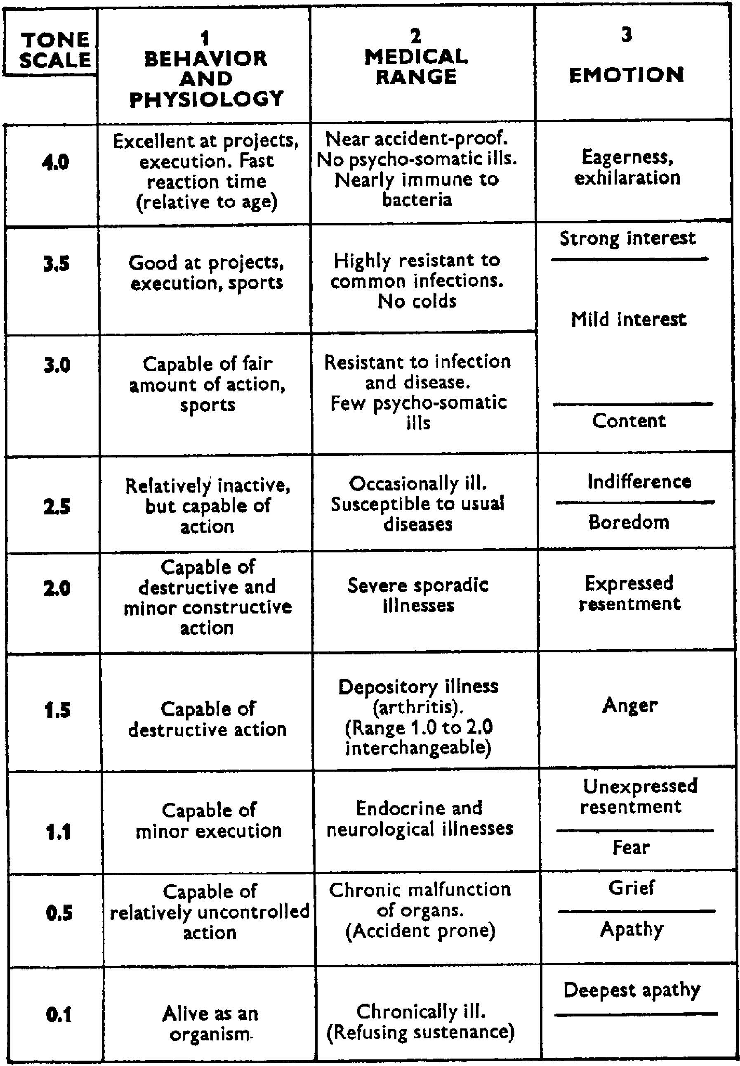
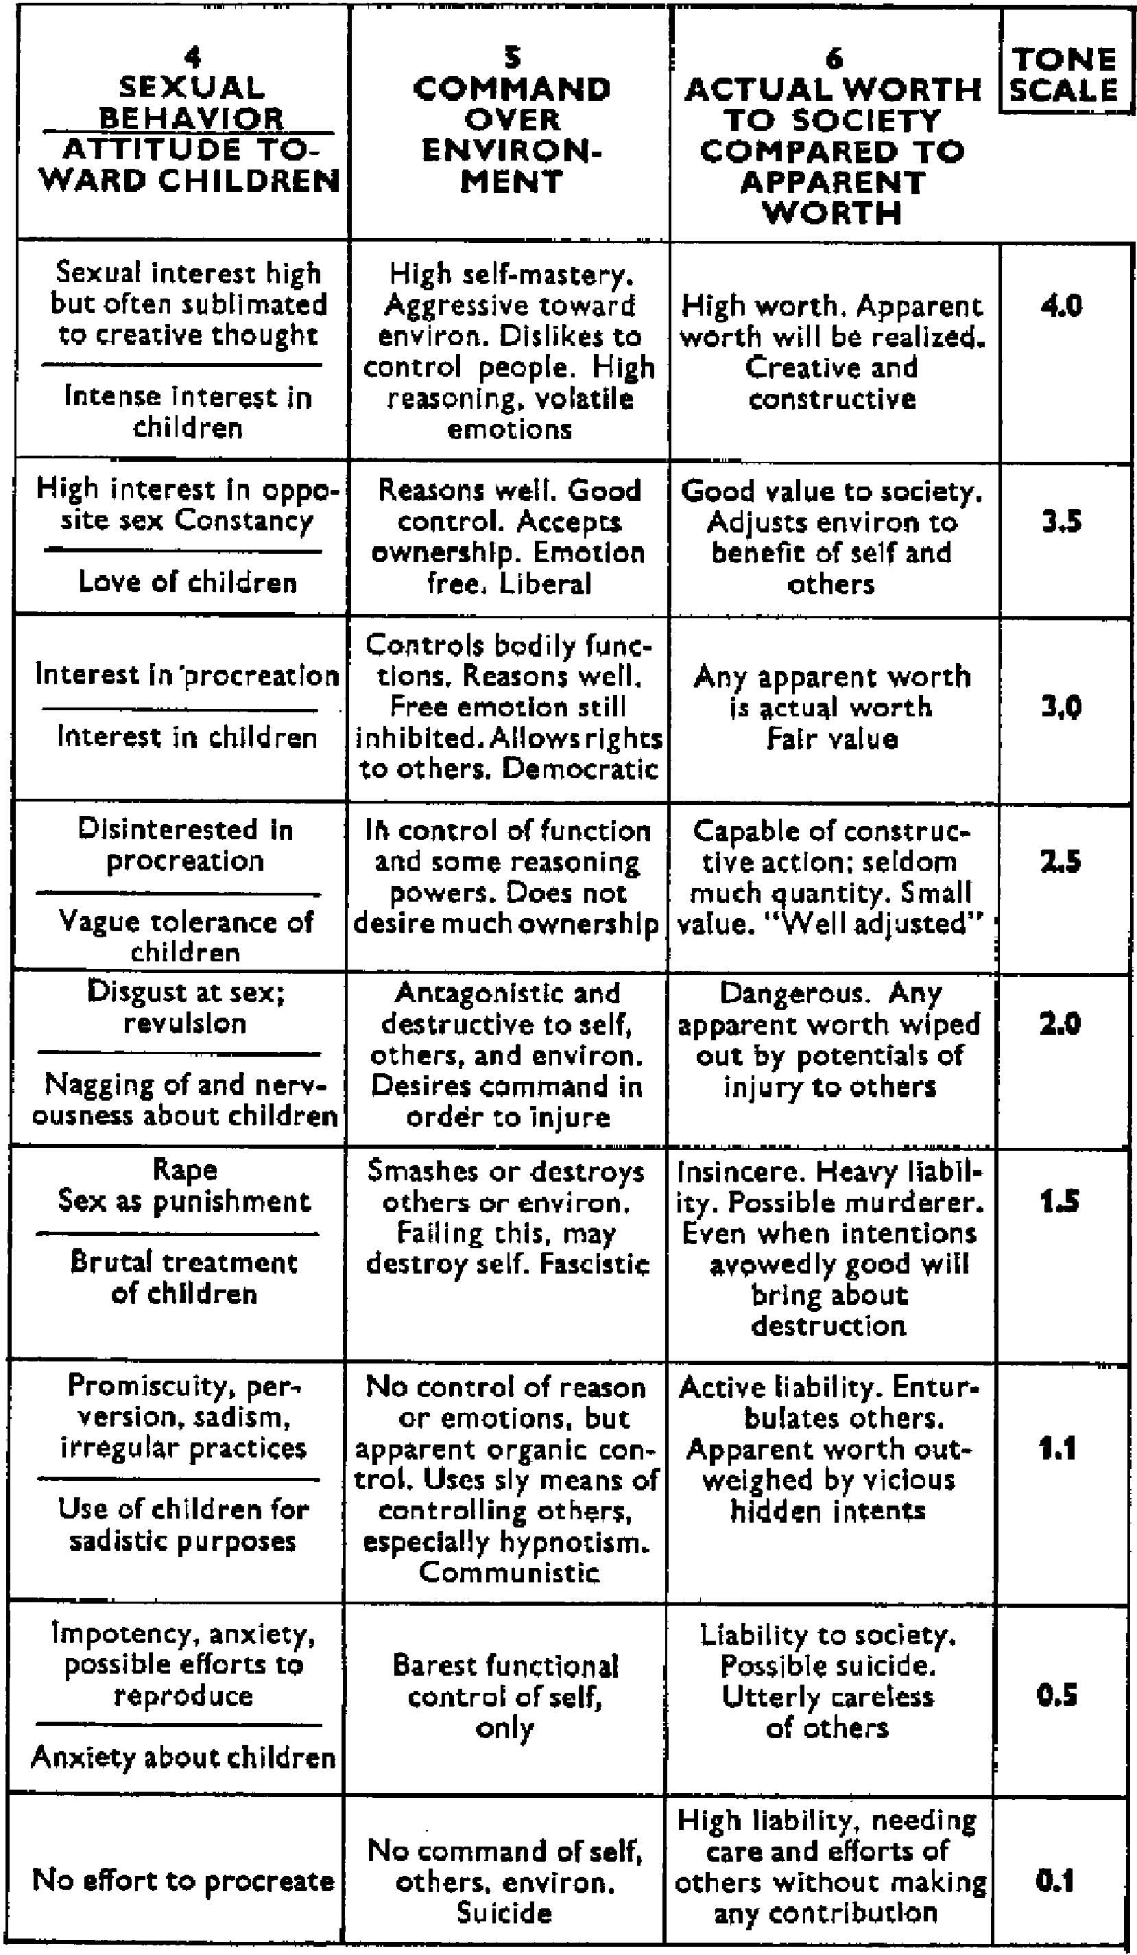
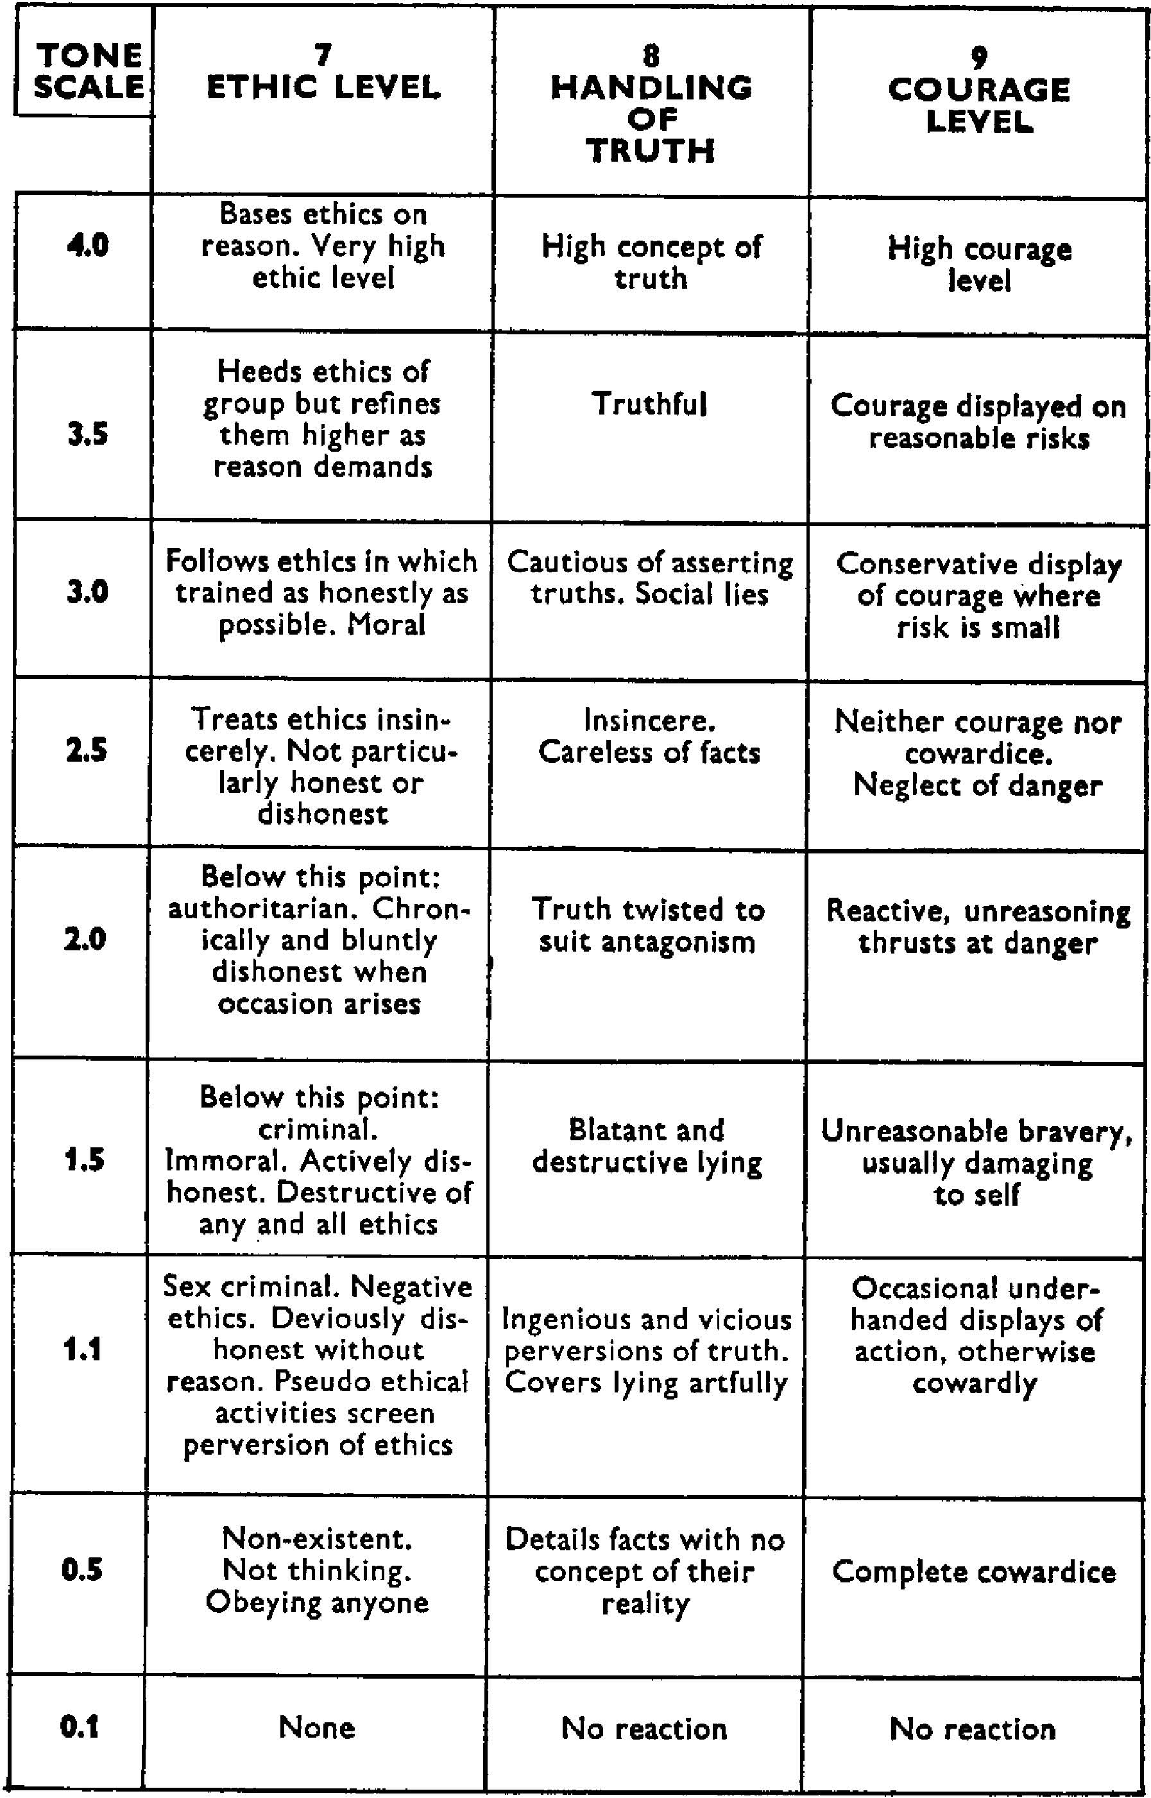
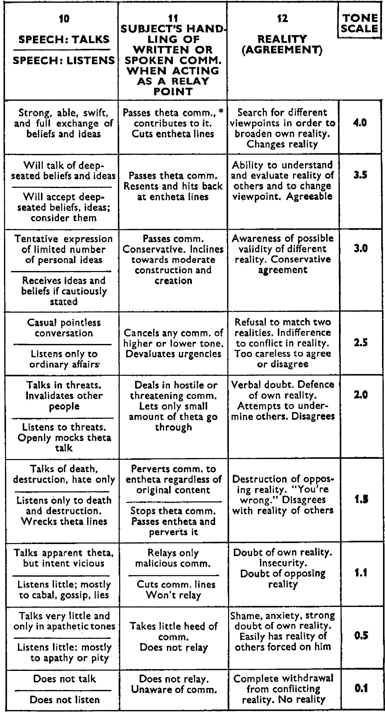
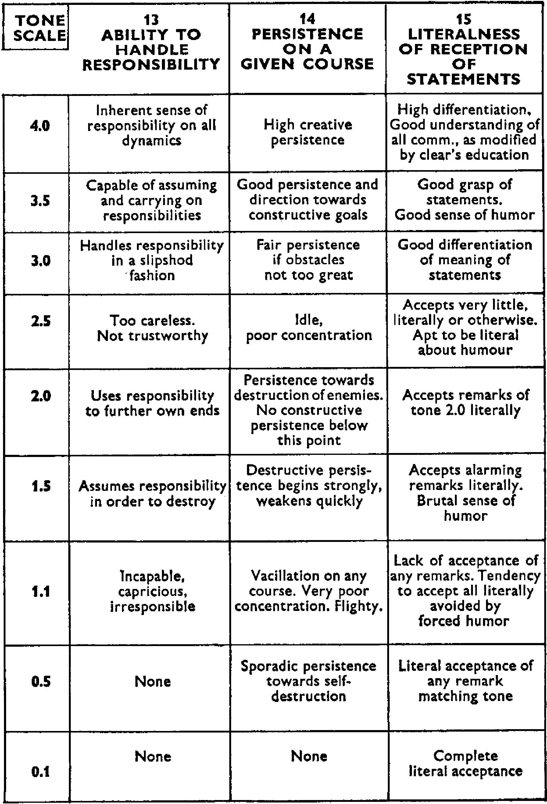
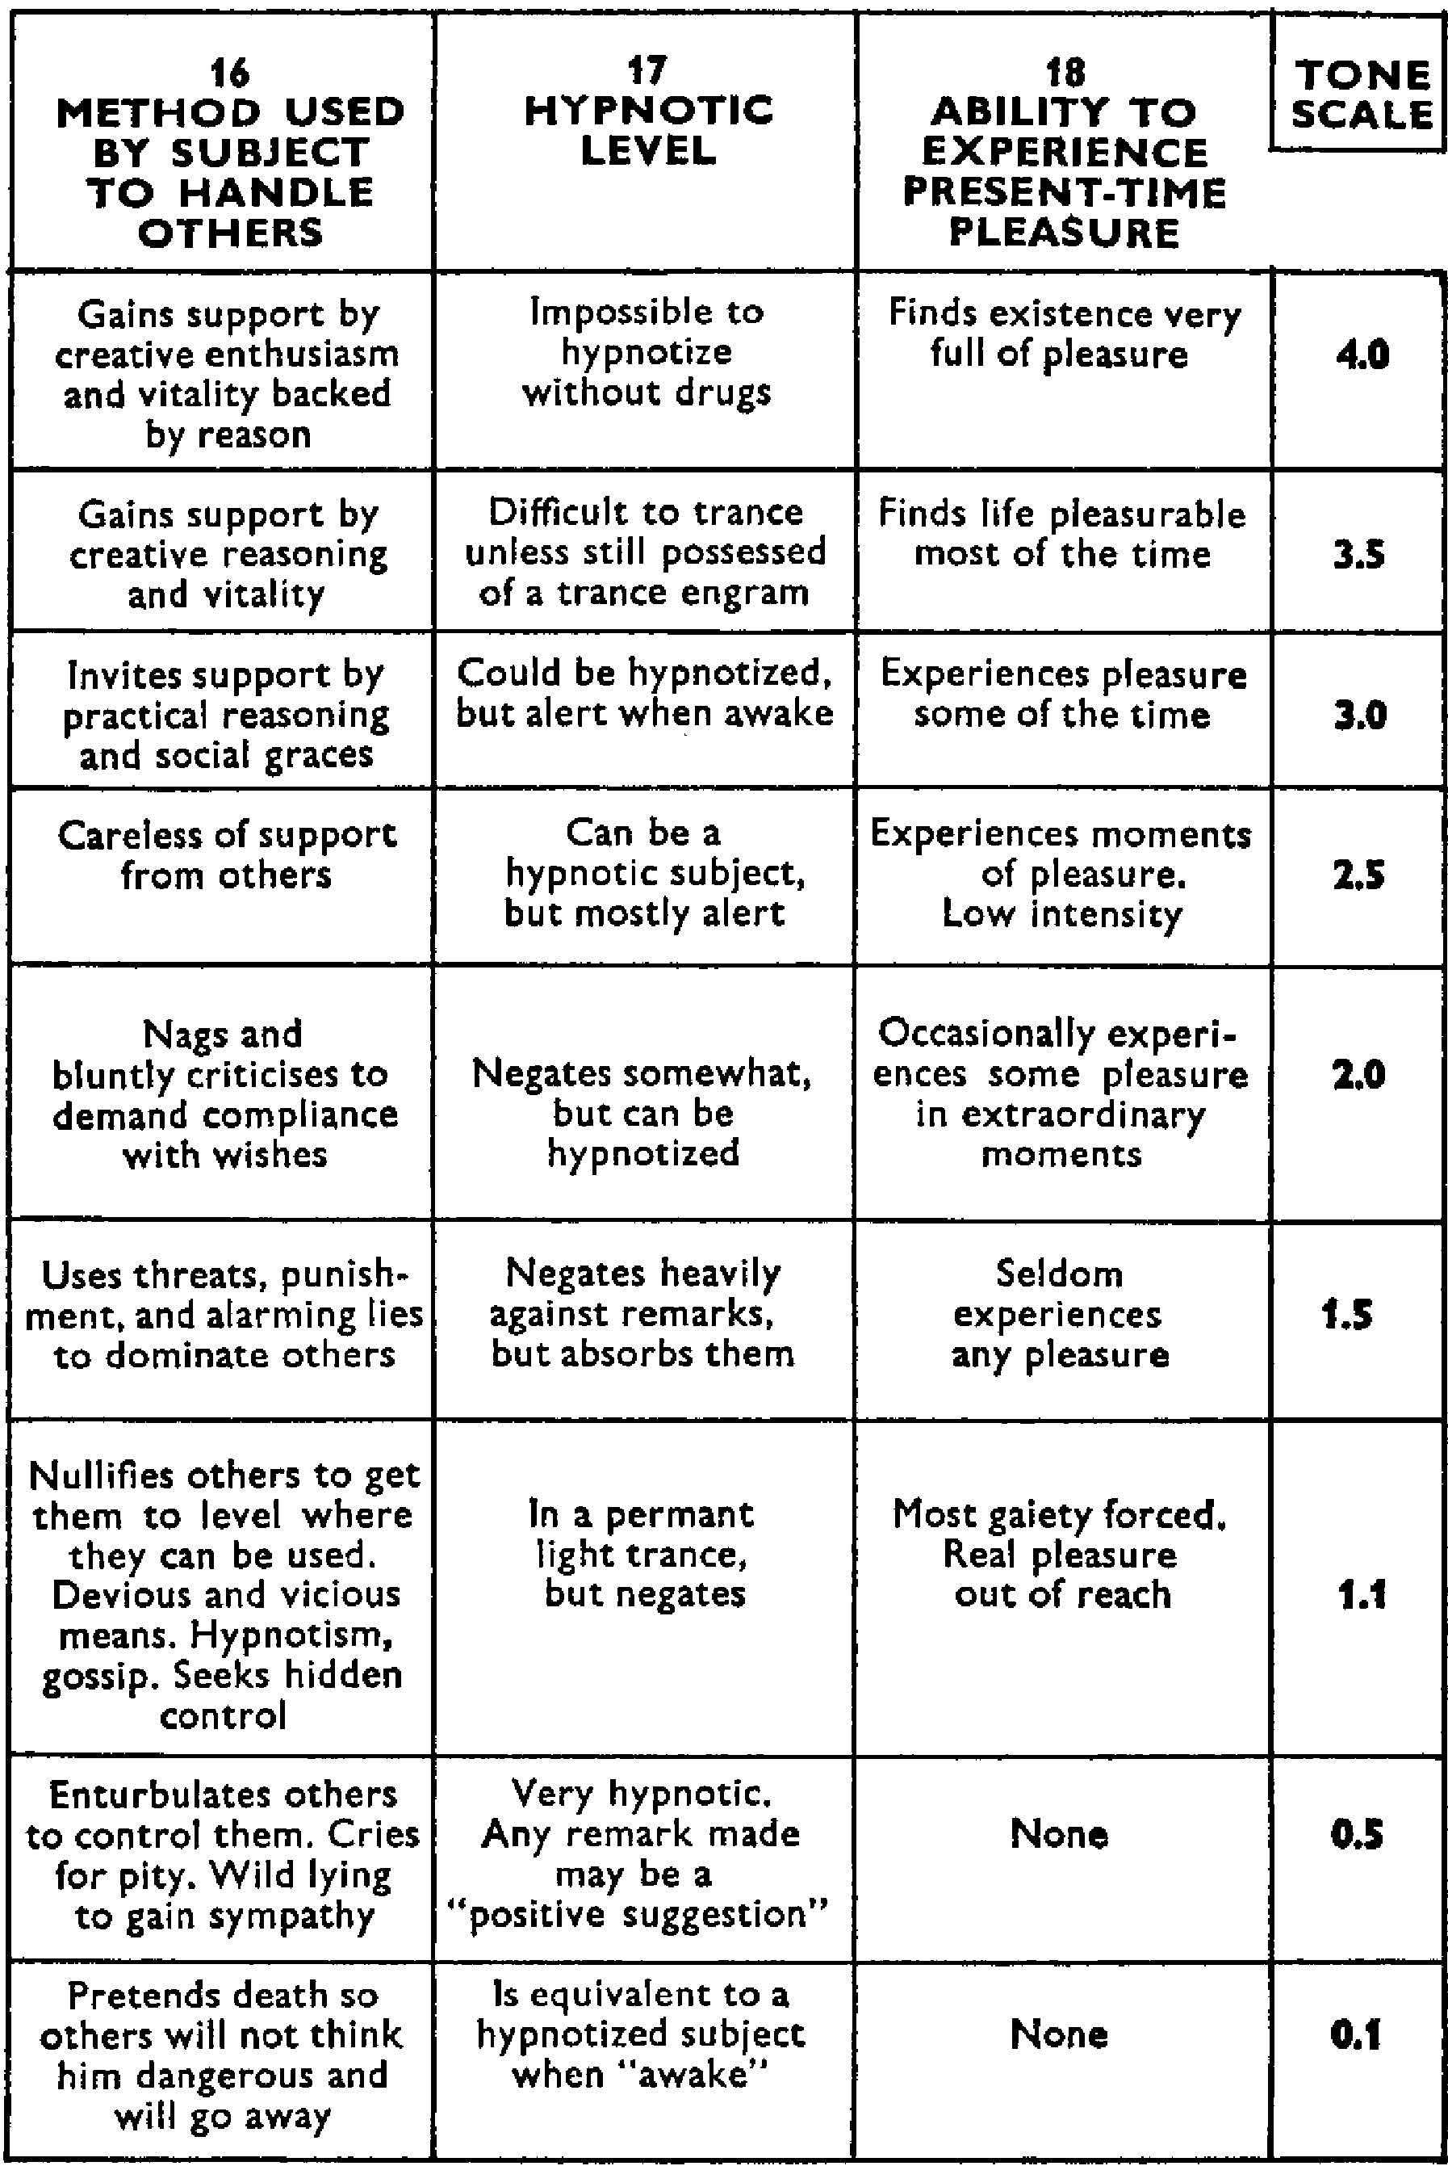
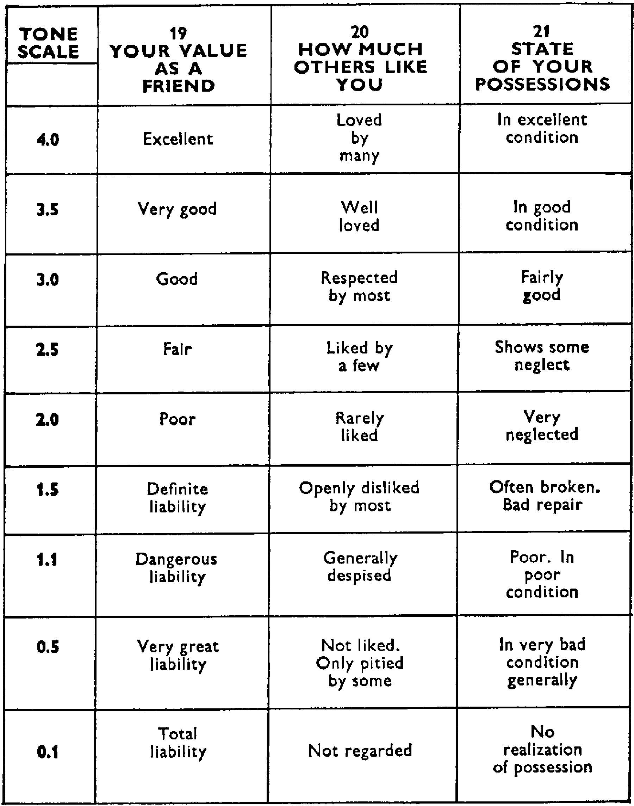
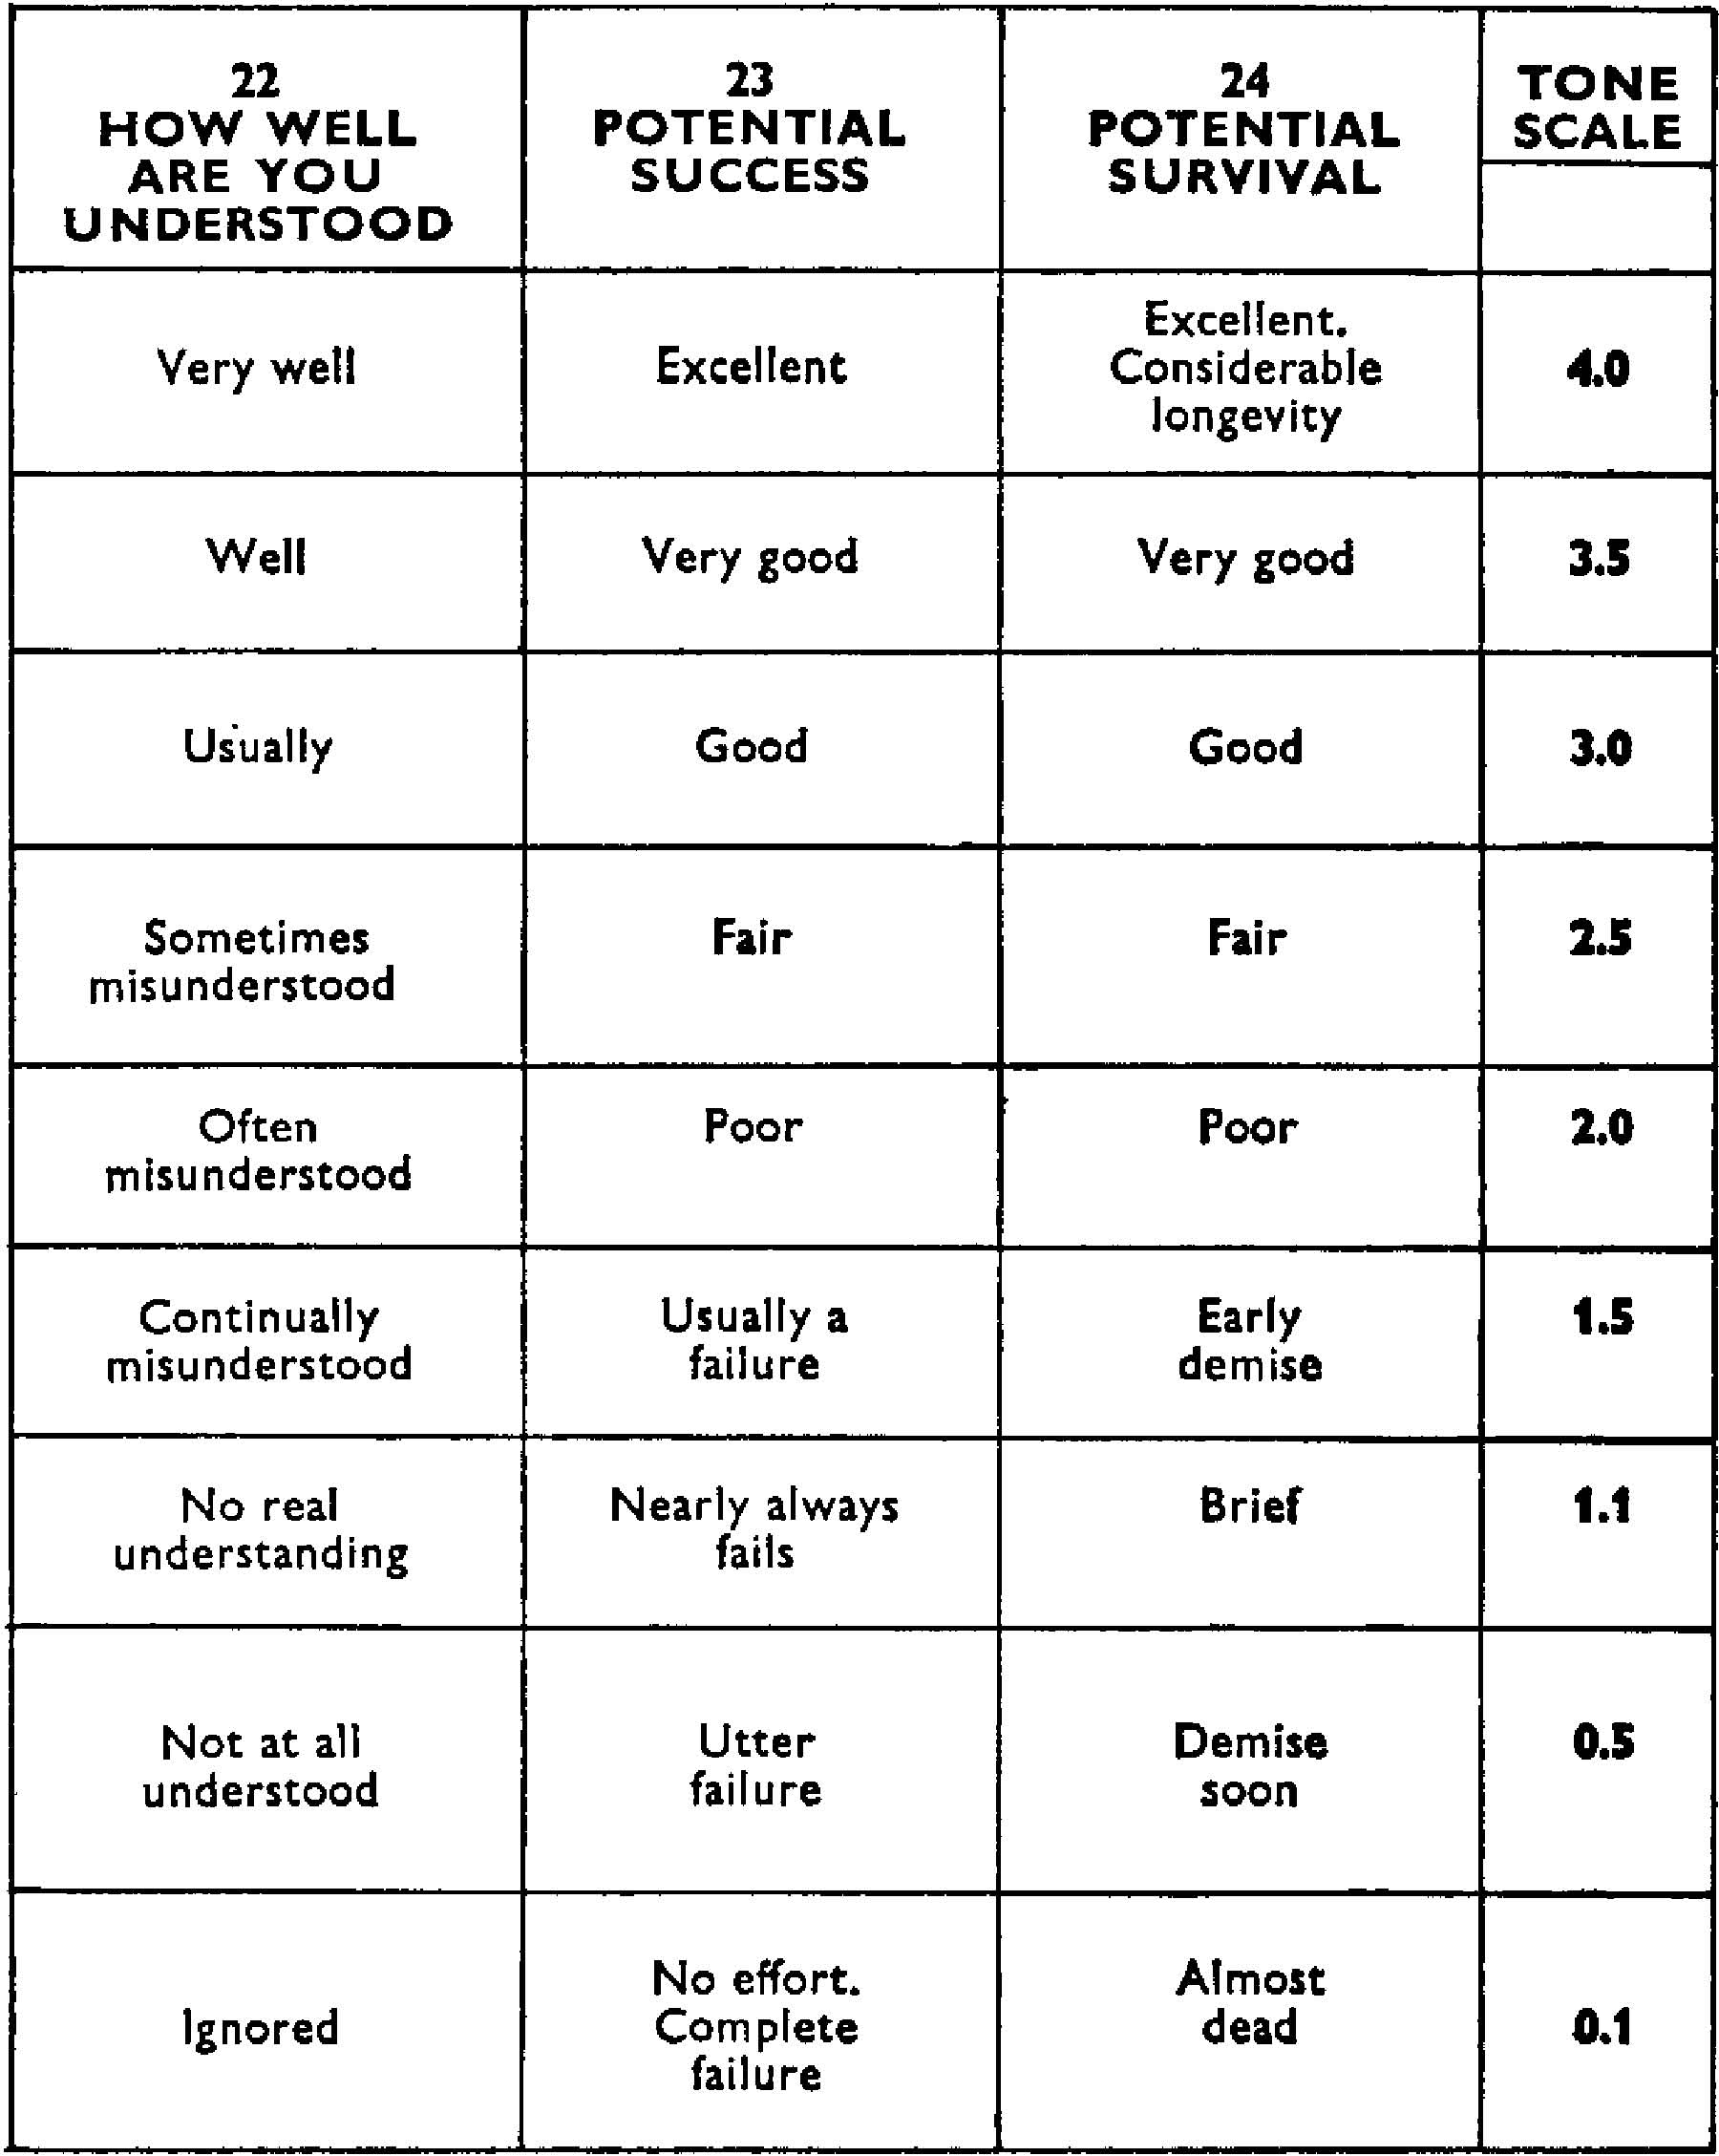
Take this test before you begin on the processing section of Self Analysis.
Be fair and as honest as possible in your findings.
Use, as a basis, how you have been in the ]ast year. Earlier conditions in your life do not count.
Open up Chart to Column One, Behavior and Physiology. Ask yourself how active you are physically. Locate the place in this column which most nearly seems to fit you.
Look on the Tone Scale for the number of the square you have found. Is it 3.0? Is it 2.5?
Take this number and go to the graph at right.
Under Column 1, as marked at the top of the graph, locate the number (3.0, 2.5 or whatever it was) and place an X in this square. This gives the same place on the graph that you found on the chart.
Go to Column 2 on the Chart, Medical Range.
Find the square which best describes your health. Note the number given in the Tone Scale column opposite the square you have chosen. (3.5, 2.0 or whatever it was.)
Turn back to the graph of Test 1. In Column 2 on the graph, put an X in Column 2 opposite the tone scale number you got from the Chart.
Carry through this process with all Columns until you have an X in each Column of the graph. Omit the last six.
Take a straight edge or ruler. Move it on the graph, holding it horizontally, until you have the level of the graph which contains the most X’s. Draw a line through these X’s all the way across the chart and out to the edge. This line will give you your position in the last six columns.
The horizontal line you have just drawn gives you your position on the tone scale. This level of the Chart is yours.
Leave this Graph in the book. Keep it so that you can compare it in a few weeks when you do Test 2.
Note that in Columns 4 and 10 the squares are divided in the same manner as the squares on the chart. You make two evaluations of yourself for these columns and you put an X in a half square, using two half squares for each column, even if one X falls at 3.0 and the other X falls at 1.1.
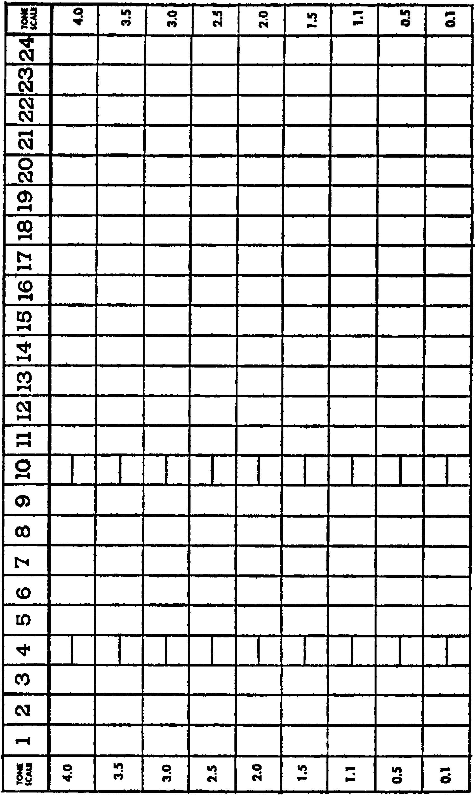
Use as your data how you have felt about things since taking Test One.
Use this test after you have been processing yourself two months.
Use as data how you have felt about things since taking the second test.
Use the same directions as given in Test One.
A slotted disc is provided for the reader’s use. The disc must be used. Without using the disc, the benefit of processing is cut more than eighty per cent.
The disc is placed over Question 1 of a list so that the question shows through. One recalls the incident desired.
Then one looks at the uppermost word on the disc itself. This says, for instance, “SIGHT”.
One seeks to “see” in recall, the incident desired.
One tries then to recall another incident without moving the disc. He then seeks to “see” this incident in recalling it.
One tries to recall, then, the earliest incident of this kind he can and seeks to “see” this one.
Then one drops the disc one question, rotating it at the same time so that another “sense” appears at the top. He uses this sense particularly in recalling the incident.
Turn the disc over on each new page, so that a new set of perceptions come up.
It does not matter what “sense” you begin to recall with. It does not matter which side you first begin to use.
Eventually you should be able to get more and more perceptions on any one incident until, at last, you may recover all of them without strain.
If you lose the disc, the full list of perceptions on it are at the bottom of every page. Take a pencil and check them off one at a time just as though they were appearing on the disc.
A green disc and a white disc are provided. Use the one you like best.
IF YOU ONLY GET A VAGUE CONCEPT OF WHAT THE SENSE MUST HAVE BEEN LIKE, IF YOU DO NOT AT FIRST GET ACTUAL RECALL BY THE SENSE ITSELF, BE SURE THAT YOU AT LEAST GET A CONCEPTION OF IT.
DIANETIC PROCESSING;
Here begin the lists of questions by which the individual can explore his past and improve his reactions toward life. Dianetically speaking, this self-processing section could be called “straight wire”. It is not “auto processing”. The reader is actually being processed by the author.
In the full use of Dianetics these questions could be considered as preparatory to coauditing. The auditor is assisted by these lists in that they open a case for the running of engramsand secondaries and raise the pre-clear on a tone scale. These question sections, so far as is known at this time, will not run out engrams and secondaries as such but will desensitize them to a marked extent with a consequent improvement in the mental and physical being of the individual.
An auditor, as the practitioner in Dianetics is called since he both listens and computes, can use these questions during a session with a pre-clear. Further, two people can work with these sections—one of them asking the questions of another who answers—or both of them reading the questions and both of them attempting to get a recall on such an incident as that one called for.
These lists are used repetitively; that is to say the individual goes over them again and again. There is no finite period to the work. The reason the recall of these questions is important is that they reveal and discharge locks which have formed above the basic engrams (moments of physical pain and unconsciousness) and secondaries (moments of acute loss as death of a loved one). The discharging of these locks renders engrams and secondaries relatively ineffective. A full dianetic clearing of the individual’s engrams and secondaries gives the highest possible attainable results, but these questions provide self-processing which prepares the case for such an action and are in themselves highly beneficial.
In the process of using these questions the pre-clear may discover many manifestations in himself. He may experience
considerable emotional release. He may become angry at the recollection of some of the things which have happened to him and he may even feel like crying over some of the losses he has sustained and indeed may very well cry. However, the intent of these questions is not to focus the self-processor’s attention upon the bad things which have happened to him but upon the good things which have taken place in his life. A concentration upon these happier circumstances tends to discharge the unhappy circumstances and render them far less forceful.
These questions are based upon the dianetic discoveries, axioms and postulates which have done so much toward amplifying the understanding of people, concerning the nature of existence and their roles in it. Life can be considered to have as its fundamental purpose Survival in the material universe. When one closely examines Survival he discovers that the concept embraces all the activities of an individual, a group, a state, life itself or the material universe.
The material universe is composed of matter, energy, space and time. Life can then be considered to be engaged upon the conquest of matter, energy, space and time, induding other life forms, organisms and persons. If an organism or a group has been successful in handling other organisms, groups and the material universe, its survival potential is very great. If the organism has been unsuccessful, its survival potential is lower. Its moments of success, as its moments of pain, are highly charged. It is possible, by certain processes, to remove the charge from painful incidents. One of the ways of doing this is to lay the stress and concentration of the organism upon the tirnes it has been successful in surviving.
With the invention of language man brought upon himself an unexpected source of aberration. While language itself is very far from the whole reason an organism is less successful than it might be, our current social order lays undue stress upon language. Words are only symbols which represent actions. A child learns these actions very early and learns the symbols which represent the actions. Later on he begins to mistake the action for the symbol and begins to believe the words themselves have force and power which they do not. If you believe that words have force and power, hold your hand in front of your mouth and say a few words. You will see how negligible is the force of utterance, no matter what words you use. Underlying this mistaken emphasis on the force of words lie actual physical actions of which the words are the symbols. The main point then is that words are not powerful but actions are. For example, when an individual has been told to hold still he obeys simply because he has experienced earlier in his life the action of being made to hold still by physical force.
For many reasons it is important for the organism to increase its mobility. The discovery of all the times the organism has been told to hold still and has obeyed has some therapeutic value but the discovery of actual incidents when the organism has been physically forced to remain motionless is much more important in restoring the mobility of the organism.
These lists, then, tend to devaluate the importance of language. This is only one of their many functions but an important one; therefore, the reading of these lists should direct the individual to moments action took place, not when somebody said it took place. Just as hearsay evidence is not admissible in a court of law, so are words and phrases given to the individual by others inadmissible in self-processing. For instance, when one is asked for a time when somebody went away one should not try to recall the time when somebody said somebody went away or the statement that somebody was going away, but the actual physical departure, regardless of what was said.
You will find that words are communicated through the physical universe to other organisms. Sounds, for instance, originate within the organism, are translated into sound waves and reach the other person as sound waves. The written word is made into symbols of ink which are then seen, the other physical fact, of light, byanother organism. Whereas theremayvery well be such things as ESP, it is not aberrative.
There are many perceptions, which is to say channels, through which one can contact the physical universe. You are aware of the physical universe because of sight, sound, mouth and other message systems. Therefore, each time you are asked to recall an incident of a certain kind you will be asked, after you have recalled it, to pay attention to a certain sense channel which was present during the time when you experienced the incident. The circular disc is provided for this purpose. You will notice the disc has two sides.
The perceptions or sense messages listed on one side are different from those on the other side. As you read the questions one after the other you should read them through a s]ot provided in the disc. Going to the next question you should rotate the slot once counterclockwise for each new question. This will give you a new perception. For instance the question may pertain to a time somebody went away from you. You will recall a time when this occurred, selecting the moment of actual physical departure. Undoubtedly you will get some perception of the scene and you may even get a very full perception of the scene. Many people see, feel, hear and otherwise perceive memories when they recall them. Some people are too occluded. These lists wipe away occlusion. As you recall the person walking away from you then, you are not supposed to recall merely the concept that somebody had walked away, but the moment when they actually did and get as many perceptions as possible of them doing so. The disc which overlies this question will have uppermost at random one particular perception. That perception may be sound—thus you should attempt to recover whatever sounds were present when this individual walked away as the particular emphasis of perception. If you are unable to recover the sounds as such, hearing them again, at least recover the concept °S what they rnay have been.
If you will examine this disc, you will find that it lists six perceptions with which you have contacted the physical universe. Actually there are many more of these than six.
When the word “emotion” is uppermost above a question ffler you have recalled the incident suggested by the question, you then try to recall in particular and feel again, if possible, the emotion you felt at the time. When the next question is addressed the disc is rotated one turn counterclockwise. You will find that “loudness” is now uppermost. You should get an incident in recall suggested by the question and having perceived the incident you should then give your attention in particular to the loudness of the various sounds in the incident.
Going to the next question, you should rotate the disc once more counterclockwise. You will find that “body position” is now uppermost. You should read the question and recall some incident it suggests, perceive it as well as you possibly can and then give particular attention to the position your own body was in at the time the incident occurred. Going to the next question and rotating the disc once more you will find that “sound” is now uppermost. You should recall the incident the question calls for and then give particular attention to the sounds in that incident. Going to the next question and rotating the disc once more, you will &d that “weight” is uppermost. In the incident you recall you should then give attention to the heaviness of things, including the pull of gravity on yourself and the weight of anything you may actually be supporting in the incident such as your clothes, a ball or any other thing which you are actually holding at the time the incident occurred.
Rotating the disc once more to the next question on the list, you will find that “personal motion” falls uppermost. When you have answered the question then you should give attention to the motion which you yourself were undertaking at the time the incident occurred.
Every time you go to a new page you should turn the disc upside down. You will find here a new set of perceptics. These, of course, are applied in such a way that when you go over the list a second time you will probably not have the same perception, as these things fall at random. Thus while you might have answered a question the first time about somebody coming towards you with attention to sound called for by the disc, the next time you reach this question, on going over the list again, you may find “emotion” uppermost. You should then contact any and all emotion on the second time, whereas you contacted the sound the first time. You will find on the reverse side of the disc the perceptions of sight, srnell, touch, color, tone and external motion. Sight is what you actually saw at the time. A person whose perceptions are in good condition will see again what he has seen before when the incident actually occurred. Thus sight calls for what was seen while the incident called for was taking place. Smell requests the individual to recall any and all odors which were present during the scene he is recalling. Touch requests the recall of anything the individual was actually touching at the time with the sensation of touch, including pressure. One is always in contact with the material world in terms of touch, even if only the touch of his feet on the ground or the feel of his clothes upon him. The perception of color, when uppermost, should cause the individual to try to perceive again the color which was contained in the scene called for
When tone is requested the individual should attempt to contact the quality of the sound present when the scene occurred. When external motion is uppermost the individual, in recalling the incident called for by the question, should attempt to perceive in the incident recalled the movement contained in the incident, the motion of other people or objects or of energy.
As one goes over these questions then with the disc, he is exploring his own life and during that exploration is attempting to call into view with the highest possible level of reality those things he has perceived. The immediate result is a heightening of perception of his present-time world. Another result is a strengthening of his memory. Yet another result is the rearrangement and reevaluation of things which have happened to him. Another and more mechanical and fundamental result is the deintensification of unpleasant experiences—like bringing them into the light. For a while one may feel it is better to forget unpleasant things. Forgotten, they have more force and destructive quality than when examined.
The individual will find himself, as he repeatedly uses a list, getting earlier and earlier incidents. It is not impossible for him to remember straight back to the earliest beginnings of his life, much less his infancy.
Again, and it cannot be emphasized too strongly, these questions are requesting actual physical actions, not statements about physical actions. It is perfectly legitimate to recall scenes which have been seen in the movies or read about in books, but when one recalls such scenes one should have full awareness, in the case of the movies, of the screen and the seat and where the incident is taking place and when. In the case of books one should get not the scene the author would like the reader to see but the actual scene of reading and the recall should be recaptured in terms of print and sitting in a chair, not in terms of imagining.
There is a great deal of technology out of sight back of these questions. All that is important is that this operation, continued persistently, going over one list and then another and recalling the things required, considerably improves the individual’s thinking and acting abilities and his physical well being and considerably enhances his relationship with his present environment.
You will find the very last list is named the “End of Session List.” This means that after you have worked a list, or worked as long as you desire to, during any one period of selfprocessing, you should turn to the “End of Session List” and answer the questions as a routine operation.
You will also find a list entitled “When Uncomfortable”, which is placed next to the last in the book. If you find during a session of self-processing that you grow considerably uncomfortable or unhappy, you should then turn to the “When Uncomfortable” list. Using it should restore your good spirit swiftly.
If you find it is extremely difficult to recall any one question in these lists, simply pass over it and go to the next question. If you find you are having difficulty in answering any of these lists you will do better if some friend reads them to you.
If undergoing self-processing makes you extremely unhappy it is probable that your case should be given the attention of a dianetic auditor until such time as you are capable of handling this matter for yourself.
You can go over a list many times before going on to the next list or you can continue on through all of the lists consecutively without repeating any. You will probably find that going over each list many times before going on to the next will work better than going through the book consecutively. You will notice that after you have been over the same memory several times, even though it be an unpleasant one, that it will cease to have any effect upon you. This means its intensity is decreasing and that the energy which it contained and which was affecting your present time life is dissipating. If you can remember several incidents of the same kind, do so; and if they are troublesome to you, simply go over the things you remembered once more, one after the other, and then again. This, dianetically speaking, is called repetitive straight wire. It de-intensifies unpleasant memories. However, this list is aimed toward the recall of pleasant incidents. Pleasant incidents do not de-intensify as unpleasant ones do but, underneath the level of attention, deintensify unpleasant incidents when the pleasant incident is recalled.
All you really need to work these lists is to know that actions, not words, are required and that the disc should be used to give you the particular kind of recall you should have on the recollection called for. If you lose the disc you will note that the bottom of the page has a list of the perceptions for your reference. When using the bottom-of-the-page list you should merely take the recalls,.the perceptions, consecutively one after the other and use them the same way you used them with the disc.
Don’t simply answer questions “Yes” or “No”. Select an actual moment in your life called for by the question. Try to re-sense that moment with the perceptic called for on the disc.
If going over the questions makes you unhappy, simply continue with the list you are working, over and over. The unhappiness should “wear out” after unhappy incidents are recalled many times. The feeling will turn to one of relief.
Some people are frightened at the idea of persevering with these questions. Certainly you’ve got more nerve than that. The worst they could do is kill you.
Don’t be surprised if you feel sleepy after using some of these questions. The sleepiness is only a symptom of relaxing. The very least the book can do for you is replace your sedatives!
If, while answering these questions, you begin to yawn, that is good. Yawning is a release of former periods of unconsciousness. You may yawn so much the tears come out of your eyes. That is progress.
Should you feel very groggy while answering these questions, that is only “boil-off “, the manifestation of former periods of unconsciousness boiling off. Simply persist in recalling the incident or others like it and the feeling wiU pass away, leaving you more alert than before. If you interrupt this “boil-off” and stop your session, you may feel cross or irritable. This grogginess occasionally amounts to nearly complete unconsciousness, but it always goes away. That unconsciousness was what was keeping you from being high on the tone scale.
Occasionally vague or even sharp pains may turn on and off as you are answering questions. Don’t try to find out where they came from. They will go away if you persist with these questions. Simply ignore them. They are the ghosts of what they used to call psychosomatic ills, former injuries restirnulated.
An individual is suppressed by these deposits of past pain and unconsciousness. Self Analysis makes such past moments pass away and de-intensify at least partially, without your having tofind out what was in them.
A full description of these manifestations and their causes occurs in SCIENCE OF SURVIVAL, the popular text on Dianetics, which you will find on the book list in the back of this book.
Use Lists Many Times. Try for the earliest incident you can get for each question.
General Incidents
The purpose of this list is to give you practice in recalling things. Use the disc provided in the back of the book and look at the beginning of this section for instructions as to how this list is to be used.
Can you recall a time when:
1. You were happy.
2. You had just finished constructing something.
3. Life was cheerful.
4. Somebody had given you something.
5. You ate something good.
6. You had a friend.
7. You felt energetic.
8. Somebody was waiting for you.
9. You drove fast.
10. You saw something you liked.
11. You acquired something good.
12. You threw away something bad.
13. You kissed somebody you liked.
14. You laughed at a joke.
15. You received money.
16. You felt young.
17. You liked life.
18. You played a game.
19. You bested something dangerous.
20. You acquired an animal.
21. Somebody thought you were important.
22. You enjoyed a good loaf.
23. You chased something bad.

Sight, Smell, Touch, Color, Tone, External Motion, Emotion, Loudness. Body Position, Sound, Weight. Personal Motion
44
24. You were enthusiastic.
25. You enjoyed life.
26. You went fast.
27. You owned something.
28. You felt strong.
29. Somebody departed.
30. Somebody helped you.
31. You gathered something good.
32. You measured something.
33. You took a pleasant journey.
34. You turned on a light.
35. You heard some good music.
36. You controlled something.
37. You destroyed something.
38. You mastered something.
39. You were lucky.
40. You felt peaceful.
41. You saw a pretty scene.
42. You poured something good.
43. You acquired something that was scarce.
44. You made an enemy scream.
45. You had a pleasant seat.
46. You handled something well. (actual physical handling)
47. You moved something.
48. You watched something fast.
49. You were together with friends.
50. You occupied a good space.
51. Somebody loved you.

Sight, Smell, Touch, Color, Tone, External Motion, Emotion, Loudness. Body Position, Sound, Weight. Personal Motion
45
52. You enjoyed somebody.
53. You invented something.
54. You harnessed some energy.
55. You killed a bug.
56. You pocketed something.
57. You made progress.
58. You walked.
59. You saved something.
60. You stopped a machine.
61. You started a machine.
62. You had a good sleep.

62. You stopped a thief.
64. You stood under something.
65. You started a fire.
66. You went upstairs.
67. You were warm.
68. You went riding.
69. You were adroit.
70. You swam.
71. You stood your ground.
72. You lived well.
73. You were respected.
74. You won a race.
75. You ate well.

Sight, Smell, Touch, Color, Tone, External Motion, Emotion, Loudness. Body Position, Sound, Weight. Personal Motion
46 Time Orientation
This list is intended to aid your general sense of time as applied to periods in your life. Everyone has a full recording of everything that happened to him during his life. It may be that he cannot immediately recall certain periods. These periods are said to be occluded. Working with these lists in general, such occluded periods will gradually disappear when one’s life is in recall to the betterment of his mental and physical well being and his perception of his presenttime environment- In Dianetics it is considered that everyone has a “time track”. Everything which an individual has perceived throughout his life is recorded on this “time track” from the beginning to the end. It is dangerous to have occlusions since the data in the occluded area becomes compulsive and causes less than optimum conduct. This list is intended to straighten out the track in general. Do not be dismayed if you cannot recall the actual instant of the memory. Get the memory first. If you can answer the remaining questions,that is all to the good.
Can you recall an incident which happened:
1. A long time ago. (the year? the month? the hour ?)
2. Yesterday. (the hour? the date?.)
3. Last month. (position of the sun?.)
4. When you were very small. (clothes people wore? position of sun?.)
5. When you were half your present size. (the sizes of others at that time ?.)
6. When you were a third your present weight. (position of the sun?.)
7. When your mother looked younger. (her clothes ? position of the sun?.)
8. When you felt agile. (the year? the hour?.)
9. Last Christmas. (time of day ?)
10. Your fifth Christmas. (clothing of others?.)
11. Your eighth birthday. (furniture?.)
12. A birthday. (the appearance of others ? year ? position of sun?.)
13. This day last year. (the house you lived in? the date? the season?.)
14. At noon today.
15. At a banquet. (clothing of people present?)
16. At a marriage. (year? season ?)
17. At a birth. (season?.)
18. On a date with someone. (hairdo ?)

Sight, Smell, Touch, Color, Tone, External Motion, Emotion, Loudness. Body Position, Sound, Weight. Personal Motion
47
19. About a clock. (position of the sun?.)
20. About a wrist watch. (motion of second hand?)
21. With an animal. (when he was smaller ?)

Can you recall incidents which compare:
1. Clothing today and clothing when you were small.
2. Hairdo today and hairdo when you were in your teens.
3. Something which is now old when it was new.
4. Something which was small which is now big.
5. Something which is now old when it was young.
6. The way the sun shines in the morning and in the afternoon.
7. Winter with summer.
8. Spring with winter.
9. Fall with spring.
10. Sunrise with sunset.
11. A morning shadow and an evening shadow.
12. Clothing now old when it was new.
13. A house now standing where no house was.
14. An open space which is now cut up.
15. A long time and a short time.
16. A cigarette when it was lighted and when it was put out.
17. The beginning and the end of a race.
18. Bedtime and getting up.
19. School in the morning and getting out in the afternoon.
20. Your size now and when you were little.
21. A cloudy day and a sun- shiny day.
22. Stormy weather and rainy weather.
23. Something hot and when it got cold.
24. Something young and something old.

Sight, Smell, Touch, Color, Tone, External Motion, Emotion, Loudness. Body Position, Sound, Weight. Personal Motion
48
25. A fast heartbeat and a slow heartbeat.
26. When you were over- heated and when you were chilly.
27. When you had lots of room and when you had little room.
28. When the light was bright and when it was dim.
29. When a fire burnt bright and when it down.
30. An object half built when it was started.
31. The same person when he was big with when was small.
32. When you felt little when you felt grown
33. Yesterday morning this morning.
34. A complete calendar and when it had its leaves torn off.
35. A stopped clock and a running clock.
36. The sun’s motion and the moon’s motion.
37. When you felt tired and when you felt energetic.
38. Cars then with cars now.

Sight, Smell, Touch, Color, Tone, External Motion, Emotion, Loudness. Body Position, Sound, Weight. Personal Motion
49 Orientation of Senses
This list is arranged especially to call your attention to the existence of many of the channels by which you perceive yourself and the physical universe about you. While each of the questions listed pertains to a specific sense channel such as light or sound, the disc could still be used, for what is required are specific moments when you were using various senses and any specific moment includes many other sense messages than the one which is called for. Therefore, use the disc as in any other questions and after you have recalled a specific incident called for in the question then try recalling it with specific attention to that sense which happened to be uppermost on the disc at that time.
Time Sense
Anyone has a sense of time. This sense is apt to become aberrated. The existence of clocks at every hand seems to tell us that we need mechanical assistance in knowing what time it is. The first person that had an aberrated or dearranged time sense made the first clock desirable—but only for him. Clocks and calendars are artificial symbols representing time which is an actual commodity and which can be sensed directly by the individual. This section and almost every other section in these lists rehabilitates the sense of time. Time in most people’s minds is confused with space. The words which describe time are also the words which describe space, which shows that man has an indifferent attention for his time sense. The organism measures time in many ways, but mostly in terms of motion and growth or decay. Change is the most striking symbol of time passage, but there is a direct sense of time which everyone has although it may be occluded by a society which, using clocks and calendars, seems to invalidate the fact that it exists no confusion of any kind about time.
Can you recall a time when:
1. It was very late.
2. You were early.
3. You had to wait.
4. You had to stand for some time supporting a weight.
5. You went very fast.
6. You covered a great deal of space.
7. You used a lot of time (when you really did, not when somebody said you did).
8. An object ran down (not a clock).
9. A long length of space.
10. A short length of space.
11. An object moving.
12. An animal moving.

Sight, Smell, Touch, Color, Tone, External Motion, Emotion, Loudness. Body Position, Sound, Weight. Personal Motion
50
13. A clock hand moving.
14. A round object.
15. An object near an object.
16. A lightning bolt.
17. Breaking a watch. (did time stop’?)
18. A good time.
19. You were too late. ( Additional questions are in the second half of LIST 2 )

Sight, Smell, Touch, Color, Tone, External Motion, Emotion, Loudness. Body Position, Sound, Weight. Personal Motion
51
There are several portions of the sense channel called sight. Light waves, coming from the sun, moon, stars, or artificial sources, reflect from objects and the light waves enter the eyes and are recorded as present time action or as memory for future reference. Light sources are also recorded. This is the sense perception called sight. It has subdivisions. First of these might be considered to be motion, wherein sight depends upon a time span to record a continuously changing picture. While one may see motion in present time, various aberrations of sight may cause him to recall only still pictures. Nevertheless, all the motions are still recorded and can be recalled as moving pictures. In this way all other senses have a dependence upon time in order to bring in the message of motion, since motion is also recorded by the other perceptions. More particularly, part of sight is color perception. There are people who are color blind in present time; that is to say, they can see color but are unable to perceive differences of shading. There are people who may see color in present time but in trying to recall what they have seen, recall only in black and white. This would be recall color blind- ness. The color is fully deleted. It is an aberration easily re- medied when one recalls things he has seen in color as black and white or as still pictures.
Another part of sight is depth perception. Depth perception is observed in two ways. One is by seeing the difference in size of objects and so having a conception of the fact that one is further back than another or that the object itself is at a distance and the other is a “stereoscopic” effect occasioned by the fact is again remediable. An individual who could not perceive motion in present time and who additionally could not perceive color or depth would be a very bad risk as a driver; almost as bad is that individual who cannot recall what he has seen; depth perception in present time and yet, in recall, see pictures flat and without depth perception. This lack of depth perception is again remediable. An individual who could not perceive motion in present time and who additionally could not perceive color or depth would be a very bad risk as a driver; almost as bad is that individual who cannot recall what he has seen; or if he can recall it, cannot do so with depth perception, full color and motion. This part of this list is devoted to giving you a better insight into sight. All these perceptics are exercised over and over by these lists in general. If you cannot immediately see in recall what you have looked at some other time simply try to get a concept of how things looked at specific times.
Can you recall a sight which was:
1. Very bright.
2. Dark.
3. Green.
4. Vast.
5. Moving.
6. Flat
7. Deep
8. Colorful.
9. Swift.
10. Slow.

Sight, Smell, Touch, Color, Tone, External Motion, Emotion, Loudness. Body Position, Sound, Weight. Personal Motion
52
11. Pleasant.
12. Desirable.
13. Pretty.
14. Rare.
15. Remarkable.
16. Confused.
17. Mysterious.
18. Lazy.
19. Warm.
20. Cheerful.
21. Nearly invisible.
22. Blurred.
23. Sharply defined.
24. Lovable.
25. Passionate.

Sight, Smell, Touch, Color, Tone, External Motion, Emotion, Loudness. Body Position, Sound, Weight. Personal Motion
53
The recognition of one’s size in relationship to the scene in which he finds himself and the objects and organisms of that scene is, in itself, a sense message. It is particularly trying on children, and undoubtedly was on you when you were a child, to be surrounded with objects which are so large. When one is actually getting a good recall on a childhood incident he is quite often startled to see how big things appeared to him and how large were those giants, the adults, with which he was surrounded. The feeling of being small in the vicinity of large objects sometimes produces the feeling of inadequacy. It is even said that people who are smaller than the average feel less secure in their environment. This evidently stems from the fact that their grown up size has not reached the average and thus the feeling of smallness and inadequacy during childhood is in constant restimulation. It is not because the person, though smaller, is really inadequate. In such a way people who are taller than the average become aware of the fact, mostly because people smaller than themselves find ways and means of nullifying them because of their size. The perception of relative size is therefore an important perception to rehabilitate and a person who is larger than others on the average would do well to change the reading disc with which he is working these questions so that the word “loudness” on the disc is marked out and “relative size” is substituted.
Can you recall a time when:
1. You were bigger than an animal.
2. You were smaller than an object.
3. You were bigger than a person.
4. You were smaller than a person.
5. Things looked little to you.
6. Things looked big to you.
7. You were in a vast space.
8. You looked at the stars.
9. You were dwarfed by an object.
10. You saw a giant.
11. You scared somebody.
12. Somebody waited on you.
13. You chased somebody.
14. You licked a larger boy.
15. Furniture was too small for you.
16. A bed was too small for you.

Sight, Smell, Touch, Color, Tone, External Motion, Emotion, Loudness. Body Position, Sound, Weight. Personal Motion
54
17. A bed was too big for you.
18. A hat didn’t fit.
19. You had to be polite.
20. You bullied somebody.
21. Your clothes were too large.
22. Your clothes were too small.
23. The vehicle was too large.
24. The vehicle was too small.
25. A space was too big.
26. A table was too big.
27. Your arm was too big.
28. A cook was small.
29. You could reach something above you.
30. A ball was too small.
31. A daughter was smaller.
32. A desk was too small.

Sight, Smell, Touch, Color, Tone, External Motion, Emotion, Loudness. Body Position, Sound, Weight. Personal Motion
55
33. A big fork.
34. A small kettle.
36. A small fish.
37. A little flower.
38. A small doctor.
39. A tiny dog.
40. A small man.
41. A little child.
42. A small cat.
43. A little house.
44. A small machine.
45. Short legs.
46. A small face.
47. A small place.

Sight, Smell, Touch, Color, Tone, External Motion, Emotion, Loudness. Body Position, Sound, Weight. Personal Motion
56
Sound consists of the perception of waves emanating from moving objects. An object moves rapidly or slowly, and sets into vibration the air in its vicinity which pulses. When these pulses strike the eardrum they set into motion the individual’s sound recording mechanism and the sound is registered. Sound is absent in a vacuum and is actually merely a force wave. Sound in too great a volume or too discordant can be physically painful, just as light in too great a quantity can hurt the eyes. However, the amount of nervousness occasioned by sound, as by light, is mainly an aberration and it is not warranted, since the sound itself is not ordinarily damaging, and there are few incidents in anyone’s life when a sound has had enough physical force to be physically damaging. Apprehension and anxiety about the physical universe and other persons can, however, cause the individual to be nervous about sound, as it is one of the most reliable warning mechanisms; but starting at every sound in a civilized environment, being afraid of voices of others, or even traffic noises is foolish, since men rarely live a tooth-and-claw existence which warrants such attention. As sound becomes intermingled with past pain, the individual mis- takes the moment and time he is hearing the sound, and so may associate it, as he may with other perceptics, with past pain. These lists permit an individual to rehabilitate his skill in telling the difference between one time and another or one situation . another.
Sound has several parts. The first is pitch. This is the number of vibrations per unit of time of any object from which sound, coming. The second is quality or tone which is simply the difference between a jagged or ragged sound wave and smooth sound wave as in a musical note. The third is volume which merely means the force of the sound wave, its loudness or quietness.
Rhythm is actually a part of the time sense, but is also ability to tell the spaces between sound waves which are pulse regularly, as in the beating of a drum.
Many people have what is called extended hearing, which is say they have too high an alertness to sounds. This accompanies quite ordinarily, a general fear of the environment or the people in it. There is also deafness by which the individual simply shuts out sounds. Some deafness is, of course, occasioned by entirely mechanical trouble with the recording mechanism, but most deafness, particularly when partial, is psychosomatic or caused by mental aberration. The individual may or may not be able, at first, to recall what he has heard and which has be recorded in the past, when he remembers it. In other words, it does not get a sound when he remembers that he heard a sound. This is an occlusion of sound recordings. Recalling a sound in hearing it again is called “sonic” in Dianetics and is a desirable circumstance which can be returned to the individual.
It is interesting to note that there is also a depth perception in sound. A person having two ears gets a “stereoscopic” effect on sources of sound so that he can tell how far they are from him and where they are located in relationship to him.
1. A gentle wind.
2. A quiet voice.
3. A pleasant sound.
4. A pleasant voice.
5. A breeze.
6. A dog whining.
7. A bell.
8. A cheerful voice.
9. A musical instrument.
10. A door close.
11. Water running.
12. Liquid coming from a bottle.
13. Good food frying.
14. A ball rolling.
15. A wheel singing.
16. A car starting.
17. A child laughing.
18. A ball bouncing.
19. A sewing machine running.
20. A cat mewing.
21. A pen writing.
22. A child running.
23. A book page turning.
24. A newspaper being opened.
25. A kiss.
26. A stimulating sound.

Sight, Smell, Touch, Color, Tone, External Motion, Emotion, Loudness. Body Position, Sound, Weight. Personal Motion
58
27. A smooth sound.
28. A rhythmic sound.
29. A happy sound.
30. A rubbing sound.
31. An enthusiastic sound.
32. A sigh.
33. An eager voice.
34. A revelry.
35. A band.
36. A silky sound.
37. Restful water.
38. A sound in a big place.
39. A wanted sound.
40. An endearing sound.
41. A domestic sound.
42. A busy sound.
43. A pleasant sound.
44. A far-off sound.
45. A nearby sound.
46. A number of sounds jumbled together.
47. A safe sound.
48. A sound that is very real to you.

Sight, Smell, Touch, Color, Tone, External Motion, Emotion, Loudness. Body Position, Sound, Weight. Personal Motion
59
The sense of smell is evidently activated by small particles escaping from the object, which is thus sensed traveling through space and meeting the nerves. When one comes to think of it, this seems rather unpleasant at times, but there are also many very pleasant smells.
The sense of smell has four subdivisions which are mainly categories of the type of odor.
Taste is usually considered to be a part of the sense of smell.
Can you recall a time when you smelled the following:
1. Something sweet.
2. Something sharp.
3. Something oily.
4. Something pungent.
5. Something desirable.
6. Something burned.
7. Something stimulating.
8. Something cheerful.
9. A good person.
10. A happy person.
11. A warm person.
12. A friendly animal.
13. A pleasant leaf.
14. Cut grass.
15. Something passionate.
16. Something you wanted.
17. Something you threw away.
18. A bird.
19. Something exciting.
20. Something desirable.

Sight, Smell, Touch, Color, Tone, External Motion, Emotion, Loudness. Body Position, Sound, Weight. Personal Motion
60
21. A child.
22. Face powder.
23. Perfume.
24. Lipstick.
25. Leather.
26. Pipe smoke.
27. Sweat.
28. Wool.
29. Clean sheets.
30. Fresh air.
31. A bouquet.
32. Money.
33. Paper.
34. Furniture.
35. A beautiful morning.
36. A party.
37. A pleasant odor that is very real to you.

Sight, Smell, Touch, Color, Tone, External Motion, Emotion, Loudness. Body Position, Sound, Weight. Personal Motion
61
1. Soup.
2. Eggs.
3. Bread.
4. Biscuits.
5. Coffee.
6. Tea.
7. Milk.
8. Cereal.
9. Dumplings.
10. Fish.
11. Beef.
12. Chicken.
13. A steak.
14. Duck.
15. Stuffing.
16. Cheese.
17. A fillet.
18. Potatoes.
19. Water melon.
20. A cocktail.
21. Liquor.
22. A hot sandwich.
23. Jelly.
24. Ice cream.
25. Pudding.
26. Candy.

Sight, Smell, Touch, Color, Tone, External Motion, Emotion, Loudness. Body Position, Sound, Weight. Personal Motion
62
27. Pickles.
28. Punch.
29. A vegetable.
30. An apple.
31. An orange.
32. A fruit.
33. Cake.
34. Something you really thought was well cooked.
35. Something you like to eat raw.
36. A cookie.
37. A cracker.
38. Meat.
39. Something cold.
40. Something warm.
41. Your favorite dish.
42. Something in a swanky place.
43. Something at a party.
44. Something in the open.
45. Something on a holiday.
46. Something when you were very hungry.
47. Something which was rare.
48. Something which made you feel good.
49. Something for which you were grateful.
50. Something you had waited for a long time.
51. Something you had not been able to get.
52. Something you stole.

Sight, Smell, Touch, Color, Tone, External Motion, Emotion, Loudness. Body Position, Sound, Weight. Personal Motion
63
The sense of touch is that communication channel which informs the central control system of the body whenever some portion of the body is in contact with the material universe, other organisms, or the organism itself. Probably the sense of touch is the oldest sense in the terms of the central nervous system. It has four subdivisions.
The first of these is pressure; the second is friction; the third is heat or cold; and the last is oiliness. Just as an individual can be hard of hearing or have bad eyesight so can his sense of touch be dulled or even almost absent. This condition is known as anaesthesia. Just as in any other perceptic, the sense of touch can be pleasurable, unpleasant or painful. When an individual has been considerably harmed, as in accidents, illness or injury, he tends to cut communication with the physical universe and other organisms, just as he cuts communication by getting bad eyesight, becoming hard of hearing, etc.
Not only can the sense of touch be dulled in some people, but it can be too sensitive in others who have this sense channel aberrated until it seeks to contact danger more avidly than danger exists. One of the manifestations of the aberrated sense of touch is too high a sensitivity to sexual contact rendering it painful or anxious, or a dulling of this contact sc that sensation can be nearly absent.
A sense of touch is very important. It is partially responsible for pleasure, as in sex and is to a large measure responsible for the sensation we know as physical pain. The sense of touch extends from the central nervous system to the skin surface and as such is intimately connected and most basically in contact with the physical universe. Sight and sound and the olfactory systems contact things usually at a distance, whereas touch is alert only to the closest proximity of actual contact.
Touch is partially responsible for the pleasure taken in food and crosses, to this extent, the sense of taste. As a demonstration of how poorly the sense of touch serves many people, try laying your hand in a friendly fashion on the shoulder of someone. All too many people will dodge or shrink away from the contact. An aberrated sense of touch is partially responsible for a dislike of food as well as impotency and antipathy for the sexual act.
The rehabilitation of the sense of touch goes a long way toward rehabilitating one’s confidence in one’s environment and considerably enhances survival by making it possible for the individual to obtain pleasure, where before there might only have been distaste.
1. The pressure on your feet while you stood.
2. A fork.
3. A greasy surface.
4. The pressure of a movie seat.
5. A steering wheel.
6. A cat.
7. Another person.
8. Cool clothing.
9. Your hair.
10. A child.
11. Something you admired.
12. Something new.
13. An arm.
14. A ball.
15. An easy chair.
16. A collar.
17. A poker.
18. A musical instrument.
19. Something comfortable.
20. Something which gave you confidence.
21. Something bright.
22. A desk.
23. A girl.
24. A boy.
25. A fish.
26. A doll.

Sight, Smell, Touch, Color, Tone, External Motion, Emotion, Loudness. Body Position, Sound, Weight. Personal Motion
65
27. Silk.
28. Velvet.
29. Your ear.
30. Your body.
31. Something which made you feel enthusiastic.
32. Something which delighted you.
33. Something you desired eagerly.
34. Someone who was faithful.
35. A happy child.
36. A generous hand.
37. A good machine.
38. A pleasant letter.
39. A newspaper containing good news.
40. A telephone when you received good news.
41. A hat.
42. A dear face.
43. A stair bannister.
44. A kind object.
45. A moving object.
46. An object you loved.
47. An enemy being hurt.
48. A polite person.
49. Something pretty.
50. Something which made you rejoice.
51. A food you liked.
52. Something you believed in.
53. Something you like stroke.

Sight, Smell, Touch, Color, Tone, External Motion, Emotion, Loudness. Body Position, Sound, Weight. Personal Motion
66
54. A strong person.
55. A little person.
56. Water you enjoyed.
57. A shower.
58. An old person.
59. Something warm.
60. Something cold.
61. A wind.
62. A sleepy person.
63. A cool bed on a warm night.
64. Something which made you enthusiastic.
65. Something you touched this morning.
66. Something you are touching now.

Sight, Smell, Touch, Color, Tone, External Motion, Emotion, Loudness. Body Position, Sound, Weight. Personal Motion
67
There are many emotions. The principal ones are happiness, boredom, antagonism, anger, covert hostility, fear, grief, and apathy. Other emotions are usually simply greater or lesser magnitude than the ones listed. Terror, for instance, is a volume of fear. Sadness is a small volume of grief. Dejection is a small part of apathy. Love is an intensity of happiness addressed in a certain direction. These emotions form a gradient scale which make up in Dianetics the Emotion section of the tone scale. Happiness is the highest emotion and apathy is the lowest. A person can be chronically emotional along any level of this tone scale. An individual tends to move up or down this scale through these various listed emotions in the order of the first sentence.
Emotion monitors or regulates the endocrine system. The perceptions and the central nervous system call for certain emotional secretions to catalyse the body to meet the various situations in the environment. Emotion is one of the easiest things to aberrate. There are individuals who feel they must be perpetually sad, even when their circumstances should make them happy. There are individuals who believe they have to be happy regardless of their environment and who yet are very miserable. Most people are not emotional—they are mis emotional, in that they do not react to the situations in their environment with the emotion which would be most rational to display The social order has confused irrationality with emotionalism. Actually a person who is fully rational would be most able to respond to the stimulus of his environment. Being rational does not mean being cold and calculating. An individual who is rationally happy can be counted upon to make the best calculations. Without free emotion, an individual cannot appreciate as he should the pleasant things in his environment. Lack of appreciation for art or music comes about when the individual cannot be freely emotional. The person who feels he must be coldblooded in order to be rational is what is called in Dianetics a “control case”, and on examination will be found to be very far from as rational as he might be. People who cannot experience emotion because of their aberrations are ordinarily sick people. Well people can experience emotion.
Derangements in the endocrine system, such as the thyroid, the pancreas and other glands, come about because of aberrations concerning emotion. It has been conclusively tested and proven in Dianetics that function controls structure. To a man or a woman who is aberrated sexually, injections of hormones are of little or no avail in moving the mental aberrations which make injections ineffective. Removing emotional aberration rehabilitates the endocrine system so that the injections are usually not even necessary. When a person’s emotional reaction becomes frozen, he can expect various physical difficulties such as ulcers, hypo-thyroid conditions, diabetes, and other ills which are more or less directly traceable to the endocrine system.
Inhibited or excessive mis-emotionalism is one of the most destructive things which can occur in the human organism. A person who is so aberrated is unable to experience happiness and so enjoy life. His physical body will not thrive.
1. Somebody was angry.
2. Somebody wanted something.
3. You desired something.
4. You were happy.
5. You were pleased.
6. You won by being antagonistic.
7. You felt affectionate.
8. You admired something.
9. Something was amiable.
10. You were amused.
11. You approved of an object.
12. You were surprised by something pleasant.
13. You attacked something successfully.
14. You attacked someone.
15. You were “attached” to something.
16. You had to blush.
17. You felt bold.
18. You couldn’t be bothered.
19. You were energetic.
20. You found out you weren’t clumsy.
21. You were satisfied.
22. You cared for somebody.
23. You were confident.
24. You influenced somebody.
25. You were glad to be idle.
26. Somebody was patient.

Sight, Smell, Touch, Color, Tone, External Motion, Emotion, Loudness. Body Position, Sound, Weight. Personal Motion
69
27. You enjoyed life.
28. You were joyful.
29. You laughed.
30. You were in love.
31. You received good news.
32. You enjoyed the music.
33. You thought it was pretty.
34. You were satiated.
35. You were passionate.
36. You prevented something.
37. You produced something.
38. You were glad to avoid a quarrel.
39. You were glad to hurt somebody.
40. You rejoiced.
41. You felt very safe.
42. You screamed with laughter.
43. You enjoyed the silence
44. You got to go to bed.
45. You found it was beautiful day.
46. You won the struggle.
47. You subdued a person.
48. You conquered something.
49. You obtained what you wanted.
50. You surprised somebody.
51. You contributed.
52. You were permitted to handle something.
53. You were glad you didn’t have to be sorry.

Sight, Smell, Touch, Color, Tone, External Motion, Emotion, Loudness. Body Position, Sound, Weight. Personal Motion
70
54. You found the anxiety was for nothing.
55. You discovered your suspicions were unfounded.
56. You finally got rid of it.
57. You stopped somebody from being terrified.
58. You were happy.
59. Somebody understood you.
60. Somebody listened you respectfully.
61. You felt energetic.
62. You were vigorous.
63. You knew it was well done.
64. You didn’t have to watch any more.
65. You liked to watch.
66. You stopped somebody from weeping.
67. You wandered at will.
68. You felt free.
69. You helped somebody.
70. You felt young.
71. You won.
72. You were glad to be together.
73. You were glad to leave.
74. You liked emotion.
75. You enjoyed moving.
76. The motion gave you joy.
77. You caught sight of something you had been waiting for.
78. You received a present you liked.
79. You found something out.
80. You pushed something away.

Sight, Smell, Touch, Color, Tone, External Motion, Emotion, Loudness. Body Position, Sound, Weight. Personal Motion
71
81. You pulled something to you.
82. You produced something.
83. You were proud of it.
84. You raised something high.
85. You prevailed.
86. You harnessed some energy.
87. You made the time pleasant.
88. You were glad to be with a friend.
89. You made something obey.
90. You were happy to give offence.
91. You realized your luck was good.
92. You overcame antagonism.
93. You found it was fun to leap.
94. You got out of work.
95. You didn’t have to sit there anymore.
96. You realized it was the last day of school.
97. You were happy it was real.
98. You felt virtuous.
99. You knew you shown courage.
100. Your desire was gratified.
101. You succeeded in y deception.
102. You conquered dejection.
103. You were glad it over.
104. You waited eagerly.
105. You dispersed them
106. You could tell the difference.
107. Your parent was proud of you.

Sight, Smell, Touch, Color, Tone, External Motion, Emotion, Loudness. Body Position, Sound, Weight. Personal Motion
108. Somebody was faith to you.
109. You escaped.
110. You found you had hidden without cause
111. You frightened so body.
112. You overcame conservatism.
113. You discovered a friend.
114. You were friendly.
115. You did something forbidden and got away with it.
116. You gave somebody the gate.
117. You healed something.
118. You acquired a pet.
119. It was a relief.
120. You found you we hurt.
121. You received a pleasant call.
122. Your income was increased.
123. You found you had influence.
124. You were ambitious.
125. You succeeded.
126. You found you didn’t want it after all.
127. You conquered being poor.
128. Many were proud of you.
129. You were loved.
130. They rejoiced for you.
131. You were considered remarkable.

Sight, Smell, Touch, Color, Tone, External Motion, Emotion, Loudness. Body Position, Sound, Weight. Personal Motion
73
Organic sensation is that sense which tells the central nervous system the state of the various organs of the body. Don’t be alarmed if you feel groggy for a while or if you yawn prodigiously. These manifestations are good and they will pass away if you recall a certain additional number of recollections on the same question that made you feel strange.
Can you recall a time when:
1. You felt yourself to be in good physical condition.
2. You enjoyed yourself physically.
3. You had just eaten something you liked.
4. Your head felt good.
5. Your back felt good.
6. You felt very relieved.
7. You were excited.
8. You felt very much alive.
9. You were proud of your body.
10. Your body was competent.
11. Your heart was beating calmly.
12. You didn’t have a single ache or pain.
13. You felt refreshed.
14. Everybody was having a good time.
15. Both of you enjoyed it.
16. Your back felt strong.
17. You stood very straight.
18. You liked your position.
19. You got a new position.
20. You made it right.
21. Your head felt clear.

Sight, Smell, Touch, Color, Tone, External Motion, Emotion, Loudness. Body Position, Sound, Weight. Personal Motion
74
22. It was good to breathe fresh air.
23. You got it up.
24. You got it out.
25. You felt strong again.
26. You had eaten a good dinner.
27. You were enjoying it.
28. You did it with ease.
29. You poured something out.
30. You were tense with excitement.
31. You were relaxed.
32. Your chest felt good.
33. Your throat felt good.
34. Your eyes felt good.
35. You weren’t aware of your breathing.
36. Your ears weren’t ringing.
37. Your hands did something competent.
38. Your legs served you well.
39. Your feet felt good.
40. You knew you looked good.

Sight, Smell, Touch, Color, Tone, External Motion, Emotion, Loudness. Body Position, Sound, Weight. Personal Motion
75
Amongst the various perceptions is that of personal motion. This is awareness of change of position in space. Many other perceptions assist this awareness of motion of self. This perception is assisted by sight, the feel of wind, changes in body weight, and by the observation of external environment. However, it is a perceptic in itself and in the following questions your attention is called simply to the internal awareness of yourself in motion.
Can you recall a time when:
1. You were running.
2. You were walking.
3. You enjoyed a stroll.
4. You overcame something.
5. You threw something away you didn’t want.
6. You won a tug of war.
7. You skipped rope.
8. You rode.
9. You did something successful in sports.
10. You lay down.
11. You stood up.
12. You turned around and around.
13. You jumped.
14. You stood on something that moved.
15. You leaped up.
16. You won a race.
17. You did something were admired for physically.
18. You enjoyed moving.
19. You enjoyed stand still.
20. You pointed out something.
21. You showed your superior physically.

Sight, Smell, Touch, Color, Tone, External Motion, Emotion, Loudness. Body Position, Sound, Weight. Personal Motion
76
22. Your right hand something skilful.
23. Your left hand did something skilful.
24. You tamed an animal.
25. You bested another person.
26. You did something physical you enjoyed.
27. You stepped up.
28. You held something close to you.
29. You threw something away you didn’t want.
30. You felt lazy.
31. You turned the page of a book you enjoyed reading.
32. You dressed.
33. You got up when you wanted to.
34. You enjoyed wrestling with somebody.
35. You handled a complicated object successfully.
36. You drove well.
37. You carried some weight
38. You gathered things together.
39. You packed.
40. You wouldn’t let some thing go.
41. You enjoyed the morning.
42. You danced well.
43. You amused people cause you wanted to
44. You refused to do was wanted of you did what you wanted.
45. You were glad you you.
46. You were complimented on posture.
47. You shook hands with somebody you were glad to see.
48. You grabbed something you desired.

Sight, Smell, Touch, Color, Tone, External Motion, Emotion, Loudness. Body Position, Sound, Weight. Personal Motion
77
The observation of external motion is accomplished by mans sense channels. The ability to perceive motion in present time and the ability to recall things which have moved and perceive that they are moving are two different things. Inability to perceive well various motions occurring in one’s environment is dangerous, but it is caused by the misapprehension that the movements one perceives are dangerous when they most ordinarily are not. For every dangerous motion in one’s environment there are countless thousands of safe and friendly motions. Because motion has been dangerous in the past is no reason to conceive all motion is dangerous. Possibly one of the most aberrative actions above the level of unconsciousness is striking a person suddenly when he does not expect it. Slapping children, particularly when they are not alert to the fact that they are about to be slapped, tends to give an individual a distrust of all motion and even when they become of an age when a slap would be the last thing they would expect they still continue to distrust motion. In recalling motions you have seen externally, make an effort to see the actual movements which were around you.
Can you recall a time when:
1. Something pleasant moved very fast.
2. You saw somebody didn’t like running away from you.
3. You enjoyed seeing rain come down.
4. You enjoyed seeing children play.
5. Trees rustled in a small wind.
6. A quiet brook flower.
7. You played ball.
8. You saw a kite flying.
9. You were exhilarated riding downhill.
10. You saw a bird fly gracefully.
11. You perceived the man had moved.
12. You scared an animal away from you.
13. You saw a graceful dancer.
14. You saw an accomplished musician.
15. You saw an excellent actor.
16. You watched a graceful girl.
17. You watched a happy child.

Sight, Smell, Touch, Color, Tone, External Motion, Emotion, Loudness. Body Position, Sound, Weight. Personal Motion
78
18. You started an object.
19. You stopped an object.
20. You broke something you didn’t like.
21. You watched a graceful man.
22. You enjoyed watching a ferocious animal.
23. You were glad to see something fall.
24. You watched something going around and around.
25. You enjoyed bouncing something.
26. You were happy to see something shoot up in the air.
27. You watched a fast horse.
28. You heard something swift.
29. You saw a “shooting star”.
30. You saw grass moving in the wind.
31. You watched the second hand of a clock.
32. You saw somebody you didn’t like walk away from you.
33. You saw somebody you liked walk towards you.
34. Somebody ran up and greeted you.
35. You saw an animal chasing an animal.
36. You moved an object.
37. You lifted an object.
38. You threw an object down.
39. You watched a friendly fire.
40. You saw a light come on.
41. You saw something go into something.
42. You emptied something.
43. You pulled something out.
44. You heard a friendly movement.

Sight, Smell, Touch, Color, Tone, External Motion, Emotion, Loudness. Body Position, Sound, Weight. Personal Motion
79
One is aware of the position of one’s body by special perceptions. These include joint position. With the following questions give particular attention in the incident you recall to the position of your body at the time the incident occured.
Can you recall a time when:
1. You enjoyed just sitting.
2. You fought your way of a place where you didn’t want to be.
3. You stood and enjoyed a view.
4. You put your toe in mouth.
5. You tried to stand your head.
6. You tried to see if could be a contortionist.
7. You drank something pleasant.
8. You ate an excel meal.
9. You drove a good car.
10. You were doing something you liked.
11. You enjoyed handling something.
12. You were competent in a sport.
13. You were admired.
14. You were happy.
15. You enjoyed a chance to sit down.
16. You enthusiastically stood up to go some place.
17. You got rid of something.
18. You watched a child being trained.
19. You wanted to stay and did.
20. You wanted to leave and did.

Sight, Smell, Touch, Color, Tone, External Motion, Emotion, Loudness. Body Position, Sound, Weight. Personal Motion
80 Standard Processing
One can consider that the missions of the energy of Life, or at least one of them, is the creation, conservation, maintenance, acquisition, destruction, change, occupation, grouping and dispersal of matter, energy, space and time, which are the component factors of the material universe.
So long as an individual maintains his own belief in his ability to handle the physical universe and organisms about him and to control them if necessary or to work in harmony with them, and to make himself competent over and among the physical universe of his environment, he remains healthy, stable and balanced and cheerful. It is only after he discovers his inabilities in handling organisms, matter, energy, space and time, and when these things have been sharply painful to him, that he begins to decline physically, become less competent mentally, and to fail in life. These questions are aimed toward the rehabilitation of his ability to handle organisms and the physical universe.
It was a pre-dianetic error that an individual was healthy so long as he was adjusted to his environment. Nothing could be less workable than this “adaptive” postulate and had anyone cared to compare it with actuality he would have discovered that the success of man depends upon his ability to master and change his environment. Man succeeds because he adjusts his environment to him, not by adjusting himself to the environment. The “adjusted” postulate is indeed a viciously dangerous one, since it seeks to indoctrinate the individual into the belief that he must be a slave to his environment. The philosophy is dangerous because the people so indoctrinated can be enslaved in that last of all graveyards, a welfare state. However, this postulate is very handy in case one wishes to subjugate or nullify human beings for his own ends. The effort in the direction of adjusting men to their environment by giving them “social training”, by punishing them if they are bad, and by otherwise attempting to subdue and break them, has filled the society’s prisons and insane asylums to the bursting point. Had anyone cared to look at the real universe he would have found this to be true: No living organism can be broken by force into an adjusted state and still remain able and amiable. Any horse trainer, for instance, knows that the horse must not be pushed or broken into submission if one wishes to retain his abilities, but, as they used to say in the army, mules were far more expensive than men, and perhaps it was not in the interest of pre-dianetic thought to preserve men in a happy state. However, one should not be too harsh on these previous schools of thought since they had no knowledge of the natural laws of thought and in the absence of these, criminals can only be punished and not cured and the insane can only be driven down into the last dregs of tractability. The nearer to death, according to those schools of thought, the better, as witness electric shock “therapy” and brain surgery—those efforts on the part of the mental medical men to as closely approximate euthanasia as possible without crossing the border into the legal fact of death. These past schools have now been taken under the wing of Dianetics, which embraces all fields of thought, and are being re-educated. It is found that they quickly desert the punishment- drive “therapies” as soon as they completely understand that they are not necessary, now that the natural laws of thought and behaviour are known. One cannot, however, wholly repress a shudder at the fate of the hundreds of thousands of human guinea pigs whose lives and persons were ruined by the euthanistic methods employed in the dark ages of unreason.
Your health depends almost entirely upon your confidence in your ability to handle the physical universe about you and to change and adjust your environment so that you can survive in it. It is actually an illusion that you cannot ably handle your environment, an illusion implanted by aberrated people in the past, during moments when you were unconscious and could not defend yourself or when you were small and were directed and misdirected and given pain and sorrow and upset, and had no way to effect your right to handle yourself in your environment.
On Lake Tanganyika the natives have a very interesting way of catching fish. There on the Equator the sun shines straight down through the clear water. The natives take blocks of wood and string them along a long rope. They stretch this rope between two canoes and with these abreast begin to paddle toward the shoal water. By the time they have reached the shoals, schools of fish are piled and crowded into the rocks and onto the beach. The blocks of wood on the rope made shadows which went all the way down to the bottom of the lake and the fish, seeing the approach of these shadows and the apparent solid bars which they formed in the water, swam fearfully away from them and so were caught.
A man can be driven and harassed and worked upon by aberrated people about him until he too conceives shadows to be reality. Should he simply reach out toward them, he would discover how thin and penetratable they are. His usual course, however, is to retreat from them and at last find himself in the shadows of bad health, broken dreams and an utter disownment of himself and the physical universe.
A considerable mechanical background of the action and peculiarities of the energy of thought make it possible for these lists to bring about the improved state of being that they do, when properly used; but over and above these mechanical aspects, the simple recognition that there have been times in one’s life when he did control the physical universe as needful, when he was in harmony with organisms about him, validate the reality of his ability.
Caught up by the illusion of words, stressed into obedience when he was a child by physical means, man is subject to his greatest shadow and illusion—language. The words, forcefully spoken, “Come here !” have no actual physical ability to draw the individual to the speaker. Yet he may approach, although he may be afraid to do so. He is impelled in his approach because he has been made to “come here” by physical force so many times in the early period of his life, while the words “come here” were being spoken, that he is trained much like a dog to obey a signal. The physical force which made him approach is lost to view and in its place stands the shadow “come here”; thus, to that degree he loses his selfdeterminism on the subject of “come here”. As life goes on, he makes the great error of supposing that any and all words have force and importance. With words, those about him plant their shadow cages. They restrict him from doing this; they compel him to do that and almost hour-by-hour and day-by-day he is directed by streams of words which in the ordinary society are not meant to help him but only to restrain him because of the fear of others. This Niagara of language is effective only because it substitutes for periods when he was physically impelled against his wishes to accept things he did not want, to care for things for which he actually had no use or liking, to go where he did not wish to go, and to do what he did not want to do. Language is quite acceptable when understood as a symbol for the act and thing, but the word “ash tray” is no substitute for an ash tray. If you do not believe this, try to put your ashes on the air waves which have just carried the words “ash tray”. Called a “saucer” or an “elephant”, the object intended for ashes serves just as well.
By the trick of language, then, and a magical wholly un- substantial trick it is, men seek to order the lives of men for their own advantage, and men caged about by the shadows observe and believe to their own detriment.
All languages derive from observation of matter, energy, space and time and other organisms in the environment. There is no word which is not derived and which does not have the connotation of the physical universe and other organisms.
Thus, when you answer these questions by recalling incidents which they evoke, be very sure that you do not evoke language incidents but action incidents. You do not want the time when you were told to do something—you want the time when you performed the action. You do not have to connect the language to the action in any way, but you will find as you answer questions on any of these lists that the value of language begins to depreciate considerably and that language strangely enough will become much more useful to you.
1. You moved an object.
2. An object moved you.
3. You threw an organism up into the air.
4. You walked down stairs.
5. You acquired something you wanted.
6. You created something good.
7. You felt big in a certain space.
8. You were proud to move something heavy.
9. You handled energy well.
10. You built a fire.
11. You lost something you didn’t want.
12. You forced something on somebody.
13. You promoted survival.
14. You pleasantly expended time.
15. You closed in space.
16. You were master of your own time.
17. You opened up a space.
18. You handled a machine well.
19. You stopped a machine.
20. You raised an object.
21. You lowered yourself.
22. You destroyed something you didn’t want.
23. You changed something for the better.
24. An organism you did not like moved away from you.
25. You obtained something you wanted.
26. You maintained a person.

Sight, Smell, Touch, Color, Tone, External Motion, Emotion, Loudness. Body Position, Sound, Weight. Personal Motion
83
27. You brought somebody you liked close to you.
28. You left a space you didn’t like.
29. You conquered energy.
30. You destroyed a bad organism.
31. You handled fluid well.
32. You brought a number of pleasant objects together.
33. You placed a number of objects into space.
34. You threw unwanted objects away.
35. You dispersed many objects.
36. You tore an unwanted object to pieces.
37. You filled a space.
38. You regulated another’s time.
39. You held an object close that you wanted.
40. You improved an object.
41. You emptied a space you wanted.
42. You went a distance.
43. You let time go.
44. You did what you wanted to do yourself.
45. You won out over an organism.
46. You got out from under domination.
47. You realized you were living your own life.
48. You knew you didn’t have to do it.
49. You escaped from a dangerous space.
50. You entered upon a pleasant time.

Sight, Smell, Touch, Color, Tone, External Motion, Emotion, Loudness. Body Position, Sound, Weight. Personal Motion
84 Assists to Remembering
“Remember” is derived, of course, directly from action in the physical universe. How would a deaf mute teach a child to remember? It would be necessary for him to keep forcing objects or actions on the child when the child left them alone or omitted them. Although parents are not deaf mutes, children do not understand languages at very early ages, and as a consequence learn to “remember” by having their attention first called toward actions and objects, spaces and time. It violates the self-determinism of the individual, and therefore his ability to handle himself, to have things forced upon him without his agreement. This could be said to account, in part, for some of the “poor memories” about which people brag or complain.
Because one learns language at the level of the physical universe and action within it, he could be said to do with his thoughts what he has been compelled to do with the matter, energy, space and time in his environment. Thus, if these have been forced upon him and he did not want them, after a while he will begin to reject the thoughts concerning these objects, but if these objects, spaces, times and actions are forced upon him consistently enough he will at length go into an apathy about them. He will not want them very much but he thinks he has to accept them. Later on, in school, his whole livelihood seems to depend on whether or not he can remember the “knowledge” which is forced upon him.
The physical universe level of remembering then, is retaining matter, energy, space and time. To improve the memory, it is only necessary to rehabilitate the individual’ s choice of acceptance of the material universe.
In answering these questions, particular attention should be paid to the happier incidents. Inevitably many unhappy incidents will flick through, but where selection is possible happy or analytical incidents should be stressed. This list does not pertain to asking you to remember times when you remembered. It pertains to acquiring things which you wanted to acquire.
1. You acquired something you wanted.
2. You threw away something you didn’t want.
3. You abandoned something you knew you were supposed to have.
4. You did something else with the time which was otherwise appointed for you.
5. You went into a space you were not supposed to occupy.
6. You left the place you were supposed to be.
7. You were happy to have acquired something.
8. You happily defied directions you had been given.
9. You were sent to one place and chose to go to another.
10. You chose your own clothing.
11. You wore something in spite of what people would think.
12. You got rid of something which bored you.
13. You were glad to have choice over one of two objects.
14. You didn’t drink any more than you wanted to.
15. You successfully refused to eat.
16. You did what you pleased with yourself.
17. You did what you pleased with a smaller person.
18. You were right not to have accepted something.
19. You gave away a present you had received.
20. You destroyed an object somebody forced upon you.
21. You had something you wanted and maintained it well.
22. You maliciously scuffed your shoes.
23. You didn’t read the book you had been given.
24. You refused to be owned.
25. You changed somebody’s orders.
26. You slept where you pleased.

Sight, Smell, Touch, Color, Tone, External Motion, Emotion, Loudness. Body Position, Sound, Weight. Personal Motion
86
27. You refused to bathe.
28. You spoiled some clothing and were cheerful about it.
29. You got what you wanted.
30. You got back something you had lost.
31. You got the person you wanted.
32. You refused a partner.
33. You threw the blanket off the bed.
34. You had your own way.
35. You found you had been right in refusing it.

Sight, Smell, Touch, Color, Tone, External Motion, Emotion, Loudness. Body Position, Sound, Weight. Personal Motion
87 Forgetter Section
It is generally conceded that the opposite to remember is to forget. People can easily become confused between these two things so that they forget what they think they should remember and remember what they think they should forget. The basic and underlying confusion between forget and remember has to do, evidently, with what has been done to the individual on a physical level and what has been forced on him or taken away from him in terms of matter, energy, space and time.
The word forget rests for its definition on the action of leaving something alone. How would a deaf mute teach a child to forget something? He would, of course, have to hide it or consistently take it away from a child until the child went into apathy about it and would have nothing further to do with it. If he did this enough, so that the child would abandon the object, a child could be said to have forgotten the object, since the child, or any person, will do with his thoughts what he has done with the matter, energy, space, time and organisms around him, thoughts being an approximation in symbological form of the physical universe. If a child has been forcefully made to leave alone or abandon objects, energy, spaces and times, later on when he hears the word forget, this means he must abandon a certain thought and if he is in apathy concerning the forced loss of objects or having them taken away from him in childhood, he will proceed to forget them very thoroughly.
It could be said that an individual will occlude as many thoughts as he has had to leave alone or those objects in life. Pain itself is a loss being uniformly accompanied by the loss of cells of the body. Thus the loss of objects, or organisms, by the individual can be misconstrued as being painful. Memories then can be called painful which actually contain no physical pain. But the individual must have had physical pain in order to understand that the loss means pain.
Punishment often accompanies, in child training, the times when the child is supposed to leave something alone. Thus, having to leave something alone is equivalent to being painful. Thus to remember something one is supposed to forget could be erroneously judged to be painful and indeed it is not.
There is a whole philosophy in existence that the best thing to do with unpleasant thoughts is to forget them. This is based securely upon an apathy occasioned by early training. A child when asking for an object will usually at first be cheerful and when he does not procure it will become angry; if he still does not procure it he may cry; and at last goes into apathy concerning it and says that he does not want it. This is one of the derivations of the dianetic tone scale and can be observed by anyone.
These questions, then, are an effort to overcome the times when one has had to leave things alone, when one has had to lose things, and when the loss has been enforced. Thus, when answering these questions, it would be very well to try to find several incidents for each, particularly a very early incident.
1. You put something aside because you thought it was dangerous but it wasn’t.
2. You acquired something you were not supposed to have and kept it.
3. You cheerfully got into everything you were supposed to leave alone.
4. You went back to something you had been pulled away from.
5. You found the caution to leave something alone groundless.
6. You cheerfully destroyed an expensive object.
7. You threw away something you wanted.
8. You played with somebody you were supposed to leave alone.
9. You were right in disobeying.
10. You read a forbidden book.
11. You enjoyed having things.
12. You acquired a dangerous object and enjoyed it.
13. You stole some food and were cheerful about it.
14. You ate exactly what you pleased.
15. You fixed some electrical wiring successfully.
16. You played with fire.
17. You successfully drove dangerously.
18. You touched something in spite of all warnings.
19. You got away with it.
20. She walked out on you.
21. You and some friends collected objects.
22. You touched a forbidden thing happily.
23. You got it anyway.
24. You went where you weren’t supposed to and enjoyed it.
25. You owned something that was once forbidden.
26. He walked out on you.

Sight, Smell, Touch, Color, Tone, External Motion, Emotion, Loudness. Body Position, Sound, Weight. Personal Motion
89
27. You threw away something you had had to accept.
28. You found something which had been hidden from you.
29. You acquired a habit you weren’t supposed to have and enjoyed it.
30. You were right and they were wrong.
31. You enjoyed yourself in a forbidden space.
32. You weren’t supposed to do it and you did.
33. People were glad they had been wrong about you.
34. You recovered something somebody had thrown away.
35. You bullied somebody into giving you something you wanted.
36. You kept on with this processing despite what was said.
37. You persisted in doing something until they agreed you had a right to.
38. You suddenly realized you could do anything you wanted with an object.
39. You did something dangerous and got away with
40. Your group finally got something they had been denied.
41. You found you didn’t have to sit there anymore.
42. You realized you didn’t have to go to school ever again.
43. You realized it was recess.
44. You played hooky.
45. You made something look like something else.
46. You found where an adult had made a mistake.
47. You discovered it wasn’t what they said it was.
48. You found yourself master of all your possessions.
49. You discovered you didn’t necessarily have to go to sleep at night.
50. Although you felt you had to eat it, you left it alone.
51. You ate something that wasn’t good for you and enjoyed it.
52. You let yourself get mad and were glad of it.
53. You suddenly decided you couldn’t be that bad.

Sight, Smell, Touch, Color, Tone, External Motion, Emotion, Loudness. Body Position, Sound, Weight. Personal Motion
90
54. You opened a forbidden door.
55. You made it go very fast when it should have gone slow.
56. You stole some time.
57. You found some love you didn’t know was there.
58. You abandoned somebody and were glad of it.
59. You refused to leave that time alone.
60. You sneaked off and built a fire.
61. You didn’t realize it could be that good.
62. You found out it wasn’t bad to play.
63. You couldn’t see what was wrong with pleasure.
64. You left off doing something you were supposed to do to do something you enjoyed.
65. You acquired a space you once wouldn’t have had.
66. You indulged yourself thoroughly.
67. They couldn’t keep you back from it.
68. You successfully refused to come to the table.
69. You got burned anyway and didn’t care.
70. You got rid of an object and acquired liberty.

Sight, Smell, Touch, Color, Tone, External Motion, Emotion, Loudness. Body Position, Sound, Weight. Personal Motion
91 Survival Factors
In that the basic drive of life is Survival and in that good Survival must contain an abundance, the survival characteristics of people, organisms, matter, energy, space and time, from the viewpoint of an individual, are very important. The incentive toward Survival is the acquisition of pleasure. The thrust away from death is the threat of pain. High ideals and ethics enhance the potentialities of the individual and the group in surviving. The ultimate in Survival is immortality.
The factors which make up life can become contradictory in that one item can, in itself, assist survival and inhibit survival. A knife for instance is prosurvival in the hand, but contra survival when pointed at the breast by somebody else. As a person advances in life, he becomes confused as to the survival value of certain persons, various objects, energy, space and time. The individual desires survival for himself, for his family, for his children, for his group, for life in general, and the physical universe. Confusing one thing with another and beholding an item which was once survival become nonsurvival, beholding nonsurvival entities taking on survival qualities, the ability of the individual to evaluate his environment in terms of whether it assists or inhibits survival deteriorates.
An individual, a family, a group best survives, of course, when prosurvival entities are in proximity and available and when contrasurvival entities are absent. The struggle of life could be said to be the procurement of prosurvival factors and the annihilation, destruction, banishment of contrasurvival factors.
Emotion is directly regulated by prosurvival and contra survival factors in life. When an individual procures and has in his proximity a strong survival entity such as another person or animal or object, he is happy. As this prosurvival entity departs from him, his emotional reaction deteriorates in direct ratio to his belief in his ability to recover it. As it threatens to depart he becomes antagonistic and fights to keep it near him. If its departure seems certain, he will become angry and lest it become prosurvival for another life form and he is assured he has lost it, he will even destroy it. When he realizes what his own state may be or the state of his family, children or group with his prosurvival entity departed he experiences fear that its loss will be permanent. When he recognizes what he believes to be a nearly irretrievable absence of this prosurvival entity he experiences grief. When it is considered to be lost permanently he experiences apathy and in apathy he may even go to the point of saying he did not want it. Actually, from antagonism on down the tone scale of emotion all the way to grief, he is still fighting to get it back and only in apathy abandons it and negates against it.
In the case of a person, animal, object, energy, space or time which threatens the survival of an individual, his family, his children, or his group, the best survival can be accomplished when such an entity has been banished or destroyed or is as distant as possible from the individual, his family, his children, or his group. In the case of the mad dog, the greatest danger exists when he is nearest and the greatest safety exists when he is most distant or absent. With contrasurvival objects, then, we have the tone scale in reverse. When the contrasurvival object is present and cannot be put away, the individual experiences apathy. When the individual believes himself to be threatened or when he feels his family, his children or his group are threatened by a contrasurvival object to a point where he cannot easily repel it, grief is experienced, for grief contains some hope of victory through enlisting the sympathy of one’s allies. When a contrasurvival entity is threatening to approach, fear is experienced, providing one feels that direct attack is not possible. If the contrasurvival object is near, but the individual, his family, his children or his group feel that it can be conquered, even though it is already too close, anger results. If a contra survival entity might possibly approach, antagonism is demonstrated. Above this level contrasurvival objects may be more and more distant or easily handled up to the point where the individual can even be cheerful about them, at which time they are either absent or can be handled with ease. Individuals get into a fixed emotional state about their environment when contrasurvival objects remain too statically in their environment or when prosurvival objects are too difficult to obtain and cannot be procured or brought near or seem inclined to leave. Mixed with these emotional states is the confusion occasioned by a dulled ability to differentiate between the pro and contrasurvival of an entity.
A parent is contrasurvival in that he punishes, is much too big, and cannot be contributed to, which lessens the survival potentialities of a child. On the other hand, the same parent furnishing food, clothing and shelter, and also, but not least, being an entity which loves and can be loved, is a prosurvival entity. The parent entirely absent, then, is not a satisfactory survival state. The parent present is not a satisfactory survival state. Hence an indecision results and the individual demonstrates anxiety toward the parent. But this anxiety exists because of many hidden situations extending back to the beginning of an individuals life. The following questions are designed so as to permit the individual to reevaluate the prosurvival and contrasurvival nature of persons, animals, objects, energies, space and time in general.
1. A person you disliked was about.
2. An individual you liked stood above you.
3. You finally accepted a person you liked.
4. You enjoyed accompanying a person you liked.
5. You were against a person you liked.
6. You acquired an individual you liked.
7. You and a person you liked engaged in a pleasant action.
8. Your action resulted in getting rid of somebody you didn’t like.
9. You enjoyed seeing somebody you admired.
10. You advanced toward a person you liked.
11. You acquired an object which you adored.
12. You knew somebody felt affection for you.
13. You got away from a person of whom you were afraid.
14. You walked after a person you liked.
15. A person you liked aided you.
16. You and people you liked were all together.
17. You almost met somebody you disliked.
18. You were glad to be alone.
19. Somebody aided your ambition.
20. You were among people you liked.
21. You found somebody amiable.
22. A person amused you.
23. You finally didn’t have to be anxious.
24. A person you liked appeared suddenly.
25. You had a good appetite.

Sight, Smell, Touch, Color, Tone, External Motion, Emotion, Loudness. Body Position, Sound, Weight. Personal Motion
94
26. You approached somebody you honored.
27. Somebody approved of you.
28. A person you liked arose.
29. You were arrested by somebody’s beauty.
30. You enjoyed an arrival.
31. You found out you didn’t have to be ashamed.
32. Somebody you liked was asleep.
33. You assailed an enemy successfully.
34. A person you honored assisted you.
35. You enjoyed an associate.
36. You felt assured by a person you liked.
37. You were astonished to find out somebody respected you after all.
38. You attacked somebody you didn’t like.
39. You were attached to a friend.
40. Somebody you liked gave you attention.
41. You were attractive to somebody.
42. You were awakened by somebody of whom you were fond.
43. You were glad to find somebody was bad.
44. You played ball.
45. You played a battle with children.
46. Somebody considered you beautiful.
47. You discovered you had become fond of someone.
48. Somebody you disliked begged you.
49. You began a friendship.
50. You discovered you didn’t have to behave.
51. A person you disliked was behind you.
52. You were below somebody you liked.

Sight, Smell, Touch, Color, Tone, External Motion, Emotion, Loudness. Body Position, Sound, Weight. Personal Motion
95
53. Somebody of whom you were fond bested you.
54. You were beside your favorite friend.
55. You discovered you were liked better than you thought.
56. You were between two friends.
57. You bit somebody you disliked.
58. You decided to be blind to a fault.
59. You liked somebody who was black.
60. Somebody asked you to blow hard.
61. Somebody’s question made you blush pleasantly.
62. Somebody made you feel bold.
63. You were glad somebody had been born.
64. Nobody could bother you.
65. You had reached the. bottom and started up.
66. You bowed to a friend.
67. You were in a box with a pleasant person.
68. You broke bread with somebody you liked.
69. You breakfasted with somebody you liked.
70. You liked somebody so much you could hardly breathe.
71. You brought somebody a present.
72. You brushed against somebody you liked.
73. Somebody helped you build something.
74. Somebody kissed a burn.
75. You were so happy you felt you would burst.
76. You buried something you didn’t want.
77. You were too busy to see an enemy.
78. You stood by somebody.
79. You saw something you disliked in a cage.

Sight, Smell, Touch, Color, Tone, External Motion, Emotion, Loudness. Body Position, Sound, Weight. Personal Motion
96
80. You answered a call from a friend.
81. You broke a cane.
82. You captured an enemy.
83. You no longer had to be careful.
84. You found somebody cared.
85. You enjoyed being careless.
86. A cat you didn’t like walked away from you.
87. You discovered you weren’t the cause.
88. They couldn’t catch you and you realized it.
89. You were certain of a friend.
90. You discovered you had charm.
91. You enjoyed a child.
92. You found a church pleasant.
93. You discovered there were friends in the city.
94. You and others left the classroom.
95. Somebody believed you were clever.
96. You found an enemy was clumsy.
97. You didn’t have to clothe yourself as directed.
98. You threw away a collar.
99. You didn’t have to comb your hair.
100. You were comfortable with a person.
101. You saw an enemy coming and didn’t meet him.
102. You could come as you pleased.
103. An enemy had to obey your command.
104. You found you were in command.

Sight, Smell, Touch, Color, Tone, External Motion, Emotion, Loudness. Body Position, Sound, Weight. Personal Motion
97 Imagination
One of the most important parts of the thinking process is imagination. Imagination is actually a form of computation. Imagination gives calculated and instinctive solutions for the future. If an imagination is dulled, one’s computation is seriously handicapped. Imagination is a good thing, not a bad thing. With daydreaming, for instance, a person can convert a not too pleasant existence into something livable. Only with imagination can one postulate future goals to attain.
Can you recall a time when:
1. You foresaw how son thing should be and arranged it.
2. You imagined something and constructed it.
3. You envisioned how place would look a went there.
4. You were forced to admit you lied when you had told the truth.
5. Somebody disarranged what was yours and you put it back.
6. You delighted in filling up space with imaginary things.
7. You did a masterpiece of creation.
8. You saw something come into actuality which you had imagined.
9. You imagined it there and destroyed it.
10. Your vision was complemented.
11. You planned what to with some time and did it.
12. You ignored interruptions and went on according to schedule.
13. You saw how some space could be bettered and bettered it.
14. You drew a plan and people followed it.
15. Things were smoother because you had thought of them that way.

Sight, Smell, Touch, Color, Tone, External Motion, Emotion, Loudness. Body Position, Sound, Weight. Personal Motion
98 Valences
You may have noticed, as you were perceiving things which have occurred in the past, that you were sometimes apparently inside your own body and sometimes may have been observing yourself. There are people who are never out of their own body in recall and people who are never in it. There are many valences in everyone. By a valence is meant an actual or a shadow personality. One’s own valence is his actual personality. Be assured, however, he can get into a confusion with other bodies and persons. If one is in one’s own valence when he is recalling things, he sees what he has seen just as though he was looking at it again with his own eyes. This is a very desirable condition of affairs. The symptom of being out of one’s own valence and in a shadow valence might be said to mean that one finds his own body too dangerous to occupy in thought. Being out of valence makes perceptions hard to contact in recall. You will find, as you continue these lists, repeating each one over and over, that it becomes easier and easier to see things again out of one’s own eyes.
In the following list of questions and in any recall, one should make an effort to take the viewpoint of himself, which is to say, to see the scene and get the perceptions as he himself got them at the time.
Can you recall a time when:
1. You watched a person you didn’t like doing something you liked to do.
2. You saw a person you liked doing something you didn’t like to do.
3. You watched a person you liked doing something you liked to do.
4. You saw a person you disliked doing something you disliked to do.
5. You noticed somebody wearing something you wore.
6. You found somebody using a mannerism you used.
7. You adopted a mannerism.
8. You found yourself and a dog being treated alike.
9. You made faces at yourself in the mirror.
10. You decided to be completely different from a person.
11. You discovered you were like an object.
12. You were classified with an unfavourable person.
13. You were classified with a favorable person.
14. You found yourself dressed like many others.
15. You found you were different from somebody, after all.
16. You noticed the difference between yourself and others.

Sight, Smell, Touch, Color, Tone, External Motion, Emotion, Loudness. Body Position, Sound, Weight. Personal Motion
99
17. You ate with somebody you liked.
18. You met a person who reminded you of another and noticed the difference between them.
19. You walked in step with somebody you liked.
20. You rode with somebody you admired.
21. You had to take the same position as somebody else.
22. You played a game with people you liked.
23. You found yourself doing something because somebody in your early youth did it.
24. You found yourself refusing to do something because somebody in your early youth did it.

Note that the word like is used to mean admire or feel affection for and also to be similar to. The effort of valences could be said to mean trying to be like one’s friends and unlike one’s enemies. Unfortunately in life one often has comparisons and similarities between himself and his enemies and has dissimilarities pointed out between himself and his friends. The adjustment of this is desirable so that one feels free to follow through any motion or action of any human being without associating the motion or action with either friend or enemy.
As an effort to straighten out one’s associations and dis- associations regarding people, the following questions are appended as the second part of List 9.

Sight, Smell, Touch, Color, Tone, External Motion, Emotion, Loudness. Body Position, Sound, Weight. Personal Motion
100
1. A person who looks like you.
2. A person who has physical troubles similar to yours.
3. A person from whom you got a particular mannerism.
4. A person who reminds you of an animal you knew.
5. A person who compared you unfavorably to unfavorable persons.
6. A person who compared you favorably to favorable persons.
7. Two people whom you had confused with each other.
8. A person you knew long ago like a person you are living with.
9. A person whom you knew earlier who reminds you of a person with whom you are now connected.
10. Who you are most like? Who said so ?
11. Who used to be afraid of sentiment ?
12. Who didn’t like to eat?
13. Who was never supposed to amount to anything?
14. Who associated with people too much?
15. Who made life miserable for everybody?
16. Who had bad manners?
17. Who did you know earlier that had the pain that bothers you?
18. Who would you most want to be like ?
19. Who would you most hate to be like ?
20. Who held that you amounted to nothing?
21. Who tried to keep you in line ?
22. Who flattered you?
23. Who fed you?

Sight, Smell, Touch, Color, Tone, External Motion, Emotion, Loudness. Body Position, Sound, Weight. Personal Motion
101 Interruptions
Slowness or uncertainty of speech, stage fright in part, slowness of computation, which is to say thinking, and hesitancy in taking directions stem mainly from being interrupted in physical actions during early youth.
The child, because he may bring danger upon himself, is continually interrupted in his physical actions. He reaches for something and is turned away from it, not simply by words, but by being himself removed from the object or having the object removed from him. He is kept out of spaces he wishes to enter by being pulled back. He is given one thing when he wants another. His self-determinism is continually interrupted thus in his efforts to explore, obtain or get rid of matter, energy, space or time. From these early interruptions the child builds up a long chain of experiences of interruption, not simply by speech but by barriers and obstacles in the physical universe. If he has not been thoroughly interrupted when a child, he can analytically assess later interruptions, but if he has been handled and denied so as to interrupt him when he is young, his power of decision is inhibited, to say nothing of his power of speech and thought.
Recalling special incidents as requested in this list brings them into the light and takes the power from these chains of interruptions.
Can you recall a time when:
1. An object resisted you and you overcame it.
2. You couldn’t move and then succeeded in getting away.
3. Somebody took something out of your hands and finished it.
4. Your physical action was interrupted.
5. A machine did not start.
6. Somebody jumped at you unexpectedly.
7. You were told a ghost story.
8. You had to give up a career.
9. Somebody touched your mouth.
10. You tried to raise your hand and were blocked.
11. You found the road was closed.
12. You couldn’t get something into something.
13. You were halted by a friend.
14. Your father showed you how it was really done.
15. Somebody made you take care of something.

Sight, Smell, Touch, Color, Tone, External Motion, Emotion, Loudness. Body Position, Sound, Weight. Personal Motion
102
16. It was demonstrated you were putting it to the wrong use.
17. You were corrected “for your own good”.
18. You knew somebody who had a mania for using only the right word.
19. You were “helped” by having your sentence finished.
20. You couldn’t go at the last minute.
21. You knew somebody who corrected the words you used for songs.
22. You weren’t permitted to cry.
23. Noise got on somebody’s nerves.
24. You couldn’t finish it for want of time.
25. You had to be patient.
26. You couldn’t go just then.
27. You were going but you were stopped.
28. Somebody tried to stop you but you kept on anyway.
29. You used it just as pleased.
30. You had not been halted.
31. You got loose and continued.
32. You yelled anyway.
33. You completed it despite somebody.
34. You had to stop bolting your food.
35. You drank all you pleased.
36. You weren’t supposed fight.
37. Somebody checked a muscular reaction.
38. You were very enthusiastic and somebody cooled it quickly.
39. You went on in spite of weariness.
40. You broke a habit.
41. You found somebody wasn’t as strong as you had supposed.
42. You discovered you could have it after all.

Sight, Smell, Touch, Color, Tone, External Motion, Emotion, Loudness. Body Position, Sound, Weight. Personal Motion
103
43. You found the real motive was selfishness.
44. You got out from under domination.
45. You discovered it wasn’t for your own good after all.
46. You stopped yourself from interrupting somebody.
47. You found other people weren’t wiser than you.
48. Everybody thought you were wrong but discovered you had been right.
49. You attained the goal anyway.
50. You discovered another person wasn’t worth having.
51. You restrained an urge to destroy something.
52. You disobeyed the law and got away with it.
53. Lightning didn’t strike you.
54. You fixed something.

Sight, Smell, Touch, Color, Tone, External Motion, Emotion, Loudness. Body Position, Sound, Weight. Personal Motion
104 Invalidation
Aberrated individuals use two distinct and very aberrated methods of controlling others. The first consists of forcing the other person to do exactly what is desired with the mechanism of recrimination and denial of friendship or support unless instant compliance takes place. In other words, “You do exact what I say or I am no ally of yours”. This is outright domination. Additionally, it seeks by anger and outright criticism, accusations, and other mechanisms to pound another individual into submission by making him less. The second method might be called domination by nullification. This is covert and quit often the person upon whom it is exerted remains unsuspecting beyond the fact that he knows he is very unhappy. This is the coward’s method of domination. The person using it feels that he is less than the individual upon whom he is using it and has no the honesty or fortitude to admit the fact to himself. He the begins, much as termites gnaw away a foundation, as in California, to pull the other individual “down to size”, using small carping criticisms. The one who is seeking to dominate strike heavily at the point of pride and capability of his target and yell if at any moment the target challenges the nullifier, the person using the mechanism claims he is doing so solely out of assistance and friendship, or disavows completely that it has been done. Of the two methods, the latter is far more damaging. A person using this method seeks to reduce another individual down to a point where he can be completely controlled and will not stop until he has reduced the target into a confused apathy. The lowest common denominator of nullification could be called “invalidation”. The nullifier seeks to invalidate not only the person but the skills and knowledge of his target. The possessions of the target are said to be not quite as important as they might be. The experiences of the person being nullified a minimized. The target’s looks, strength, physical capabilities and potentialities are also invalidated. All this may be done so covertly that it appears to be “in the best interest of” the target. The nullifier seeks to “improve” the person being invalidated.
The first question of this list should be, of course, how many people have you known who have sought consistently under the mask of seeking to aid you to tear you apart as a person, and reduce your future, your hopes, your goals, and the very energy of your life.
1. A person much smaller than you resented your size.
2. A person bigger than you made you feel inferior.
3. A person would not let you finish something.
4. An object was too much for you.
5. You found a space too big.
6. You were pushed back because you were too small.
7. You didn’t make the team.
8. You found you were adequate.
9. You found somebody had lied about how bad you were.
10. You discovered you had been right, after all.
11. You found your decision would have been best.
12. You solved a problem nobody else could do.
13. You discovered there were homelier people in the world than you.
14. You found you could ignore somebody’s opinion.
15. You found somebody else thought you really had done something good.
16. You were admired your looks.
17. You overcame a machine.
18. You accomplished arduous journey.
19. You discovered somebody who slurred was dishonest in other ways.
20. You found yourself bigger and more powerful than an animal.
21. You discovered your competence.
22. You bested somebody thoroughly.
23. An enemy cried quarter.
24. You drew blood somebody else.
25. You took the lion’s share and kept it.
26. You made your weight felt.

Sight, Smell, Touch, Color, Tone, External Motion, Emotion, Loudness. Body Position, Sound, Weight. Personal Motion
106
27. You were too heavy for somebody.
28. You killed something.
29. You won.
30. You were able to get away from somebody who invalidated you.
31. You discovered you were right and the old man was wrong.
32. You found you could get better.
33. You got well when they had no hope for you.
34. You surprised yourself with your own endurance.
35. You discovered you did understand.
36. You did a job nobody believed possible.
37. You were proud of your self today.

Sight, Smell, Touch, Color, Tone, External Motion, Emotion, Loudness. Body Position, Sound, Weight. Personal Motion
107 The Elements
Man’s primary foe in his environment is the weather. Houses, stoves, clothes, and even food, in the degree that it furnishes body warmth and mobility, are weapons of defense against storm, cold, heat and night.
Can you recall a time when:
1. You bested a storm.
2. You enjoyed thunder.
3. You had fun in snow
4. You enjoyed the sun shine.
5. Everyone else said it too hot but you enjoyed it.
6. You bested an area of water.
7. The rain was soothing.
8. You were glad it was a cloudy day.
9. The wind excited you.
10. The night was soft.
11. You were glad to see the sun.
12. The weather was friendly.
13. You bested some surf.
14. The air was exhilarating.
15. You were glad of the season.
16. You got warm after being too cold.
17. A dawn excited you.
18. You felt you owned stars.
19. You were excited over a hailstone.
20. You discovered the temperature of snow flakes.
21. The dew was bright.

Sight, Smell, Touch, Color, Tone, External Motion, Emotion, Loudness. Body Position, Sound, Weight. Personal Motion
108
22. A soft fog rolled.
24. It was terrible outside and you were snug in your house.
25. The wind felt good.
26. You lived through it.
27. You discovered you liked your own climate.
28. You were glad to see spring.
29. You felt you could best the winds of the world.
30. You admired a storm.
31. You enjoyed lightning.

Sight, Smell, Touch, Color, Tone, External Motion, Emotion, Loudness. Body Position, Sound, Weight. Personal Motion
109 If Recalling A Certain Thing Made You Uncomfortable
It may be, as you recall incidents in your life, that you are rendered uncomfortable. There are several ways of overcoming this. If actual physical pain is part of the situation you have recalled, do not try to force yourself further into it, but concentrate on later incidents which gradually get you back up to present time. These questions will assist you to do that.
1. Recall a pleasant incident which happened later.
2. Recall what you were doing this time last year.
3. Recall a moment when you were really enjoying yourself.
4. Recall what you were doing this time last month.
5. Recall what you were doing yesterday.
6. Recall something pleasant that happened today. Recall these things consecutively again.

Sight, Smell, Touch, Color, Tone, External Motion, Emotion, Loudness. Body Position, Sound, Weight. Personal Motion
110
1. The next time after that you acquired something you liked.
2. Recall something you have now which you enjoy.
3. Recall something you wanted a long time and finally got.
4. Recall the time somebody was very nice to you.
5. Recall the last money you got.
6. Recall eating dinner last night.
7. Recall eating today.

Recall all of these incidents over again with all available perceptics.

Sight, Smell, Touch, Color, Tone, External Motion, Emotion, Loudness. Body Position, Sound, Weight. Personal Motion
111
1. Recall the incident again in its entirety from first to last.
2. Recall the incident once more.
3. Recall an earlier incident similar to it.
4. Recall an incident earlier.
5. Recall the earliest incident that you can get like it.
6. Recall all these incidents, one after the other, in their entirety.
7. Recall all the incidents again, one after the other, from the earliest to the latest.
8. Recall all these incidents again.
9. Go over the chain of similar incidents and later ones on up to present time.
10. Recall a pleasant incident which has happened in the last few days. Get all possible perceptics on it.
11. Recall what you were doing an hour ago.

Sight, Smell, Touch, Color, Tone, External Motion, Emotion, Loudness. Body Position, Sound, Weight. Personal Motion
112
1. Recall a time which really seems real to you.
2. Recall a time when you felt real affinity for someone.
3. Recall a time when someone was in good communication with you.
4. Recall a time when felt deep affinity somebody else.
5. Recall a time when knew you were really communicating to somebody.
6. Recall a time when several people agreed with you completely.
7. Recall a time when you were in agreement with somebody else.
8. Recall a time within the last two days when you felt affectionate.
9. Recall a time in the last two days when somebody felt affection for you.
10. Recall a time in the last two days when you were in good communication with someone.
11. Recall a time in the last two days which really seems real to you.
12. Recall a time in the last two days when you were in good communication with people. Recall several incidents of each kind.

Sight, Smell, Touch, Color, Tone, External Motion, Emotion, Loudness. Body Position, Sound, Weight. Personal Motion
113

