Cheet Sheets: Windows 2000 Directory Services Infrastructure (70-217)
Copyright Keen Interactive 2000

Last updated 8/20/00

- You are the administrator of a Windows 2000 domain. The domain has four domain controllers named Server1, Server2, Server3, and Server4. Server1 is an older computer with several components that are outdated.

Because of changed hardware requirements, you want to replace Server1 with a newer computer named Server5. You want Server5 to be a domain controller in the domain. You no longer want Server1 to function as a domain controller.

What should you do?
- Install Server5 as a stand-alone server in a workgroup named Work. Disconnect Server1 from the network. Rename Server5 to Server1. On Server2, force replication of Active Directory to all replication partners.
- Install Server5 as a stand-alone server in a workgroup named Work. Restore the system state backup of Server1 on Server5. On Server1, use the Active Directory Installation wizard to remove Active Directory from Server1.
- Install Server5 as a member server in the domain. On Server1, use the Ntdsutil utility to copy the Active Directory files to Server5. Use the Active Directory Installation wizard to remove Active Directory from Server1.
- Install Server5 as a member server in the domain. On Server5, use the Active Directory Installation wizard to install Active Directory on Server5. On Server1, use the Active Directory Installation wizard to remove Active Directory from Server1.

- You administer a Windows 2000 network. Recently, your network security was compromised and confidential data was lost. You are now implementing a stronger network security policy.

You want to require encrypted TCP/IP communications on your network.

What should you do?
- Implement TCP/IP packet filtering, and open only the ports required for your network services.
- Create a Group Policy Object (GPO) for your domain and configure it to assign the Secure Server IPSec Policy.
- Edit the local security policies on the servers and client computers, and enable digitally signed client and server communication.
- Create a GPO for your domain. Configure it to assign the Server IPSec Policy and to enable Secure channels: Require string session key

- You are the administrator of your company's Windows 2000 network. You have three domains: weconsult.com, sales.weconsult.com, and acct.weconsult.com. All three domains are located in the Atlanta site. All three domains contain Organizational Units (OUs) as shown below:

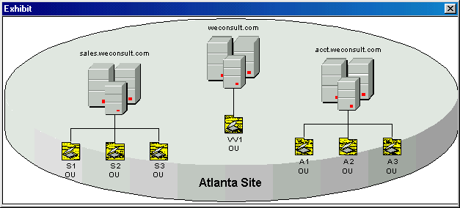

The following group policy objects (GPOs) exist with any GPO options listed:

Group Policy Type Group Policy Name GPO Options
Site GPO Atlanta None
Domain GPO Sales No override
OU GPO S1 Block Policy Inheritance
OU GPO S2 No override
OU GPO S3 None

A user named JohnD, a member of the S2 OU, logs on to a computer in the S2 OU.

What are his effective permissions?
- Only the permissions from the S2 GPO
- Only the permissions from the Atlanta GPO
- Only the permissions from the Sales GPO
- A combination of the permissions from the Atlanta GPI, the Sales GPO and the S2 OU GPO

- You are the administrator for your Windows 2000 network. Currently you have three domains in Active Directory.

You have been experiencing some problems with replication between your domain controllers. After troubleshooting the problem, you determine that the cause was poor connections between the domain controllers. You fix the problem and then decide that you should immediately force replication between the replication partners.

Which two tools could you use? (Choose two.)
- Netdom
- Dcpromo
- ReplMon
- RepAdmin
- Active Directory Sites and Services

- You are the administrator for your Windows 2000 network. In Active Directory, you have one forest with three domains.

You use the MoveTree utility to move an OU and its contents to a different domain. You successfully move the OU to the destination domain, but several objects that were previously in the OU are missing.

You search the source domain but fail to find the missing objects.

What happened to the objects?
- They were placed in the LostAndFound container in the source domain
- They were moved into the Orphaned container in the destination domain
- They were renamed and placed in the moved OU in the destination domain
- They were deleted because of error conditions or operation restrictions

- You are the administrator for your company's Windows 2000 network. Your Active Directory consists of two domains with two domain controllers each.

At 10:15 a.m., you are notified that several computers were accidentally deleted from Active Directory and need to be restored. Luckily, the System State data was backed up on a domain controller at 10:00 a.m., just before the deletes took place.

You want to restore the System State data.

What should you do?
- Perform a normal restore
- Perform an authoritative restore
- Perform a nonauthoritative restore
- Do nothing. The deleted computers will be restored when replication occurs

- You are the administrator for your Windows 2000 domain. One morning while performing routine maintenance you receive the following message:

"Security logging has been disabled. Use the Event Viewer to reduce the retention period and then enable security logging."

You have decided that you want to change the retention period and the log size for the security log.

Of the following, what are the two best tools to use to edit these settings?
- Group Policy
- Event Viewer
- Registry Editor
- Active Directory Sites and Services
- Active Directory Domains and Trusts

- You are administering a Windows 2000 network. The network consists of 4 Windows 2000 Server computers and 45 Windows 2000 Professional client computers. The network is configured to use Active Directory and RIS.

A user is attempting to use Remote OS Installation to install Windows 2000. He informs you that he receives an error message before receiving the Welcome.osc screen. The message is "File Not Found. . .".

You discover that the following file does not exist:

\\Server1\Reminst\Oschooser\Welcome.osc

What can you do?
- Copy the OSChoice.osc file and rename it Welcome.osc
- Run the Risetup program from a command line with the /check parameter
- Delete the computer object from Active Directory and restart the computer
- Enter the directory service path for the computer object in the Custom.osc file

- Your company recently hired a Directory Services Administrator to oversee the different directory services running on your network. You have three domains, named weconsult.com, account.com, and sales.com. You need to give the Directory Services Administrator permissions to perform the following tasks in the weconsult.com domain only:

Delete sites, site links, subnets, and inter-site transports.
Create and manage user accounts and groups in the weconsult.com domain.
Back up and restore Active Directory.
Manage DNS and Active Directory integration.
Extend the schema.

You created a user object for the Directory Engineer and granted membership in the Domain Admins global group, the Schema Admins group, and the Account Operators and Backup Operators domain local groups.

Which tasks can the Directory Engineer perform? (Choose all that apply.)
- Extend the schema
- Back up and restore Active Directory
- Manage DNS and Active Directory integration
- Delete sites, site links, subnets, and inter-site transports
- Create and manage user accounts and groups in the weconsult.com domain

- You are the administrator of a network supporting Windows 2000 computers. Multiple group policy objects (GPOs) have been configured. By default, which group policy settings have precedence?
- Those in the last applied GPO
- Those in the first applied GPO
- Those in the most restrictive GPO
- Those in the least restrictive GPO

- You are the administrator for your company's Active Directory-integrated Domain Name System (DNS) zone. You want to establish baseline statistics for the activity of Active Directory.

You want to be able to get information about the Knowledge Consistency Checker (KCC) and the activity of the Extensible Storage Engine (ESE).

Which object or objects should you select in Performance Monitor? (Choose all that apply.)
- The DNS object
- The NTDS object
- The Objects object
- The Database object
- The Active Directory object

- You have an application that you want to deploy using Group Policy. You need to create a file so that you can use the application's setup program (Setup.exe) to deploy the application. Which file type can you create using the Notepad application?
- .trm
- .zap
- .mst
- .msi

- You are the administrator of a Windows 2000 domain using Active Directory Services. You want to use group policy to prevent users from configuring TCP/IP, DNS, and WINS settings. Select the object containing the appropriate policy.

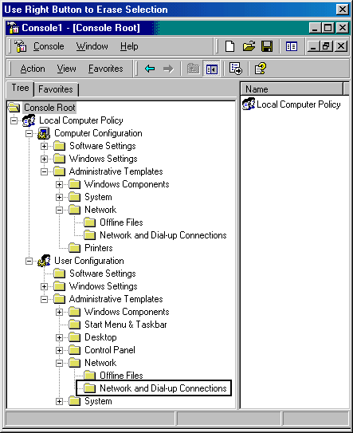

- You are the administrator for your Windows 2000 domain. You have an Active Directory-integrated zone running in mixed mode. There are three domains in this zone.

You have forty users and have created their user accounts. You are now attempting to place these users in groups.

Which type of group cannot be used?
- Local groups
- Global groups
- Universal groups
- Domain local groups

- You are the administrator for a Windows 2000 network. The network uses Active Directory and Group Policy.

You need to make a company wide change to the Group Policy Object below.

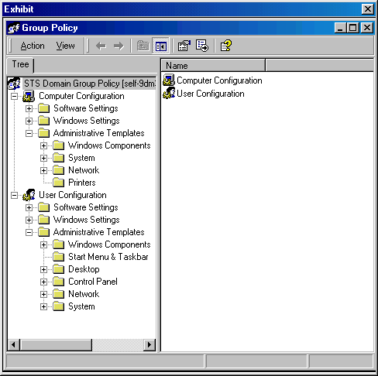
You open the Group Policy Object snap-in to make the required changes. From User Configuration Administrative Templates, you click System.

Which change can you make from these actions?
- You can specify printer options for each computer within the domain linked to the Group Policy Object
- You can specify which settings will display in the control panel for each user within the domain linked to the Group Policy Object.
- You can specify a program shortcut to display on the start menu for each computer within the domain linked to the Group Policy Object.
- You can specify the maximum amount of disk space each user is allowed to use on each of the NTFS file system volumes within the domain linked to the Group Policy Object.

- You are implementing a group policy for your Active Directory network. You have created a Group Policy Object (GPO) and you now perform the following actions:

You enter MMC in the Run dialog box.
You click Add/Remove Snap-in in the Console menu.

What will these actions accomplish?
- Allow you to modify the order of GPOs for an object
- Allow you to specify the Block Policy Inheritance option
- Allow you to specify the No Override option for a domain
- Allow you to add the Group Policy snap-in to an MMC and create a GPO console

- As a contractor installing a Windows 2000 network at a mid-size company, you must use RIS to configure company workstations as follows:

You must create a company-wide, standard installation of Windows 2000 Professional.
You must only have one RIS server on the network.
You must propagate changes to the RIS policy immediately.
You must use a member server as the RIS server.

You have configured a Windows 2000 domain controller with DHCP, DNS, and Active Directory. There is also a Windows 2000 member server on the network.

The proposed actions follow:
You install RIS on the member server and the domain controller.
You configure RIS to company standards.
You create a RIPrep image.
You go to the DHCP Administration Tool. Right-click the DHCP root node, and click Manage Authorized Servers. Click Authorize and enter the IP address or name of the RIS server.
You create a single image of the OS for RIS and do not allow any optional components to be installed.
You restart the RIS server.

Which requirements do the actions meet? (Choose all that apply.)
- A member server serves as the RIS server
- There is only one RIS server on the network
- Changes are propagated on the RIS policy immediately
- There is a company-wide, standard installation of Windows 2000 Professional

- You are the administrator for your company's Windows 2000 network. Your network has been assigned the Class C IP addresses of 205.100.10.0/24. Your domain name is weconsult.com. You use an Active Directory-integrated zone.

You want to edit some of the properties for the Reverse Lookup zone.

What is the name of the Reverse Lookup zone as displayed in the DNS console?
- 205.100.10.cachedns
- 205.100.10.reverse.dns
- in-addr.arpa.10.100.205
- 205.100.10.in-addr.arpa
- 10.100.205.in-addr.arpa

- You are the administrator of your network. You have one Active Directory forest with one parent domain and two child domains: local.com, account.local.com, and acct.local.com.

You want to accomplish the following goals:

Move all users in the Accounting Organization Unit (OU) to the Acct OU.
Move all Global Groups in the account.local.com domain to the acct.local.com domain.
Move all Local Groups in the account.local.com domain to the acct.local.com domain.
Maintain all users' existing passwords.

You decide to use the Active Directory Object Manager (MoveTree.exe) utility included in the Windows 2000 Support Tools.

Using this utility, which goal or goals are you able to accomplish? (Choose all that apply.)
- Maintain all users’ existing passwords
- Move all users in the Accounting Organization Unit to the Acct OU
- Move all Local Groups in the account.local domain to the acct.local domain
- Move all Global Groups in the account.local domain to the acct.local domain

- You are the administrator for your company's Windows 2000 network. You have a Windows 2000 Server computer on which you plan to install Active Directory. This computer has one physical disk installed formatted with NTFS version 5.

You want to accomplish the following goals:

optimize controller performance
optimize security
increase ease of administration
provide unattended setup
prevent anonymous Read access

You take the following actions:

You run the Active Directory Installation Wizard. You accept all defaults except that you change the Pre-Windows 2000 compatible permissions option to Windows 2000-only permissions.

Which goal or goals do you accomplish with these actions? (Choose all that apply.)
- optimize security
- provide unattended setup
- prevent anonymous Read access
- optimize controller performance
- increase ease of administration

- As a contractor installing a Windows 2000 network at a mid-size company, you must use RIS to configure company workstations as follows:

You must create a company-wide, standard installation of Windows 2000 Professional.
You must only have one RIS server on the network.
You must propagate changes to the RIS policy immediately.
You must use a member server as the RIS server.

You have configured a Windows 2000 domain controller with DHCP, DNS, and Active Directory. In addition to the domain controller, there is a Windows 2000 member server on the network.

You take the following actions:

You install RIS on the member server and the domain controller.
You configure RIS to company standards.
You create a RIPrep image.
You go to the DHCP Administration Tool. Right-click the DHCP root node, and click Manage Authorized Servers. You then select Authorize and enter the IP address or name of the RIS server.
You create a single image of the OS for RIS and do not allow any optional components to be installed.
You type secedit /refreshpolicy /MACHINE_POLICY at the command prompt on the RIS server.

Which goal or goals are met by these actions? (Choose all that apply.)
- A member server serves as the RIS server
- There is only one RIS server on the network
- Changes are propagated to the RIS policy immediately
- There is a company-wide, standard installation of Windows 2000 Professional

- You want to use NSLOOKUP to verify DNS server responsiveness. The domain name is weconsult.com. The DNS server's IP address is 10.0.0.25.

You go to the command prompt at the DNS server. You enter NSLOOKUP weconsult.com 127.0.0.1.

If the server is responding, which result should be returned?
- Server: localhost
Address: 127.0.0.1
- Name: weconsult.com
Address: 10.0.0.25
- Default Server: localhost
Address: 127.0.0.1
- Default Server: localhost
Address: 10.0.0.25
- Server: localhost
Address: 127.0.0.1
Name: weconsult.com
Address: 10.0.0.25

- You are the administrator for your Windows 2000 network and are implementing Active Directory for your domain. The domain contains the Dallas and Denver sites, which are connected by a permanent 128 Kbps WAN link.

You implement a site link between the two cities.

What is the purpose of this?
- To allow ease of administration
- To allow backups to occur between the two sites
- To allow the two sites to exist in the same forest
- To allow replication to occur between the two sites

- You have a group policy object (GPO) that affects several organizational units (OUs) in Active Directory. This group policy is automatically refreshed every 90 minutes.

You have a Windows 2000 Server computer that is a domain controller. You have made several changes to the GPO. You want to apply these changes to the Windows 2000 Server computer. However, you do not want to interrupt any services from this domain controller that may currently be working.

What should you do?
- Reboot the computer
- At a command prompt, type secedit /refreshpolicy
- At a command prompt, type secedit /refreshpolicy USER_POLICY
- At a command prompt, type secedit /refreshpolicy MACHINE_POLICY

- You are troubleshooting a replication problem with Active Directory. The biggest impediment to solving the problem is a lack of documentation for the replication topology.

You need a record of the enterprise configuration, including each site, site links, site link bridges, subnets and domain controllers and the GUID for each object. If you had this information, troubleshooting the problem would be much easier.

Which Active Directory support tool should you use?
- ACL Diagnostics (ACLDiag.exe)
- Active Directory Administration Tool (Ldp.exe)
- Security Descriptor Check Utility (Sdcheck.exe)
- Active Directory Replication Monitor (Replmon.exe)

- You are auditing your domain controller to track trends of system usage. You notice that the Event Viewer Security log is approaching its limit.

You need to archive the security log files. You want to retain the binary data.

What file format should you use when archiving the log files?
- .evt
- .txt
- .csv
- .ocx

- You are the administrator for your Windows 2000 network. You have decided to deploy Remote Installation Services (RIS). You set up, configure, and authorize a RIS server. After creating the source computer, you create a RIPrep image and store it on the RIS server. You notify the users about what they will need to do the next morning.

You are contacted the next morning by a user stating that he did not receive any special messages you included in the notification. He is concerned that the installation did not perform on his computer. After examining the user's computer, you perform the following steps:

- Run the RBFG utility.
- Insert a formatted disk into the disk drive.
- In the Windows 2000 Remote Boot Disk Generator dialog box, you click the disk drive with the formatted disk inserted.

What did you determine to be the problem with the user's computer?
- The computer is not boot enabled
- The computer does not have RIS installed
- The computer does not have a PXE-based ROM
- The computer is not running the correct operating system to work with RIS

- You are the administrator for a Windows 2000 network. The network consists of all Windows 2000 Server computers and Windows 2000 Professional client computers. The network is configured with Active Directory and a DHCP server.

You perform the following actions:

You log on with an Enterprise Admins group account.
Open the Administrative Tools and select DHCP.
Right-click the DHCP root node, and click Manage Authorized Servers.
Click Authorize, enter the IP address for a RIS server, and click OK.

What do these actions accomplish?
- The actions authorize a RIS server in DHCP
- The actions authorize a DHCP server in RIS
- The actions authorize a RIS server in Active Directory
- The actions authorize a DHCP server in Active Directory
- The actions authorize a Active Directory server in RIS

- You are the administrator for your company's Windows 2000 network. You have three domains set up in Active Directory: weconsult.com, resources.com, and true.com. You have a Domain Name System (DNS) server on weconsult.com named DNS1.weconsult.com. You add a second DNS server to the domain and name it DNS2.weconsult.com.

A client computer on the resources.com domain is having trouble contacting DNS2.weconsult.com. You suspect that it is because the client has an old negative response for the host name in its cache.

What are two possible ways to remove the negative response? (Choose two.)
- At DNS2, run the nslookup command
- At DNS2, run the ipconfig /flushdns command
- At the client computer, run the nslookup command
- At the client computer, run the ipconfig /flushdns command
- At DSN2, run the net stop dns command. Then run the net start dns command.
- At the client computer, run the net stop dns command. Then run the net start dns command.

- You are the administrator for your company's Windows 2000 network. In this network, you have an Active Directory domain named network.com. You have created a group policy object (GPO) named enforce.

You want all members of the Managers group to be able to edit the enforce GPO , but you do not want this GPO to be applied to the members of the Managers group. You do not want the Managers group to have more permissions than are absolutely necessary.

Which permissions should be configured?
- Set Read to Allow
- Set Write to Allow
- Set Full Control to Allow
- Set Apply Group Policy to Allow
- Set Write to Allow, and set Read to Allow
- Set Read to Allow, set Apply Group Policy to Allow, and set Write to Allow

- You are the administrator for a Windows 2000 domain, which has two domain controllers named DC1 and DC2. The volume that contains the Active Directory database file on DC1 is running out of disk space.

You decide to move the database file to an empty volume on a different disk on DC1.
- Use Logical Disk Manager to mount the empty volume in the folder that contains the Active Directory database file
- Restart DC1 in Directory Services Restore Mode. Use the Ntdsutil utility to move the database file to the empty volume.
- Stop the NetLogon service on DC1. Use Windows Explorer to move Ntds.dit to the empty volume. Start the NetLogon service again. Force replication from DC2.
- Use Windows Backup to create a backup of the System State data of DC1. Restart DC1 in Directory Services Restore Mode. Restore the System State data to the empty volume.

- You are the administrator for your company’s Windows 2000 domain. Srv1 is your company’s Windows 2000 DHCP Server. You have decided to implement Remote Installation Services (RIS) on a Windows 2000 Server named Srv2.

Currently Srv2 has 64 MB of RAM and a 10 GB hard drive installed. One NTFS partition of 5 GB has been set up as the C: drive. The C: drive currently has a second NTFS partition of 2 GB and 1 GB of free space. The remainder of the hard drive is unformatted. You plan to install Active Directory, DHCP, and DNS.

You want to install RIS on Srv2. You do not want to purchase any more hardware than is absolutely necessary. You want to accomplish these goals with as little administrative overhead as possible.

What should you do?
- Purchase additional RAM for a total of 64 MB of RAM on Srv2
- Purchase additional RAM for a total of 128 MB of RAM on Srv2
- Create an additional NTFS partition of 1 GB on which to install RIS
- Create an additional NTFS partition of 8 GB on which to install RIS

- You are administering a Windows 2000 network with Active Directory and Group Policy enabled. The network consists of all Windows 2000 Server computers and Windows 2000 Professional computers.

You want to deploy Office 2000 to Windows 2000 clients using Software Installation and Group Policy objects. You also create a .mst file to use for the installation.

What is the purpose of this file?
- To provide a repackaged application
- To update software through patches or service packs
- To provide instructions about how to publish an application
- To customize the installation of applications through modifications

- You are the administrator of your company's network. You have one Active Directory forest with one parent domain and two child domains: qwert.com, max.qwert.com, and min.qwert.com.

You want to accomplish the following goals:

Move all users in the Managers Organization Unit (OU) to the Mgr OU.
Move all Global Groups in the max.qwert.com domain to the min.qwert.com domain.
Move all Local Groups in the min.qwery.com domain to the max.qwert.coml domain.
Join a Windows 2000 computer, named XYZ1, to the max.qwert.coml domain
Maintain all users' existing passwords.

You decide to use the Active Directory Object Manager (MoveTree.exe) utility and the Windows 2000 Domain Manager (NetDom.exe) included in the Windows 2000 Support Tools.

Using these utilities, which goal or goals are you able to accomplish? (Choose all that apply.)
- Maintain all users’ existing passwords
- Move all users in the Managers Organization Unit to the Mgr OU
- Join a Windows 2000 computer, named XYZ1, to the max.qwert.com domain
- Move all Global Groups in the max.qwert.com domain to the min.qwert.com domain
- Move all Local Groups in the min.qwery.com domain to the max.qwert.com domain

- You are the administrator for your Windows 2000 domain. You have set up a Windows 2000 Server computer to act as your Remote Installation Services (RIS) server. You set up, authorize, and configure the RIS Server to deliver a RIPrep image to your Windows 2000 Professional systems.

You decide to implement a change to the answer file for a RIPrep image. You perform the following steps:

- Open the RIPREP.SIF file.
- Add the line: ProductID = "xxxxx-xxx-xxxxxx-xxxxx"

What will these actions accomplish?
- It will prompt the users for the product identification number during installation
- It will prevent the users from having to type in the product identification number during installation
- It will store the product identification number in a text file on the client computers during installation
- It will retrieve the product identification number from the client computers during installation and send it back to the network to be stored in a text file

- You are the administrator for your Windows 2000 network. You use Active Directory to manage your forest of three domains. You are at one of the domain controllers on the sales.com domain.

You want to accomplish the following goals:

View the history of replication status.
View the replication metadata for the user object Administrator.
View whether the monitored server is a Global Catalog server.
View the connection objects for the domain controller.
View servers with which the computer is replicating both directly and transitively.

You decide to use the Replication Diagnostics Tools (RepAdmin.exe).

Using this tool, which goal or goals can you accomplish? (Choose all that apply.)
- View the history of replication status
- View the connection objects for the domain controller
- View whether the monitored server is a Global Catalog server
- View the replication metadata for the user object Administrator
- View servers with which the computer is replicating both directly and transitively

- Your network contains the seabreezecruises.com and oceanbreezecruises.com domains. Both domains are running in mixed mode.

A few members of the oceanbreezecruises.com domain need access to the Caribbean Organizational Unit in the seabreezecruises.com domain. Members of the seabreezecruises.com domain receive permissions to the Caribbean Organizational Unit through membership in a domain local group named CaribbeanUsers. You want to accomplish this with the least amount of administrative overhead.

What could you do to allow users in the oceanbreezecruises.com domain to access the Caribbean OU in the seabreezecruises.com domain?
- Add the users from the oceanbreezecruises.com domain to the CaribbeanUsers domain local group
- Change the CaribbeanUsers group to a Global group and add the users from the oceanbreezecruises.com domain.
- Change the CaribbeanUsers group to a Universal group and add the users from the oceanbreezecruises.com domain.
- Create a Global group in the oceanbreezecruises.com that grants access to the Caribbean OU and add users from the oceanbreezecruises.com domain.

- You have been asked to implement a Windows 2000 network for a new company. All servers are Windows 2000 Server computers, and all clients are Windows 2000 Professional clients. You install the Domain Name System (DNS) on one of the Windows 2000 Server computers.

You want to accomplish the following goals:

DNS zone transfer traffic will be minimized on the network.
Administrative overhead for maintaining DNS zone files will be minimized.
Unauthorized host computers will not have records created in the zone.
All zone updates will come only from authorized DNS servers.
All zone transfer information will be secured as it crosses the network.

You take the following actions:

Create a standard primary zone.
In the Zone Properties dialog box, set Allow Dynamic updates option to Yes.
Create and assign an IPSec policy that encrypts all DNS traffic between the DNS servers.

Which goal or goals are accomplished with these actions? (Choose all that apply.)
- DNS zone transfer traffic will be minimized on the network
- All zone updates will come only from authorized DNS servers
- Unauthorized host computers will not have records created in the zone
- All zone transfer information will be secured as it crosses the network
- Administrative overhead for maintaining DNS zone files will be minimized

- You made changes to the account policies for a Group Policy object applied to an Organizational Unit named Computers. However, the changes are not taking affect.

You check the Event Log and notice an event message of Event ID 1202, which signifies that security policies are not being refreshed. You want to immediately refresh the security settings.

What should you do?
- Use the Secedit command-line tool
- Ensure the No Override option is enabled for the Group Policy object
- Look for specific errors that occur during policy propagation in the Winlogon.log file located in the systemroot\Security\Logs folder.
- Check the DNS configuration to make sure there are no stale entries in the DNS database, and resolve local DNS servers and Internet service provider (ISP) DNS server entries.

- You are the administrator for your Windows 2000 network. You are responsible for managing all Active Directory domains.

You want to restore a machine account that was deleted by mistake.

Which tool should you use?
- Ldp
- Netdom
- Dsastat
- Ntdsutil
- Repadmin

- Your company has decided that it wants to implement Active Directory.

You run the Active Directory Installation Wizard and experience multiple errors. You want to view the errors you encountered.

What should you do?
- Examine the dcpromo.log and dcpromoui.log files located in the %SystemRoot%\ntds folder
- Examine the dcpromo.log and dcpromoui.log files located in the %SystemRoot%\debug folder
- Examine the dcpromo.log and dcpromoui.log files located in the %SystemRoot%\system32\ntds folder
- Examine the dcpromo.log and dcpromoui.log files located in the %SystemRoot%\system32\debug folder

- You are the administrator for your company's Windows 2000 network. You have installed Active Directory. Within Active Directory, you have two domains which contain all computers and users on your network.

You want to monitor the activity of Active Directory. When you open System Monitor, the NTDS object is unavailable.

What should you do to load the NTDS object?
- Stop and restart the Active Directory service
- Stop and restart the DNS Server service
- Reboot the domain controller on which you plan to use System Monitor
- At a command prompt, change the directory to %systemroot%. Type lodctr.exe ntdsctrs.ini and restart the computer
- At a command prompt, change the directory to %systemroot%\system32. Type lodctr.exe ntdsctrs.ini and restart the computer

- You are the administrator of your network. Currently you have two forests in your enterprise. One forest is a Windows 2000 forest, and the other is a Windows NT 4.0 domain.

You want to accomplish the following goals:

Move all users in the Windows NT 4.0 domain to the Windows 2000 forest.
Move all Global Groups in the Windows NT 4.0 domain to the Windows 2000 forest.
Move all Local Groups in the Windows NT 4.0 domain to the Windows 2000 forest.
Maintain all users' existing passwords.

You decide to use the Active Directory Migration Tool.

Using this utility, which goal or goals are you able to accomplish? (Choose all that apply.)
- Maintain all users’ existing passwords
- Move all users in the Windows NT 4.0 domain to the Windows 2000 forest
- Move all Local Groups in the Windows NT 4.0 domain to the Windows 2000 forest
- Move all Global Groups in the Windows NT 4.0 domain to the Windows 2000 forest

- You are the administrator for your company's Windows 2000 domain. You have been contacted by the manager of the human resources department. This department uses one folder to store all departmental files. A user in that department was terminated at 10 a.m. this morning, and it is suspected that this user deleted several important files purposely.

Auditing of object access is turned on through a group policy and assigned to the entire domain. The human resources folder is one of the folders audited.

The human resources manager is sure that the files were available at 8:00 a.m. this morning. The user who is suspected of the deletions is User523.

You configure a filter for the security log as shown below:

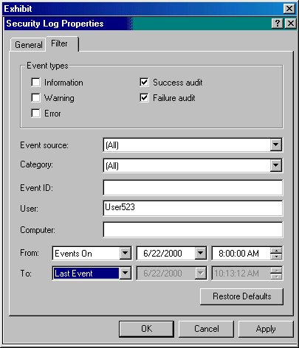

Which events will you see?
- All success and failure audits recorded in the system log for User523
- All success and failure audits recorded in the security log for User523
- All success and failure audits recorded in the system log for User523 between 8:00am this morning until the current time
- All success and failure audits recorded in the security log for User523 between 8:00am this morning until the current time

- You are the administrator for your company's Windows 2000 network. You are concerned that someone inside your company might have stolen a user name and password for an administrative account. You suspect that this person is using that user name and password to grant rights to his/her user account that he/she should not have.

You need to define an audit policy to help you combat this threat to network security. Because all of your domain controllers are located in the same Organizational Unit (OU), you can implement an audit policy once at the OU to audit all your domain controllers.

You open the Group Policy snap-in for your Group Policy, and expand the Audit Policy security area as shown below:

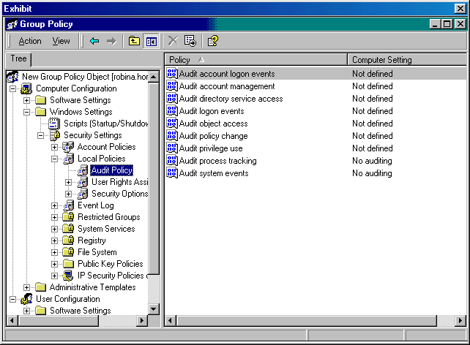

Which event should you audit to combat this threat?
- Success audit of system events
- Success audit of object access events
- Success audit for policy change events
- Success audit of directory service access events

- You are the administrator for a Windows 2000 network. The network uses Active Directory and Group Policy.

You want to configure options to redirect My Documents to a location on the network for all users in an Active Directory OU. In addition, you want the My Pictures folder to remain in the same directory structure with the My Documents folder. You have completed the configuration of the options on the Target tab. You need to configure the options on the Settings tab.

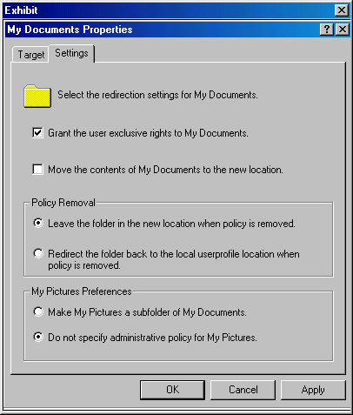

Which option will allow you to accomplish your goal with the My Pictures folder?
- Make My Pictures a subfolder of My Documents
- Do not specify administrative policy for My Pictures
- Move the contents of My Documents to the new location
- Redirect the folder back to the local userprofile location when policy is removed

- You are the administrator for your Windows 2000 network. TomD is a member of the ACCT Organizational Unit (OU), the HR OU, and a group named TEST.

There is a shared folder, named Test1, in Active Directory. The security permissions for Test1 are:

ACCT OU Allow Read
HR OU Allow Read
TEST group Allow Write
TomD Deny Write

TomD logs on at her new workstation properly.

What is his effective permission for Test1?
- Allow Read
- Allow Write
- Denied all access
- Allow Read & Write

- You are the administrator for your Windows 2000 network. You have decided to deploy Remote Installation Services (RIS). You set up, configure, and authorize a RIS server. After creating the source computer, you create a RIPrep image and store it on the RIS server. You notify the users about what they will need to do the next morning.

You are contacted the next morning by a user stating that he did not receive any special messages you included in the notification. He is concerned that the installation did not perform on his computer. After examining the user's computer, you perform the following initial steps to a procedure:

- Run the RBFG utility.
- Insert a formatted disk into the disk drive.

Which procedure are these initial steps performing?
- You are creating an RIPrep image
- You are creating an RIS boot disk
- You are creating an OSCHOICE.OSC file
- You are including the PID in the RIPREP.SIF file

- You are the administrator for your company's Windows 2000 network. Over the past few weeks, there have been several times where you had to reconfigure the settings for a network printer, named HPLJ5, that is connected to one of your member servers. Also there have been several occasions when users have reported that pending documents were deleted from the print queue.

You decide to set up auditing to track access to printers. You have set the audit object access event category in your audit policy, and now need to specify the types of access and the groups to audit for the HPLJ5 printer attached to a member server.

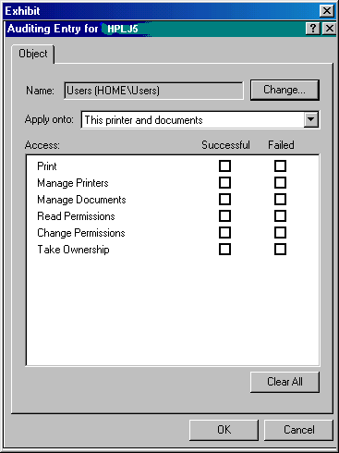

You want to audit this printer to determine who keeps changing the printer's settings and to determine who keeps deleting print jobs.

Which events should you audit?
- Successful print
- Successful take ownership
- Successful manage printers
- Successful read permissions
- Successful manage documents

- You are the administrator for your company's Windows 2000 network. You have a Windows 2000 Server computer on which you plan to install Active Directory. This computer has two separate physical disks installed in it, both formatted with NTFS version 5.

You want to accomplish the following goals:

optimize controller performance
optimize security
increase ease of administration
provide unattended setup
prevent anonymous Read access

You take the following actions:

You use the Active Directory Installation Wizard. You install the Ntds.dit file on one physical disk and install the log files on another.

Which goal or goals do you accomplish with these actions? (Choose all that apply.)
- Optimize security
- Provide unattended setup
- Prevent anonymous Read access
- Optimize controller performance
- Increase ease of administration

- You are the administrator for a portion of a Windows 2000 network. You want to use Software Installation to distribute common applications to all computers in this portion of the network.

The portion of the network for which you are responsible is a mixed-mode Active Directory domain with Windows 95, Windows 98, Windows NT 4.0, and Windows 2000 Professional client computers. The domain is further divided into the Sales, Engineering, and Production OUs. The Production OU contains Windows 95 and Windows 98 clients. The Engineering OU contains Windows 2000 Professional and Windows NT clients and the Marketing OU contains Windows 95 and Windows 98 clients.

You want to use Software Installation and a GPO linked to the domain to distribute and maintain common applications to all clients in the domain.

For which OU are you able to distribute and maintain software using this method?
- Sales OU
- Production OU
- Engineering OU
- None of the OUs

- You are the administrator for your network, which contains Windows 2000 Server computers, Windows 2000 Professional computers, Windows NT Server 4.0 computers, and Windows NT Workstation 4.0 computers.

Your network has three zones managed by Active Directory. Replication is configured between the domain controllers, each of which is either a Windows 2000 Server computer or a Windows NT Server 4.0 computer.

You want to be able to generate a status report of each of the domain controllers. You decide to use Active Directory Replication Monitor.

On which type of computer can this component be installed?
- Windows 2000 Server member server
- Windows NT Server 4.0 member server
- Windows 2000 Server domain controller
- Windows NT Server 4.0 domain controller
- Windows 2000 Professional member workstation
- Windows 2000 Professional stand-alone computer

- You are the administrator for your company's Windows 2000 network. You are using the Ntdsutil utility to authoritatively restore an Organizational Unit (OU) that was mistakenly deleted.

The deleted OU is named "orders" and was located in the weconsult.com domain.

Which command should be entered at the authoritative restore prompt to authoritatively restore the Organizational Unit (OU)?
- ntdsutil OU=orders,DC=weconsult,DC=com
- restore subtree OU=orders,DC=weconsult,DC=com
- restore database OU=orders,DC=weconsult,DC=com
- authoritative restore OU=orders,DC=weconsult,DC=com

- You need to create a group. You want to achieve these results:

Users should be able to use the group to send email to a collection of users.
Administrators should be able to use the group to define permissions on resources.
Pre-Windows 2000 users should be able to use the group.
Group members can come from any domain in the forest.

You start Active Directory Users and Computers, click the home.local domain, right-click the Users container, point to New, and click Group. You then configure the New Object-Group dialog as shown below:

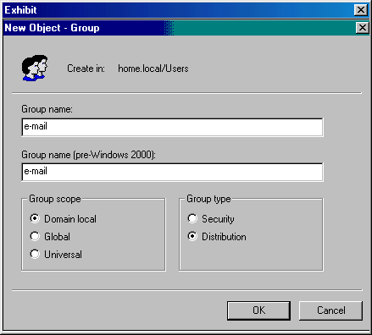

Which results did you achieve? (Choose all that apply.)
- Group members can come from any domain in the forest
- Pre-Windows 2000 users should be able to use the group
- Users should be able to use the group to send email to a collection of users
- Administrators should be able to use the group to define permissions on resources

- Your network contains one active directory domain. The domain contains four Organizational Units (OUs): Domain Controllers, Computers, Member Servers and Users. The Domain Controllers OU contains only Domain Controllers. The Member Servers OU contains Windows 2000 member servers. The Computers OU contains Windows 2000 workstations, Windows NT workstations, and Windows 98 workstations.

You want to enable auditing of a printer, named HPLJ5, attached to a Windows 2000 member server. You have the Audit Policy configured as shown below:

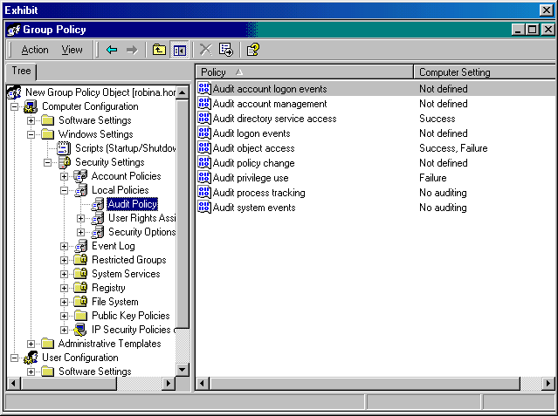

You go to the member server to access HPLJ5's properties and enable auditing for it.

Which type of events will be monitored?
- failures only
- successes only
- both successes and failures
- None. Although auditing is enabled, no events are defined.

- You are the administrator for a Windows 2000 network. You use Active Directory Services to manage your network. Currently you have two servers that are responsible for replicating all Active Directory data.

Your company has recently built a new office in a remote location. You have been asked to set up a server at this site. You want the server to accept all replication data so that clients at the remote location can contact the local server for Active Directory data.

What kind of server should it be?
- A site license server
- A Remote Access server
- A Global Catalog server
- A DNS server
- A WINS server
- A DHCP server

- You are the administrator of a Windows 2000 domain using Active Directory Services. You want to use group policy to prevent users from publishing printers. Click on the appropriate area and indicate the appropriate object to expand.

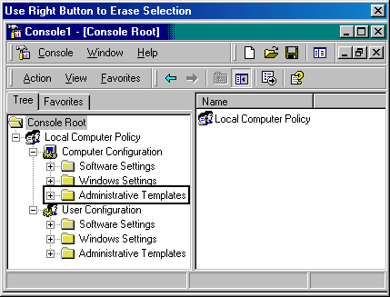

- You are the administrator for your Windows 2000 network. You recently implemented a smart card system on your domain.

Each user was assigned a smart card, which he or she uses to log on to computers in the domain. The smart card system is working properly for logging on to the system, but logging off is inconsistent. You need to ensure that a user is logged off when the user removes his or her smart card.

You open the Group Policy snap-in for the domain Group Policy Object and expand the security settings node.

Select the security setting you must configure to force a logoff when a user removes his or her smart card.

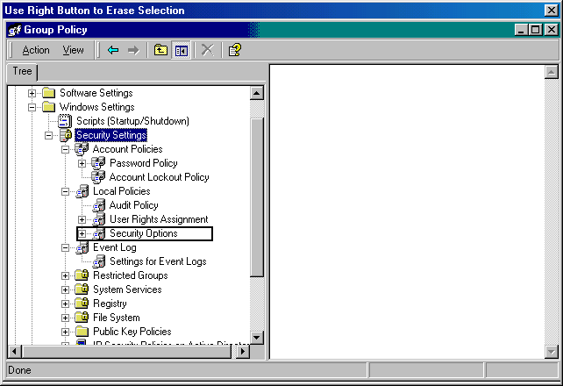

- You are the administrator of your company's network. Currently you have two forests in your enterprise. One forest is a Windows 2000 forest, and the other is a Windows NT 4.0 domain.

You want to accomplish the following goals:

Move all users in the Windows NT 4.0 domain to the Windows 2000 forest.
Move all Global Groups in the Windows NT 4.0 domain to the Windows 2000 forest.
Move all Local Groups in the Windows NT 4.0 domain too the Windows 2000 forest.
Join a Windows 2000 computer, named XYZ1, to the resource.anywhere.com domain in the Windows 2000 forest.
Maintain all users' existing passwords.

You decide to use the ClonePrincipal (Clonepr.dll) utility and the Windows 2000 Domain Manager (NetDom.exe ) utility included in the Windows 2000 Support Tools.

Using this utility, which goal or goals are you able to accomplish? (Choose all that apply.)
- Maintain all users’ existing passwords
- Move all users in the Windows NT 4.0 domain to the Windows 2000 forest
- Move all Local Groups in the Windows NT 4.0 domain to the Windows 2000 forest
- Move all Global Groups in the Windows NT 4.0 domain to the Windows 2000 forest
- Join a Windows 2000 computer, named XYZ1, to the resource.anywhere.com domain in the Windows 2000 forest

- You need to set up and administer auditing on a Windows 2000 network. To simplify the process, you want to configure auditing on your domain controllers using a nonlocal Group Policy Object.

You want to audit file and folder access.

What is a requirement for setting up this auditing?
- The files and folders to be audited must be on NTFS volumes
- The files and folders to be audited must be set up as network shares
- The HISECDC.INF predefined security template must be applied to the domain controllers prior to setting up auditing.
- The SECUREDC.INF predefined security template must be applied to the domain controllers prior to setting up auditing.

- You are the administrator for your company's Windows 2000 network. In Active Directory, you have three domains in one forest.

You need to move a computer from one domain to another. You want to ensure that the computer is removed from its source domain and joined to its target domain.

Which tool should you use?
- Netdom
- Sdcheck
- MoveTree
- ClonePrincipal

- You have been asked to implement a Windows 2000 network for a new company. All servers are Windows 2000 Server computers, and all clients are Windows 2000 Professional clients. You install the Domain Name System (DNS) on one of the Windows 2000 Server computers.

You want to accomplish the following goals:

DNS zone transfer traffic will be minimized on the network.
Administrative overhead for maintaining DNS zone files will be minimized.
Unauthorized host computers will not have records created in the zone.
All zone updates will come only from authorized DNS servers.
All zone transfer information will be secured as it crosses the network.

You take the following actions:

Create an Active Directory integrated zone.
In the Zone Properties dialog box, set the Allow Dynamic Updates to Only Secure Updates. Use the Access Control List (ACL) to specify which users and groups have authority to modify the zone and records in the zone.
On the Name Servers tab of the Zone Properties, enter the names and addresses of all DNS servers on the network.

Which goal or goals are accomplished from these actions? (Choose all that apply.)
- DNS zone transfer traffic will be minimized on the network
- All zone updates will come only from authorized DNS servers
- Unauthorized host computers will have records created in the zone
- All zone transfer information will be secured as it crosses the network
- Administrative overhead for maintaining DNS zone files will be minimized

- You are the administrator for your company's Windows 2000 network. You have three domains that you manage through Active Directory.

Replication is set up to occur at regular intervals. However, you think that there are some problems with replication that are not being logged in Event Viewer. You decide to edit the registry so that the Event Viewer will log more events in the directory service log.

You open the registry editor and maneuver to the HKEY_LOCAL_MACHINE\SYSTEM\CurrentControlSet\Services\NTDS\Diagnostics registry key.

What is the highest value that is recommended for this key?
- 0
- 1
- 2
- 3
- 4
- 5

- You are the administrator of your company's Windows 2000 network. You have three domains: abc.com, xyz.abc.com, and mno.abc.com. All three domains are located in the Chicago site. All three domains contain Organizational Units (OUs) as shown below:

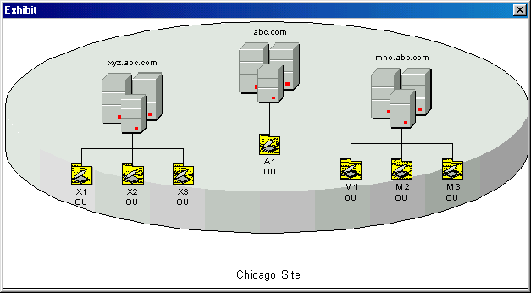

The following group policy objects (GPOs) exist with any GPO options listed:

Group Policy Type Group Policy Name GPO options
Site GPO Chicago None
Domain GPO Xyz No override
OU GPO X1 Block Policy Inheritance
OU GPO X2 No override
OU GPO X3 None

A user named SallyS, a member of the X1 OU, logs on to a computer in the X1 OU.

What are her effective permissions?
- Only the permissions from the Xyz GPO
- Only permissions from the Chicago GPO
- A combination of the permissions from the Xyz GPO and the X1 GPO
- A combination of the permissions from the Chicago GPO and the X1 GPO

- You are the administrator for your company's Windows 2000 domain. Your domain consists of one Windows 2000 Server computer acting as your Domain Name System (DNS) server and three Windows 2000 Server computers running Active Directory. Your DNS zone is an Active Directory-integrated zone.

The DNS server contains the following types of resource records:

Start of Authority (SOA)
Name Server (NS)
Address (A)
Pointer (PTR)
Mail Exchange (MX)
Service (SRV)

You move one of the computers on your network to a different subnet. This client cannot dynamically update its entry in the DNS database. You update the host resource record for this client.

Which type of record may need to be updated also?
- The associated A resource record
- The associated NS resource record
- The associated MX resource record
- The associated PTR resource record
- The associated SOA resource record

- You are the administrator for your company's Windows 2000 network. You use Active Directory to manage all users and computers at all sites within your company. You have Active Directory Replication configured between your sites.

You want to edit the replication schedule for a server named MAIN.

You want to achieve the following goals:
Replication should never occur on Sundays.
Replication should occur once an hour on Saturdays.
Replication should occur twice an hour on Mondays - Thursdays.
Replication should occur four times an hour on Fridays.

You edit the replication schedule for MAIN as shown below:

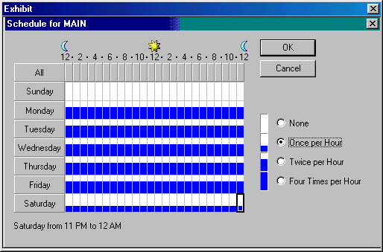

Which results are achieved with these actions? (Choose all that apply.)
- Replication should never occur on Sundays
- Replications should occur once an hour on Saturdays
- Replication should occur four times an hour on Fridays
- Replication should occur twice an hour on Mondays – Thursdays

- You are the network administrator for a company that is deploying Windows 2000 and Active Directory into its existing network. The company currently uses Windows NT servers and Windows 95 client computers.

You replace most Windows NT servers with Windows 2000 Server with Active Directory. About one-third of the clients have been upgraded to Windows 2000 Professional, and all new client installations will run Windows 2000 Professional. You expect to add more Windows 2000 client computers within the next 6 months, but because of budget constraints, the majority of network clients will remain Windows 95 clients.

You currently use System Management Server to manage software on your client computers. However, you are considering a plan to use Software Installation and Maintenance supplemented with System Management Server to deploy and manage software maintenance and installation on your clients.

What are some advantages to implementing this plan? (Choose all that apply.)
- You will be able to schedule software deployments
- You will be able to centrally manage software for the non-Windows 2000-based clients
- You will be able to use the self-repairing capabilities of the Windows Installer on any clients
- You will be able to deploy and manage software to clients over slow network or dial-up connections
- You will be able to license or meter software using Windows 2000 software installation and maintenance and Active Directory

- You are the administrator for your company's Windows 2000 network. You have created a Group Policy Object (GPO), named User1, to control user configuration.

You want to accomplish the following goals:
Use the GPO to enable a disk quota.
Use the GPO to enforce a disk quota.
Use the GPO to set a disk quota of 50 MB for each user.
Use the GPO to set a warning level of 45 MB for each user.
Use the GPO to log an event in Event Viewer when the quota limit is exceeded.

You take the following actions:

In User1, you go to the Computer Configuration node. In the Administrative Templates area, you access the System/Disk Quotas area. You enable the Enable disk quota policy and the Enforce disk quota limit policies. You enable the Default quota limit and warning level, set the quota limit to 50 MB, and set the warning level to 45 MB.

Which goal or goals do you accomplish with these actions? (Choose all that apply.)
- Use the GPO to enable disk quota
- Use the GPO to enforce a disk quota
- Use the GPO to set a disk quota of 50 MB for each user
- Use the GPO to set a warning level of 45 MB for each user
- Use the GPO to log an event in Event Viewer when the quota limit is exceeded

- You are troubleshooting a problem with your DNS servers. You have notices several zone transfer failure messages in the DNS Event Log. It appears that the problems with zone transfers are related to the primary and secondary DNS servers.

Which actions should you take to solve the problem? (Choose three.)
- Delete the secondary DNS server from the primary zone’s Notify list
- Make sure a bridgehead server is properly configured between each zone
- Make sure the serial numbers for the zones involved in the transfer are not the same
- Use the PING command to ping each DNS server by its IP address from its remote counterpart
- Verify that the DNS servers involved in the transfer are bot started and that the zone is not paused

- You need to specify group policy settings for a nonlocal Group Policy Object (GPO). When attempting to edit the GPO, you discover that DNS is not working properly.

What is one possible way you may have discovered this problem?
- You could not open the GPO
- You received the “Failed to Open The Group Policy Object” message
- The Group Policy settings are not taking affect on the user’s computers
- You received the “Active Directory Will Not Allow The Package To Be Deployed”message

- You are the administrator for your network. You have several Domain Name System (DNS) servers installed. All zones that have been created are Active Directory-integrated zones.

You want to test the performance of one of your DNS servers using Nslookup. But you do not want the server you are querying to query other servers if it does not have the information you want.

Which Nslookup option does this?
- set debug
- set search
- set no debug
- set recursion
- set no recursion

- You are the administrator for your Windows 2000 network. SallyC, a member of the Accounting department, has transferred to the Human Resources department. She is currently a member of the ACCT Organizational Unit (OU). You need to move her to the HR OU.

Using Active Directory Users and Computers, you move SallyC's user object from the ACCT OU to the HR OU within the same domain.

SallyC logs on at her new workstation properly. Later that day, she contacts you and says she can no longer access a folder on the network where she has data stored. The folder is named Data1.

What could be the cause of this problem?
- The ACCT OU has permission to access Data1. The HR OU does not.
- The HR OU has permission to access Data1. The ACCT OU does not.
- During the MOVE operation, all permissions granted to SallyC are lost
- An object named SallyC already existed in the HR OU. When the MOVE was performed, the two objects were merged, producing unpredictable results.

- You are the administrator of a domain with three Windows 2000 servers, two Windows NT 4.0 file and print servers, 100 Windows 2000 Professional clients, and 100 Windows NT 4.0 Workstation clients. Your company has standardized on using the first name and last initial as the computer name. The configuration of the three Windows 2000 servers follows:

W2KS_1
Domain Controller
Windows 2000 Advanced Server
Active Directory

W2KS_2
DHCP
DNS
RIS

W2KS_3
RAS
SQL 7.0.

You are adding 50 Windows 2000 Professional computers to your network. The computers are Pentium III 500 MHz computers with 256 MB of RAM and a 20-GB hard drive. There is no operating system on these computers, and you decide to use RIS to install Windows 2000 Professional on these computers. You must meet the following remote installation requirements for the installation:

You must require only prestaged clients to use the RIS server.
You must use the most secure setting for the RIS server.
You must use the company’s current naming convention.
You must create the client accounts in the sts.local\Users folder.

You take the following action:
You configure the RIS server as shown below:

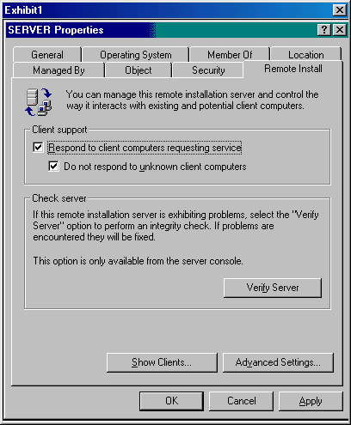
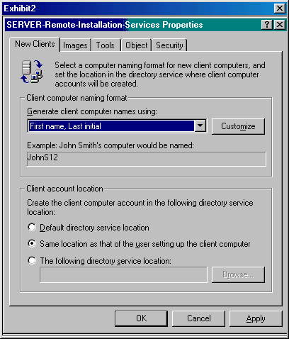

Which requirements do the actions meet? (Choose all that apply.)
- Only prestaged clients can use the RIS server
- The actions do not meet any of the requirements
- The client accounts are stored in the sts.local\Users folder
- The most secure setting for the RIS server is properly configured
- The company’s current naming convention for the computer name is properly configured

- Your network contains one domain. The domain contains four Organizational Units (OUs): Domain Controllers, Computers, Member Servers and Users. The Domain Controllers OU contains only Domain Controllers. The Member Servers OU contains Windows NT and Windows 2000 member servers. The Computers OU contains Windows 2000 workstations, Windows NT workstations, and Windows 98 workstations. You want to achieve these results:

Implement a secure and consistent password policy on all Windows 2000 computers.
Users should not be able to install unsigned drivers onto Windows 2000 computers.
All users should be removed from the Power Users group on Windows 2000 computers.
Computers running Windows NT and Windows 98 must be able to communicate with Windows 2000 computers.

You propose to apply the BASICDC.INF predefined security template at the Domain Controllers OU, and the COMPATWS.INF predefined security template at the Computers and Member Servers OUs.

Which result does the proposed solution provide?
- Implement a secure and consistent password policy on all Windows 2000 computers
- Users should not be able to install unsigned drivers onto Windows 2000 computers
- All users should be removed from the Power Users group on Windows 2000 computers
- Computers running Windows NT and Windows 98 must be able to communicate with Windows 2000 computers

- Your company recently hired a Directory Services Administrator to oversee the different directory services running on your network. You need to give the Directory Services Administrator permissions to perform the following tasks in your Active Directory domain:

Delete sites, site links, subnets, and inter-site transports.
Create and manage user accounts and groups in Active Directory.
Back up and restore Active Directory.
Manage DNS and Active Directory integration.
Extend the schema.

You created a user object for the Directory Engineer and granted membership in the Replicators, Account Operators, and Backup Operators domain local groups.

Which tasks can the Directory Engineer perform? (Choose all that apply.)
- Extend the schema
- Back up and restore Active Directory
- Manage DNS and Active Directory integration
- Delete sites, site links, subnets, and inter-site transports
- Create and manage user accounts and groups in Active Directory

- You are the administrator for your Windows 2000 network. HarryP is a member of the ACCT Organizational Unit (OU), the HR OU, and a group named TEST.

There is a shared folder, named Test1, in Active Directory. The security permissions for Test1 are:

ACCT OU Allow Read
HR OU Allow Read
TEST group Allow Full Control
HarryP Deny Full Control

HarryP logs on at her new workstation properly.

What is his effective permission for Test1?
- Allow Read
- Allow Write
- Denied all access
- Allow Full Control

- You are the administrator for a Windows 2000 network. You have decided to use the Domain Name System (DNS) for locating domain names on your network.

You want to provide increased fault tolerance and security. You want to accomplish this with the least amount of administrative overhead.

What should you do?
- Create a standard primary zone on your DNS server
- Create an Active Directory-integrated zone on your DNS server
- Create a standard primary zone on your DNS server. Create a secondary DNS server, and create a secondary zone on it. Set up the primary zone as such on the secondary DNS server.
- Create an Active Directory-integrated zone on your DNS server. Create a secondary DNS server, and create a secondary zone on it. Set up the Active Directory-integrated zone as the primary zone on the secondary DNS server.

- You are creating a new user object using the Active Directory Users and Computers console for a temporary employee who will start work in a few days. You want to achieve these results:

The user should be the only person who knows the password.
The password must be at least 7 characters in length.
The user should be forced to recreate the password every 30 days.
The account should only be used until December 29, 2000.

In order to achieve these results, you configure password settings as shown below:

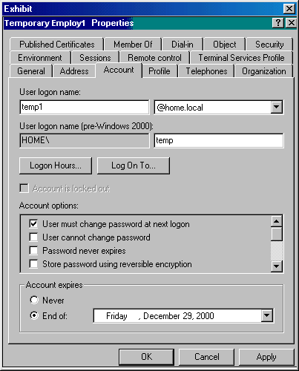

Which desired results are achieved? (Choose all that apply.)
- The password must be at least 7 characters in length
- The account should only be used until December 29, 2000
- The user should be the only person who knows the password
- The user should be forced to recreate the password every 30 days

- You are the administrator of your company's Windows 2000 network. You have three domains: orangecorp.com, apple.orangecorp.com, and lemon.orangecorp.com. All three domains are located in the New York site. All three domains contain Organizational Units (OUs) as shown below:

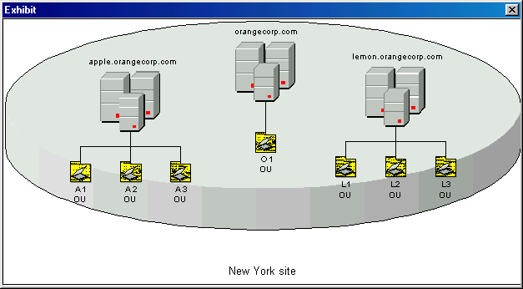

The following group policy objects (GPOs) exist with any GPO options listed:

Group Policy Type Group Policy Name GPO Options
Site GPO New York None
Domain GPO Lemon Block Policy Inheritance
OU GPO L1 Block Policy Inheritance
OU GPO L2 No override
OU GPO L3 None

A user named MaryW, a member of the L1 OU, logs on to a computer in the L1 OU.

What are her effective permissions?
- Only the permissions form the L1 GPO
- Only the permissions from the New York GPO
- A combination of the permissions from the Lemon GPO and the L1 GPO
- A combination of the permissions from the New York GPO and the L1 GPO

- Your company has a Windows 2000 network and uses Active Directory to manage your domains. One of your domain controllers has crashed.

You want to restore the System State data.

Which user can perform this task?
- Backup Operator
- Server Operator
- Local Administrator
- Domain Administrator
- Enterprise Administrator

- You upgraded all servers and workstations in your network to Windows 2000. About 50% of the domain controllers were clean-installed.

Half of the domain controllers were upgraded to Windows 2000 Server from a previous version of Windows. This has caused problems with network security, because the upgraded computers do not have the same security settings as the Windows 2000 domain controllers that were clean-installed.

You need to ensure that the upgraded Windows 2000 domain controllers have the same default security settings that were applied to the clean-installed domain controllers. You want to use a predefined security template to ensure that all domain controllers have the same Windows 2000 default security settings.

Which predefined security template should you apply?
- BASICDC.INF
- HISECDC.INF
- OCFILESS.INF
- SECUREDC.INF
- DC SECURITY.INF

- You are the administrator for your company's Windows 2000 network. You have three domains configured in Active Directory. Each domain is located at a different site. All sites are connected through site links.

One of the sites uses a firewall to protect the site from hackers. Some of the domain controllers for this site are outside the firewall.

You want this site to be able to replicate directory information successfully.

What should you do?
- Create a Proxy Server
- Create a Preferred Bridgehead Server
- Create a new site link for the firewall
- Open a port on the firewall for Active Directory traffic

- You have recently been hired as the administrator for your company's Windows 2000 network. The network uses Active Directory.

You are making Group Policy configuration changes. You perform the following actions:

You open the Group Policy snap-in, and open the GPO linked to a specific site.
You open the folders, User Configuration, Windows Settings, and Folder Redirection.
You right-click the My Documents folder and click Properties.
From the Target tab, you select Advanced-Specify Locations For Various User Groups setting.
You enter a specific path.
You accept the default property settings.

Which configuration change will these actions provide?
- Redirect the My Documents folder to one location for everyone in a specific site
- Redirect the My Documents and My Pictures folders to one location for everyone in a specific site
- Redirect the My Documents and My Pictures folders to a location according to security group memebership
- Redirect the My Documents folder to a location according to security group membership for the OU of the site

- You add three new SCSI hard disk drives to your company's domain controller. The SCSI disks are configured in a hardware RAID-5 array. You have two other physical disks in this domain controller.

You want to optimize the speed of the Active Directory database.

What should you do? (Choose two.)
- Move the ntds.dit file to the RAID-5 array
- Move the Netlogon share to the RAID-5 array
- Move the log files and the ntds.dit file to the RAID-5 array
- Create a mirror volume and place the log files on the mirror
- Move the log files to a separate physical disk from the operating system

- You are the administrator for your company's Windows 2000 network. You have three domain controllers with Active Directory Services deployed.

After one of the servers crashes, you decide that you must perform an authoritative restore on the system. You want to restore the entire directory and override the version increase.

Which command should you type at the authoritative restore prompt of the Ntdsutil?
- Restore database verinc <version increase>
- Restore database version <version increase>
- Restore subtree <subtree distinguished name> verinc <version increase>
- Restore subtree <subtree distinguished name> version <version increase>

- You are administering a Windows 2000 network for your company. You are using the software installation and maintenance features of Windows 2000 to distribute an application to all Windows 2000 users in the Active Directory domain. You have copied the application's .msi file to the Software Distribution Point, created the software installation package and set deployment options for the application package in the Group Policy snap-in for the GPO linked to the domain. You have assigned all Read permissions to authenticated users.

You discover that you need to assign Apply Group Policy permissions to the GPO. How did you make this discovery?
- Group Policy is not taking effect on the local printer
- Users open an already installed application, and the Windows Installer starts
- The users receive an error message such as “Another Installation Is Already In Progress”
- When users log in, they receive the message, “The feature you are trying to install cannot be found in the source directory”

- You are the administrator of your company's Windows 2000 network. You have three domains: testing.com, sat.testing.com, and act.testing.com. All three domains are located in the Charlotte site. All three domains contain Organizational Units (OUs) as shown below:

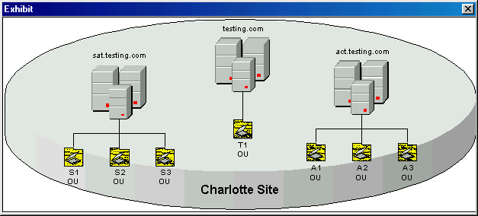

At the present time, there are no Group Policy Objects (GPOs) created in Active Directory.

You want to create a GPO for the Charlotte site.

Which tool should you use?
- GPO console of the MMC
- Active Directory Domains and Trusts
- Active Directory Sites and Services
- Active Directory Users and Computers

- You are the administrator for a Windows 2000 network that uses Active Directory to manage its domain.

You have performed a restore from the Backup tool and want to verify that the Active Directory database files were successfully recovered.

Which tool should you use?
- LDP
- SDCheck
- NTDSUtil
- Backup Tool

- Your network uses Active Directory services to manage a single mixed mode domain, which contains three Organizational Units (OUs): Domain Controllers, Computers, and Users.

The Domain Controllers OU contains only Domain Controllers. The Computers OU contains Windows 2000 workstations and member servers. The Users OU contains only users accounts.

You need to configure system services settings for a Group Policy object linked to the Computers OU. All computers require DNS and DHCP services.

You want to configure the proper settings so that computers in the Computers OU can access the DHCP and DNS services. You want to accomplish this with the least amount of administrative overhead.

What option in the Security Settings of the Group Policy object should you modify?
- Registry
- File System
- Local Policies
- System Services
- Account Policies

- You are the administrator for your Windows 2000 network. In Active Directory, you have two domains: weconsult.com and internal.com. In the weconsult.com domain, you have three Organizational Units (OUs). These OUs are SALES OU, MGMT OU, and ACCT OU.

JohnD is a member of the MGMT OU of the weconsult.com domain. You have been asked to implement Microsoft NetMeeting so that JohnD can discuss sales figures with upper management. The internal.com domain's BOSS OU contains all upper management users.

You want to publish Microsoft NetMeeting service to Active Directory.

Where should you publish the service? (Choose two.)
- In the BOSS OU of internal.com
- In the MGMT OU of weconsult.com
- In the JohnD’s computer container
- At the root of domain internal.com
- At the root of domain weconsult.com

- You are the administrator for your company's Windows 2000 network. You are concerned with changes being made to a specific user account.

You decide to audit all changes made to a user account, named Guest.

You open the Group Policy snap-in for your Group Policy, and expand the Audit Policy security area as shown below:

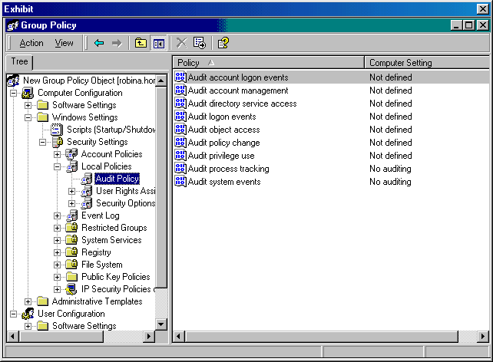

Which audit policy should you enable?
- account logon
- object access
- policy change
- privilege use
- process tracking
- directory service access

- You are the administrator for your Windows 2000 network. You use Active Directory to manage your network. All users, computers, and printers are listed in Active Directory.

You are viewing the Security tab of a computer. Listed on this tab are several groups and users with various permissions. You notice that one of the groups, Enterprise Admins, has Allow permissions that have been shaded as shown below:

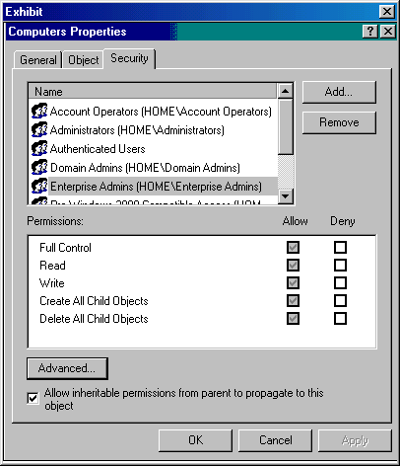

How do you get rid of the shaded permissions?
- Clear each permission
- Manually start Active Directory replication
- Restart the computer whose permissions you are viewing
- Restart the domain controller where you are accessing Active Directory
- Clear the allow inheritable permissions from parent to propagate to this object check box

- You are the administrator of your company's Windows 2000 network. You have three domains: musiccorp.com, country.musiccorp.com, and blues.musiccorp.com. All three domains are located in the Nashville site. All three domains contain Organizational Units (OUs) as shown below:

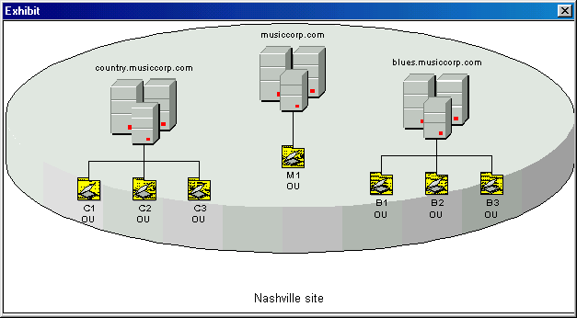

At the present time, there are no Group Policy Objects (GPOs) created in Active Directory.

You want to create a a GPO for the country.musiccorp.com domain.

Which tool should you use?
- Group Policy Snapin
- Active Directory Domains and Trusts
- Active Directory Sites and Services
- Active Directory Users and Computers

- You are the administrator for your Windows 2000 network. Active Directory is used to manage all network resources.

You are using the Shared Folders snap-in that is preconfigured in the Computer Management console.

Which shared folders are you able to monitor?
- The shared folders in the domain
- The shared folders in the forest
- The shared folders in the enterprise
- The shared folders on the local computer

- You are the administrator of your company's Windows 2000 network. You have three domains: weconsult.com, sales.weconsult.com, and acct.weconsult.com. All three domains are located in the Atlanta site. All three domains contain Organizational Units (OUs) as shown below:

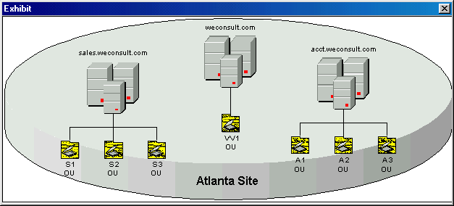

There is a site group policy object (GPO) in place. Each domain has its own GPO. All OUs have their own GPO.

A user name JohnD logs on to his Windows 2000 Professional computer as a member of the Sales workgroup.

Which GPOs are processed?
- Only the site GPO
- Only the local GPO
- Only the workgroup GPO
- The local GPO and then the site GPO
- Only the sales.weconsult.com domain GPO

- You are hired by Quota, Inc. to secure its Windows 2000 network. You use security templates to create a custom template and save it as Securequota.inf. You need to use this template on four domain controllers in the quota.com domain.

What should you do? (Choose two.)
- Create a new security database
- Import the Securequota.inf file
- Rename the Securequota.inf file to Ntconfig.pol
- Copy the Securequota.inf file to the sysvol shared folder on one domain controller
- Create a Group Policy object (GPO) on the Domain Controllers’ Organization Unit (OU)

- You are the administrator for your company's Windows 2000 network. You have three domains in the same forest. All the domains have two-way trusts with each other. Each domain has at least two domain controllers that manage Active Directory objects.

One of the domain controllers on the domain crashes. You must perform an authoritative restore on this machine. After performing the restore, you notice that the restored password values for the trust relationships are different than the current values.

Which tools could you use to reset these passwords? (Choose two.)
- Netdom tool
- Ntdsutil tool
- Active Directory Domains and Trusts snap-in
- Active Directory User and Computers snap-in

- You are the administrator for a Windows 2000 network with Active Directory enabled.

Using a Group Policy object (GPO), you want to use the software installation and maintenance features of Windows 2000 to distribute an application to all Windows 2000 users in the Active Directory domain that you administer. You want to be able to assign the software package to deploy to users and computers, and publish the software package to deploy to users.

How can you accomplish this task?
- Set creation options for the software package
- Set deployment options for the software package
- Create a Windows Installer package to deploy to the domain controller
- Create a Windows Installer package to deploy to the Active Directory server

- You are the administrator for your Windows 2000 network, which contains a Remote Installation Services (RIS) server. You have several images residing on this RIS server.

You need to perform maintenance on the images on the RIS server. You begin by deleting the directory and subdirectories of a particular image.

What will this accomplish?
- It will disable the RIS server
- It will refresh the RIPrep image
- It will completely remove an RIPrep image
- It will remove the unattended setup answer file for an RIPrep image

- Your network consists of three Windows 2000 Server computers that are domain controllers in your Active Directory. One of these servers crashes. You know that some of the data on the crashed server should take precedence over data on the other servers.

You decide to perform an authoritative restore.

Which tools should you use? (Choose two.)
- The LDP tool
- The Backup tool
- The Replmon tool
- The Ntdsutil tool
- The Repadmin tool

- You are setting up new computers for your company's network. The network is one domain consisting of one Windows 2000 DNS Server with Active Directory installed on it. There are no other Windows 2000 servers on your TCP/IP network. The 50 client machines you want to add to the network contain the same hardware configuration.

You want to accomplish the following goals:

You want to use Remote Installation Services (RIS) to install Windows 2000 Professional on the 50 new computers.
You want to provide all members of the Information Technology (IT) group with access to all of the Installation options.
You want to restrict general users to only the Automatic Setup and the Maintenance and Troubleshooting options.
You want all clients to be prestaged for security.

You take the following actions:

On your DNS Server, you install the DHCP Server service and configure all options properly. On that same server, you set up and authorize RIS. You create the RIPrep image and set the client support properties to "Respond to client computers requesting service". You set the Client Account Location to "Default Directory Service Location". You then set up a Group Policy object setting for the IT group, allowing these users access to all setup options.

Which goals are accomplished from these actions? (Choose all that apply.)
- All clients are prestaged for security
- Members of the IT group have access to all of the Installation options
- RIS is used to install Windows 2000 Professional on the 50 new computers
- All general users are restricted to the Automatic Setup and the Maintenance and Troubleshooting options

- You are the administrator for your Windows 2000 network. You have reason to believe that someone is trying to hack into your network by guessing passwords.

In order to combat this problem, you want to configure security settings for your domain Group Policy so that an account is locked after 3 unsuccessful logon attempts. You also want both successful and unsuccessful logon attempts to be logged into the security logs.

You open the Group Policy snap-in for the domain Group Policy Object and expand the security settings node.

Select the two security settings you must configure to enable the system to lock accounts after 3 unsuccessful logon attempts and to log both successful and unsuccessful logon attempts into the security logs:

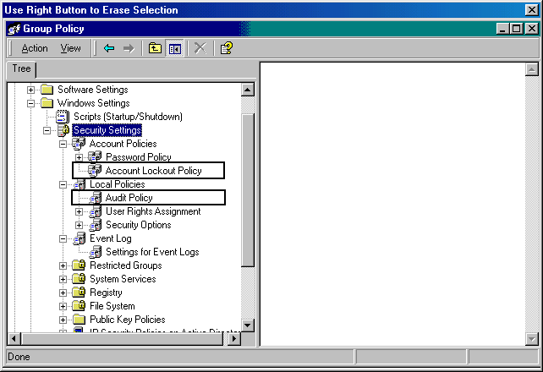
- You are the administrator for your company's Windows 2000 network. The network is very large with over 200 sites configured in Active Directory.

You have noticed that periods of high CPU activity occur every 15 minutes when the Knowledge Consistency Checker (KCC) runs.

What should you do?
- Change the cost value for some of the site links to a higher cost
- Change the replication time for some of the site links to a longer interval
- Clear the Bridge all site links check box for the transport object you use
- Select the Bridge all site links check box for the transport you use

- You are the administrator for a Windows 2000 network. The network consists of 5 Windows 2000 Server computers and 80 Windows 2000 Professional client computers. The network is configured to use Active Directory and Remote Installation Services.

The RIS server on the network contains several RIPrep images. You want to combine any duplicate images. You need to do this to consume less disk space on the server.

What should you install to accomplish this?
- Single Instance Store services
- Remote Installation Answer Files services
- Boot Information Negotiation Layer services
- Trivial File Transfer Protocol Daemon services

- You have been asked to implement a Windows 2000 network for a new company. All servers are Windows 2000 Server computers, and all clients are Windows 2000 Professional clients. You install the Domain Name System (DNS) on one of the Windows 2000 Server computers.

You want to accomplish the following goals:

DNS zone transfer traffic will be minimized on the network.
Administrative overhead for maintaining DNS zone files will be minimized.
Unauthorized host computers will not have records created in the zone.
All zone updates will come only from authorized DNS servers.
All zone transfer information will be secured as it crosses the network.

You take the following actions:

Create a standard primary zone on the DNS server.
Set up a Windows 2000 Server computer as the secondary DNS server.
Configure the secondary DNS server to initiate an incremental zone transfer.
In the Zone Properties dialog box, set Allow Dynamic updates option to Yes.
Create and assign an IPSec policy that encrypts all DNS traffic between the DNS servers.

Which goal or goals are accomplished from these actions? (Choose all that apply.)
- DNA zone transfer traffic will be minimized on the network
- All zone updates will come only from authorized DNS servers
- Unauthorized host computers will not have records created in the zone
- All zone transfer information will be secured as it crosses the network
- Administrative overhead for maintaining DNS zone files will be minimized

- You are the administrator for your company's Windows 2000 domain. Your domain contains five domain controllers running Active Directory and one DNS server. The DNS server uses an Active Directory-integrated zone.

Replication is used so that Active Directory data is copied to all domain controllers in the domain. You are concerned about the zone data being replicated properly.

To which server(s) is the zone data from the DNS server replicated?
- Only to the Global Catalog server
- To no other computers in the domain
- To every domain controller in the domain
- Only to the Active Directory operations master
- Only to the PDC

- You are the administrator for your network. You are upgrading some of the computers on your network. Part of this process involves migrating DNS from standard primary zones to Active Directory-integrated zones.

The portion of the network that you are now upgrading contains one DNS server, which maintains both a forward and reverse lookup zone. You need to migrate both zones to the Windows 2000 Active Directory server.

What should you do first?
- Move the zone files from the current DNS server to an easily accessible location on the network
- Copy the zone files from the current DNS server to the %systemroot%\DNS folder on the Windows 2000 Active Directory server.
- Copy the zone files from the current DNS server to the %systemroot%\System32\DNS folder on the Windows 2000 Active Directory server.
- Export the zone information from the current DNS server into a BIND file and copy this information to an easily accessible location on the network.
- Import the zone information from the current DNS server into Active Directory by launching the DNS console, right-clicking the Master DNS server, and selecting the Zone Import Wizard.

- You are the administrator for your company's Windows 2000 network. You have Active Directory deployed to manage your forest.

You have made plans to replace your current domain naming master with a newer, faster Windows 2000 Server computer. Today when you got to work, the current domain naming master had crashed.

You decide to go ahead and set up the new Windows 2000 Server computer as your domain naming master.

Which tool should you use?
- LDP
- NETDOM
- REPLMon
- NTDSUtil
- MoveTree

- You need to make some additions and changes to your Active Directory on the Windows 2000 network. You begin by opening the Active Directory Sites and Services dialog box.

Which addition or change can you make with this first step?
- You can add a Group Policy console
- You can add a Group Policy setting
- You can create a Group Policy Object (GPO) linked to a site
- You can create a Group Policy Object (GPO) linked to a domain

- You are troubleshooting a problem with DNS for Active Directory. You want to log information in the DNS server activity log.

You start the DNS console at your DNS server named MAIN, right-click the name server, and click Properties. You then select the Logging tab.

You would like the log to display the total number of DNS query messages and the total number of DNS requests.

For each Logging option you must enable in order to meet your goal, click on the appropriate checkbox in the Logging tab of the MAIN Properties dialog box.

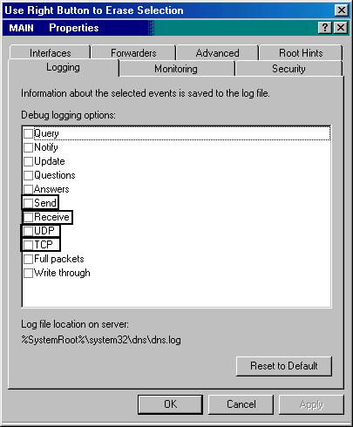
- You are the administrator for your company's Windows 2000 network. Active Directory is used to manage all domain objects.

You notice an event message in the Event Viewer, as shown below:

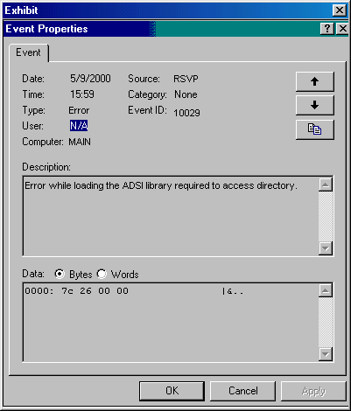

What should you do?
- Manually start Active Directory replication
- Restart all domain controllers in the domain
- Restart the Active Directory service on the domain controller where the error message was encountered
- Reinstall the Active Directory Service Interface library (adsldpc.dll) from the Windows 2000 installation disk

- You are the administrator for a Windows 2000 network with Active Directory and Group Policy enabled. You need to configure Deployment options for an application that will be distributed to all Active Directory users in your domain. You want to accomplish the following goals:

The application will appear in the Add/Remove Programs console in Control Panel the next time the user logs on. The user can select install options for the application during the application setup process.
The application will install when the user double-clicks an associated file extension and software associated with the file extension is not already installed. The user can repair the software after it is installed but should not be able to remove it.

You perform the following actions:

You open the Group Policy snap-in for the GPO linked to your domain.
From User Configuration, you open Software Settings and select the Software installation node.
You double-click the WebApp software package, select the Deployment tab of the WebApp properties, and configure the software package Deployment tab as shown below:

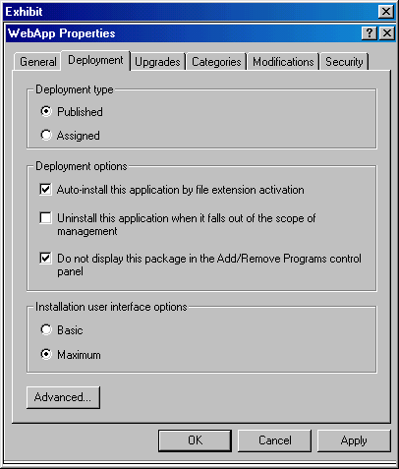

Finally, you click the Apply button and close the Group Policy MMC snap-in.

Which goal or goals are accomplished from these actions? (Choose all that apply.)
- The user can repair the software after it is installed but should not be able to remove it
- The user can select install options for the application during the application setup process
- The application will appear in the Add/Remove Programs console in Control Panel the next time the user logs on
- The application will install when the user double-clicks an associated file extension and the software associated with the file extension is not already installed

- You are the administrator for your company's network. You have an Active Directory forest that contains three domains: weconsult.com, sales.com, and acct.com. The weconsult.com domain contains only Windows 2000 computers. The sales.com and acct.com domains contain both Windows 2000 and Windows NT 4.0 computers.

You have several Power Users in your organization that you want to be able to monitor the status of Active Directory replication using the Active Directory Replication Monitor (ReplMon.exe). You want to install the Active Directory Replication Monitor on these users' computers.

On which of the following systems can you install this utility? (Choose all that apply.)
- Windows NT 4.0 Server member servers
- Windows 2000 Server domain controllers
- Windows NT 4.0 Server domain controllers
- Windows 2000 Server stand-alone computers
- Windows 2000 Professional member workstations
- Windows 2000 Professional stand-alone computers

- You are the administrator for your company's Windows 2000 network. You have a Windows 2000 Server computer on which you plan to install Active Directory. This computer has two separate physical disks installed in it, one formatted with NTFS version 5 and the other formatted with FAT.

You want to accomplish the following goals:

optimize controller performance
optimize security
increase ease of administration
provide unattended setup
prevent anonymous Read access

You take the following actions:

You use the Active Directory Installation Wizard. You install the Ntds.dit file on the FAT drive and install the log files and system volume share on the NTFS drive.

Which goal or goals do you accomplish with these actions? (Choose all that apply.)
- optimize security
- provide unattended setup
- prevent anonymous Read access
- optimize controller performance
- increase ease of administration

- Your company's network is an FDDI Windows 2000 network. It consists of three Windows 2000 servers, 30 Windows 2000 Professional workstations, and 25 Windows 98 Second Edition workstations. Your Windows 2000 servers run the following services:

SERVER_1:
DHCP
DNS
RAS

SERVER_2:
DNS

You are in charge of deploying 100 more Windows 2000 Professional workstations. The workstations have RIS compliant network adapters in them, but they do not support Pre-Boot eXecution Environment (PXE) DHCP-based remote boot ROMS. All of the computers have a 100BaseT network card in them. You are the Administrator of SERVER_1, an authorized Active Directory server. As the Administrator, you have local Administrative rights to it. You must configure Remote Installation Services (RIS) to meet the following requirements:

You must install RIS services on SERVER_1.
You must authorize the RIS Service.
You must apply the changes immediately so you can install Windows 2000 Professional on the 100 Windows 2000 Professional computers.
You must prepare the Windows 2000 computers for remote installation over the network.

You take the following actions:

You install RIS on SERVER_1 using the RIS installation wizard.
You authorize the RIS Service from SERVER_1.
You configure RIS to company standards.
You create a RIPrep image.
You create boot disks for the clients.
You restart SERVER-1.

Which requirements do the actions meet? (Choose all that apply.)
- The changes are applied immediately
- RIS services are installed on the server
- The RIS server is authorized in the Active Directory Enterprise
- The RIS server can be accessed by the clients (without an operating system on the client computer) and installed over the network

- You are the administrator for your company's Windows 2000 network. Your network contains one domain. You want to apply account policies to enforce established security policies.

Your domain contains three Organizational Units (OUs): Domain Controllers, Computers, and Users. The Domain Controllers OU contains only Domain Controllers. The Computers OU contains Windows 2000 workstations and member servers. The Users OU contains only users accounts and global groups.

You create one group policy object (GPO) and apply it to the root domain of the domain tree.

Which unit will be affected by this account policy?
- all accounts in the domain
- all accounts in the Users OU
- all accounts in the Computers OU
- all accounts in the Domain Controller OU

- You are the administrator for your Windows 2000 network. You use Active Directory to manage all objects on your network.

You have a user named TomD that is a consultant for your company. You want to limit the computers to which he can log on.

Which protocol must be used to control this?
- DLC
- TCP/IP
- IPX/SPX
- NetBIOS over TCP/IP

- You are the administrator of your Windows 2000 domain, which contains a RIS server on which a RIPrep image resides.

The RIPrep image was created on a source computer configured as follows:

Pentium 300 Mhz Processor
128 MB RAM
3 GB hard disk drive C:
3 GB hard disk drive D:
Supported PCI Plug and Play network adapter card

The client computers on which you want the image to be installed are configured as follows:

Pentium 166 Mhz processor
16 MB RAM
3 GB hard disk drive C:
Supported PCI Plug and Play network adapter card

Which change must be made to have a successful install of the image?
- Add 16 MB RAM
- Upgrade to a 10 GB hard disk
- Upgrade to a 200 Mhz processor
- Add a PXE-based remote boot ROM

- You are the administrator for your network. Originally your network was a Windows NT 4.0 network with one primary domain controller (PDC) and three backup domain controllers (BDCs). You have upgraded the PDC and two of the BDCs to Windows 2000 Server. The last BDC cannot be upgraded because of compatibility issues with an application it contains.

You install Active Directory on the Windows 2000 Server computers. You then decide you want to clean up the users and groups used in your domain.

Which type(s) of Windows 2000 groups can you NOT use? (Choose all that apply.)
- local groups
- global groups
- universal groups
- domain local groups

- You are the administrator for your company’s network. Your network consists of Windows 2000 Server computers, Windows 2000 Professional computers, and Windows 98 computers. All clients must be able to log on to ALL Windows 2000 Professional computers and all Windows 98 computers.

What is one limitation you must keep in mind when setting up user accounts?
- The password cannot be more than 14 characters in length
- The username cannot be more than 14 characters in length
- The password cannot be more than 127 characters in length
- The username cannot be more than 127 characters in length

- You are the administrator for your company's Windows 2000 domain. You have a Windows 2000 Server computer that is your Active Directory and Domain Name System (DNS) server for your small network.

You want to view the properties of the DNS server, the DNS zones, and the resource records (RRs).

Which tool could you use?
- Dnscmd.exe
- Netdom.exe
- Nltest.exe
- Dnsstat.exe
- Netdiag.exe

- You are the administrator for your company's network. You have just completed upgrading all your Windows NT 4.0 computers to Windows 2000. You have implemented Active Directory.

You want to change the domain from Windows 2000 mixed mode to Windows 2000 native mode.

What should you do?
- Run dcpromo.exe
- Use the NTDSUtil tool
- Use the Clonepr.dll tool
- Do nothing. Once your last Windows NT computer was upgraded, the domain automatically switched from mixed mode to native mode
- In Active Directory Domains and Trust, get the Properties dialog box of the domain you wish to change. Click the Change mode button.

- You are the administrator for your Windows 2000 network. SallyC is a member of the ACCT Organizational Unit (OU), the HR OU, and a group named TEST.

There is a shared folder, named Test1, in Active Directory. The security permissions for Test1 are:

ACCT OU Allow Read
HR OU Allow Read
TEST group Allow Write
SallyC No explicit permissions granted or denied

SallyC logs on at her new workstation properly.

What is her effective permission for Test1?
- Allow Read
- Allow Write
- Denied all access
- Allow Read & Write

- Your domain contains the San Diego, Los Angeles, and Phoenix sites. The San Diego and Los Angeles sites are connected by a T1 link. The Phoenix site is connected to the San Diego site by a permanent 128 Kbps link and to the Los Angeles site by a dial-up ISDN line. The network is fully routed.

You created site links between San Diego and Los Angeles, San Diego and Phoenix, and Los Angeles and Phoenix. Replication is occurring properly, but the replication traffic across the Los Angeles/Phoenix site is costing your company a great deal of money in extra connection and usage fees.

You assign the following cost values to the site links:
San Diego/Los Angeles - 1
San Diego/Phoenix - 500
Los Angeles/Phoenix - 1000.

What is the result of this action?
- Replication occurs only between the San Diego/Los Angeles site link.
- When the Phoenix site attempts to replicate, it will first try to use the San Diego/Phoenix site link. If that is unavailable, it will try to use the Los Angeles/Phoenix site link.
- When the Phoenix site attempts to replicate, it will first try to use the Los Angeles/Phoenix site link. If that is unavailable, it will try to use the San Diego/Phoenix site link.
- When the Phoenix site attempts to replicate, it will first try to use the San Diego/Los Angeles site link. If that is unavailable, it will try to use the San Diego/Phoenix site link.

- You are the administrator for your Windows 2000 network. All servers on your network are Windows 2000 Server computers, and all workstations on your network are Windows 2000 Professional computers.

One of your workstations is having trouble resolving Domain Name System (DNS) names. You decide you want to remove all entries in the DNS cache. There are two ways to do this.

What should you do? (Choose two.)
- At a command prompt on the DNS server, type ipconfig /flushdns
- At a command prompt on the workstation computer, type ipconfig /flushdns
- At a command prompt on the workstation computer, type nslookup /flushdns
- At a command prompt on the workstation computer, type net stop “dns client”. Then type net start “dns client”.

- You configured deployment options for a software package so that when a user in the Active Directory domain double-clicks a file with the .htm or .html extension, Microsoft Front Page 2000 is automatically delivered to the user and installed, if an application associated with the file type is not already installed. However, the application is not being deployed as planned.

You discover that the package is corrupt. What caused you to make this discovery?
- Group policy is not affecting users and computers in an Active Directory container.
- Users receive an error message such as "Another Installation Is Already In Progress".
- When users attempt to edit a GPO, the "Failed To Open The Group Policy Object" message appears.
- Users who double-click an .htm or .html file, and do not already have an application associated with the file type, consistently receive the error message "Cannot Prepare Package For Deployment".

- You are the administrator for your company's Windows network. You have recently upgraded all servers on your network to Windows 2000 Server. You then upgrade about half of the existing client computers to Windows 2000 Professional. You still have some client computers running Windows 95, Windows 98, and Windows NT 4.0 Workstation.

Concerned with security, you apply the HISECDC.INF predefined security template to all domain controllers.

After you do this, which computers can successfully communicate with the domain controllers?
- All Windows 98 computers
- All Windows NT 4.0 Workstation computers
- All Windows 2000 Server computers
- All Windows 2000 Professional computers

- You want to set up auditing for your Windows 2000 domain controllers. The domain controllers are in an Organizational Unit named Domain Controllers. You want to audit these events:

local user logons and logoffs
modifications to user and group accounts, such as creating, deleting, or renaming
system time changes
modifications to user security options
system restarts and shutdowns

You propose to configure an auditing policy in a nonlocal Group Policy object (GPO) for the domain. You will set the auditing policy for the GPO and enable the auditing for successes and failures for the following events:

logon events
directory service access
object access
policy change
privilege use
system events

Which events will you successfully audit when the proposed solution is implemented? (Choose all that apply.)
- system time changes
- local user logons and logoffs
- system restarts and shutdowns
- modifications to user security options
- modifications to user and group accounts, such as creating, deleting, or renaming

- You are administering a Windows 2000 network that uses all Windows 2000 Server and Professional computers. The network is configured to use Active Directory and RIS.

A user informed you that he is having problems with RIS during system startup. After researching the problem, you discover that the RIS server is not authorized in Active Directory.

How did you make this discovery?
- After the client started, it did not receive the message "DHCP."
- After the client started, it did not receive the message "BINL."
- After the client started, it did not receive the message "TFTP."
- After the client started, it did not receive the message "BootP."

- You are the administrator for your Windows 2000 network. You have several Active Directory domains that you must manage.

During the past month, you have been decommissioning several old Windows NT 4.0 computers. The end result is that one of your domains has been orphaned. You now want to remove the orphaned domain.

Which tools could you use?
- Ldp
- Netdom
- Sdcheck
- Ntdsutil
- Repadmin

- You are the administrator for your Windows 2000 network. You have a Windows 2000 Server computer that has Active Directory installed. Because you have a small network, it is the only Active Directory server on your network.

The Active Directory server crashes one night. When you come in the next morning, you find out that it was hit by a power surge and it is not cost efficient to repair the current system. You have a complete system backup of the server that was performed one hour before the crash.

You decide to purchase a new system to replace it. You know that you cannot purchase a system with the exact configuration as the one destroyed.

Which rule applies in this situation?
- Both computers must have the same type of CD-ROM drive
- Both computers must have the same type of video adapter
- Both computers must have the same number of disk drives
- Both computers must have the same type of network interface card

- One of your domain controllers needs Active Directory restored. You decide to use the Backup tool to restore the domain controller from backup.

What must you do?
- Stop the Active Directory service
- Pause the Active Directory service
- Restart the domain controller in Safe Mode
- Restart the domain controller in Directory Services Restore Mode

- You are the administrator of a Windows 2000 domain using Active Directory Services. You want to use group policy to configure the system to delete local copies of users' offline files when the users log off. Click the object containing the appropriate policy.

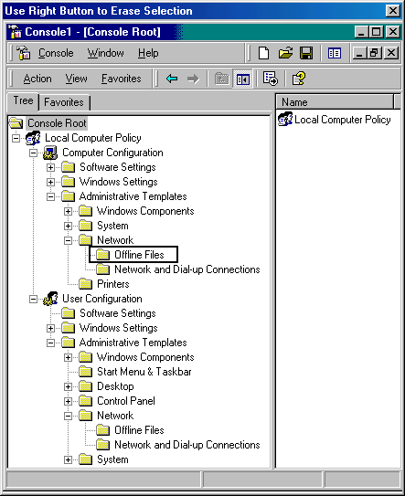
- You are the administrator of a Windows 2000 domain using Active Directory Services. You want to use group policy to prevent users from starting the Network Connection wizard. Click the object containing the appropriate policy.

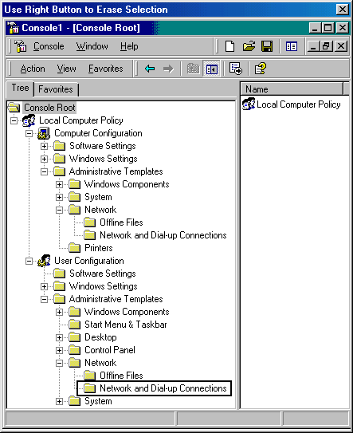
- Your domain contains two sites, which are connected by a 28-Kbps dial-up connection. The site link is operating correctly, and replication occurs at regular intervals.

The Replication frequency between the two sites is set at 60 minutes. The Replication schedule between the two sites is from 8:00 to 17:00 daily. It takes an hour and fifteen minutes for replication to complete.

What is the maximum number of times replication occurs between these two sites daily?
- 4
- 5
- 7
- 9
- 18

- As a contractor installing a Windows 2000 network at a mid-size company, you must use RIS to configure company workstations as follows:

You must create a company-wide, standard installation of Windows 2000 Professional.
You must have one RIS server on the network.
You must propagate changes to the RIS policy immediately.
You must use a member server as the RIS server.

You have configured a Windows 2000 domain controller with DHCP, DNS, and Active Directory. There is also a Windows 2000 member server on the network.

You take the following actions:

You install RIS on the member server.
You configure RIS to company standards.
You create a RIPrep image.
You go to the DHCP Administration Tool. Right-click the DHCP root node, and click Manage Authorized Servers. Click Authorize and enter the IP address or name of the RIS server.
You create a single image of the OS for RIS and do not allow any optional components to be installed.
You type secedit /refreshpolicy /MACHINE_POLICY at the command prompt on the RIS server.

Which requirements do the actions meet? (Choose all that apply.)
- A member server serves as the RIS server
- There is only one RIS server on the network
- Changes are propagated to the RIS policy immediately
- There is a company-wide, standard installation of Windows 2000 Professional

- You are the administrator for your company's Windows 2000 network. You have a Windows 2000 Server computer installed on your network as the Domain Name System (DNS) server, named DNS1. The DNS zone is an Active Directory-integrated zone.

Recently you have become concerned with fault tolerance for your DNS server. Your Internet Service Provider (ISP) has a UNIX server that acts as its DNS server. They have authorized you to use this server as a backup to your DNS server. You configure the appropriate TCP/IP settings for this.

Users inform you that they are not able to connect to the URL of the company's Web server. You investigate this problem and discover that this inability to connect occurs during the time when the primary DNS server is unavailable.

You want to prevent this problem from happening again.

Click on the appropriate checkbox in the Advanced tab of the DNS1 Properties dialog box.

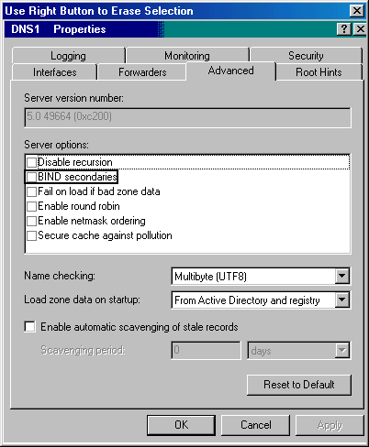
- You are the administrator of a Windows 2000 domain using Active Directory Services. You want to use group policy to administer and customize Microsoft Internet Explorer maintenance. Indicate the appropriate object to expand.

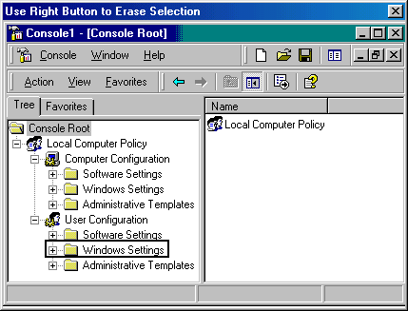
- Your company's network is an FDDI Windows 2000 network. It consists of ten Windows 2000 servers, 300 Windows Professional workstations, and 75 Windows 98 Second Edition workstations:

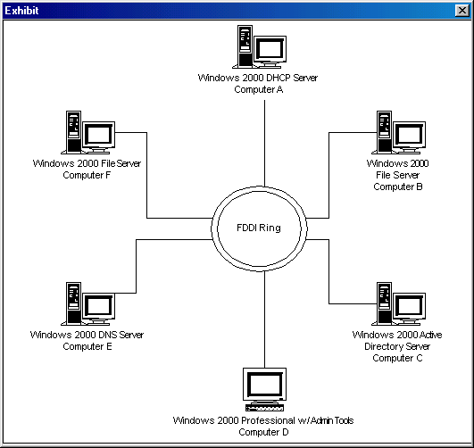

You are in charge of deploying 100 more Windows 2000 Professional workstations. The workstations have RIS compliant network adapters in them, but they do not support Pre-Boot eXecution Environment (PXE) DHCP-based remote boot ROMS. All of the computers have a 100BaseT network card in them. You are the Administrator of Computer C, an authorized Active Directory server. As the Administrator, you have local Administrative rights to it. You must configure Remote Installation Services (RIS) to meet the following requirements:

You must install RIS services on Computer A.
You must authorize the RIS Service in the Active Directory enterprise.
You must apply the changes immediately so you can install Windows 2000 Professional on the 100 Windows 2000 Professional computers.
You must prepare the Windows 2000 computers for remote installation over the network.

You take the following actions:

You install RIS on Computer A using the RIS installation wizard.
You configure RIS to company standards.
You create a RIPrep image.
You create boot disks for the clients.
You restart the computer.

Which requirements do the actions meet? (Choose all that apply.)
- The changes are applied immediately
- RIS services are installed on the server
- The RIS server is authorized in the Active Directory Enterprise
- The RIS server can be accessed by the clients (without an operating system on the client computer) and installed over the network

- You are the administrator for your company's network. You created a new user object for a user using the Active Directory Users and Computers console. When you set up the account, you enable the Store Password Using Reversible Encryption option.

What does this do?
- It requires the use of a smart card
- It enables the user to log on using a UNIX computer
- It enables the user to log on using a Macintosh computer
- It prevents the user from using Kerberos preauthentication

- You are the administrator for your Windows 2000 network. Your Active Directory domain contains three domain trees in the same forest. Replication between the three trees is transitive.

You have reason to believe that replications are late in being performed. You want to use a tool that will only perform a basic test, not an in-depth test.

Which tool should you use to check if you are correct?
- Dcdiag
- Netdom
- ReplMon
- RepAdmin
- Event Viewer

- You are the administrator of a Windows 2000 domain using Active Directory Services. You use the Group Policy snap-in to configure the Administratively assigned offline files policy in both the Computer Configuration and User Configuration folders. What effect does this have?
- The system applies the default settings
- An error is raised if the policies are conflicting
- The setting in Computer Configuration takes precedence over the setting in User Configuration
- The setting in User Configuration takes precedence over the setting in Computer Configuration

- You are the administrator for your Windows 2000 network. You want to log directory service access successes and failures. You also want to specify that the logs cannot be overwritten.

You open the Group Policy snap-in for the domain Group Policy Object and expand the security settings node.

Select the two security settings you must configure to enable directory service access success and failure logging and to specify that the logs cannot be overwritten:

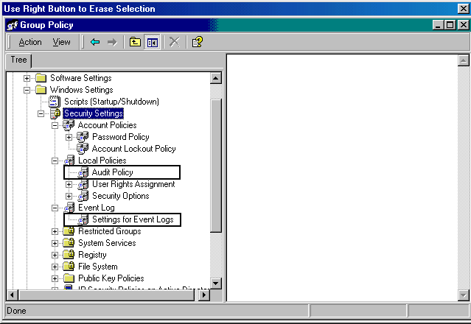
- You are the administrator for a Windows 2000 network with Active Directory and Group Policy enabled. The network uses only Windows 2000 Server computers and Windows 2000 Professional client computers.

You want to use the software installation and maintenance features of Windows 2000 to distribute an application to all Windows 2000 users in the Active Directory domain that you administer. Because the application is necessary for all users in the domain to do their work, you must make sure that all Windows 2000 users have access to the application.

You decide to assign the software application package to deploy to computers. What is another reason for this decision?
- You want to ensure that all users can remove the application.
- You want to ensure that only specific users can access the application.
- You want to ensure that all users are not able to remove the application.
- You want to ensure that only specific users can add the application to their computers.

- You are the administrator for your company's Windows 2000 network. You have created a Group Policy Object (GPO), named Enforce1, to control user configuration.

You want to accomplish the following goals:
Use the GPO to enable a disk quota.
Use the GPO to enforce a disk quota.
Use the GPO to set a disk quota of 50 MB for each user.
Use the GPO to set a warning level of 45 MB for each user.
Use the GPO to log an event in Event Viewer when the quota limit is exceeded.

You take the following actions:

In Enforce1, you go to the Computer Configuration node. In the Administrative Templates area, you access the System/Disk Quotas area. You enable the Default quota limit and warning level, set the quota limit to 50 MB, and set the warning level to 45 MB.

Which goal or goals do you accomplish with these actions? (Choose all that apply.)
- Use the GPO to enable a disk quota
- Use the GPO to enforce a disk quota
- Use the GPO to set a disk quota of 50 MB for each user
- Use the GPO to set a warning level of 45 MB for each user

- You are a network administrator for a Windows 2000 network. The network uses Active Directory and DNS.

You need to deploy applications to all users in the Active Directory. You want to optimize the deployment time to the users.

What is the most efficient method for accomplishing this task?
- By deploying the applications using separate OUs
- By deploying the applications using a single domain
- By deploying the applications using a single group policy object
- By deploying the applications using separate group policy objects

- You want to set up auditing for your Windows 2000 domain controllers. The domain controllers are in an Organizational Unit named Domain Controllers. You want to audit these events:

domain controller requests to validate a user account
modifications to user and group accounts, such as creating, deleting, or renaming
system time changes
modifications to user security options
system restarts and shutdowns

You propose to configure an auditing policy in a nonlocal Group Policy object (GPO) for the domain. You will set the auditing policy for the GPO and enable the auditing for successes and failures for the following events:

account logon
privilege use
system events
policy change
process tracking

Which events will you successfully audit when the proposed solution is implemented? (Choose all that apply.)
- system time changes
- system restarts and shutdowns
- modifications to user security options
- domain controller requests to validate a user account
- modifications to user and group accounts, such as creating, deleting, or renaming

- You are the administrator for a Windows 2000 network. The network uses an Active Directory domain.

You plan to use Software Installation and Active Directory to deploy applications to users. These applications must be deployed to all users in the organization. These users are located in five separate departments within the organization.

What should you do to accomplish this task?
- Create an OU and add all users in the domain as members of the OU. Deploy the applications to the OU.
- Create a GPO for each department. Add users to the GPOs according to their department. Deploy the applications to the main GPO.
- Create a site and create separate OUs for each department. Add users to the OUs according to their department. Deploy the applications to the main OU.
- Create a separate domain, create five sites within that domain, and create a GPO. Add each user to the sites in the new domain according to their department. Deploy the applications to the GPO.

- Your company has several branch offices that each contain at least one domain controller. Each branch office is configured as a separate site. Connection costs at the Paris office are very high.

When the domain controller in Paris needs to replicate changes to the main office, it dials an ISP and establishes a tunneled connection with the main office.

You decide you want to implement reciprocal replication on the Paris site link in order to lower communication costs.

What does the replication feature offer?
- Two-way replication between the main office and the branch offices over the ISP connection.
- Push replication between the main office and the branch office over the ISP connection. The push replication originates with the main office.
- Pull replication between the main office and the branch office over the ISP connection. The pull replication originates with the main office.
- Push replication between the main office and the branch office over the ISP connection. The push replication originates with the branch office.

- You are the administrator for your company's Windows 2000 network. You have decided to install Active Directory to provide directory services.

Active Directory has certain requirements for the computer on which it will be installed. Checks will be performed to ensure that these things exist.

What are some of the requirements? (Choose four.)
- The TCP/IP protocol must be installed on the local computer
- The local computer must be a DNS client
- The NetBEUI protocol must be installed on the local computer
- One logical disk drive must be formatted with the NTFS version 5 file system
- One physical disk drive must be formatted with the NTFS version 5 file system
- The current user logged on to the local computer is a member of the Administrators group on the local computer

- You must use Software Installation and Active Directory to deploy applications to users in your Active Directory domain. You must meet the following requirements for deployment and user convenience:

You must auto-install Microsoft Word 2000 so when a user double-clicks a file with a .doc, .htm, or .html extension, the package is deployed, if there is no application associated with this file type installed.
You must deploy this application to all users in your organization.
You must allow users to access their My Documents folder regardless of the computer the user logs on to.

You take the following actions:

You create the installation GPO and assign the .htm, .html, and .doc extensions to Microsoft Word 2000 using the File Extensions Tab of the Software Installation Dialog box.
You configure the My Documents folder as shown below:

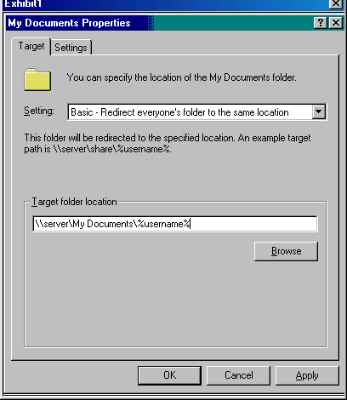
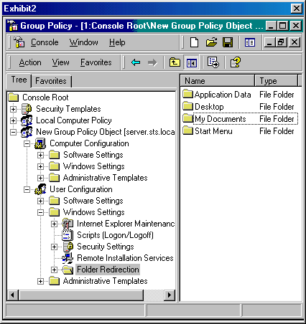
Which requirements are met by the actions? (Choose all that apply.)
- None of the requirements are met by the actions
- This application deploys to all users in your organization
- Users can access their My Documents folder regardless of the computer the user logs on to
- Microsoft Word 2000 will auto-install when a user double-clicks a file with a .doc, .htm, or .html extension if there is no application associated with these extensions

- You are in charge of creating a software installation to deploy custom software for a group of users. All users are listed in Active Directory. The installation package has an .msi extension. You must configure the Group Policy to meet the following requirements:

You want to deploy the installation to users in all of your domains.
You must deploy six applications.
You must optimize the deployment time to the users.
You must be able to assign, publish, or configure package properties when you add the new package.

You take the following actions:

You configure an OU unit name as GPInstall and make all users that need to run this program members of the OU.
You deploy all six applications using a single Group Policy Object.

Which requirements are met by the proposed actions? (Choose all that apply.)
- Six applications are deployed
- The deployment time to the users is optimized
- The installation is deployed to users in all of your domain
- You can assign, publish, or configure package properties when you add the new package

- You are the administrator for your network. You have just finished a total network upgrade, which involved upgrading all systems on your network from Windows NT 4.0 Server and Workstation to Windows 2000 Professional and Server.

The upgrade is complete. Active Directory has been installed to manage all directory objects. However, you notice that policies that existed in the Windows NT 4.0 environment were not migrated to the Windows 2000 Active Directory environment.

What caused this to happen?
- You did not perform the migration properly.
- Windows NT 4.0 system policies are stored in one policy file with group information embedded.
- You did not convert the system policies at the proper time. They should be converted before performing the operating system upgrades.
- You did not convert the system policies at the proper time. They should be converted after upgrading the operating system but before installing Active Directory.

- You are the administrator for a Windows 2000 network that uses Active Directory. You are specifying deployment options for a software package that will deploy Microsoft Outlook 2000 to all Windows 2000 desktops in your company. You also created a transforms file that you want to use in the software package to customize the install.

You select the Modifications tab in the Windows 2000 Administration Tools Properties dialog box. What should you do from this tab?
- Add the transforms file to the software package
- Edit installation options for the transforms file
- Set up application categories for the transforms file
- Set automatic installation options based on the transforms file

- You used security templates to apply security policies in your Windows 2000 network. Since the policies were first applied, you have had to temporarily change security levels to troubleshoot a network problem.

You are concerned that the temporarily changed security levels might not have been changed back, and you want to use the Security and Analysis tool determine if this is indeed the case.

After accessing the Security Configuration and Analysis tool, you set a working security database. You then import a security template into the security database. However, you realize that you have imported the wrong template.

You want to replace the template with a new one with the least amount of administrative overhead.

What should you do?
- Select the new template. All of its settings will overwrite the other template.
- Select the new template. All of its settings will merge with the other template.
- Exit the Security Configuration and Analysis console. Then restart it and choose the correct template.
- Select the new template. Then click the Clear This Database Before Importing check box in the Import Template dialog box.

- You are the administrator for a Windows 2000 domain with Active Directory enabled.

You are configuring Group Policies for computers and users in the domain. The domain contains the Sales, Engineering, and Production OUs. The Production OU contains mostly Windows 2000 Terminal Services clients, while the Engineering and Marketing OUs contain only Windows 2000 Professional clients.

Because you would like to use the same global scripts for all computers within the domain, you configure startup and shutdown scripts for the Group Policy Object linked to the domain. You also use administrative templates to further configure the environments for those computers and users who are in the domain. However, one of the settings (Disable the Command Prompt) is preventing the scripts from running properly on the Terminal Services clients.

No Override is applied to the domain GPO link. You discover that you need to remove the No Override exception from the domain GPO and configure a GPO for the Production OU that disables the Disable the Command Prompt setting.

What will these actions accomplish?
- It will ensure that the Disable the Command Prompt in the local GPO does not affect the Terminal Services clients in the Production OU.
- It will ensure that the Disable the Command Prompt in the domain GPO does not affect the Terminal Services clients in the Production OU.
- It will ensure that the Block Policy Inheritance exception in the GPO does not affect the Terminal Services clients in the Production OU.
- It will ensure that the Block Policy Inheritance exception in the local Terminal Services computers does not affect the GPO linked to the Production OU.

- You are the administrator for a Windows 2000 network with Active Directory and Group Policies installed. Security filtering is not enabled.

You need to implement configuration changes for Group Policy. You access the Group Policy snap-in, and open the GPO linked to a specific OU. Next, you open the User Configuration folder, Windows Settings folder, and the Folder Redirection folder. You then right-click the My Documents folder and click Properties. From the Target tab, you select Basic-Redirect Everyone's Folder To The Same Location, enter a path, and accept the default property settings.

Which configuration change will these actions provide?
- Redirect the My Documents folder to one location for everyone in a specific OU
- Redirect the My Documents folder to a location according to security group membership
- Redirect the My Documents and My Pictures folders to one location for everyone in a specific domain
- Redirect the My Documents and My Pictures folders to a location according to security group membership

- You are the administrator for your Windows 2000 domain. Your domain contains a Windows 2000 Server computer named Mgmt. You have twenty users who frequently work on different Windows 2000 Professional computers. All Windows 2000 Professional computers are in the domain.

You want to accomplish the following goals:

All users in the domain will be able to work on all the Windows 2000 Professional computers and have their own predefined desktop settings available on all computers.
User will be allowed to make changes to desktop settings while logged on.
Changes users make will not be saved when they log off.
A user's home directory will be mapped to the same drive at each log on.

You take the following actions:

You configure a roaming user profile for every user on your domain. You use the \\Mgmt\Profiles\%username% path to store each user's profile. You rename the ntuser.dat file to ntuser.man for each user. You create the home directory for each user on \\Mgmt\Users\%username%. On the Profile tab of the Properties dialog box of each user account, you specify the profile path and the home directory drive letter and network path.

Which goal or goals do these actions achieve? (Choose all that apply.)
- Changes users make will not be saved when they log off
- A user’s home folder will be mapped to the same drive at each log on
- Users will be allowed to make changes to desktop settings while logged on
- All users in the domain will be able to work on all the Windows 2000 Professional computers and have their own predefined desktop settings available on all computers

- You edit the Default Domain Controllers Group Policy on the selftest.com domain to require passwords to be seven characters long. However, users are able to create passwords that do not comply with the implemented policy.

What should you do?
- Edit the Default Domain Group Policy to require passwords to be at least seven characters long
- Edit the Default Domain Controllers Group Policy to force the password to meet complexity requirements
- Initiate replication to make sure the Group Policy containers and the Group Policy templates are replicated
- Configure each client computer to have a local Group Policy that requires passwords to be at least seven characters long

- You are the administrator for your company's Windows 2000 network. The network uses Active Directory.

Using a Group Policy object (GPO), you want to implement Software Installation services to deploy applications to users. You plan to deploy software close to the root in the Active Directory tree.

What are the advantages of using this strategy to implement Software Installation? (Choose all that apply.)
- Fewer software distribution points are needed
- Applications can be targeted to the appropriate set of users
- It is easy to provide all users in an organization with access to an application
- Group policy security settings are not required to target the appropriate set of users
- Administration overhead is reduced because it allows you to create and manage a single Group Policy Object

- You are the administrator for your company's Windows 2000 network. You have three domain controllers with Active Directory Services deployed.

After one of the servers crashes, you decide that you must perform an authoritative restore on the system. You restore the entire directory and override the version increase. You then want to verify that the authoritative restore was successful by checking the version number increase on the directory.

Which tool should you use?
- LDP
- Replmon
- Repadmin
- Ntdsutil

- You are the administrator for a Windows 2000 network that uses Active Directory and DNS. The network consists of all Windows 2000 Server computers and Windows 2000 Professional client computers.

You need to deploy applications to the users using Windows Installer packages. You configure the General Properties of the Software Installation Properties page as shown below:

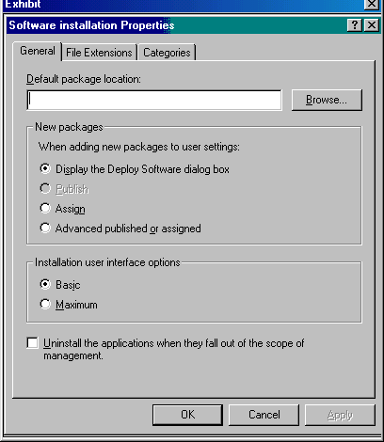

What will this action allow you to do when the new application package is added?
- It will allow you to assign, publish, and configure package properties
- It will allow you to deploy applications to users in all parts of the domain
- It will allow you to optimize the deployment time of the applications to the users
- It will allow the applications to be available for users the first time the users log in to the network

- You are the administrator for your company's Windows 2000 Active Directory domain. You are implementing a disaster recovery plan for all domain controllers.

Your first step in the disaster recovery plan is to create an Emergency Repair Disk for all domain controllers in the domain.

Which tool should you use?
- The Emergency Repair Disk wizard in the Backup tool
- The Emergency Repair Disk wizard in the Registry tool
- The \bootdisk\makeboot utility on the Windows 2000 CD
- The Active Directory Installation Wizard (dcpromo.exe)

- You are the administrator for your company's Windows 2000 network. In this network, you have an Active Directory domain named salescorp.com. You have created a group policy object (GPO) named manage.

You want the manage GPO to be applied to all members of the Managers group. You do not want the Managers group to have more permissions than are absolutely necessary.

Which permissions should be configured?
- Set Read to Allow
- Set Write to Allow
- Set Full Control to Allow
- Set Apply Group Policy to Allow, and set Read to Allow
- Set Apply Group Policy to Allow, and set Write to Allow

- You have been asked to implement a Windows 2000 network for a new company. All servers are Windows 2000 Server computers, and all clients are Windows 2000 Professional clients. You install the Domain Name System (DNS) on one of the Windows 2000 Server computers.

You want to accomplish the following goals:

DNS zone transfer traffic will be minimized on the network.
Administrative overhead for maintaining DNS zone files will be minimized.
Unauthorized host computers will not have records created in the zone.
All zone updates will come only from authorized DNS servers.
All zone transfer information will be secured as it crosses the network.

You take the following actions:

Create a standard primary zone on the DNS server.
Set up a Windows 2000 Server computer as the secondary DNS server.
Configure the secondary DNS server to initiate a full zone transfer.
In the Zone Properties dialog box, set Allow Dynamic updates option to Yes.
Create and assign an IPSec policy that encrypts all DNS traffic between the DNS servers.

Which goal or goals are accomplished with these actions? (Choose all that apply.)
- DNS zone transfer traffic will be minimized on the network
- All zone updates will come only from authorized DNS servers
- Unauthorized host computers will not have records created in the zone
- All zone transfer information will be secured as it crosses the network
- Administrative overhead for maintaining DNS zone files will be minimized

- You are the administrator of a Windows 2000 domain using Active Directory Services. You want to expedite startup and logon for users. What should you do?
- Enable the User Configuration settings in the appropriate Group Policy object
- Disable the User Configuration settings in the appropriate Group Policy object
- Enable the Computer Configuration settings in the appropriate Group Policy object
- Disable the Computer Configuration settings in the appropriate Group Policy object

- Your company has two offices: one in New York and one in Los Angeles. The offices are connected via a T1 line. You use Active Directory to manage the two sites who are members of the same domain. Replication occurs between the two sites daily. Currently each office has only one preferred bridgehead server.

The preferred bridgehead server in Los Angeles crashes. You want to assign a new bridgehead server to replace it.

What should you do? (Choose two.)
- Create a Global Catalog server at Los Angeles
- Create a site link bridge between New York and Los Angeles
- Create a second site link between New Your and Los Angeles
- Add the new bridgehead server on a domain controller in New York
- Add the new bridgehead server on a domain controller in Los Angeles

- You are the administrator for your Windows 2000 network. You are implementing a new security plan for your company after normal business hours. You decide to use some of the predefined security templates included with Windows 2000.

Where are these files located by default?
- in the %sytemroot%\Security folder
- in the %systemroot%\Templates folder
- in the %systemroot%\system32\Security folder
- in the %systemroot%\Security\Templates folder

- You are the administrator for your company's Windows 2000 network. You have offices in New York, London, and Tokyo. Each office has its own domain. You use Active Directory, and all domains are sites of the same forest.

Because you have low speed connections between the offices, you are concerned with the transmission of replication data.

Which protocol should you use?
- IP
- PPP
- SMTP
- PPTP

- You are the administrator for your Windows 2000 domains. You have three Windows 2000 Server computers that have Active Directory installed. You also have a Windows 2000 Server computer that is your Web server.

The Web server registers the same name as one of Active Directory domain names. This is causing the Web browser on some client computers to locate a domain controller instead of the Web server. You do not want to register A resource records for the domain name.

Which tool should you use to disable the A record registration?
- The Dnscmd tool
- The Netdom tool
- The Registry Editor
- IIS

- You are the administrator for your company's Windows 2000 network. You have decided to use Active Directory to provide directory services to all clients on your network.

You need to install Active Directory services on a Windows 2000 server. Which methods can you use to launch the Active Directory Installation Wizard? (Choose two.)
- Run SETUP from the Run dialog box
- Run ADSETUP form the Run dialog box
- Run DCPROMO from the Run dialog box
- Run Install Active Directory on the Actions menu of the Active Directory Sites and Services utility
- Run the Active Directory option of the Configure Your Server option on the Administrative Tools menu of the Start menu

- You are the administrator for a Windows 2000 network. You have two sites that are connected by four types of site links.

The four links connecting the two sites are 56 Kbps, ISDN, T1 and Gigabit Ethernet. The costs assigned to them are:
56 Kbps=100
ISDN=90
T1=50
Gigabit=80

Which link will be favored?
- T1=50
- ISDN=90
- Gigabit=80
- 56 Kbps=100

- You are the network administrator for Quota, Inc. Part of the multisite network is shown below:

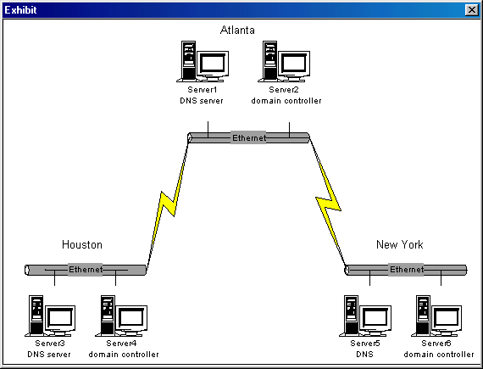
Server1 is configured with the primary zone for quota.com. Server3 and Server5 are configured with secondary zones for quota.com.

You discover an error in several host records that is preventing client computers in New York from accessing some shared resources. You make the necessary changes on Server1. You want them propagated to New York immediately.

What should you do?
- At Server1, stop and start the DNS Server service
- At Server5, select Allow zone transfers on the quota.com domain
- At Server5, perform Transfer from master action for the quota.com zone
- On the Action menu for the quota.com zone, click Update Server Data Files

- You are the administrator for your Windows 2000 domain. You have a RIS Server named RIS1 that has been properly configured and authorized.

You have installed the operating system and desktop applications on the source computer, named Source1. From the Source1's Start menu, you click Run. You then type the following:

\\RIS1\Reminst\Admin\i386\RIPrep.exe

Why did you perform these actions?
- to run the Remote Installation Services Setup to create the image
- to run the Client Installation Wizard remotely to create the image
- to run the Remote Installation Preparation Wizard to create the image
- to run the Software Installation and Maintenance utility to create the image

- You suspect that someone is using an administrative account to change user account and group account settings to which they should not have access. To confirm your suspicions, you set up auditing to track access to account management events on the domain controllers.

The system has been logging account management events for the past 36 hours. You now need to view the log file to examine the events that have occurred during the log period.

You start Event Viewer at a domain controller as shown below:

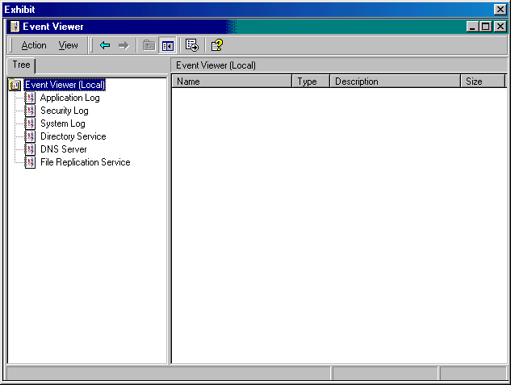
Which log should you use to view these events?
- system log
- security log
- DNS server log
- Application log
- Directory service log

Answer Key:
- D
- B
- D
- D
- A
- B
- A,B
- B
- A,B,C,E
- A
- B,D
- B
- Network and Dial-up Connections
- C
- D
- D
- A,C
- E
- A,B
- A,C,E
- A,C,D
- E
- D
- B
- D
- A
- C
- C
- D,F
- E
- B
- B
- D
- A,B,C
- B
- B,D
- A
- A,D,E
- A
- B
- B
- E
- A,B,C,D
- D
- C
- A
- A
- B
- C,E
- A,D
- C
- A,C,E,F
- B
- A,B,C
- C
- C
- Administrative Templates
- Security Options
- B,C,D,E
- A
- A
- A,B,C,E
- D
- C
- D
- A,B,D
- A,B,D,E
- A,B,C,D
- C,D,E
- B
- E
- A
- A,D,E
- D
- B,E
- C
- B
- B,C
- A
- C
- A
- B
- C
- A,E
- A
- C
- C
- C
- D
- A,C
- F
- E
- D
- D
- B
- B,E
- A,C
- B
- C
- B,D
- B,C
- Account Lockout Policy; Audit Policy
- C
- A
- A,D,E
- C
- C
- D
- C
- Send; Receive; UDP; TCP
- D
- C
- B,D,E,F
- D
- A,B,C,D
- A
- D
- A
- C,D
- A
- A
- E
- D
- B
- B
- D
- C,D
- A,B,C,D
- A
- D
- C
- D
- Offline Files
- Network and Dial-up Connections
- B
- A,B,C,D
- BIND secondaries
- Windows Settings
- A,B,D
- C
- A
- C
- Audit Policy; Settings for Event Logs
- C
- C,D
- C
- A,B,C,D
- A
- A
- A,B,D,F
- C,D
- A,B,C
- B
- A
- D
- B
- A
- A,B,C,D
- A
- C
- C
- A
- A
- D
- D,E
- B
- D,E
- D
- C
- C
- C
- A
- D
- C
- B

